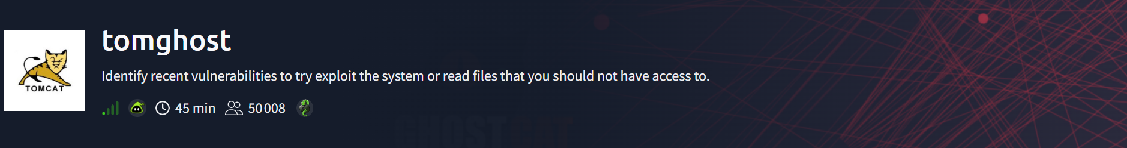

##NMAP SCAN
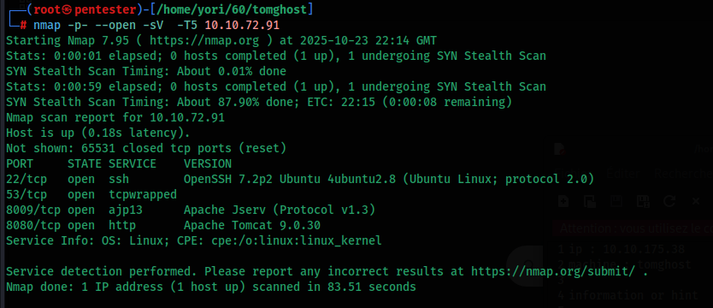

##EXPLOITATION
There are four open ports, and after checking for exploits for each service, the one that stands out is AJP13.

This vulnerability can be exploited using Metasploit .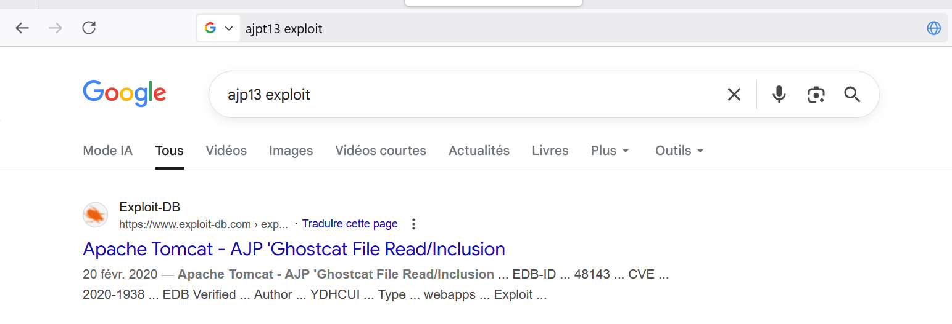.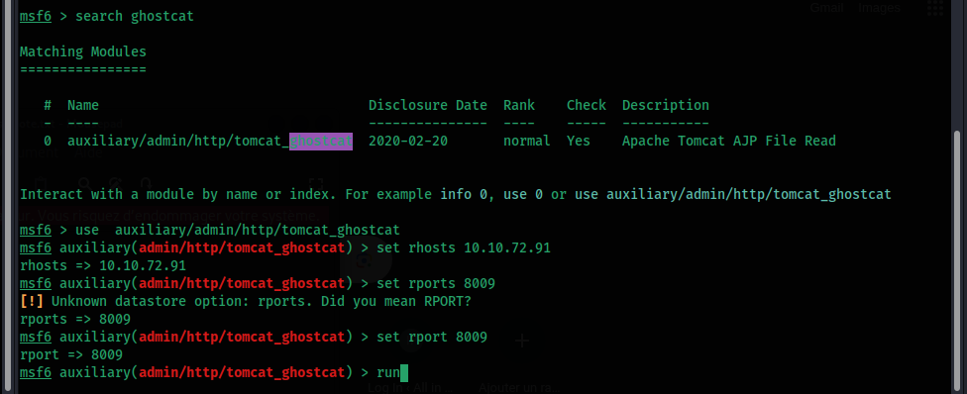
Following the run, we observed some credentials.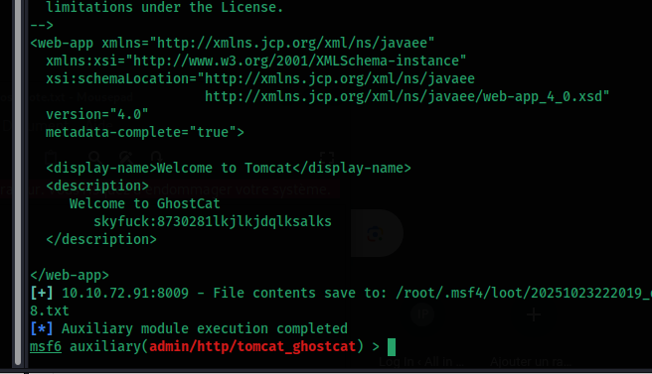

Username : skyfuck
Password : 8730281lkjlkjdqlksalks

We had previously seen the SSH service, so let's connect.

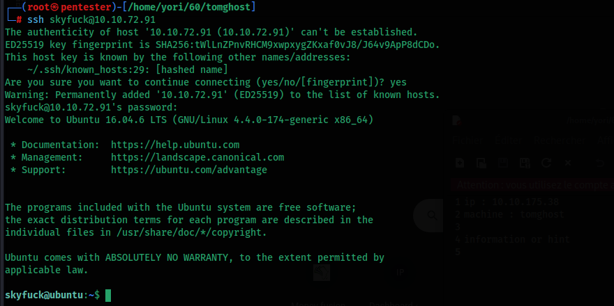

Let’s see the user flag
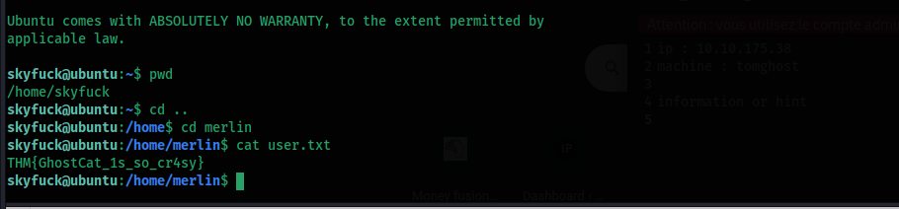

##Privilege escalation (merlin)

Let's download the files tryhackme.asc and credentials.pgp to our attacking host using SCP. Then, we can extract a hash from tryhackme.asc using gpg2john :
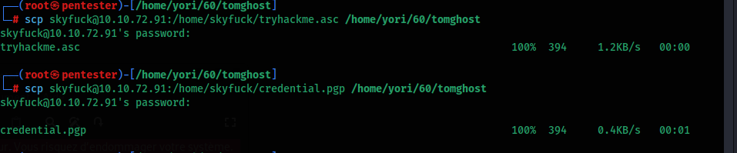

Let's find the message's passphrase — first, let's use gpg2john.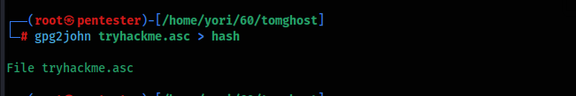
john –wordlist=/usr/share/wordlists/rockyou.txt hash
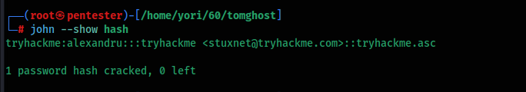
The passphrase we found is alexandru; it's the password we'll use to decrypt credential.pgp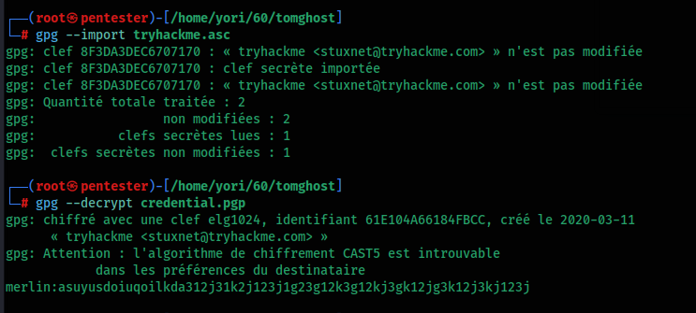

The PGP file, once decrypted, provided additional credentials.
Username : merlin
Password : asuyusdoiuqoilkda312j31k2j123j1g23g12k3g12kj3gk12jg3k12j3kj123j

With these credentials, we connect via SSH.
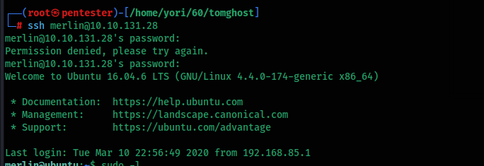

##Privilege escalation (root)

After running sudo -l we can see that the user merlin is allowed to run zip with sudo. We can use the GTFOBins technique to get a root shell or to read root-owned files.

