Analysis of RAA loss data

CLRS Concurrent Session

Thursday, September 10, 2015

Load the ChainLadder package and view the RAA triangle.

library(ChainLadder)  
RAA

## dev  
## origin 1 2 3 4 5 6 7 8 9 10  
## 1981 5012 8269 10907 11805 13539 16181 18009 18608 18662 18834  
## 1982 106 4285 5396 10666 13782 15599 15496 16169 16704 NA  
## 1983 3410 8992 13873 16141 18735 22214 22863 23466 NA NA  
## 1984 5655 11555 15766 21266 23425 26083 27067 NA NA NA  
## 1985 1092 9565 15836 22169 25955 26180 NA NA NA NA  
## 1986 1513 6445 11702 12935 15852 NA NA NA NA NA  
## 1987 557 4020 10946 12314 NA NA NA NA NA NA  
## 1988 1351 6947 13112 NA NA NA NA NA NA NA  
## 1989 3133 5395 NA NA NA NA NA NA NA NA  
## 1990 2063 NA NA NA NA NA NA NA NA NA

Form the triangle of age-to-age factors and initially select the weighted average link ratios.

## dev  
## origin 1-2 2-3 3-4 4-5 5-6 6-7 7-8 8-9 9-10  
## 1981 1.650 1.319 1.082 1.147 1.195 1.113 1.033 1.003 1.009  
## 1982 40.425 1.259 1.977 1.292 1.132 0.993 1.043 1.033 NA  
## 1983 2.637 1.543 1.163 1.161 1.186 1.029 1.026 NA NA  
## 1984 2.043 1.364 1.349 1.102 1.113 1.038 NA NA NA  
## 1985 8.759 1.656 1.400 1.171 1.009 NA NA NA NA  
## 1986 4.260 1.816 1.105 1.226 NA NA NA NA NA  
## 1987 7.217 2.723 1.125 NA NA NA NA NA NA  
## 1988 5.142 1.887 NA NA NA NA NA NA NA  
## 1989 1.722 NA NA NA NA NA NA NA NA  
## smpl 8.206 1.696 1.315 1.183 1.127 1.043 1.034 1.018 1.009  
## vwtd 2.999 1.624 1.271 1.172 1.113 1.042 1.033 1.017 1.009

## 1-2 2-3 3-4 4-5 5-6 6-7 7-8 8-9 9-10   
## 2.999 1.624 1.271 1.172 1.113 1.042 1.033 1.017 1.009

## Analyze tail

The average link ratios seem to follow a pattern.

age <- 1:9  
logLDF <- log(selectedATA - 1)  
plot(age, logLDF)  
fit <- lm(logLDF ~ age)  
abline(fit)

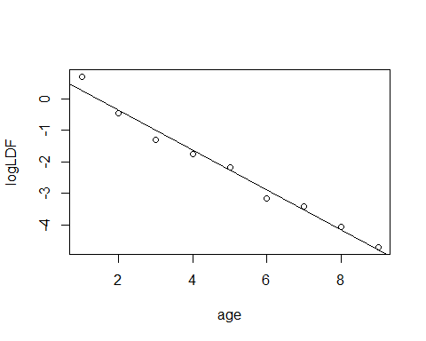

summary(fit)

##   
## Call:  
## lm(formula = logLDF ~ age)  
##   
## Residuals:  
## Min 1Q Median 3Q Max   
## -0.30799 -0.12857 0.08537 0.09332 0.42221   
##   
## Coefficients:  
## Estimate Std. Error t value Pr(>|t|)   
## (Intercept) 0.90448 0.17662 5.121 0.00137 **   
## age -0.63404 0.03139 -20.201 1.82e-07 ***  
## ---  
## Signif. codes: 0 '***' 0.001 '**' 0.01 '*' 0.05 '.' 0.1 ' ' 1  
##   
## Residual standard error: 0.2431 on 7 degrees of freedom  
## Multiple R-squared: 0.9831, Adjusted R-squared: 0.9807   
## F-statistic: 408.1 on 1 and 7 DF, p-value: 1.825e-07

Assuming the pattern continues, what magnitude of tail is implied? Investigate the next 10 years versus the next 100 years.

moreAges <- data.frame(age = 10:19)  
moreLDF <- predict(fit, newdata = moreAges, type = "response")  
  
tail_10 <- prod(exp(moreLDF) + 1)  
  
moreAges <- data.frame(age = 10:109)  
LDF_100 <- predict(fit, newdata = moreAges, type = "response")  
  
tail_100 <- prod(exp(LDF_100) + 1)

Over the next 100 years, the tail would be 1.009309. We use this as our estimated tail factor.

In addition, select the simple average link ratio for the 1-2 period. Here is the cumulative loss development pattern:

## 9-10 8-9 7-8 6-7 5-6 4-5 3-4 2-3 1-2   
## 1.009 1.018 1.036 1.070 1.115 1.241 1.454 1.848 3.002 24.632

## Project to ultimate

LDEst <- data.frame(Latest = getLatestCumulative(RAA), CDF,   
 Ultimate = round(getLatestCumulative(RAA) * CDF, 0))  
Total <- colSums(LDEst)  
Total[2] <- NA  
rbind(LDEst, Sum = Total)

## Latest CDF Ultimate  
## 1981 18834 1.009 19004  
## 1982 16704 1.018 17005  
## 1983 23466 1.036 24311  
## 1984 27067 1.070 28962  
## 1985 26180 1.115 29191  
## 1986 15852 1.241 19672  
## 1987 12314 1.454 17905  
## 1988 13112 1.848 24231  
## 1989 5395 3.002 16196  
## 1990 2063 24.632 50816  
## Sum 160987 NA 247293