# Relational Databases & Design PSIS4142

Fall 2013

# 

Ishiyama, Shitizshichijibhatia

Miller, Kimberly

Oden, Robert

Priestly, Karen

Contents

Design Rationale 3

Normalized Tables 4

Database Entity Relationships Diagrams 5

Significant Tables 6

Costume Table 6

Costume Table View 6

Costume Table Design View 6

Customer Table View 7

Customer Table Design View 7

Transaction Table 8

Transaction Table View 8

Transaction Table Design View 8

Sample Queries, Forms & Reports 9

Queries 9

Costume Sales by Category 9

Inventory Query 10

Forms 12

Customer Form 12

Costumes Form 12

Reports 14

Costumes in Inventory 14

Cost of Inventory 15

Database Data Dictionary 16

# Design Rationale

The following assumptions were made after reviewing the needs and requirements of Letty’s Costume Rentals:

* Letty’s Costume Rental is a Virginia business and charges the mandatory 5% sales tax.
* Base Cost is the wholesale price that Letty paid to the Vendor for the costume purchase.
* If a costume category is no longer available, the option to select that category will be removed so that it can’t be selected, but deleting a category is not an option because all costumes from that category would need to be reclassified. *A category may have many costumes, but each costume can only belong to one category.*
* A shopper becomes a Customer upon a valid rental or purchase execution and documentation. For rental transactions, this occurs upon payment of the rental deposit. Customers are entered into the database to initiate a rental or purchase transaction. This will facilitate expedited agreement completions for future rentals/purchases, preferred shopping, and targeted advertising. *Therefore a Customer must complete one or more transactions and each transaction can belong to only one customer*.
* Costume Rentals must be secured with a credit card.
* Payment of the rental deposit secures the costume. This amends the inventory upon rental pick-up.(Accuracy check required)
* Rental Period is 48 hours. Extensions are $5.00 per day.
* Each Rental, Sale and Costume Purchase that occurs will be recorded as a separate transaction. Each transaction will have its own transaction number. The available inventory and stock levels are controlled by total completed transactions.
* Letty’s Costume Rental uses one set fee for daily rentals and one set cleaning fee for an Adult or Child costume.
* Employee/transaction information is maintained to facilitate lost ticket queries and possible future bonus structures. *Therefore one Employee may complete one or more transactions, but each transaction will be credited to only one employee*.
* When Costume is returned by customer, the employee manually changes the status of the costume in the database to *“maintenance”* (regardless if the costume is out for repair or cleaning).
* When the Costume is returned from either the cleaner or seamstress, the employee manually changes the status of the costume in the database to *“available”*.

# Normalized Tables

# Database Entity Relationships Diagrams

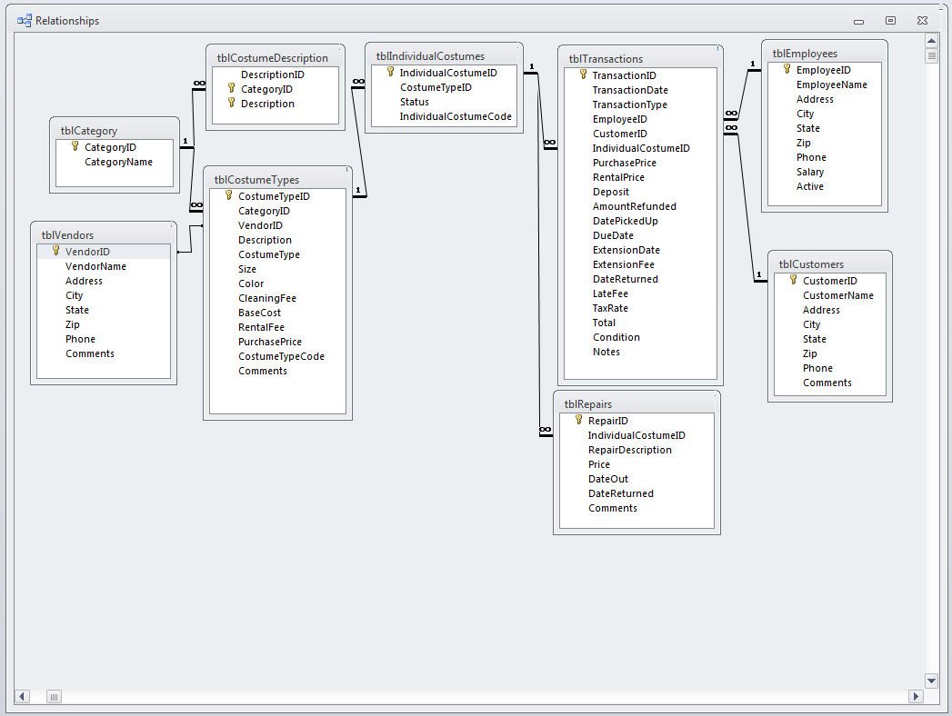

# Significant Tables

## Costume Table

Primary Key: **CostumeID**

Foreign Key: *CategoryID*

Other Keys: Description, CostumeType, Size, Color, BaseCost, PurchasePrice, Status, Previous Rentals, Comments

Relationships:

Linked to – tblTransactions, tblCategory, tblRepairs and tblFees

Queries:

This table will be found in multiple queries including: Customer Transactions, Inventory, and Costume Status.

### Costume Table View

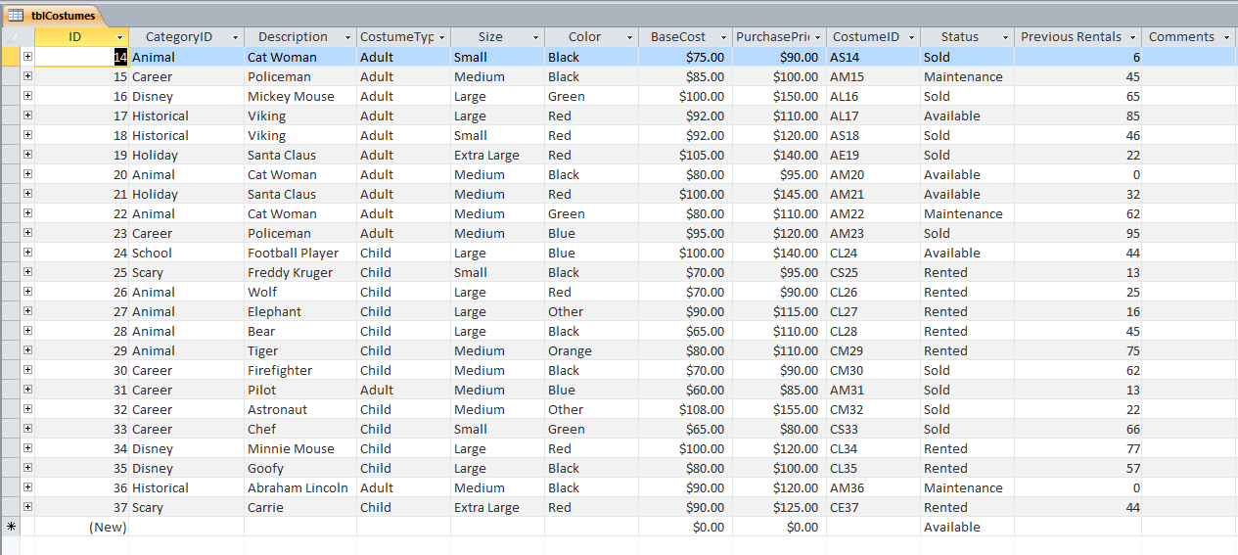

### Costume Table Design View

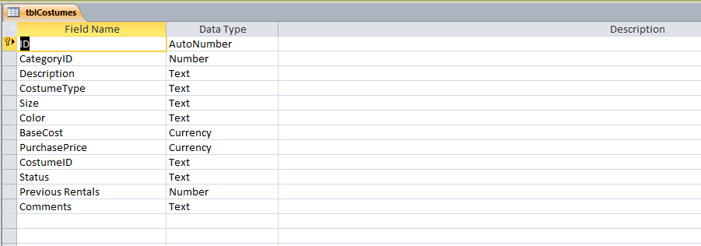**Customer Table**

Primary Key: **CustomerID**

Other Keys: CustomerName, Address, City, State, Zip, Phone, Preferred Type, Preferred Size, Comments

Relationships:

Linked to – tblTransactions

Queries:

This table can be found in a number of queries including: Customer Status, Quantity and Type of Transactions per Customer and Employee productivity reports.

### Customer Table View

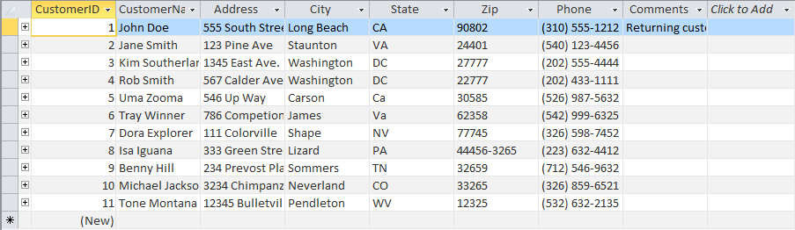

### Customer Table Design View

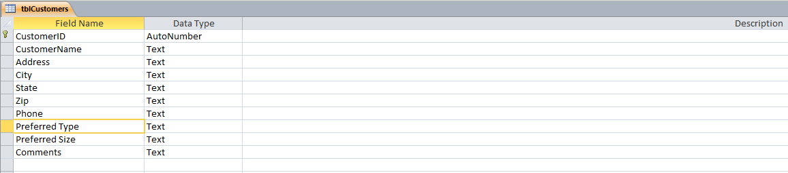

## Transaction Table

Primary Key: **TransactionID**

Foreign Key: *EmployeeID*, *CustomerID* and *CostumeID*

Other Keys: TransactionDate, TransactionType, PreviousRentals, PurchasePrice

Relationships:

Linked to – tblCustomer, tblEmployee, tblCostumes

Queries:

This table can be found in a number of queries including: Costume Status, Employee Productivity, Number of Sales and Number of Rentals

### Transaction Table View

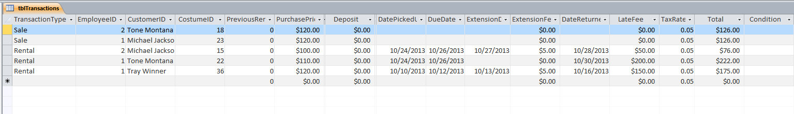

### Transaction Table Design View

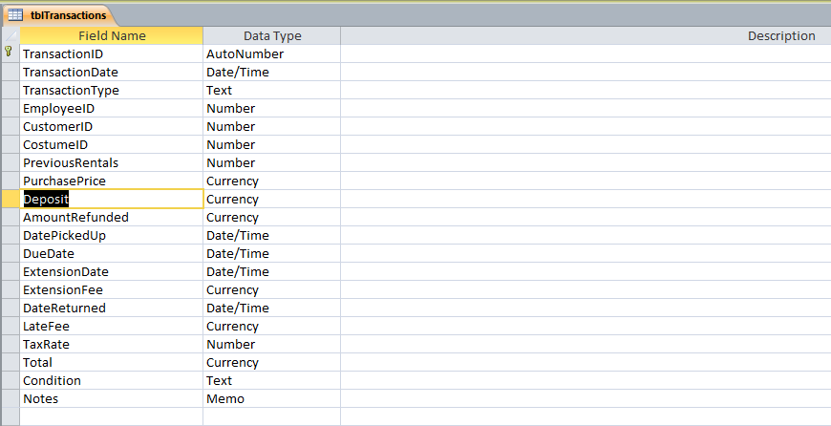

Sample Queries, Forms & Reports

## Queries

### Costume Sales by Category

The purpose of this Query is to produce a listing of costumes that were sold and in turn, removed from inventory. It is updated every time a customer makes a purchase. It will also provide useful information to Letty when computing year-end sales profits.

**SQL:**

SELECT tblCostumes.Status, tblCategory.CategoryID, tblCategory.CategoryName, tblCostumes.CostumeID, tblCostumes.BaseCost

FROM (tblCategory INNER JOIN tblCostumeDescription ON tblCategory.CategoryID = tblCostumeDescription.CategoryID) INNER JOIN tblCostumes ON tblCategory.CategoryID = tblCostumes.CategoryID

GROUP BY tblCostumes.Status, tblCategory.CategoryID, tblCategory.CategoryName, tblCostumes.CostumeID, tblCostumes.BaseCost

HAVING (((tblCostumes.Status)="sold"))

ORDER BY tblCategory.CategoryID;

Table View:

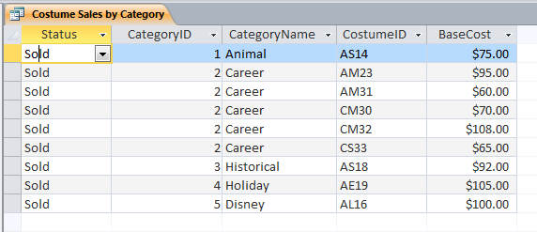

Design View:

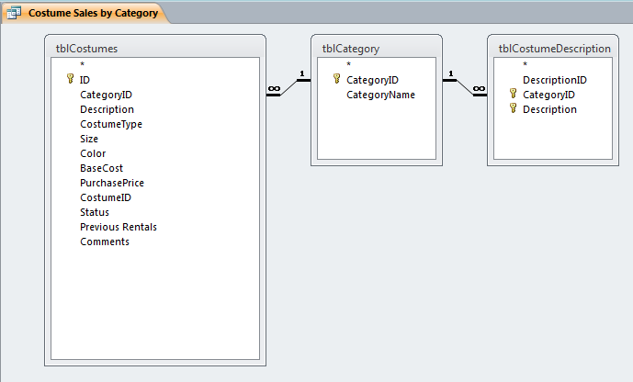

### Inventory Query

The purpose of this Query is to produce a listing of costumes in inventory. It is updated every time a customer makes a rental or purchase and when new costumes are purchased and received from supply vendors. It will also provide the total cost of inventory to Letty’s Costume Rentals. This is not the available inventory list. Inventory constitutes anything that ***is not*** SOLD.

SQL:

SELECT tblCostumes.ID, tblCostumes.Description, tblCostumes.Status, tblCostumes.BaseCost

FROM tblCostumes

WHERE (((tblCostumes.Status)<>"sold"));

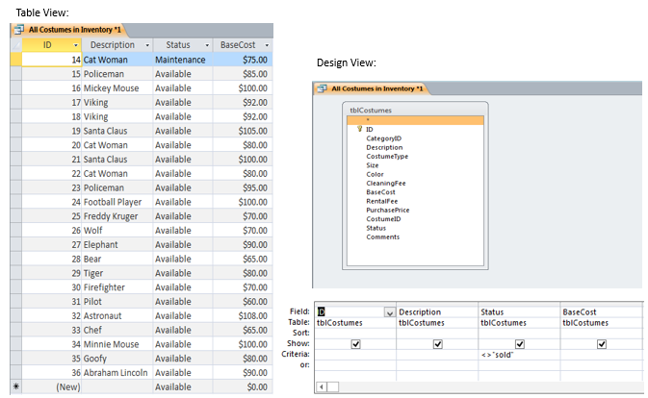

## Forms

### Customer Form

The purpose of this form is to allow for the addition, edit and deletion, of Customers to the database. This form is accessible from the main screen and is the customers’ introduction to conducting business with Letty’s Costume Rental.

### Costumes Form

This form is used in conjunction with the Category and Description form to allow the entry of new costumes into Letty’s Database. This form is accessible from the main screen and is protected by the Administrator password.

Form View:

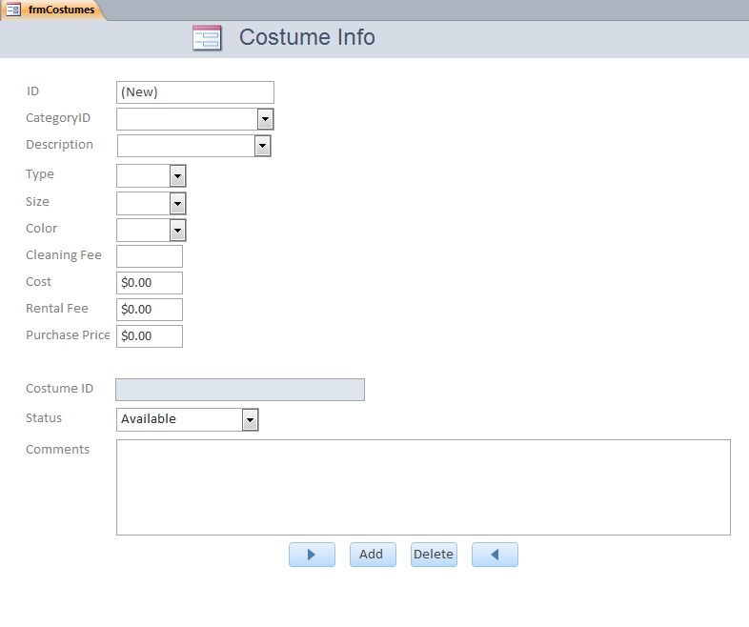

## Reports

### Costumes in Inventory

This report lists all the costumes owned by Letty’s Costume Rental and therefore constitutes the inventory. This form will be useful for end of year reporting purposes and details stock levels. This report is generated by the All Costumes in Inventory Table and includes any costume whose status is not sold.

Report View:

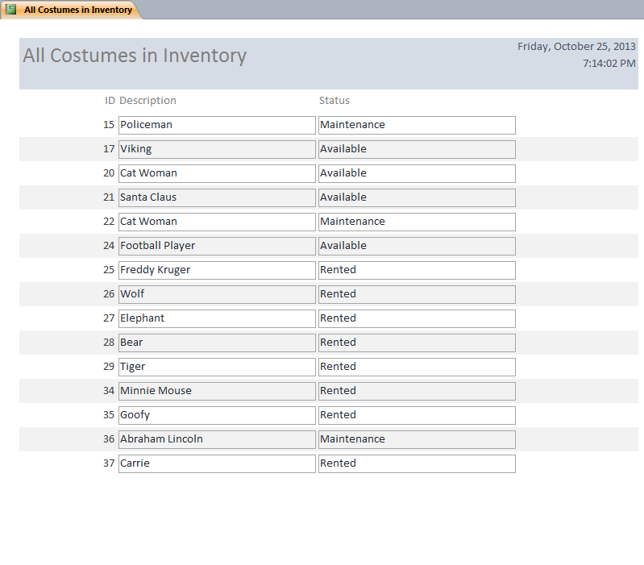

### Cost of Inventory

This report provides the total cost of Letty’s inventory. The report is created from the total cost of inventory query.

Report View:

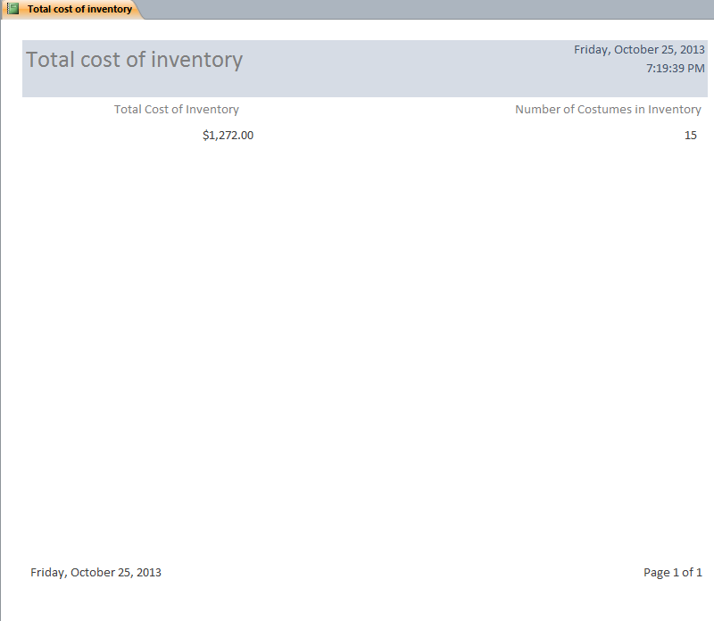

Database Data Dictionary

This is the Database Data Dictionary for the Customer Table, Costume Form and the Cost of Inventory Query.

C:\Users\southerlandk\Downloads\LettyCostumeVer7_KMedits.accdb Friday, October 25, 2013

Table: tblCategory

Properties

AlternateBackShade: 95 AlternateBackThemeC 1

AlternateBackTint: 100 BackShade: 100

BackTint: 100 DatasheetForeTheme 0

DatasheetGridlinesTh 3 DateCreated: 10/13/2013 7:25:07 AM

DefaultView: 2 DisplayViewsOnShare 1

FilterOnLoad: False GUID: {guid {CD480F9B-

ACA6-4EC1-A944-

HideNewField: False LastUpdated: 10/24/2013 6:23:50 PM

NameMap: Long binary data OrderByOn: False

OrderByOnLoad: True Orientation: Left-to-Right

PublishToWeb: 1 ReadOnlyWhenDiscon False

RecordCount: 7 ThemeFontIndex: 1

TotalsRow: False Updatable: True

Columns

Name Type Size

CategoryID Long Integer 4

AggregateType: -1

AllowZeroLength: False

AppendOnly: False

Attributes: Fixed Size, Auto-Increment

CollatingOrder: General

ColumnHidden: False

ColumnOrder: Default

ColumnWidth: Default

CurrencyLCID: 0

DataUpdatable: False

GUID: {guid {82039593-30B8-4597-9766-0D3D9C302A9F}}

OrdinalPosition: 0

Required: False

ResultType: 0

SourceField: CategoryID

SourceTable: tblCategory

TextAlign: General

CategoryName Short Text 50

AggregateType: -1

AllowZeroLength: False

AppendOnly: False

Attributes: Variable Length

CollatingOrder: General

ColumnHidden: False

ColumnOrder: Default

ColumnWidth: 1824

CurrencyLCID: 0

DataUpdatable: False

DisplayControl: Text Box

GUID: {guid {DD700382-F7C5-4D0E-996B-D3D9876CFA50}}

IMEMode: 0

IMESentenceMode: 3

Table: tblCategory

OrdinalPosition: 1

Required: True

ResultType: 0

SourceField: CategoryName

SourceTable: tblCategory

TextAlign: General

UnicodeCompression: True

Relationships

tblCategorytblCostumeDescription

tblCategory tblCostumeDescriptio

CategoryID 1 ¥ CategoryID

Attributes: Enforced, Cascade Updates, Cascade Deletes

RelationshipType: One-To-Many

tblCategorytblCostumes

tblCategory tblCostumes

CategoryID 1 ¥ CategoryID

Attributes: Enforced, Cascade Updates, Cascade Deletes

RelationshipType: One-To-Many

Table: tblCategory

Fields:

CategoryID Ascending

User Permissions

admin Delete, Read Permissions, Set Permissions, Change Owner,

Read Definition, Write Definition, Read Data, Insert Data,

Group Permissions

Admins Delete, Read Permissions, Set Permissions, Change Owner,

Read Definition, Write Definition, Read Data, Insert Data,

Users Delete, Read Permissions, Set Permissions, Change Owner,

Read Definition, Write Definition, Read Data, Insert Data,

Table: tblCostumeDescription

Properties

AlternateBackShade: 95 AlternateBackThemeC 1

AlternateBackTint: 100 BackShade: 100

BackTint: 100 DatasheetForeTheme 0

DatasheetGridlinesTh 3 DateCreated: 10/13/2013 7:47:11 AM

DefaultView: 2 DisplayViewsOnShare 1

FilterOnLoad: False GUID: {guid {2056AC07-B29C-

4F8B-8169-

HideNewField: False LastUpdated: 10/24/2013 6:23:50 PM

NameMap: Long binary data OrderByOn: False

OrderByOnLoad: True Orientation: Left-to-Right

PublishToWeb: 1 ReadOnlyWhenDiscon False

RecordCount: 30 ThemeFontIndex: 1

TotalsRow: False Updatable: True

Columns

Name Type Size

DescriptionID Long Integer 4

AggregateType: -1

AllowZeroLength: False

AppendOnly: False

Attributes: Fixed Size, Auto-Increment

CollatingOrder: General

ColumnHidden: False

ColumnOrder: 1

ColumnWidth: Default

CurrencyLCID: 0

DataUpdatable: False

GUID: {guid {17CE3189-50AD-4A72-AB62-FC1D6B1C38CC}}

OrdinalPosition: 0

Required: False

ResultType: 0

SourceField: DescriptionID

SourceTable: tblCostumeDescription

TextAlign: General

CategoryID Long Integer 4

AggregateType: -1

AllowMultipleValues: False

AllowValueListEdits: True

AllowZeroLength: False

AppendOnly: False

Attributes: Fixed Size

BoundColumn: 1

CollatingOrder: General

ColumnCount: 2

ColumnHeads: False

ColumnHidden: False

ColumnOrder: Default

ColumnWidth: Default

ColumnWidths: 0;1440

Table: tblCostumeDescription

CurrencyLCID: 0

DataUpdatable: False

DecimalPlaces: Auto

DisplayControl: Combo Box

GUID: {guid {8C1D5D06-0977-43E0-865C-91712DCF9727}}

LimitToList: True

ListRows: 16

ListWidth: 0twip

OrdinalPosition: 1

Required: True

ResultType: 0

RowSource: SELECT tblCategory.CategoryID,

tblCategory.CategoryName FROM tblCategory ORDER

RowSourceType: Table/Query

ShowOnlyRowSourceV False

SourceField: CategoryID

SourceTable: tblCostumeDescription

TextAlign: General

Description Short Text 25

AggregateType: -1

AllowZeroLength: False

AppendOnly: False

Attributes: Variable Length

CollatingOrder: General

ColumnHidden: False

ColumnOrder: Default

ColumnWidth: Default

CurrencyLCID: 0

DataUpdatable: False

DisplayControl: Text Box

GUID: {guid {887F0BD5-7BEA-4053-BE9C-67CE94B79AFA}}

IMEMode: 0

IMESentenceMode: 3

OrdinalPosition: 2

Required: True

ResultType: 0

SourceField: Description

SourceTable: tblCostumeDescription

TextAlign: General

UnicodeCompression: True

Relationships

tblCategorytblCostumeDescription

tblCategory tblCostumeDescriptio

1 ¥

CategoryID CategoryID

Attributes: Enforced, Cascade Updates, Cascade Deletes

RelationshipType: One-To-Many

Table Indexes

Name Number of Fields

Table: tblCostumeDescription

idxDescription 2

Clustered: False

DistinctCount: 30

Foreign: False

IgnoreNulls: False

Name: idxDescription

Primary: True

Required: True

Unique: True

Fields:

CategoryID Ascending

Description Ascending

tblCategorytblCostumeDescription 1

Clustered: False

DistinctCount: 7

Foreign: True

IgnoreNulls: False

Name: tblCategorytblCostumeDescription

Primary: False

Required: False

Unique: False

Fields:

CategoryID Ascending

User Permissions

admin Delete, Read Permissions, Set Permissions, Change Owner,

Read Definition, Write Definition, Read Data, Insert Data,

Group Permissions

Admins Delete, Read Permissions, Set Permissions, Change Owner,

Read Definition, Write Definition, Read Data, Insert Data,

Users Delete, Read Permissions, Set Permissions, Change Owner,

Read Definition, Write Definition, Read Data, Insert Data,

Table: tblCostumes

Properties

AlternateBackShade: 95 AlternateBackThemeC 1

AlternateBackTint: 100 BackShade: 100

BackTint: 100 DatasheetForeTheme 0

DatasheetGridlinesTh 3 DateCreated: 10/13/2013 8:07:32 AM

DefaultView: 2 DisplayViewsOnShare 1

FilterOnLoad: False GUID: {guid {3E36DA59-121E-

4945-8905-

HideNewField: False LastUpdated: 10/25/2013 7:41:01 PM

NameMap: Long binary data OrderByOn: False

OrderByOnLoad: True Orientation: Left-to-Right

PublishToWeb: 1 ReadOnlyWhenDiscon False

RecordCount: 24 ThemeFontIndex: 1

TotalsRow: False Updatable: True

Columns

Name Type Size

ID Long Integer 4

AggregateType: -1

AllowZeroLength: False

AppendOnly: False

Attributes: Fixed Size, Auto-Increment

CollatingOrder: General

ColumnHidden: False

ColumnOrder: 1

ColumnWidth: Default

CurrencyLCID: 0

DataUpdatable: False

GUID: {guid {4EBF1E74-C130-4913-ADA9-1DA64F61AFF8}}

OrdinalPosition: 0

Required: False

ResultType: 0

SourceField: ID

SourceTable: tblCostumes

TextAlign: General

CategoryID Long Integer 4

AggregateType: -1

AllowMultipleValues: False

AllowValueListEdits: False

AllowZeroLength: False

AppendOnly: False

Attributes: Fixed Size

BoundColumn: 1

CollatingOrder: General

ColumnCount: 2

ColumnHeads: False

ColumnHidden: False

ColumnOrder: 2

ColumnWidth: 1770

ColumnWidths: 0;1440

Table: tblCostumes

CurrencyLCID: 0

DataUpdatable: False

DecimalPlaces: Auto

DisplayControl: Combo Box

GUID: {guid {E71E95EF-7DD3-421E-A41B-8AD424AAE253}}

LimitToList: True

ListRows: 16

ListWidth: 0twip

OrdinalPosition: 1

Required: False

ResultType: 0

RowSource: SELECT tblCategory.CategoryID,

tblCategory.CategoryName FROM tblCategory ORDER

RowSourceType: Table/Query

ShowOnlyRowSourceV False

SourceField: CategoryID

SourceTable: tblCostumes

TextAlign: General

Description Short Text 255

AggregateType: -1

AllowMultipleValues: False

AllowValueListEdits: False

AllowZeroLength: True

AppendOnly: False

Attributes: Variable Length

BoundColumn: 1

CollatingOrder: General

ColumnCount: 1

ColumnHeads: False

ColumnHidden: False

ColumnOrder: 3

ColumnWidth: 1725

CurrencyLCID: 0

DataUpdatable: False

DisplayControl: Combo Box

GUID: {guid {9D9C17C6-A3D4-4B19-B2F9-F32F567E8470}}

IMEMode: 0

IMESentenceMode: 3

LimitToList: False

ListRows: 16

ListWidth: 0twip

OrdinalPosition: 2

Required: False

ResultType: 0

RowSource: SELECT tblCostumeDescription.Description FROM

tblCostumeDescription;

RowSourceType: Table/Query

ShowOnlyRowSourceV False

SourceField: Description

SourceTable: tblCostumes

TextAlign: General

UnicodeCompression: False

Table: tblCostumes

CostumeType Short Text 20

AggregateType: -1

AllowMultipleValues: False

AllowValueListEdits: False

AllowZeroLength: True

AppendOnly: False

Attributes: Variable Length

BoundColumn: 1

CollatingOrder: General

ColumnCount: 1

ColumnHeads: False

ColumnHidden: False

ColumnOrder: 4

ColumnWidth: Default

CurrencyLCID: 0

DataUpdatable: False

DisplayControl: Combo Box

GUID: {guid {7530DF19-2762-4B4A-AD56-9995C66F6A8A}}

IMEMode: 0

IMESentenceMode: 3

LimitToList: False

ListRows: 16

ListWidth: 0twip

OrdinalPosition: 3

Required: False

ResultType: 0

RowSource: Adult;Child

RowSourceType: Value List

ShowOnlyRowSourceV False

SourceField: CostumeType

SourceTable: tblCostumes

TextAlign: General

UnicodeCompression: True

Size Short Text 255

AggregateType: -1

AllowMultipleValues: False

AllowValueListEdits: True

AllowZeroLength: True

AppendOnly: False

Attributes: Variable Length

BoundColumn: 1

CollatingOrder: General

ColumnCount: 1

ColumnHeads: False

ColumnHidden: False

ColumnOrder: 5

ColumnWidth: Default

ColumnWidths: 1440

CurrencyLCID: 0

DataUpdatable: False

DisplayControl: Combo Box

GUID: {guid {CEEC2EC6-2251-4C41-9DD0-FE624352C369}}

IMEMode: 0

IMESentenceMode: 3

Table: tblCostumes

LimitToList: False

ListRows: 16

ListWidth: 0twip

OrdinalPosition: 4

Required: False

ResultType: 0

RowSource: Small;Medium;Large;Extra Large

RowSourceType: Value List

ShowOnlyRowSourceV False

SourceField: Size

SourceTable: tblCostumes

TextAlign: General

UnicodeCompression: True

Color Short Text 255

AggregateType: -1

AllowMultipleValues: False

AllowValueListEdits: True

AllowZeroLength: True

AppendOnly: False

Attributes: Variable Length

BoundColumn: 1

CollatingOrder: General

ColumnCount: 1

ColumnHeads: False

ColumnHidden: False

ColumnOrder: 6

ColumnWidth: Default

ColumnWidths: 1440

CurrencyLCID: 0

DataUpdatable: False

DisplayControl: Combo Box

GUID: {guid {87565492-C069-4A79-9E37-3F0C03E8D9BF}}

IMEMode: 0

IMESentenceMode: 3

LimitToList: False

ListRows: 16

ListWidth: 0twip

OrdinalPosition: 5

Required: False

ResultType: 0

RowSource: Black;Blue;Green;Orange;Red;Other

RowSourceType: Value List

ShowOnlyRowSourceV False

SourceField: Color

SourceTable: tblCostumes

TextAlign: General

UnicodeCompression: True

BaseCost Currency 8

AggregateType: -1

AllowZeroLength: False

AppendOnly: False

Attributes: Fixed Size

CollatingOrder: General

Table: tblCostumes

ColumnHidden: False

ColumnOrder: 7

ColumnWidth: Default

CurrencyLCID: 1033

DataUpdatable: False

DecimalPlaces: Auto

Format: $#,##0.00;($#,##0.00)

GUID: {guid {55909A89-60D3-4CC4-BE8B-8A1B2B0C727E}}

OrdinalPosition: 6

Required: False

ResultType: 0

SourceField: BaseCost

SourceTable: tblCostumes

TextAlign: General

PurchasePrice Currency 8

AggregateType: -1

AllowZeroLength: False

AppendOnly: False

Attributes: Fixed Size

CollatingOrder: General

ColumnHidden: False

ColumnOrder: 8

ColumnWidth: Default

CurrencyLCID: 1033

DataUpdatable: False

DecimalPlaces: Auto

Format: $#,##0.00;($#,##0.00)

GUID: {guid {F1FECC71-DD76-4D25-A38C-4FBA6E6BE175}}

OrdinalPosition: 7

Required: False

ResultType: 0

SourceField: PurchasePrice

SourceTable: tblCostumes

TextAlign: General

CostumeID Short Text 20

AggregateType: -1

AllowZeroLength: True

AppendOnly: False

Attributes: Variable Length

CollatingOrder: General

ColumnHidden: False

ColumnOrder: 9

ColumnWidth: Default

CurrencyLCID: 0

DataUpdatable: False

DisplayControl: Text Box

GUID: {guid {3E9D6E8E-4433-46B6-9460-EEDBA782AE47}}

IMEMode: 0

IMESentenceMode: 3

OrdinalPosition: 8

Required: True

ResultType: 0

SourceField: CostumeID

Table: tblCostumes

SourceTable: tblCostumes

TextAlign: General

UnicodeCompression: True

Status Short Text 255

AggregateType: -1

AllowMultipleValues: False

AllowValueListEdits: True

AllowZeroLength: True

AppendOnly: False

Attributes: Variable Length

BoundColumn: 1

CollatingOrder: General

ColumnCount: 1

ColumnHeads: False

ColumnHidden: False

ColumnOrder: 10

ColumnWidth: Default

ColumnWidths: 1440

CurrencyLCID: 0

DataUpdatable: False

DisplayControl: Combo Box

GUID: {guid {A5B1ACF9-A49F-4C8D-9ABA-05B14514A57D}}

IMEMode: 0

IMESentenceMode: 3

LimitToList: False

ListRows: 16

ListWidth: 0twip

OrdinalPosition: 9

Required: False

ResultType: 0

RowSource: Available;Maintenance;Rented;Sold

RowSourceType: Value List

ShowOnlyRowSourceV False

SourceField: Status

SourceTable: tblCostumes

TextAlign: General

UnicodeCompression: True

Previous Rentals Long Integer 4

AggregateType: -1

AllowZeroLength: False

AppendOnly: False

Attributes: Fixed Size

CollatingOrder: General

ColumnHidden: False

ColumnOrder: 11

ColumnWidth: 1950

CurrencyLCID: 0

DataUpdatable: False

DecimalPlaces: Auto

DisplayControl: Text Box

GUID: {guid {6C03E5B6-2F10-4316-9B74-23C6B8FA83CF}}

OrdinalPosition: 10

Required: False

Table: tblCostumes

ResultType: 0

SourceField: Previous Rentals

SourceTable: tblCostumes

TextAlign: General

Comments Short Text 255

AggregateType: -1

AllowZeroLength: True

AppendOnly: False

Attributes: Variable Length

CollatingOrder: General

ColumnHidden: False

ColumnOrder: 12

ColumnWidth: Default

CurrencyLCID: 0

DataUpdatable: False

DisplayControl: Text Box

GUID: {guid {3FDF11CA-CD7E-444F-BB91-59FFB8409CD6}}

IMEMode: 0

IMESentenceMode: 3

OrdinalPosition: 11

Required: False

ResultType: 0

SourceField: Comments

SourceTable: tblCostumes

TextAlign: General

UnicodeCompression: True

Relationships

tblCategorytblCostumes

tblCategory tblCostumes

CategoryID 1 ¥ CategoryID

Attributes: Enforced, Cascade Updates, Cascade Deletes

RelationshipType: One-To-Many

tblCostumestblRepairs

tblCostumes tblRepairs

1 ¥

ID CostumeID

Attributes: Enforced, Cascade Updates, Cascade Deletes

RelationshipType: One-To-Many

Table: tblCostumes

tblCostumestblTransactions

tblCostumes tblTransactions

ID 1 ¥ CostumeID

Attributes: Enforced, Cascade Updates, Cascade Deletes

RelationshipType: One-To-Many

tblCategorytblCostumes 1

Clustered: False

DistinctCount: 7

Foreign: True

IgnoreNulls: False

Name: tblCategorytblCostumes

Primary: False

Table: tblCostumes

Required: False

Unique: False

Fields:

CategoryID Ascending

User Permissions

admin Delete, Read Permissions, Set Permissions, Change Owner,

Read Definition, Write Definition, Read Data, Insert Data,

Group Permissions

Admins Delete, Read Permissions, Set Permissions, Change Owner,

Read Definition, Write Definition, Read Data, Insert Data,

Users Delete, Read Permissions, Set Permissions, Change Owner,

Read Definition, Write Definition, Read Data, Insert Data,

Table: tblCustomers

Properties

AlternateBackShade: 95 AlternateBackThemeC 1

AlternateBackTint: 100 BackShade: 100

BackTint: 100 DatasheetForeTheme 0

DatasheetGridlinesTh 3 DateCreated: 10/13/2013 8:11:00 AM

DefaultView: 2 DisplayViewsOnShare 1

FilterOnLoad: False GUID: {guid {660A7A7A-832A-

46FD-87E5-

HideNewField: False LastUpdated: 10/24/2013 6:23:50 PM

NameMap: Long binary data OrderByOn: False

OrderByOnLoad: True Orientation: Left-to-Right

PublishToWeb: 1 ReadOnlyWhenDiscon False

RecordCount: 11 ThemeFontIndex: 1

TotalsRow: False Updatable: True

Columns

Name Type Size

CustomerID Long Integer 4

AggregateType: -1

AllowZeroLength: False

AppendOnly: False

Attributes: Fixed Size, Auto-Increment

CollatingOrder: General

ColumnHidden: False

ColumnOrder: Default

ColumnWidth: Default

CurrencyLCID: 0

DataUpdatable: False

GUID: {guid {3AED56EA-06DA-4E28-A199-20EFC19DBEDC}}

OrdinalPosition: 0

Required: False

ResultType: 0

SourceField: CustomerID

SourceTable: tblCustomers

TextAlign: General

CustomerName Short Text 255

AggregateType: -1

AllowZeroLength: True

AppendOnly: False

Attributes: Variable Length

CollatingOrder: General

ColumnHidden: False

ColumnOrder: Default

ColumnWidth: Default

CurrencyLCID: 0

DataUpdatable: False

DisplayControl: Text Box

GUID: {guid {70662478-6758-435F-851E-64181C189EEE}}

IMEMode: 0

IMESentenceMode: 3

Table: tblCustomers

OrdinalPosition: 1

Required: False

ResultType: 0

SourceField: CustomerName

SourceTable: tblCustomers

TextAlign: General

UnicodeCompression: True

Address Short Text 100

AggregateType: -1

AllowZeroLength: True

AppendOnly: False

Attributes: Variable Length

CollatingOrder: General

ColumnHidden: False

ColumnOrder: Default

ColumnWidth: Default

CurrencyLCID: 0

DataUpdatable: False

DisplayControl: Text Box

GUID: {guid {FE474E77-5896-453D-A242-FB8D84DFF609}}

IMEMode: 0

IMESentenceMode: 3

OrdinalPosition: 2

Required: False

ResultType: 0

SourceField: Address

SourceTable: tblCustomers

TextAlign: General

UnicodeCompression: True

City Short Text 50

AggregateType: -1

AllowZeroLength: True

AppendOnly: False

Attributes: Variable Length

CollatingOrder: General

ColumnHidden: False

ColumnOrder: Default

ColumnWidth: Default

CurrencyLCID: 0

DataUpdatable: False

DisplayControl: Text Box

GUID: {guid {D74CE8FD-9325-427F-83E4-759DF95C6588}}

IMEMode: 0

IMESentenceMode: 3

OrdinalPosition: 3

Required: False

ResultType: 0

SourceField: City

SourceTable: tblCustomers

TextAlign: General

UnicodeCompression: True

State Short Text 3

Table: tblCustomers

AggregateType: -1

AllowZeroLength: True

AppendOnly: False

Attributes: Variable Length

CollatingOrder: General

ColumnHidden: False

ColumnOrder: Default

ColumnWidth: Default

CurrencyLCID: 0

DataUpdatable: False

DisplayControl: Text Box

GUID: {guid {4AF0FFEA-B804-41C9-A1B8-35C065E6F30B}}

IMEMode: 0

IMESentenceMode: 3

OrdinalPosition: 4

Required: False

ResultType: 0

SourceField: State

SourceTable: tblCustomers

TextAlign: General

UnicodeCompression: True

Zip Short Text 12

AggregateType: -1

AllowZeroLength: True

AppendOnly: False

Attributes: Variable Length

CollatingOrder: General

ColumnHidden: False

ColumnOrder: Default

ColumnWidth: Default

CurrencyLCID: 0

DataUpdatable: False

DisplayControl: Text Box

GUID: {guid {2D78AE9B-A7EB-4A30-A537-52FB7ABEF2A4}}

IMEMode: 0

IMESentenceMode: 3

OrdinalPosition: 5

Required: False

ResultType: 0

SourceField: Zip

SourceTable: tblCustomers

TextAlign: General

UnicodeCompression: True

Phone Short Text 12

AggregateType: -1

AllowZeroLength: True

AppendOnly: False

Attributes: Variable Length

CollatingOrder: General

ColumnHidden: False

ColumnOrder: Default

ColumnWidth: Default

CurrencyLCID: 0

Table: tblCustomers

DataUpdatable: False

DisplayControl: Text Box

GUID: {guid {95957017-BED6-41FD-BEAB-6A9CF2F2015C}}

IMEMode: 0

IMESentenceMode: 3

InputMask: !\(999") "000\-0000;;_

OrdinalPosition: 6

Required: False

ResultType: 0

SourceField: Phone

SourceTable: tblCustomers

TextAlign: General

UnicodeCompression: True

Comments Short Text 255

AggregateType: -1

AllowZeroLength: True

AppendOnly: False

Attributes: Variable Length

CollatingOrder: General

ColumnHidden: False

ColumnOrder: Default

ColumnWidth: Default

CurrencyLCID: 0

DataUpdatable: False

DisplayControl: Text Box

GUID: {guid {F1670FEB-3820-44A8-86E8-982B5D4507FC}}

IMEMode: 0

IMESentenceMode: 3

OrdinalPosition: 7

Required: False

ResultType: 0

SourceField: Comments

SourceTable: tblCustomers

TextAlign: General

UnicodeCompression: True

Relationships

tblCustomerstblTransactions

tblCustomers tblTransactions

CustomerID 1 ¥ CustomerID

Attributes: Enforced, Cascade Updates, Cascade Deletes

RelationshipType: One-To-Many

Table Indexes

Name Number of Fields

EmployeeID 1

Clustered: False

Table: tblCustomers

DistinctCount: 11

Foreign: False

IgnoreNulls: False

Name: EmployeeID

Primary: False

Required: False

Unique: False

Fields:

CustomerID Ascending

PrimaryKey 1

Clustered: False

DistinctCount: 11

Foreign: False

IgnoreNulls: False

Name: PrimaryKey

Primary: True

Required: True

Unique: True

Fields:

CustomerID Ascending

User Permissions

admin Delete, Read Permissions, Set Permissions, Change Owner,

Read Definition, Write Definition, Read Data, Insert Data,

Group Permissions

Admins Delete, Read Permissions, Set Permissions, Change Owner,

Read Definition, Write Definition, Read Data, Insert Data,

Users Delete, Read Permissions, Set Permissions, Change Owner,

Read Definition, Write Definition, Read Data, Insert Data,

Table: tblEmployees

Properties

AlternateBackShade: 95 AlternateBackThemeC 1

AlternateBackTint: 100 BackShade: 100

BackTint: 100 DatasheetForeTheme 0

DatasheetGridlinesTh 3 DateCreated: 10/13/2013 8:10:18 AM

DefaultView: 2 DisplayViewsOnShare 1

FilterOnLoad: False GUID: {guid {F34648FC-6AB5-

44E6-810F-

HideNewField: False LastUpdated: 10/24/2013 6:23:50 PM

NameMap: Long binary data OrderByOn: False

OrderByOnLoad: True Orientation: Left-to-Right

PublishToWeb: 1 ReadOnlyWhenDiscon False

RecordCount: 2 ThemeFontIndex: 1

TotalsRow: False Updatable: True

Columns

Name Type Size

EmployeeID Long Integer 4

AggregateType: -1

AllowZeroLength: False

AppendOnly: False

Attributes: Fixed Size, Auto-Increment

CollatingOrder: General

ColumnHidden: False

ColumnOrder: Default

ColumnWidth: Default

CurrencyLCID: 0

DataUpdatable: False

GUID: {guid {F4CA76AC-345A-49D5-84A1-8FBC75AC6F13}}

OrdinalPosition: 0

Required: False

ResultType: 0

SourceField: EmployeeID

SourceTable: tblEmployees

TextAlign: General

EmployeeName Short Text 255

AggregateType: -1

AllowZeroLength: True

AppendOnly: False

Attributes: Variable Length

CollatingOrder: General

ColumnHidden: False

ColumnOrder: Default

ColumnWidth: Default

CurrencyLCID: 0

DataUpdatable: False

DisplayControl: Text Box

GUID: {guid {AFF4FDBC-F04B-4E56-81CD-79F8389F8128}}

IMEMode: 0

IMESentenceMode: 3

Table: tblEmployees

OrdinalPosition: 1

Required: False

ResultType: 0

SourceField: EmployeeName

SourceTable: tblEmployees

TextAlign: General

UnicodeCompression: True

Address Short Text 100

AggregateType: -1

AllowZeroLength: True

AppendOnly: False

Attributes: Variable Length

CollatingOrder: General

ColumnHidden: False

ColumnOrder: Default

ColumnWidth: Default

CurrencyLCID: 0

DataUpdatable: False

DisplayControl: Text Box

GUID: {guid {81C05A05-0B45-4883-B911-CEE0DD6C7BF1}}

IMEMode: 0

IMESentenceMode: 3

OrdinalPosition: 2

Required: False

ResultType: 0

SourceField: Address

SourceTable: tblEmployees

TextAlign: General

UnicodeCompression: True

City Short Text 50

AggregateType: -1

AllowZeroLength: True

AppendOnly: False

Attributes: Variable Length

CollatingOrder: General

ColumnHidden: False

ColumnOrder: Default

ColumnWidth: Default

CurrencyLCID: 0

DataUpdatable: False

DisplayControl: Text Box

GUID: {guid {B8561069-A1D2-4652-84E6-FF971827042E}}

IMEMode: 0

IMESentenceMode: 3

OrdinalPosition: 3

Required: False

ResultType: 0

SourceField: City

SourceTable: tblEmployees

TextAlign: General

UnicodeCompression: True

State Short Text 3

Table: tblEmployees

AggregateType: -1

AllowZeroLength: True

AppendOnly: False

Attributes: Variable Length

CollatingOrder: General

ColumnHidden: False

ColumnOrder: Default

ColumnWidth: Default

CurrencyLCID: 0

DataUpdatable: False

DisplayControl: Text Box

GUID: {guid {CFAB8185-7221-4192-9E02-A248131818A5}}

IMEMode: 0

IMESentenceMode: 3

OrdinalPosition: 4

Required: False

ResultType: 0

SourceField: State

SourceTable: tblEmployees

TextAlign: General

UnicodeCompression: True

Zip Short Text 12

AggregateType: -1

AllowZeroLength: True

AppendOnly: False

Attributes: Variable Length

CollatingOrder: General

ColumnHidden: False

ColumnOrder: Default

ColumnWidth: Default

CurrencyLCID: 0

DataUpdatable: False

DisplayControl: Text Box

GUID: {guid {25114FBD-2210-4FBC-9E3F-27A77D0CA8FF}}

IMEMode: 0

IMESentenceMode: 3

OrdinalPosition: 5

Required: False

ResultType: 0

SourceField: Zip

SourceTable: tblEmployees

TextAlign: General

UnicodeCompression: True

Phone Short Text 12

AggregateType: -1

AllowZeroLength: True

AppendOnly: False

Attributes: Variable Length

CollatingOrder: General

ColumnHidden: False

ColumnOrder: Default

ColumnWidth: Default

CurrencyLCID: 0

Table: tblEmployees

DataUpdatable: False

DisplayControl: Text Box

GUID: {guid {F0EF13DB-78E8-42CC-B458-8BCB471785DE}}

IMEMode: 0

IMESentenceMode: 3

InputMask: !\(999") "000\-0000;;_

OrdinalPosition: 6

Required: False

ResultType: 0

SourceField: Phone

SourceTable: tblEmployees

TextAlign: General

UnicodeCompression: True

Salary Currency 8

AggregateType: -1

AllowZeroLength: False

AppendOnly: False

Attributes: Fixed Size

CollatingOrder: General

ColumnHidden: False

ColumnOrder: Default

ColumnWidth: Default

CurrencyLCID: 1033

DataUpdatable: False

DecimalPlaces: Auto

Format: $#,##0.00;($#,##0.00)

GUID: {guid {4E8D2A8A-4A29-480C-86F0-2AFF04200099}}

OrdinalPosition: 7

Required: False

ResultType: 0

SourceField: Salary

SourceTable: tblEmployees

TextAlign: General

Active Yes/No 1

AggregateType: -1

AllowZeroLength: False

AppendOnly: False

Attributes: Fixed Size

CollatingOrder: General

ColumnHidden: False

ColumnOrder: Default

ColumnWidth: Default

CurrencyLCID: 0

DataUpdatable: False

DisplayControl: 106

Format: Yes/No

GUID: {guid {045550CA-1601-4F84-A5EB-6027CB791C7A}}

OrdinalPosition: 8

Required: False

ResultType: 0

SourceField: Active

SourceTable: tblEmployees

TextAlign: General

Relationships

Table: tblEmployees

tblEmployeestblTransactions

tblEmployees tblTransactions

EmployeeID 1 ¥ EmployeeID

Attributes: Enforced, Cascade Updates, Cascade Deletes

RelationshipType: One-To-Many

Table Indexes

Name Number of Fields

EmployeeID 1

Clustered: False

DistinctCount: 2

Foreign: False

IgnoreNulls: False

Name: EmployeeID

Primary: False

Required: False

Unique: False

Fields:

EmployeeID Ascending

PrimaryKey 1

Clustered: False

DistinctCount: 2

Foreign: False

IgnoreNulls: False

Name: PrimaryKey

Primary: True

Required: True

Unique: True

Fields:

EmployeeID Ascending

User Permissions

admin Delete, Read Permissions, Set Permissions, Change Owner,

Read Definition, Write Definition, Read Data, Insert Data,

Group Permissions

Admins Delete, Read Permissions, Set Permissions, Change Owner,

Read Definition, Write Definition, Read Data, Insert Data,

Users Delete, Read Permissions, Set Permissions, Change Owner,

Read Definition, Write Definition, Read Data, Insert Data,

Table: tblRepairs

Properties

AlternateBackShade: 95 AlternateBackThemeC 1

AlternateBackTint: 100 BackShade: 100

BackTint: 100 DatasheetForeTheme 0

DatasheetGridlinesTh 3 DateCreated: 10/13/2013 9:07:21 AM

DefaultView: 2 DisplayViewsOnShare 1

FilterOnLoad: False GUID: {guid {8A85FB69-02BB-

49C4-9A0C-

HideNewField: False LastUpdated: 10/24/2013 6:23:50 PM

NameMap: Long binary data OrderByOn: False

OrderByOnLoad: True Orientation: Left-to-Right

PublishToWeb: 1 ReadOnlyWhenDiscon False

RecordCount: 1 ThemeFontIndex: 1

TotalsRow: False Updatable: True

Columns

Name Type Size

RepairID Long Integer 4

AggregateType: -1

AllowZeroLength: False

AppendOnly: False

Attributes: Fixed Size, Auto-Increment

CollatingOrder: General

ColumnHidden: False

ColumnOrder: Default

ColumnWidth: Default

CurrencyLCID: 0

DataUpdatable: False

GUID: {guid {9B4951AB-862F-42B8-AB66-BB81363D8702}}

OrdinalPosition: 0

Required: False

ResultType: 0

SourceField: RepairID

SourceTable: tblRepairs

TextAlign: General

CostumeID Long Integer 4

AggregateType: -1

AllowMultipleValues: False

AllowValueListEdits: True

AllowZeroLength: False

AppendOnly: False

Attributes: Fixed Size

BoundColumn: 1

CollatingOrder: General

ColumnCount: 5

ColumnHeads: False

ColumnHidden: False

ColumnOrder: Default

ColumnWidth: Default

ColumnWidths: 0;1440;1440;1440;1440

Table: tblRepairs

CurrencyLCID: 0

DataUpdatable: False

DecimalPlaces: Auto

DisplayControl: Combo Box

GUID: {guid {A5F3F2DE-AB6D-4BAC-A3D8-2BB0DE02FA97}}

LimitToList: True

ListRows: 16

ListWidth: 0twip

OrdinalPosition: 1

Required: False

ResultType: 0

RowSource: SELECT tblCostumes.CostumeID,

tblCategory.CategoryName,

tblCostumeDescription.Description, tblCostumes.Size,

tblCostumes.Color FROM (tblCostumes INNER JOIN

tblCategory ON

tblCostumes.Category=tblCategory.CategoryID) INNER

JOIN tblCostumeDescription ON

tblCostumes.Description=tblCostumeDescription.Descrip

RowSourceType: Table/Query

ShowOnlyRowSourceV False

SourceField: CostumeID

SourceTable: tblRepairs

TextAlign: General

RepairDescription Short Text 255

AggregateType: -1

AllowZeroLength: True

AppendOnly: False

Attributes: Variable Length

CollatingOrder: General

ColumnHidden: False

ColumnOrder: Default

ColumnWidth: Default

CurrencyLCID: 0

DataUpdatable: False

DisplayControl: Text Box

GUID: {guid {4A896EC5-522F-4F25-8756-09B67C62633C}}

IMEMode: 0

IMESentenceMode: 3

OrdinalPosition: 2

Required: False

ResultType: 0

SourceField: RepairDescription

SourceTable: tblRepairs

TextAlign: General

UnicodeCompression: True

Price Currency 8

AggregateType: -1

AllowZeroLength: False

AppendOnly: False

Attributes: Fixed Size

Table: tblRepairs

CollatingOrder: General

ColumnHidden: False

ColumnOrder: Default

ColumnWidth: Default

CurrencyLCID: 1033

DataUpdatable: False

DecimalPlaces: Auto

Format: $#,##0.00;($#,##0.00)

GUID: {guid {F86848EE-48B1-4861-878E-6F53C22E9D37}}

OrdinalPosition: 3

Required: False

ResultType: 0

SourceField: Price

SourceTable: tblRepairs

TextAlign: General

DateOut Date With Time 8

AggregateType: -1

AllowZeroLength: False

AppendOnly: False

Attributes: Fixed Size

CollatingOrder: General

ColumnHidden: False

ColumnOrder: Default

ColumnWidth: Default

CurrencyLCID: 0

DataUpdatable: False

GUID: {guid {249BD75C-56CD-4FCE-AC95-FE556E5A6A63}}

IMEMode: 0

IMESentenceMode: 3

OrdinalPosition: 4

Required: False

ResultType: 0

ShowDatePicker: For dates

SourceField: DateOut

SourceTable: tblRepairs

TextAlign: General

DateReturned Date With Time 8

AggregateType: -1

AllowZeroLength: False

AppendOnly: False

Attributes: Fixed Size

CollatingOrder: General

ColumnHidden: False

ColumnOrder: Default

ColumnWidth: Default

CurrencyLCID: 0

DataUpdatable: False

GUID: {guid {96834D3E-067F-4D5F-930E-DD248ADD5773}}

IMEMode: 0

IMESentenceMode: 3

OrdinalPosition: 5

Required: False

ResultType: 0

Table: tblRepairs

ShowDatePicker: For dates

SourceField: DateReturned

SourceTable: tblRepairs

TextAlign: General

Comments Short Text 255

AggregateType: -1

AllowZeroLength: True

AppendOnly: False

Attributes: Variable Length

CollatingOrder: General

ColumnHidden: False

ColumnOrder: Default

ColumnWidth: Default

CurrencyLCID: 0

DataUpdatable: False

DisplayControl: Text Box

GUID: {guid {423374A0-714E-4145-ACA2-46AC56A65E0E}}

IMEMode: 0

IMESentenceMode: 3

OrdinalPosition: 6

Required: False

ResultType: 0

SourceField: Comments

SourceTable: tblRepairs

TextAlign: General

UnicodeCompression: True

Relationships

tblCostumestblRepairs

tblCostumes tblRepairs

ID 1 ¥ CostumeID

Attributes: Enforced, Cascade Updates, Cascade Deletes

RelationshipType: One-To-Many

Table Indexes

Name Number of Fields

CostumeID 1

Clustered: False

DistinctCount: 1

Foreign: False

IgnoreNulls: False

Name: CostumeID

Primary: False

Required: False

Unique: False

Fields:

CostumeID Ascending

Table: tblRepairs

PrimaryKey 1

Clustered: False

DistinctCount: 1

Foreign: False

IgnoreNulls: False

Name: PrimaryKey

Primary: True

Required: True

Unique: True

Fields:

RepairID Ascending

RepairID 1

Clustered: False

DistinctCount: 1

Foreign: False

IgnoreNulls: False

Name: RepairID

Primary: False

Required: False

Unique: False

Fields:

RepairID Ascending

tblCostumestblRepairs 1

Clustered: False

DistinctCount: 1

Foreign: True

IgnoreNulls: False

Name: tblCostumestblRepairs

Primary: False

Required: False

Unique: False

Fields:

CostumeID Ascending

User Permissions

admin Delete, Read Permissions, Set Permissions, Change Owner,

Read Definition, Write Definition, Read Data, Insert Data,

Group Permissions

Admins Delete, Read Permissions, Set Permissions, Change Owner,

Read Definition, Write Definition, Read Data, Insert Data,

Users Delete, Read Permissions, Set Permissions, Change Owner,

Read Definition, Write Definition, Read Data, Insert Data,

Table: tblTransactions

Properties

AlternateBackShade: 95 AlternateBackThemeC 1

AlternateBackTint: 100 BackShade: 100

BackTint: 100 DatasheetForeTheme 0

DatasheetGridlinesTh 3 DateCreated: 10/13/2013 8:41:25 AM

DefaultView: 2 DisplayViewsOnShare 1

FilterOnLoad: False GUID: {guid {5DFEC3FE-B405-

4729-8D08-

HideNewField: False LastUpdated: 10/25/2013 4:17:46 PM

NameMap: Long binary data OrderByOn: False

OrderByOnLoad: True Orientation: Left-to-Right

PublishToWeb: 1 ReadOnlyWhenDiscon False

RecordCount: 5 ThemeFontIndex: 1

TotalsRow: False Updatable: True

Columns

Name Type Size

TransactionID Long Integer 4

AggregateType: -1

AllowZeroLength: False

AppendOnly: False

Attributes: Fixed Size, Auto-Increment

CollatingOrder: General

ColumnHidden: False

ColumnOrder: 1

ColumnWidth: Default

CurrencyLCID: 0

DataUpdatable: False

GUID: {guid {E4060834-8C02-46EE-BFAD-04CAD05F0B11}}

OrdinalPosition: 0

Required: False

ResultType: 0

SourceField: TransactionID

SourceTable: tblTransactions

TextAlign: General

TransactionDate Date With Time 8

AggregateType: -1

AllowZeroLength: False

AppendOnly: False

Attributes: Fixed Size

CollatingOrder: General

ColumnHidden: False

ColumnOrder: Default

ColumnWidth: Default

CurrencyLCID: 0

DataUpdatable: False

Format: n\ow()

GUID: {guid {00C1C26F-92B4-412E-8810-D2F2EF61FDDE}}

IMEMode: 0

IMESentenceMode: 3

Table: tblTransactions

OrdinalPosition: 1

Required: False

ResultType: 0

ShowDatePicker: For dates

SourceField: TransactionDate

SourceTable: tblTransactions

TextAlign: General

TransactionType Short Text 255

AggregateType: -1

AllowMultipleValues: False

AllowValueListEdits: True

AllowZeroLength: True

AppendOnly: False

Attributes: Variable Length

BoundColumn: 1

CollatingOrder: General

ColumnCount: 1

ColumnHeads: False

ColumnHidden: False

ColumnOrder: Default

ColumnWidth: 1845

ColumnWidths: 1440

CurrencyLCID: 0

DataUpdatable: False

DisplayControl: Combo Box

GUID: {guid {440081A5-DE10-4D48-9391-83F160D61A37}}

IMEMode: 0

IMESentenceMode: 3

LimitToList: False

ListRows: 16

ListWidth: 0twip

OrdinalPosition: 2

Required: False

ResultType: 0

RowSource: Rental;Sale

RowSourceType: Value List

ShowOnlyRowSourceV False

SourceField: TransactionType

SourceTable: tblTransactions

TextAlign: General

UnicodeCompression: True

EmployeeID Long Integer 4

AggregateType: -1

AllowMultipleValues: False

AllowValueListEdits: True

AllowZeroLength: False

AppendOnly: False

Attributes: Fixed Size

BoundColumn: 1

CollatingOrder: General

ColumnCount: 2

ColumnHeads: False

ColumnHidden: False

Table: tblTransactions

ColumnOrder: Default

ColumnWidth: Default

ColumnWidths: 2880

CurrencyLCID: 0

DataUpdatable: False

DecimalPlaces: Auto

DisplayControl: Combo Box

GUID: {guid {6564E7F8-2D24-4313-B271-AED69B339102}}

LimitToList: False

ListRows: 16

ListWidth: 0twip

OrdinalPosition: 3

Required: False

ResultType: 0

RowSource: SELECT tblEmployees.EmployeeID,

tblEmployees.EmployeeName FROM tblEmployees

RowSourceType: Table/Query

ShowOnlyRowSourceV False

SourceField: EmployeeID

SourceTable: tblTransactions

TextAlign: General

CustomerID Long Integer 4

AggregateType: -1

AllowMultipleValues: False

AllowValueListEdits: True

AllowZeroLength: False

AppendOnly: False

Attributes: Fixed Size

BoundColumn: 1

CollatingOrder: General

ColumnCount: 2

ColumnHeads: False

ColumnHidden: False

ColumnOrder: Default

ColumnWidth: Default

ColumnWidths: 0;2880

CurrencyLCID: 0

DataUpdatable: False

DecimalPlaces: Auto

DisplayControl: Combo Box

GUID: {guid {0B01BA93-7A81-47CA-8FA0-FBCEC653914A}}

LimitToList: True

ListRows: 16

ListWidth: 0twip

OrdinalPosition: 4

Required: False

ResultType: 0

RowSource: SELECT tblCustomers.CustomerID,

tblCustomers.CustomerName, tblCustomers.Phone

FROM tblCustomers ORDER BY

RowSourceType: Table/Query

ShowOnlyRowSourceV False

SourceField: CustomerID

SourceTable: tblTransactions

Table: tblTransactions

TextAlign: General

CostumeID Long Integer 4

AggregateType: -1

AllowMultipleValues: False

AllowValueListEdits: True

AllowZeroLength: False

AppendOnly: False

Attributes: Fixed Size

BoundColumn: 1

CollatingOrder: General

ColumnCount: 6

ColumnHeads: False

ColumnHidden: False

ColumnOrder: Default

ColumnWidth: Default

ColumnWidths: 0;0;1440;1440;1440;1440

CurrencyLCID: 0

DataUpdatable: False

DecimalPlaces: Auto

DisplayControl: Combo Box

GUID: {guid {48D06BD4-D528-44A7-818D-5BA5065C91E8}}

LimitToList: True

ListRows: 16

ListWidth: 0twip

OrdinalPosition: 5

Required: False

ResultType: 0

RowSource: SELECT tblCostumes.CostumeID,

tblCostumes.RentalFee, tblCostumes.PurchasePrice,

tblCategory.CategoryName, tblCostumes.Description,

tblCostumes.Size, tblCostumes.Color FROM

tblCostumes INNER JOIN tblCategory ON

tblCostumes.[CategoryID]=tblCategory.CategoryID

ORDER BY tblCategory.CategoryName,

tblCostumes.Description, tblCostumes.Size;

RowSourceType: Table/Query

ShowOnlyRowSourceV False

SourceField: CostumeID

SourceTable: tblTransactions

TextAlign: General

PreviousRentals Long Integer 4

AggregateType: -1

AllowZeroLength: False

AppendOnly: False

Attributes: Fixed Size

CollatingOrder: General

ColumnHidden: False

ColumnOrder: Default

ColumnWidth: Default

CurrencyLCID: 0

DataUpdatable: False

Table: tblTransactions

DecimalPlaces: Auto

DisplayControl: Text Box

GUID: {guid {7D8B322A-183D-465C-ACFF-72B4F4A66B3F}}

OrdinalPosition: 6

Required: False

ResultType: 0

SourceField: PreviousRentals

SourceTable: tblTransactions

TextAlign: General

PurchasePrice Currency 8

AggregateType: -1

AllowZeroLength: False

AppendOnly: False

Attributes: Fixed Size

CollatingOrder: General

ColumnHidden: False

ColumnOrder: Default

ColumnWidth: Default

CurrencyLCID: 1033

DataUpdatable: False

DecimalPlaces: Auto

Format: $#,##0.00;($#,##0.00)

GUID: {guid {12418675-70AD-4AA9-AA09-EE97BA665719}}

OrdinalPosition: 7

Required: False

ResultType: 0

SourceField: PurchasePrice

SourceTable: tblTransactions

TextAlign: General

Deposit Currency 8

AggregateType: -1

AllowZeroLength: False

Table: tblTransactions

AppendOnly: False

Attributes: Fixed Size

CollatingOrder: General

ColumnHidden: False

ColumnOrder: Default

ColumnWidth: Default

CurrencyLCID: 1033

DataUpdatable: False

DecimalPlaces: Auto

Format: $#,##0.00;($#,##0.00)

GUID: {guid {1FB6C9B9-52DF-47AA-9F84-26E5115944E9}}

OrdinalPosition: 9

Required: False

ResultType: 0

SourceField: Deposit

SourceTable: tblTransactions

TextAlign: General

AmountRefunded Currency 8

AggregateType: -1

AllowZeroLength: False

AppendOnly: False

Attributes: Fixed Size

CollatingOrder: General

ColumnHidden: False

ColumnOrder: Default

ColumnWidth: Default

CurrencyLCID: 1033

DataUpdatable: False

DecimalPlaces: Auto

Format: $#,##0.00;($#,##0.00)

GUID: {guid {134EFB78-1704-4774-9F12-E6A6C28B869D}}

OrdinalPosition: 10

Required: False

ResultType: 0

SourceField: AmountRefunded

SourceTable: tblTransactions

TextAlign: General

DatePickedUp Date With Time 8

AggregateType: -1

AllowZeroLength: False

AppendOnly: False

Attributes: Fixed Size

CollatingOrder: General

ColumnHidden: False

ColumnOrder: Default

ColumnWidth: Default

CurrencyLCID: 0

DataUpdatable: False

GUID: {guid {7FD93023-8DDB-4BF8-A1F5-635C165AB129}}

IMEMode: 0

IMESentenceMode: 3

OrdinalPosition: 11

Required: False

Table: tblTransactions

ResultType: 0

ShowDatePicker: For dates

SourceField: DatePickedUp

SourceTable: tblTransactions

TextAlign: General

DueDate Date With Time 8

AggregateType: -1

AllowZeroLength: False

AppendOnly: False

Attributes: Fixed Size

CollatingOrder: General

ColumnHidden: False

ColumnOrder: Default

ColumnWidth: Default

CurrencyLCID: 0

DataUpdatable: False

GUID: {guid {E8F64810-530A-4BA0-8A5C-324A3F43EDA9}}

IMEMode: 0

IMESentenceMode: 3

OrdinalPosition: 12

Required: False

ResultType: 0

ShowDatePicker: For dates

SourceField: DueDate

SourceTable: tblTransactions

TextAlign: General

ExtensionDate Date With Time 8

AggregateType: -1

AllowZeroLength: False

AppendOnly: False

Attributes: Fixed Size

CollatingOrder: General

ColumnHidden: False

ColumnOrder: Default

ColumnWidth: Default

CurrencyLCID: 0

DataUpdatable: False

GUID: {guid {9850B5A0-B452-4959-9378-077E1328F235}}

IMEMode: 0

IMESentenceMode: 3

OrdinalPosition: 14

Required: False

ResultType: 0

ShowDatePicker: For dates

SourceField: ExtensionDate

SourceTable: tblTransactions

TextAlign: General

ExtensionFee Currency 8

AggregateType: -1

AllowZeroLength: False

AppendOnly: False

Attributes: Fixed Size

Table: tblTransactions

CollatingOrder: General

ColumnHidden: False

ColumnOrder: Default

ColumnWidth: Default

CurrencyLCID: 1033

DataUpdatable: False

DecimalPlaces: Auto

Format: $#,##0.00;($#,##0.00)

GUID: {guid {D9FDD20F-B33D-4026-9418-CC63FE61B4BB}}

OrdinalPosition: 15

Required: False

ResultType: 0

SourceField: ExtensionFee

SourceTable: tblTransactions

TextAlign: General

DateReturned Date With Time 8

AggregateType: -1

AllowZeroLength: False

AppendOnly: False

Attributes: Fixed Size

CollatingOrder: General

ColumnHidden: False

ColumnOrder: Default

ColumnWidth: Default

CurrencyLCID: 0

DataUpdatable: False

GUID: {guid {C11FF57C-441D-4638-A4E4-28AC4C733B5E}}

IMEMode: 0

IMESentenceMode: 3

OrdinalPosition: 16

Required: False

ResultType: 0

ShowDatePicker: For dates

SourceField: DateReturned

SourceTable: tblTransactions

TextAlign: General

LateFee Currency 8

AggregateType: -1

AllowZeroLength: False

AppendOnly: False

Attributes: Fixed Size

CollatingOrder: General

ColumnHidden: False

ColumnOrder: Default

ColumnWidth: Default

CurrencyLCID: 1033

DataUpdatable: False

DecimalPlaces: Auto

Format: $#,##0.00;($#,##0.00)

GUID: {guid {FE23DA53-1C66-441E-BEB9-99B554675EBB}}

OrdinalPosition: 17

Required: False

ResultType: 0

Table: tblTransactions

SourceField: LateFee

SourceTable: tblTransactions

TextAlign: General

TaxRate Double 8

AggregateType: -1

AllowZeroLength: False

AppendOnly: False

Attributes: Fixed Size

CollatingOrder: General

ColumnHidden: False

ColumnOrder: Default

ColumnWidth: Default

CurrencyLCID: 0

DataUpdatable: False

DecimalPlaces: 2

DisplayControl: Text Box

GUID: {guid {0539F76A-EDE7-4E6D-A496-ECB4A72A6980}}

OrdinalPosition: 18

Required: False

ResultType: 0

SourceField: TaxRate

SourceTable: tblTransactions

TextAlign: General

Total Currency 8

AggregateType: -1

AllowZeroLength: False

AppendOnly: False

Attributes: Fixed Size

CollatingOrder: General

ColumnHidden: False

ColumnOrder: Default

ColumnWidth: Default

CurrencyLCID: 1033

DataUpdatable: False

DecimalPlaces: Auto

Format: $#,##0.00;($#,##0.00)

GUID: {guid {88FBD9B5-444E-4D80-AE64-1ED4C032C9E0}}

OrdinalPosition: 19

Required: False

ResultType: 0

SourceField: Total

SourceTable: tblTransactions

TextAlign: General

Condition Short Text 255

AggregateType: -1

AllowMultipleValues: False

AllowValueListEdits: True

AllowZeroLength: True

AppendOnly: False

Attributes: Variable Length

BoundColumn: 1

CollatingOrder: General

Table: tblTransactions

ColumnCount: 1

ColumnHeads: False

ColumnHidden: False

ColumnOrder: Default

ColumnWidth: Default

ColumnWidths: 1440

CurrencyLCID: 0

DataUpdatable: False

DisplayControl: Combo Box

GUID: {guid {3FE5FF78-EEA9-455A-9AFC-1742673A0028}}

IMEMode: 0

IMESentenceMode: 3

LimitToList: False

ListRows: 16

ListWidth: 0twip

OrdinalPosition: 20

Required: False

ResultType: 0

RowSource: Normal;Damaged;Ruined

RowSourceType: Value List

ShowOnlyRowSourceV False

SourceField: Condition

SourceTable: tblTransactions

TextAlign: General

UnicodeCompression: True

Notes Long Text -

AggregateType: -1

AllowZeroLength: True

AppendOnly: False

Attributes: Variable Length

CollatingOrder: General

ColumnHidden: False

ColumnOrder: Default

ColumnWidth: Default

CurrencyLCID: 0

DataUpdatable: False

GUID: {guid {5CE9360B-F48A-43E8-BE4B-E38376CF8F72}}

IMEMode: 0

IMESentenceMode: 3

OrdinalPosition: 21

Required: False

ResultType: 0

SourceField: Notes

SourceTable: tblTransactions

TextAlign: General

TextFormat: Plain Text

UnicodeCompression: True

Relationships

Table: tblTransactions

tblCostumestblTransactions

tblCostumes tblTransactions

ID 1 ¥ CostumeID

Attributes: Enforced, Cascade Updates, Cascade Deletes

RelationshipType: One-To-Many

tblCustomerstblTransactions

tblCustomers tblTransactions

CustomerID 1 ¥ CustomerID

Attributes: Enforced, Cascade Updates, Cascade Deletes

RelationshipType: One-To-Many

tblEmployeestblTransactions

tblEmployees tblTransactions

1 ¥

EmployeeID EmployeeID

Attributes: Enforced, Cascade Updates, Cascade Deletes

RelationshipType: One-To-Many

Table Indexes

Name Number of Fields

CostumeID 1

Clustered: False

DistinctCount: 3

Foreign: False

IgnoreNulls: False

Name: CostumeID

Primary: False

Required: False

Unique: False

Fields:

CostumeID Ascending

CustomerID 1

Clustered: False

DistinctCount: 1

Foreign: False

IgnoreNulls: False

Name: CustomerID

Primary: False

Required: False

Unique: False

Table: tblTransactions

Fields:

CustomerID Ascending

EmployeeID 1

Clustered: False

DistinctCount: 0

Foreign: False

IgnoreNulls: False

Name: EmployeeID

Primary: False

Required: False

Unique: False

Fields:

EmployeeID Ascending

PrimaryKey 1

Clustered: False

DistinctCount: 1

Foreign: False

IgnoreNulls: False

Name: PrimaryKey

Primary: True

Required: True

Unique: True

Fields:

TransactionID Ascending

RentalID 1

Clustered: False

DistinctCount: 1

Foreign: False

IgnoreNulls: False

Name: RentalID

Primary: False

Required: False

Unique: False

Fields:

TransactionID Ascending

tblCostumestblTransactions 1

Clustered: False

DistinctCount: 3

Foreign: True

IgnoreNulls: False

Name: tblCostumestblTransactions

Primary: False

Required: False

Unique: False

Fields:

CostumeID Ascending

tblCustomerstblTransactions 1

Clustered: False

DistinctCount: 1

Foreign: True

IgnoreNulls: False

Name: tblCustomerstblTransactions

Primary: False

Table: tblTransactions

Required: False

Unique: False

Fields:

CustomerID Ascending

tblEmployeestblTransactions 1

Clustered: False

DistinctCount: 0

Foreign: True

IgnoreNulls: False

Name: tblEmployeestblTransactions

Primary: False

Required: False

Unique: False

Fields:

EmployeeID Ascending

User Permissions

admin Delete, Read Permissions, Set Permissions, Change Owner,

Read Definition, Write Definition, Read Data, Insert Data,

Group Permissions

Admins Delete, Read Permissions, Set Permissions, Change Owner,

Read Definition, Write Definition, Read Data, Insert Data,

Users Delete, Read Permissions, Set Permissions, Change Owner,

Read Definition, Write Definition, Read Data, Insert Data,