ОТЧЕТ по лабораторной работе №3
по дисциплине:
«Компьютерная обработка экспериментальных данных»
на тему:
«Метод главных компонент»
Выполнил: студент гр. ПРО-433
Хакимов И.А.
« » 20 г.

Проверила: преподаватель
Абдрахманова Р.М.
« » 20 г.

Содержание
Содержание 2
1. Цель работы 3
2. Задача 3
3. Задание на лабораторной работе 3
4. Ход работы 3
Выводы 5

1. Задание
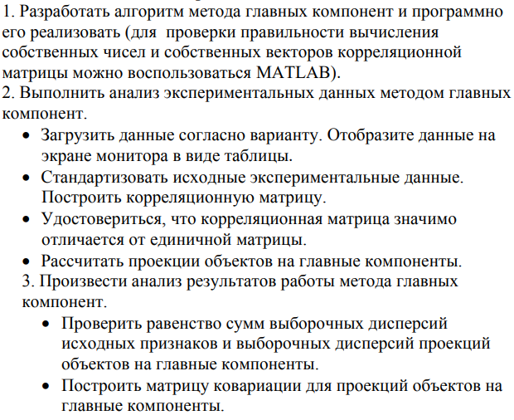
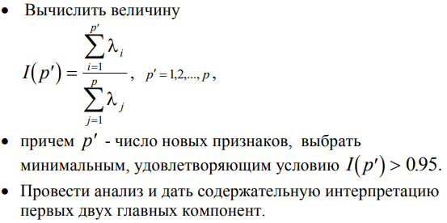
2. Ход работы
1. Код программы
from pandas import read_excel
import numpy as np

# читаем файл, получаем нужные столбцы (мой вариант - 121-130)
df = read_excel("data.xls", "Sheet1", skiprows=1, nrows=78, usecols="DR:EA")
#удаляем строки с пустыми значениями
df = df.dropna()
N = len(df)
p = len(df.columns)
print("Z - матрица данных типа объект-признак размером Nxp")
print(f"N={len(df)}, p={len(df.columns)}")
print(df.to_string())
Z = df.values.tolist()
print()
#for j in range(N):
# for i in range(p):
# print(f"{Z[j][i]:.3f}\t\t", end="")
# print()

# lab1 - нам нужны отсюда некоторые данные
# 1a) средние по столбцам, дисперсии по столбцам
#print("1a) средние по столбцам, дисперсии по столбцам")
means = [0] * p
for j in range(p):
for i in range(N):
means[j] += Z[i][j]
for i in range(p):
means[i] /= N
print("Средние:")
print(means)

dispersions = [0] * p
for j in range(p):
for i in range(N):
dispersions[j] += (Z[i][j] - means[j]) ** 2
for i in range(p):
dispersions[i] /= N
print("Дисперсии:")
print(dispersions)
print()

# 1б) стандартизированная матрица
#print("1б) стандартизированная матрица")
X = []
for i in range(N):
l = []
for j in range(p):
l.append(0)
X.append(l)
for j in range(p):
for i in range(N):
X[i][j] = (Z[i][j] - means[j]) / (dispersions[j] ** 0.5)
print("Стандартизованная матрица:")
for j in range(N):
for i in range(p):
print(f"{X[j][i]:.3f}\t", end="")
print()
print()

# 1в) ковариационная матрица
#print("1в) ковариационная матрица")
covar = []
for i in range(p):
l = []
for j in range(p):
l.append(0)
covar.append(l)
for j in range(p):
for i in range(p):
t = 0
for k in range(N):
t += (Z[k][i] - means[i]) * (Z[k][j] - means[j])
covar[i][j] = t / N
#print("Ковариационная матрица:")
#for j in range(p):
#for i in range(p):
#print(f"{covar[j][i]:.3f}\t", end="")
#print()
#print()

# 1г) корелляционная матрица
#print("1г) корелляционная матрица")
corel = []
for i in range(p):
l = []
for j in range(p):
l.append(0)
corel.append(l)
for j in range(p):
for i in range(p):
t = 0
for k in range(N):
t += X[k][i]*X[k][j]
corel[i][j] = t / N
print("Корелляционная матрица:")
for j in range(p):
for i in range(p):
print(f"{corel[j][i]:.3f}\t", end="")
print()
print()

d = 0
for i in range(p):
for j in range(p):
if i == j:
continue
d += corel[i][j] ** 2
d *= len(Z)

print(f"Проверка диагонали: {d:.3f}")

def sgn(n):
if n >= 0:
return 1
else:
return -1

def yakobi(A):
eps = 1e-2

# шаг 1
n = len(A)
t = []
for i in range(n):
t_ = []
for j in range(n):
t_.append(0)
t.append(t_)
for i in range(n):
t[i][i] = 1
# шаг 2
a_0 = 0
for j in range(1, n):
for i in range(j):
if i == j:
continue
a_0 += A[i][j] ** 2
a_0 = (2 * a_0) ** 0.5 / n
a_k = a_0

while True:
flag = True
for j in range(1, n):
for i in range(j):
if A[i][j] > abs(eps * a_0):
flag = False
if flag:
break
# шаг 3
a_pq = -1
p, q = -1, -1
for j in range(1, n):
for i in range(j):
if i == j:
continue
if abs(A[i][j]) > a_k and abs(A[i][j]) > a_pq:
a_pq = abs(A[i][j])
p = i
q = j
# шаг 4
y, x, s, c = 0, 0, 0, 0
if p != -1:
y = (A[p][p] - A[q][q]) / 2
if y == 0:
x = -1
else:
x = -1 * sgn(y) * A[p][q] / (A[p][q]**2 + y**2) ** 0.5 #
s = x / (2 * (1 + (1 - x**2) ** 0.5))**0.5 #
c = (1 - s**2)**0.5

for i in range(n):
if i != p and i != q:
z_1 = A[i][p]
z_2 = A[i][q]
A[q][i] = z_1*s + z_2*c
A[i][q] = A[q][i]
A[i][p] = z_1*c - z_2*s
A[p][i] = A[i][p]
z5 = s**2
z6 = c*c
z7 = s*c
v1 = A[p][p]
v2 = A[p][q]
v3 = A[q][q]
A[p][p] = v1*z6 + v3*z5 + v2*z7
A[q][q] = v1*z5 + v3*z6 + v2*z7
A[p][q] = (v1-v3)*z7 + v2*(z6-z5)
A[q][p] = A[p][q]
for i in range(n):
z3 = t[i][p]
z4 = t[i][q]
t[i][q] = z3*s + z4*c
t[i][p] = z3*c - z4*s
# шаг 5
a_k /= n**2
return t

t = yakobi(corel)
lamda = [0] * p
for i in range(p):
lamda[i] = corel[i][i]

# сортировка
for i in range(len(lamda)):
for j in range(i+1, len(lamda)):
if lamda[i] < lamda[j]:
tmp = lamda[i]
lamda[i] = lamda[j]
lamda[j] = tmp
for q in range(len(t)):
tmp = lamda[i]
lamda[i] = lamda[j]
lamda[j] = tmp

# транспонирование
for i in range(len(t)):
for j in range(i, len(t)):
tmp = t[i][j]
t[i][j] = t[j][i]
t[j][i] = tmp
print("Собственные числа:")
for x in lamda:
print(f"{x:.3f}", end="\t")
print()
print("Собственные вектора:")
for i in range(p):
for j in range(p):
print(f"{t[i][j]:.3f}", end="\t")
print()

# поиск y
y = []
for i in range(N):
t_ = []
for j in range(p):
t_.append(0)
y.append(t_)
for i in range(p):
yy = [0] * N
for k in range(p):
for j in range(N):
yy[j] += X[j][k] * t[i][k]
for j in range(N):
y[j][i] = yy[j]
print("Y:")
for i in range(p):
for j in range(p):
print(f"{y[i][j]:.3f}", end="\t")
print()

def average(y):
N = len(y)
p = len(y[0])
avg = [0] * p
for i in range(p):
for j in range(N):
avg[i] += y[j][i]
avg[i] /= N
return avg

def compute_variance(y):
N = len(y)
p = len(y[0])
var = [0] * p
avg = average(y)
for i in range(p):
for j in range(N):
var[i] += (y[j][i] - avg[i])**2
var[i] /= N
return var

var_X = compute_variance(X)
var_y = compute_variance(y)
sum_X = 0
for x in var_X:
sum_X += x
sum_y = 0
for x in var_y:
sum_y += x
print(f"sum_X={sum_X:.3f}, sum_y={sum_y:.3f}")

def covar(y):
N = len(y)
p = len(y[0])
avg = average(y)
cor = []
for i in range(p):
t_ = []
for j in range(p):
t_.append(0)
cor.append(t_)
for i in range(p):
for j in range(p):
x = 0
for k in range(N):
x += (y[k][i] - avg[i])**2
x /= N
cor[i][j] = x
cor[j][i] = x
return cor

def comp_ip(lamda):
p = len(lamda)
lamda_sum = 0
for x in lamda:
lamda_sum += x
lps = 0
for i in range(p):
lps += lamda[i]
print(lps)
if (lps - lamda[i]) / lamda_sum > 0.95:
return lps
return 0

y = covar(y)
ip = comp_ip(lamda)

print(f"I(p)={ip:.3f}")
print("y^1")
for i in range(10):
if i == 9:
print(f"{t[i][0]:.3f}*x^{i+1}", end=" ")
else:
print(f"{t[i][0]:.3f}*x^{i+1}+", end=" ")
print()
print("y^2")
for i in range(10):
if i == 9:
print(f"{t[i][1]:.3f}*x^{i+1}", end=" ")
else:
print(f"{t[i][1]:.3f}*x^{i+1}+", end=" ")
print()

2. Результат работы программы
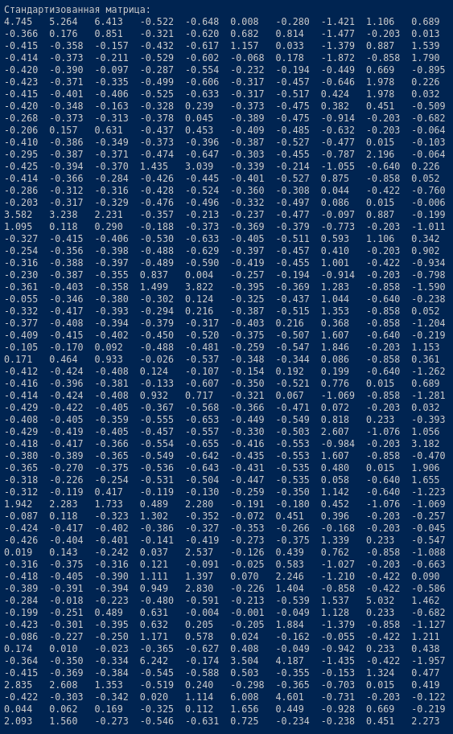
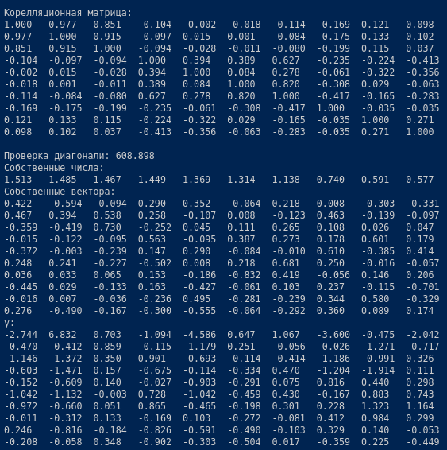
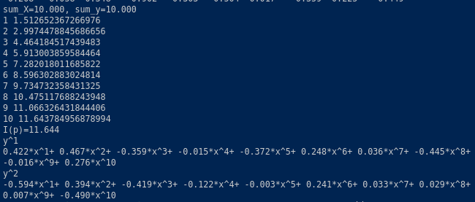

Выводы
В ходе выполнения лабораторной работы был изучен метод главных компонент

