OPSIUM-Executive Summary

PHASE 1: Clear Problem Statement (Competition-Ready)
📌 Problem Statement
FedEx faces inefficiencies in its Tricolor flight network due to inaccurate customer demand forecasting, leading to underutilized or overloaded cargo capacity. The lack of integration between customer demand signals and logistics capacity planning results in suboptimal pricing, delayed responses, and increased operational costs.
The objective is to develop an AI-driven system that forecasts customer SKU demand using promotional, sentiment, and sustainability signals, and optimizes flight capacity allocation and pricing to improve utilization, cost-effectiveness, and customer experience.

PHASE 2: Overall Flow Control (End-to-End System)

External & Customer Signals
(promotions, sentiment, sustainability)
↓
Demand Forecasting Engine (Segment 1)
↓
Forecasted SKU / Route Demand
↓
Capacity Optimization Engine (Segment 2)
↓
Optimized Flight Allocation + Pricing
↓
Customer & FedEx Recommendations

PHASE 3: Define Inputs Clearly & Their Linkage

PHASE 3: Define Inputs Clearly & Their Linkage
3.1 Segment 1 – Demand Forecasting Inputs
🔹 Input Categories
A. Customer / SKU Level
- customer_id
- sku_id
- historical_demand (synthetic)
- route (origin → destination)
B. Promotional Signals
- promotion_flag (0/1)
- discount_percentage
- campaign_type
📌 Linkage:
Promotions → increase short-term demand
C. Digital Sentiment Signals
- avg_review_rating
- sentiment_score (−1 to +1)
- social_media_buzz
📌 Linkage:
Positive sentiment → higher demand probability
D. Sustainability & Regulation Signals
- sustainable_product_flag
- regulation_impact_score
- eco_preference_index
📌 Linkage:
Sustainability trends → shift customer preference

🎯 Output of Segment 1
This is critical, because Segment 2 depends on it.
Output Variable | Meaning
forecasted_demand | Expected SKU demand
forecast_period | Time window
confidence_score | Reliability of forecast

3.2 Segment 2 – Capacity Optimization Inputs
🔹 Inputs from Segment 1
- forecasted_demand
- route
- time_period
📌 This is the direct linkage between Segment 1 and 2.
🔹 Flight Capacity Inputs (Synthetic)
- flight_id
- route
- max_capacity
- fixed_operational_cost
- variable_cost_per_unit
- departure_time
📌 These represent FedEx operational constraints.

PHASE 4: Decision Logic (Before Any Model)
4.1 Demand Forecasting Logic (Conceptual)
Demand is influenced by:
Base Demand
+ Promotion Effect
+ Sentiment Effect
+ Sustainability Effect
In words:
- Promotions push demand up
- Positive sentiment boosts trust and purchases
- Sustainability alignment shifts customer preference
📌 Even a simple weighted model is acceptable.

4.2 Capacity Optimization Logic (Conceptual)
For each route and time window:
- Compare:
  - forecasted_demand vs flight_capacity
- Allocate demand to flights:
  - without exceeding capacity
- Measure:
  - utilization percentage
- Adjust:
  - pricing
  - customer recommendations
Example Logic
- If utilization < 60% → offer discounted pricing
- If utilization > 90% → surge pricing or reroute demand
- If multiple flights exist → balance load
📌 This shows business intelligence, not just math.
DATASET ANALYSIS
DATASET 1: Customer–SKU Demand Signal Dataset - To model how customer demand is influenced by external & behavioral signals, not just historical sales.
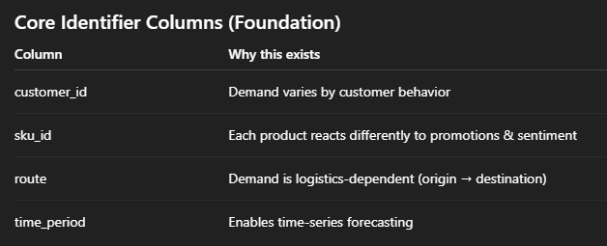
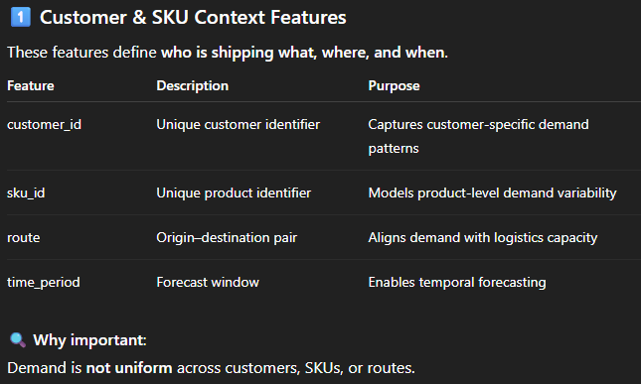
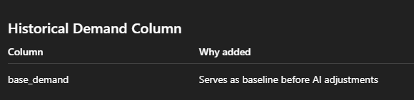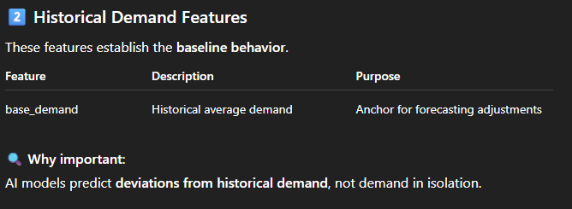
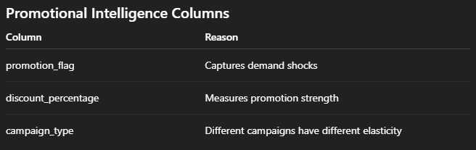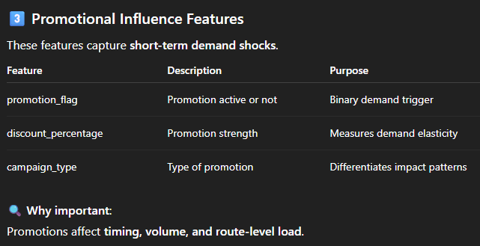
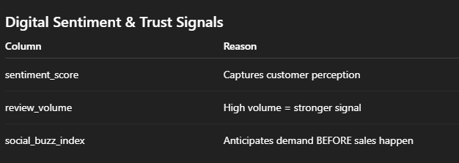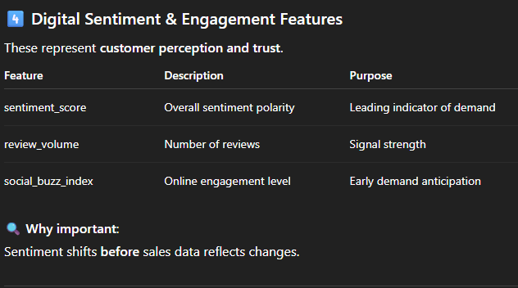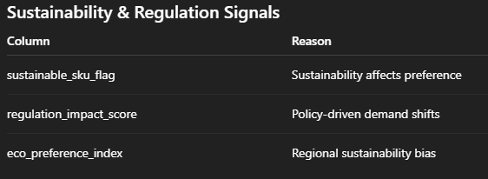
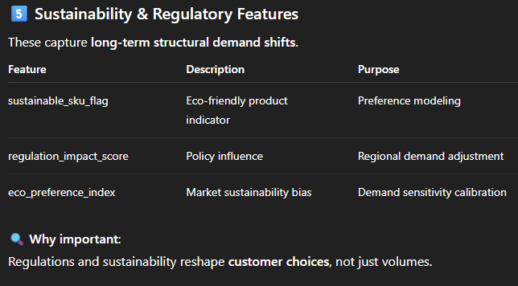
Segment 1 Output Columns
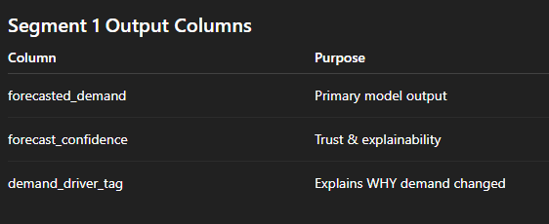
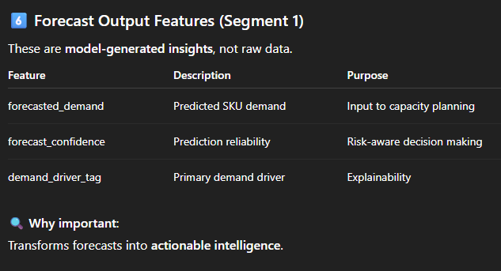

DATASET 2: Tricolor Flight Capacity Dataset - To simulate FedEx operational constraints realistically.
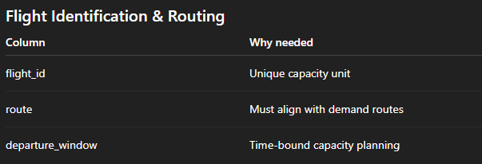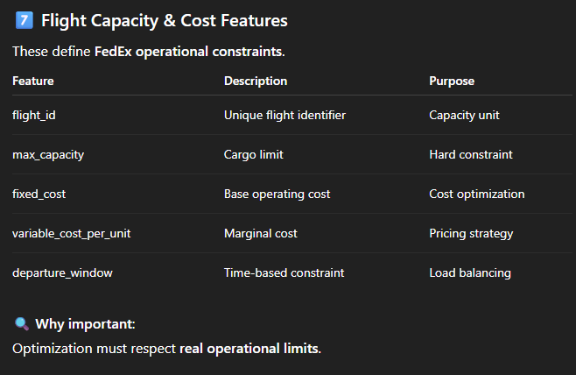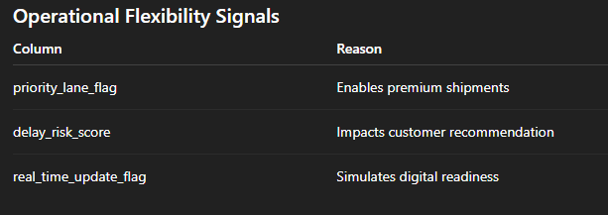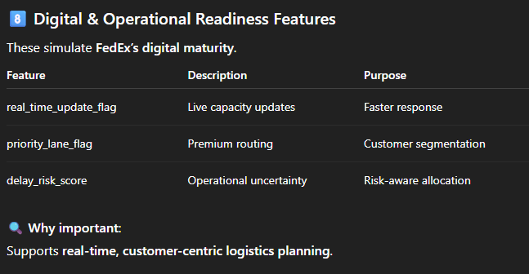

Segment 2 Output Columns

