Part 1: Activity Monitoring

1. Problem description

The first part of the mobile computing lab was to implement an android app for activity monitoring. Where we first had to read out the raw signal from the sensors, then we had to extract features to describe the signal statistically and then we had to perform a classification method based on the k-nearest neighbor algorithm

1. Sensors and methods

For this activity monitoring task, we used the 3-axis accelerometer (x/y/z). We read out the accelerometer data and stored the data into a file. With the buttons “start recording” and “stop”, we were able to create new test and training data. We also plotted the data for better understanding for what is going on at the accelerometer.

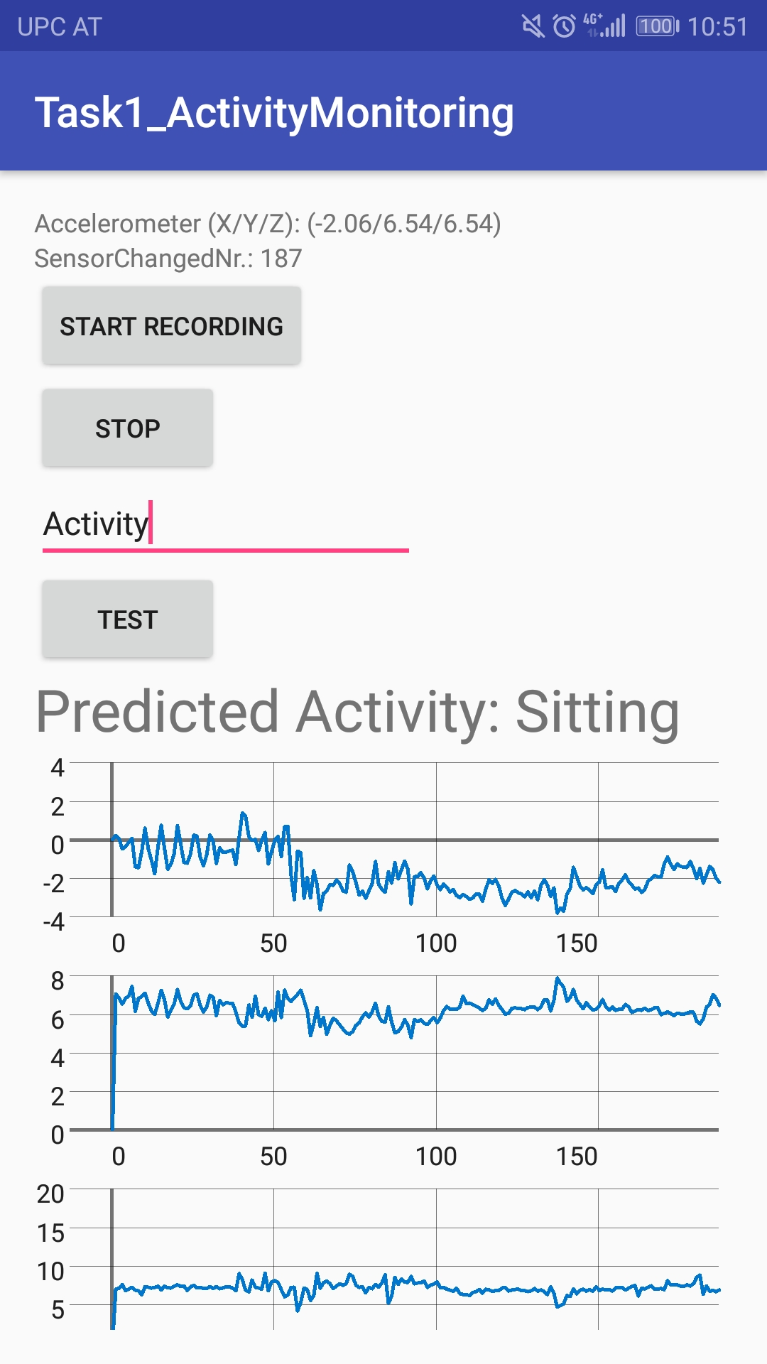

For training and testing the knn, we recorded about 2-3 minutes of data for each activity and saved the data in the corresponding file, meaning one file per activity. We selected the following three activities: running, walking and sitting.

Then we took the files with the training and testing data and did an offline analysis in python first to figure out which features do work satisfactory.

TODO: Andre bitte python part beschreiben, features beschreiben (evt screenshots von der klassifizierung)

After having good results for the classification we implemented the knn algorithm in java. We found a very useful library on GitHub for implementing knn in java [1]. Based on that, we could more or less use the knn algorithm out of the box. We just had to call the function knn(…) to train our classifier, and then we had call findKNearestNeighbors(…), and put the result into the classify(…) function to get back the label of the predicted activity.

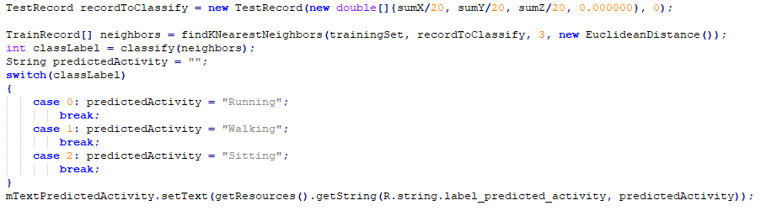

1. Evaluation

prozent für testing set beschreiben (wie gut war unser classifier?)

1. Citations

[1] <https://github.com/wihoho/KNN/blob/master/src/knn.java>

Part 2: Localization