Name: Piyush Mujmule
Module name: Automation Framework
PRN : 2509401147005
Assignment 11

1)Create Jmeter Test plan
a)Two separate Thread group employee , dept for 2 users
Create table only once and Load sample data

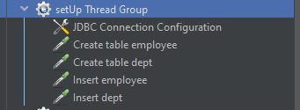

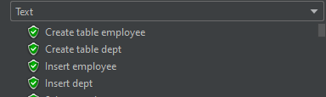
Request:
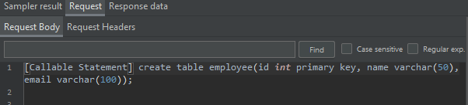
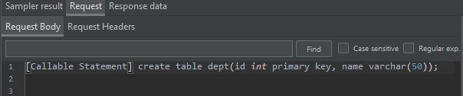
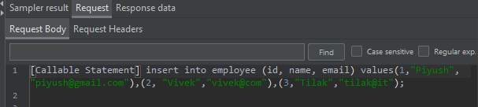
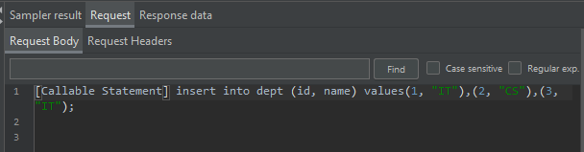

b)Execute select query for 100 times for 2 users

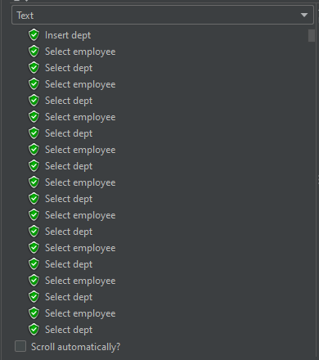
Request:
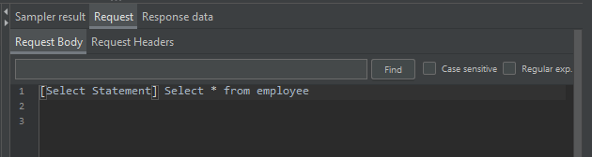
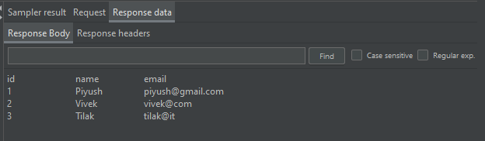
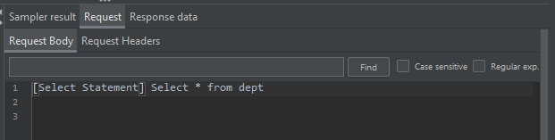
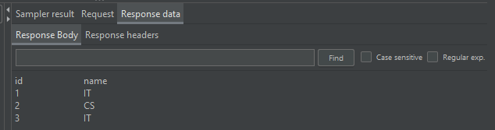

c) Delete created data only once
Delete created table only once

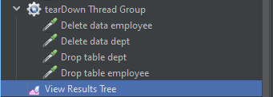

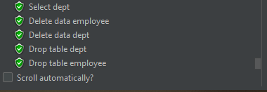

Request:
