# WORDNET

WordNet is a semantic lexicon for the English language that computational linguists and cognitive scientists use extensively.

For example, WordNet was a key component in IBM’s Jeopardy-playing Watson computer system. WordNet groups words into sets of synonyms called synsets.

For example, *{ AND circuit, AND gate }* is a synset that represent a logical gate that fires only when all of its inputs fire. WordNet also describes semantic relationships between synsets. One such relationship is the is-a relationship, which connects a hyponym (more specific synset) to a hypernym (more general synset). For example, the synset *{ gate, logic gate }* is a hypernym of *{ AND circuit, AND gate }* because an AND gate is a kind of logic gate.

# The WordNet digraph.

Your first task is to build the WordNet digraph: each vertex v is an integer that represents a synset, and each directed edge v→w represents that w is a hypernym of v. The WordNet digraph is a rooted DAG: it is acyclic and has one vertex—the root—that is an ancestor of every other vertex. However, it is not necessarily a tree because a synset can have more than one hypernym.

Here is a small subgraph of the WordNet digraph:

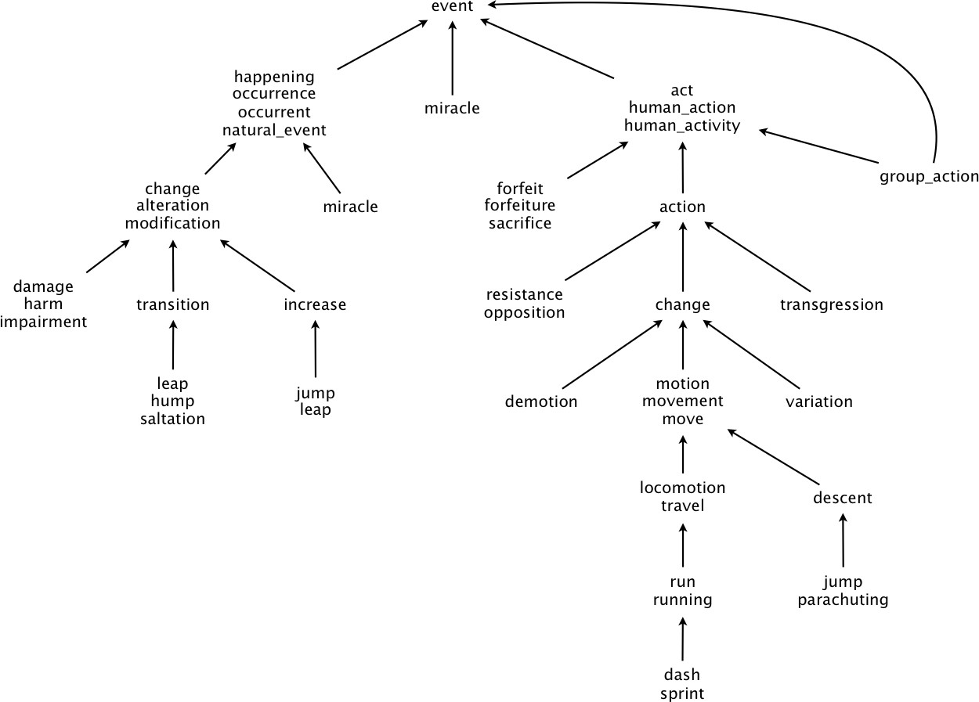

# The WordNet input file formats.

We now describe the two data files that you will use to create the WordNet digraph. The files are in comma-separated values (CSV) format: each line contains a sequence of fields, separated by commas.

* List of synsets. The file *synsets.txt* contains all noun synsets in WordNet, one per line. Line *i* of the file (counting from 0) contains the information for synset *i*. The first field is the synset *id*, which is always the integer *i*; the second field is the synonym set (or synset); and the third field is its dictionary definition (or gloss), which is not relevant to this assignment.

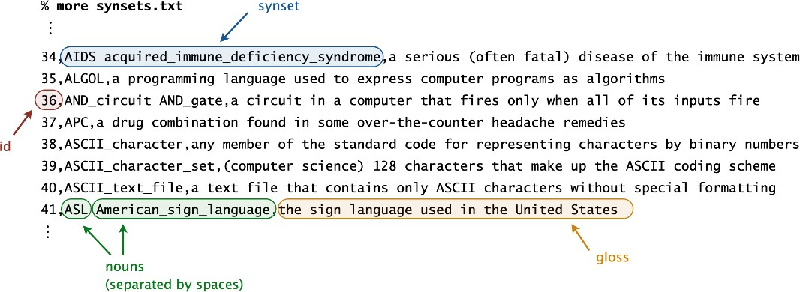

For example, line 36 means that the synset *{ AND_circuit, AND_gate }* has an id number of 36 and its gloss is *a circuit in a computer that fires only when all of its inputs fire*. The individual nouns that constitute a synset are separated by spaces. If a noun contains more than one word, the underscore character connects the words (and not the space character).

* List of hypernyms. The file *hypernyms.txt* contains the hypernym relationships. Line *i* of the file (counting from 0) contains the hypernyms of synset *i*. The first field is the synset *id*, which is always the integer *i*; subsequent fields are the id numbers of the synset’s hypernyms.

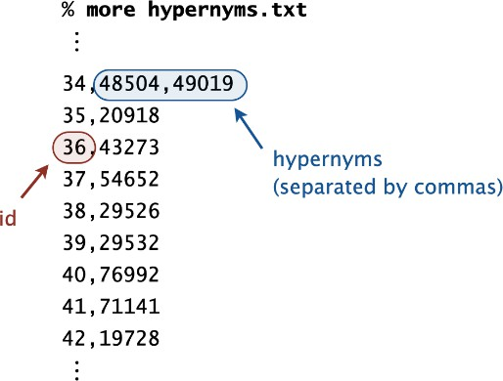

For example, line 36 means that synset 36 *(AND_circuit AND_Gate)* has 43273 (gate logic_gate) as its only hypernym. Line 34 means that synset 34 (AIDS

acquired_immune_deficiency_syndrome) has two hypernyms: 48504 (immunodeficiency) and 49019 (infectious_disease).

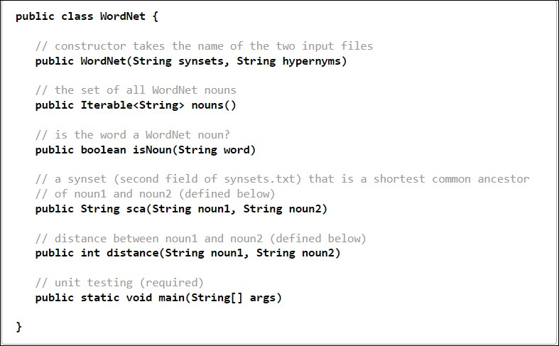

# WordNet data type.

Implement an immutable data type WordNet with the following API:

*Corner cases.* Throw an IllegalArgumentException in the following situations:

* Any argument to the constructor or an instance method is null
* Any of the noun arguments in distance() or sca() is not a WordNet noun.

You may assume that the input files are in the specified format and that the underlying digraph is a rooted DAG.

*Unit testing.* Your *main()* method must call each public constructor and method directly and help verify that they work as prescribed (e.g., by printing results to standard output).

*Performance requirements.* Your implementation must achieve the following performance requirements. In the requirements below, assume that the number of characters in a noun or synset is bounded by a constant.

* Your data type must use space linear in the input size (size of synsets and hypernyms files).
* The constructor must take time linearithmic (or better) in the input size.
* The method isNoun() must run in time logarithmic (or better) in the number of nouns.
* The methods distance() and sca() must make exactly one call to the lengthSubset() and ancestorSubset() methods in ShortestCommonAncestor, respectively.

# Shortest common ancestor.

An ancestral path between two vertices v and w in a rooted DAG is a directed path from v to a common ancestor x, together with a directed path from w to the same ancestor x. A shortest ancestral path is an ancestral path of minimum total length. We refer to the common ancestor in a shortest ancestral path as a shortest common ancestor. Note that a shortest common ancestor always exists because the root is an ancestor of every vertex. Note also that an ancestral path is a path, but not a directed path.

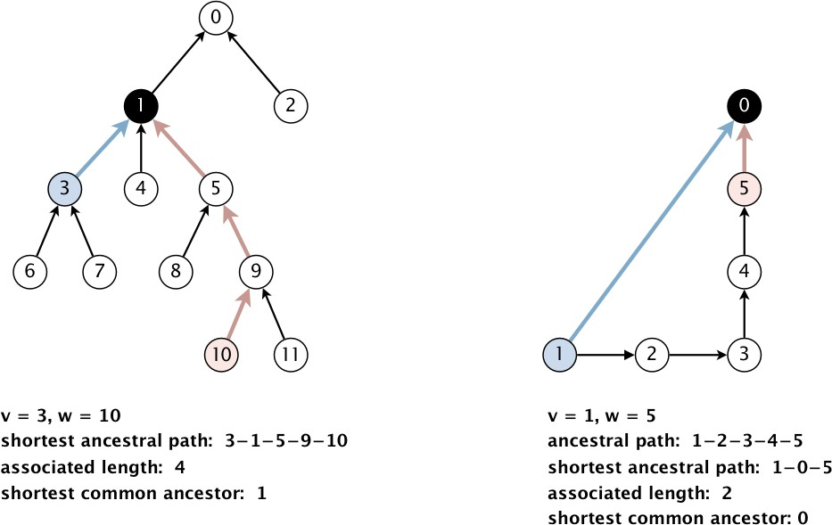

We generalize the notion of shortest common ancestor to subsets of vertices. A shortest ancestral path of two subsets of vertices A and B is a shortest ancestral path among all pairs of vertices v and w, with v in A and w in B. As an example, the following figure (digraph25.txt) identifies several (but not all) ancestral paths between the red and blue vertices, including the shortest one.

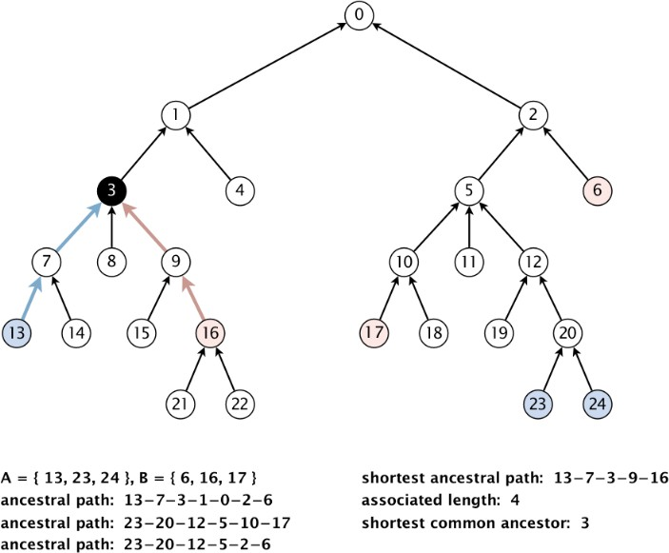

# Shortest common ancestor data type.

Implement an immutable data type ShortestCommonAncestor with the following API:

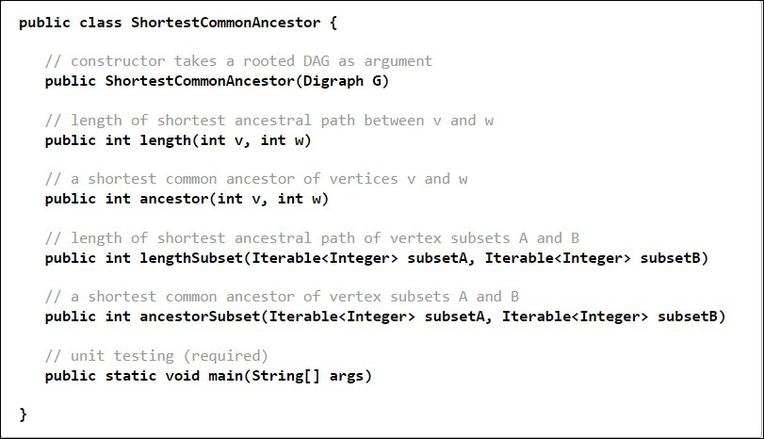

*Corner cases.* Throw an IllegalArgumentException in the following situations:

* The argument to the constructor is not a rooted DAG
* Any argument is null
* Any vertex argument is outside its prescribed range
* Any iterable argument contains zero vertices
* Any iterable argument contains a null item

*Unit testing.* Your main() method must call each public constructor and method directly and help verify that they work as prescribed (e.g., by printing results to standard output).

*Basic performance requirements.* Your implementation must achieve the following worst-case performance requirements, where E and V are the number of edges and vertices in the digraph, respectively.

* Your data type must use O(E+V) space.
* All methods and the constructor must take O(E+V) time.

# Test client.

The following test client takes the name of a digraph input file as as a command-line argument; creates the digraph; reads vertex pairs from standard input; and prints the length of the shortest ancestral path between the two vertices, along with a shortest common ancestor:

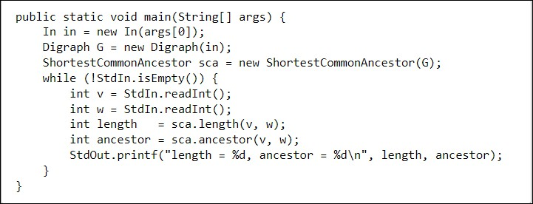

Here is a sample execution (the yellow text indicates what you type):

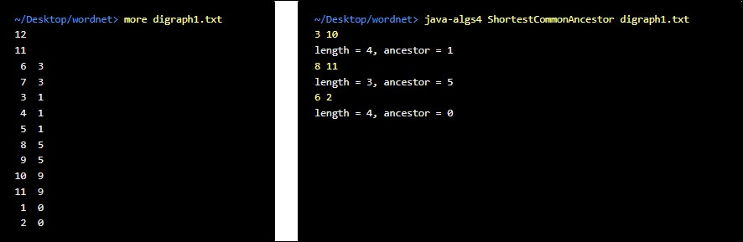

# Measuring the semantic relatedness of two nouns.

Semantic relatedness refers to the degree to which two concepts are related. Measuring semantic relatedness is a challenging problem. For example, you consider George W. Bush and John F. Kennedy (two U.S. presidents) to be more closely related than George W. Bush and chimpanzee (two primates). It might not be clear whether George W. Bush and Eric Arthur Blair are more related than two arbitrary people. However, both George W. Bush and Eric Arthur Blair (a.k.a. George Orwell) are famous communicators and, therefore, closely related.

We define the semantic relatedness of two WordNet nouns x and y as follows:

* A = set of synsets in which x appears
* B = set of synsets in which y appears
* distance(x, y) = length of shortest ancestral path of subsets A and B
* sca(x, y) = a shortest common ancestor of subsets A and B

This is the notion of distance that you will use to implement the distance() and sca() methods in the WordNet data type.

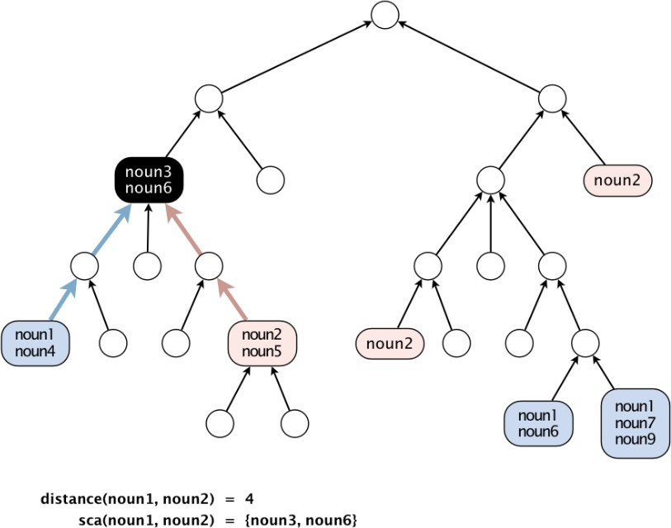

# Outcast detection.

Given a list of WordNet nouns x1, x2, ..., xn, which noun is the least related to the others? To identify an outcast, compute the sum of the distances between each noun and every other one: *di* = *distance*(*xi*, *x*1) + *distance*(*xi*, *x*2) + ... + *distance*(*xi*, *xn*)

and return a noun xt for which dt is maximum. Note that distance(xi, xi) = 0, so it will not contribute to the sum.

Implement an immutable data type Outcast with the following API:

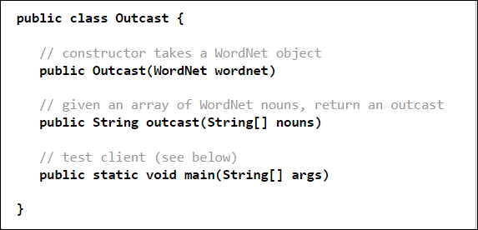

*Corner cases.* Assume that the argument to outcast() contains only valid WordNet nouns and that it contains at least two such nouns.

*Test client.* The following test client takes from the command line the name of a synset file, the name of a hypernym file, followed by the names of outcast files, and prints an outcast in each file:

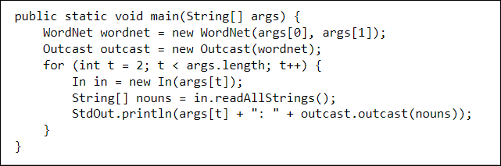

Here is a sample execution:

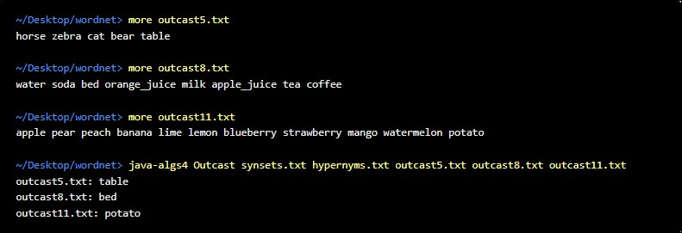

# Analysis of running time.

Analyze the potential effectiveness of your approach to this problem by answering the following questions:

* What is the order of growth of the worst-case running time of the length(), lengthAncestor(), ancestor(), and ancestorSubset() methods in ShortestCommonAncestor?
* What is the order of growth of the best-case running time of the length(), lengthAncestor(), ancestor(), and ancestorSubset() methods in ShortestCommonAncestor?

Give your answers as a function of the number of vertices V and the number of edges E in the digraph.

**Për tu dorëzuar janë klasat:**

WordNet.java, ShortestCommonAncestor.java, and Outcast.java.

**Dorëzimi i laboratorit duhet të bëhet deri me date 17.01.2025:**

<https://forms.office.com/e/VSKNgJA8rp>

**Shënim:** Mund të përdorni klasat dhe metodat e lidhura me grafet, si Digraph.java etj.