Game Design Document

Fill up the Following document

1. Write the title of your project.

The Training Camp

1. What is the goal of the game?

Overall, one will have to complete all the training i.e., all 4 minigames.

But each minigame has its own specific goal to win/ not lose.

1. Write a brief story of your game?

Cap (short for Captain America) has recently completed his first

training (in the “World’s Hardest game” project), and has now

reached the training camp. Here, he will train to beat the evil

villain, Red Skull

1. Which are the playing characters of this game?

* Playing characters are the ones which respond to the user based on the input from the user
* Cars, monkeys, dinos, wizards etc, are the playing characters in the game.

|  |  |  |
| --- | --- | --- |
| Number | Character Name | What can this character do? |
| 1 | Captain America | Move around, and complete different trainings |
| 2 | Cap’s Shield | Aim it to shoot at enemies (dummies) |
| 3 | Red dot | Move around, and find the exit of the maze |
| 4 |  |  |
| 5 |  |  |
| 6 |  |  |
| 7 |  |  |
| 8 |  |  |

1. Which are the Non Playing Characters of this game?

* Non Playing characters are the ones which don't have an action or a behaviour when the user interacts with the game.
* Hurdles, stones, bananas, coins, etc are non playing characters in the game.

|  |  |  |
| --- | --- | --- |
| Number | Character Name | What can this character do? |
| 1 | Stone walls | Act as barrier in flappy cap, and in the maze |
| 2 | Hurdles | Hurdles in the infinite runner |
| 3 | Dummies | Act as enemies, to be aimed at with cap’s shield |
| 4 |  |  |
| 5 |  |  |
| 6 |  |  |
| 7 |  |  |
| 8 |  |  |

Draw your imagination of this game. What does this game look like?

* Draw the game either on your computer or on paper,
* Add images of scenes of the game to show each of the playing and non-playing characters at least once.

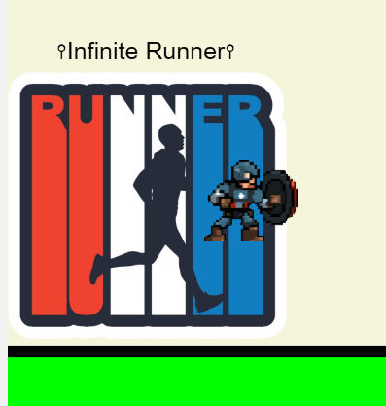

How do you plan to make your game engaging?

By starting the game with a short story, making the game interesting and

colourful , and adding score to the games.