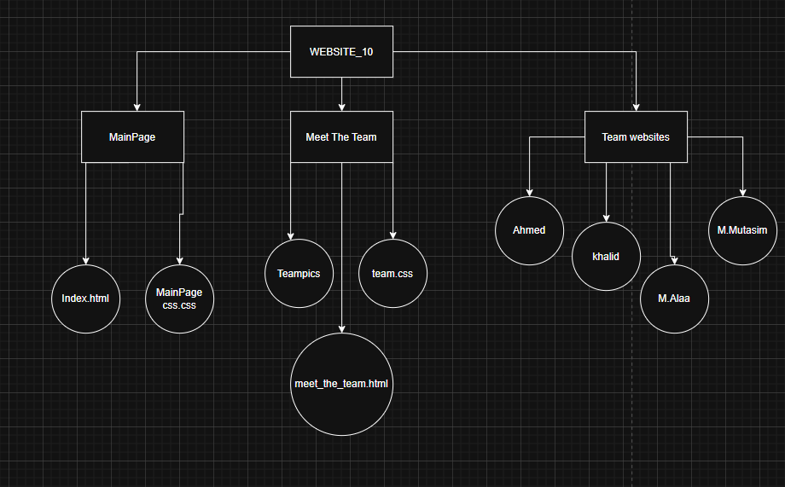
FILE STRUCTURE

What each file contains:

MainPage:
Index.html(The main page of the whole project it has buttons leading to the others)
MainPage css.css(The stylesheet used by the project’s main page)

Meet The Team:
meet_the_team.html(The meet the team website)
team.css(The stylesheet used in the meet the team website)

Teampics:
Ahmed.jpeg
Khalid.jpeg
M.Alaa.jpg
M.Mutasim.jpeg
Note: All those are pictures used in the meet the team web file as pics of their respective team members

Ahmed:
Main Page.html(The movie page done by Ahmed Abdalla)
spiderman into the spider verse poster.jpeg(The poster used in the movie page)
style.css(The stylesheet used by the movie page)

khalid:
KN.html(The movie page made by Khalid Hosham)
KN.txt(This is the stylesheet used by the movie page)
Backbutton(This is the stylesheet used for the back to the main website button in the movie page)
POSTER2(This is the movie poster used in the movie page)
trailer.mp4(This is the movie trailer used in the movie page)

M.Alaa:
Parasite.html(The movie page made by Mohammed Alaeldin)
Parasite css.css(The stylesheet used by the movie page)
PARASITE.mp4(This is the trailer used in the movie page)
Parasite_(2019_film)(This is the movie poster used in the movie page its also used as the thumbnail of the trailer)

M.Mutasim:
filmpage.html(The movie page made by Muhammed Mutasim)
filmpage.css(This is the stylesheet used by the movie page)
img(This is the folder containing the 4 images used in the movie page)

