Company Intelligence Platform — Agent Pipeline Diagram
End-to-end flow: user input → parallel research → validation → consolidation → regeneration loop → Supabase write
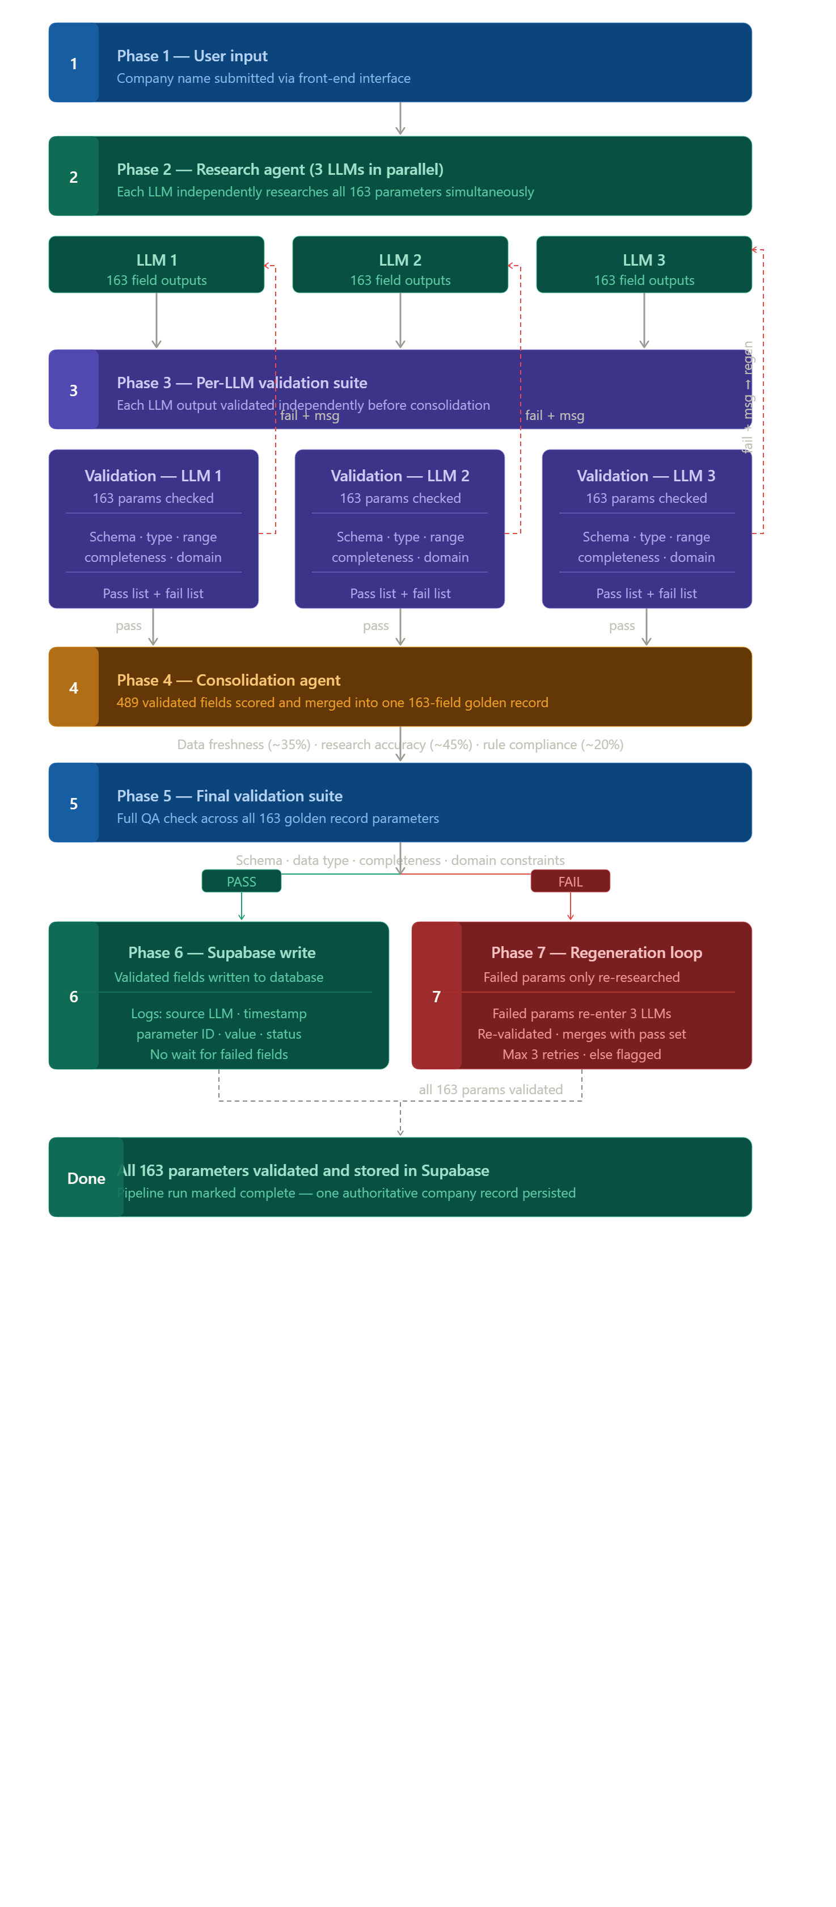

**Langchain process diagram**

