HYBRID TALENT POOL
High-Level Design
Version 2: JD-triggered scoring with two agents
Version 2.0 | October 2026
Status: Draft for review

1. Purpose and Scope
This High-Level Design (HLD) describes version 2 of the Hybrid Talent Pool. The system captures recruitment emails (mainly Naukri NVite response mails with resume attachments), stores every candidate once in a clean database, and scores and ranks candidates only after a recruiter provides a Job Description (JD). Two agents are used: a Recruiter Agent that talks to the recruiter and calls backend tools, and a Scoring Agent that scores one resume against one JD.
In scope: Outlook ingestion, normalisation, duplicate prevention, JD intake, automatic scoring (existing and new candidates), ranking by Top N, report export, multi-tenant operation.
Out of scope for v1: scraping Naukri or any portal, sending mail to candidates, ATS integration, Gmail, other mail sources without a deterministic parser.

2. What Changed in v2
Topic | v1 design | v2 design
Number of agents | 3 roles (Recruiter, Scorer, Extraction Fallback) | Exactly 2 agents: Recruiter Agent (has tools) and Scoring Agent (no tools)
Agent access | Trigger API in front of the agent | Recruiter triggers the Recruiter Agent directly by its own URL and bearer token. Scoring Agent has its own URL and bearer token. Same client code and credential pattern, only URL and token differ.
When scoring happens | At query time, on the recruiter's request | Not before a JD exists. When a JD is activated, all existing candidates are scored. After that, every new mail is scored on arrival.
Rank | Computed per query | Never created without a JD. Computed from stored scores at query time, then frozen in ranking_runs when the recruiter wants a shortlist or report.
Ranking cost | LLM at query time | No LLM at query time. Ranking is a SQL read of stored scores.
Vector search | pgvector recall funnel | Removed. All candidates are scored, so no recall step is needed.
Who saves scores | Agent via save_scores tool | Only the backend Scoring Worker. The Recruiter Agent has no write access to scores.
Unknown mail formats | LLM Extraction Fallback | Quarantined for review. A deterministic parser is added later. Resume text and contacts are still extracted.

2.1 Improvements carried over from the v1 review
Improvement | Where it lives in v2
Real NVite HTML and resumes before coding the parser | Implementation Guide, Phase 0
Evaluation set for extraction and scoring | Implementation Guide, Phases 2 and 4; stability test in LLD section 9.6
Tenant isolation with RLS and a cross-tenant test | LLD section 3.1; Security section 5
Resume and mail text is untrusted (prompt injection) | Security section 8; Scoring Agent has no tools
BRD corrections (Outlook only, risk Medium, realistic timing, mail-only for Naukri) | HLD section 15
Human in the loop, with a reason for every score | HLD section 10; every score has reason, matched and missing skills
Candidates separate from applications | LLD section 3
Commit-then-advance delta links, idempotent handlers | LLD sections 4 and 9.2
Parser warnings for unknown labels | LLD section 5
Whitelisted sort keys and filters, no free SQL from the agent | LLD sections 11 and 12
Model and prompt version stored with every score | LLD section 3 (scores table)
Data minimisation to the LLM | Contacts and personal identifiers removed from resume text before scoring
Delete and retention jobs from the start | Security section 9
Streaming, async jobs with progress | get_scoring_status and get_sync_status tools

3. Business Rules
These rules are the contract of the system. Every one of them must have a test.
# | Rule
R1 | Every mail is captured: candidate, application, resume and received_at are stored. Storing never requires a JD.
R2 | If no active JD exists, no score and no rank is created or shown. Candidates stay unscored. The tool rank_candidates returns JD_REQUIRED and the Recruiter Agent asks for a JD.
R3 | When the recruiter sends a JD to the Recruiter Agent, the JD is stored in the database first (draft). After the recruiter confirms the parsed requirements, it becomes active.
R4 | When a JD becomes active, ALL existing candidates are scored, however many there are.
R5 | After that, each new mail triggers scoring of that candidate against every active JD.
R6 | A score has three parts: details score (Python), resume score (Scoring Agent), final score (Python from both).
R7 | The Scoring Agent always receives a JD and a resume. Without a JD it refuses to score. Same inputs always return the stored score, and repeated runs on changed inputs must agree within tolerance (target 90 percent, see section 9.4).
R8 | Rank is not stored on the candidate. It is computed from stored scores when asked, and frozen into ranking_runs when the recruiter requests a shortlist or report.
R9 | Top N is 10, 20, 30 or 40 as requested. Default 10, hard maximum 50.
R10 | The agent suggests, the recruiter decides. Every ranked candidate shows reason, matched skills and missing skills.

4. Design Principles
Principle | Meaning in this system
Agent decides, tool executes | The Recruiter Agent chooses tools. All data access is done by deterministic backend endpoints.
Ingest once, score once per input | Mail is parsed once. A score is calculated once per unique combination of JD, resume, facts, model and prompt version.
Template first | NVite mails follow a fixed template, so a parser extracts fields at no cost.
LLM only where understanding is needed | Reading a resume against a JD (Scoring Agent), and conversation and JD parsing (Recruiter Agent).
Person is not a mail | A candidate (person) is separate from an application (person x job x mail).
Least privilege for agents | Recruiter Agent: allow-listed tools, no score writes. Scoring Agent: no tools at all.
Multi-tenant from day 1 | tenant_id on every table with Postgres Row Level Security.

5. System Architecture
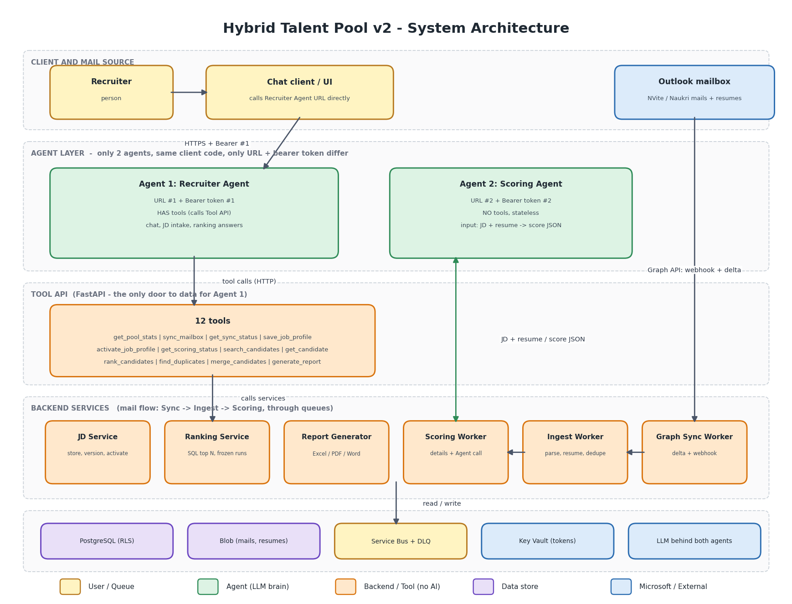

5.1 Components
Layer | Component | Responsibility
Client | Chat client or UI | Any client that can call the Recruiter Agent URL with a bearer token. Shows ranked tables and downloads reports.
Agent | Recruiter Agent (Agent 1) | Conversation, JD parsing, Top N and rank_by selection, tool calls, final answer. Has tools.
Agent | Scoring Agent (Agent 2) | Scores one resume against one JD and returns a rubric JSON. No tools, stateless.
Backend | Tool API (FastAPI) | Only door to data for the Recruiter Agent. 12 tools. Derives tenant and user from the token, never from the model.
Backend | JD Service | Stores JD drafts, versions and hashes, activation and archiving.
Backend | Graph Sync Worker | Delta query and webhook handling, attachment download.
Backend | Ingest Worker | NVite parser, resume extraction, regex for email and phone, dedupe, save. Creates scoring jobs when an active JD exists.
Backend | Scoring Worker | Computes details score, calls the Scoring Agent, validates the answer, computes final score, saves scores.
Backend | Ranking Service | SQL top N over stored scores, frozen ranking runs.
Backend | Report Generator | Excel first, then PDF and Word, from a frozen ranking run.
Data | PostgreSQL | System of record with RLS. Extensions pg_trgm and citext.
Data | Blob storage | Raw mails and resume files, encrypted.
Data | Service Bus | Ingest queue and scoring queue, each with retry and dead-letter queue.
Data | Key Vault | Agent bearer tokens, Graph credential, database credential.
External | Microsoft Graph, LLM provider | Mailbox access; model hosting behind both agents.

6. The Two Agents
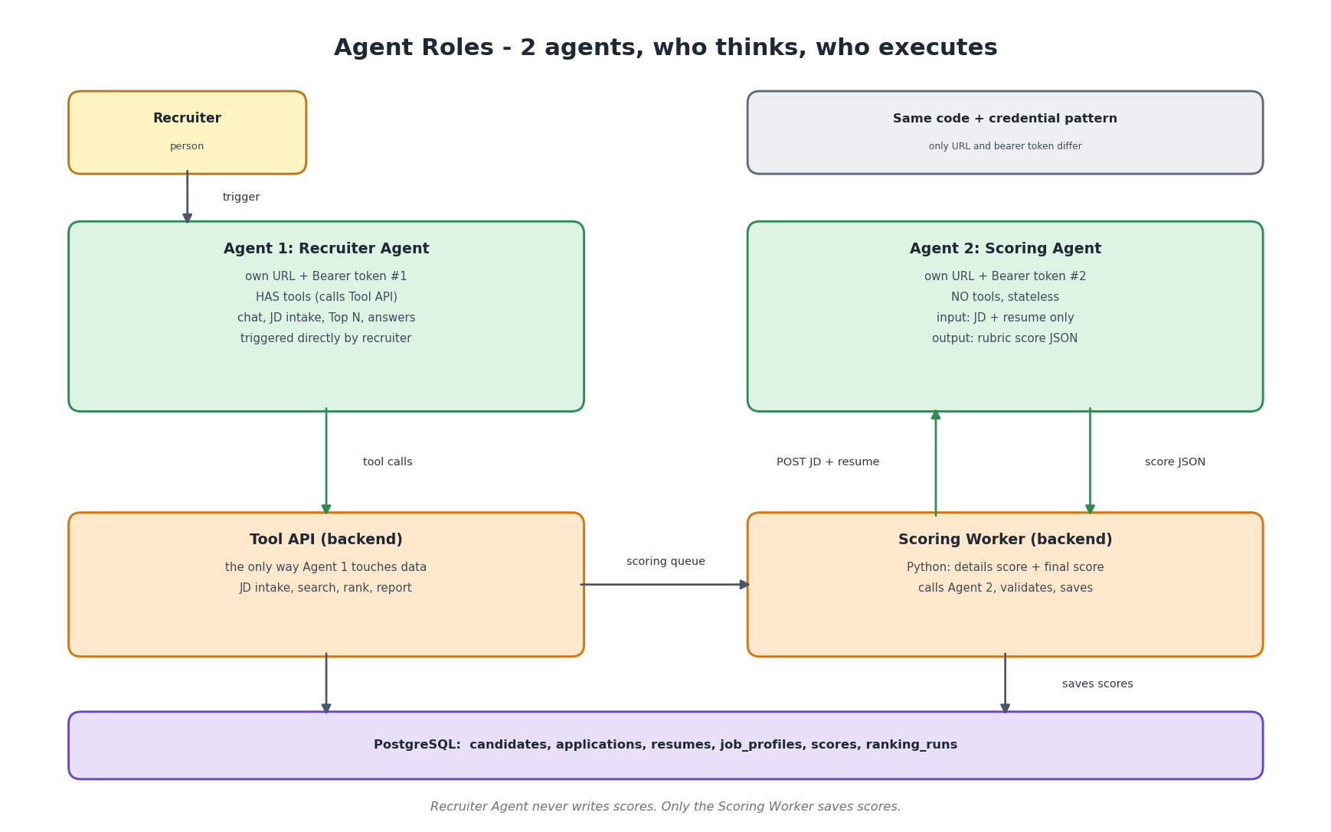
 | Agent 1: Recruiter Agent | Agent 2: Scoring Agent
Triggered by | Recruiter, directly, by URL #1 and bearer #1 | Backend Scoring Worker, by URL #2 and bearer #2
Tools | Yes, 12 backend tools | None
State | Conversation session | Stateless, one request one answer
Input | Recruiter message, optional JD text | JD (structured and raw) plus resume text plus minimal candidate facts
Output | Answer with table, reasons, progress | Rubric JSON with sub-scores, evidence, matched and missing skills, reason
Writes data | Only through tools (never scores) | Never. The Scoring Worker saves what it returns
The same client code (retry, timeout, bearer header, idempotency key) is used for both agents. Per agent, only the URL and the bearer token change. Both are stored in Key Vault and read at start-up.

7. End-to-End Flow
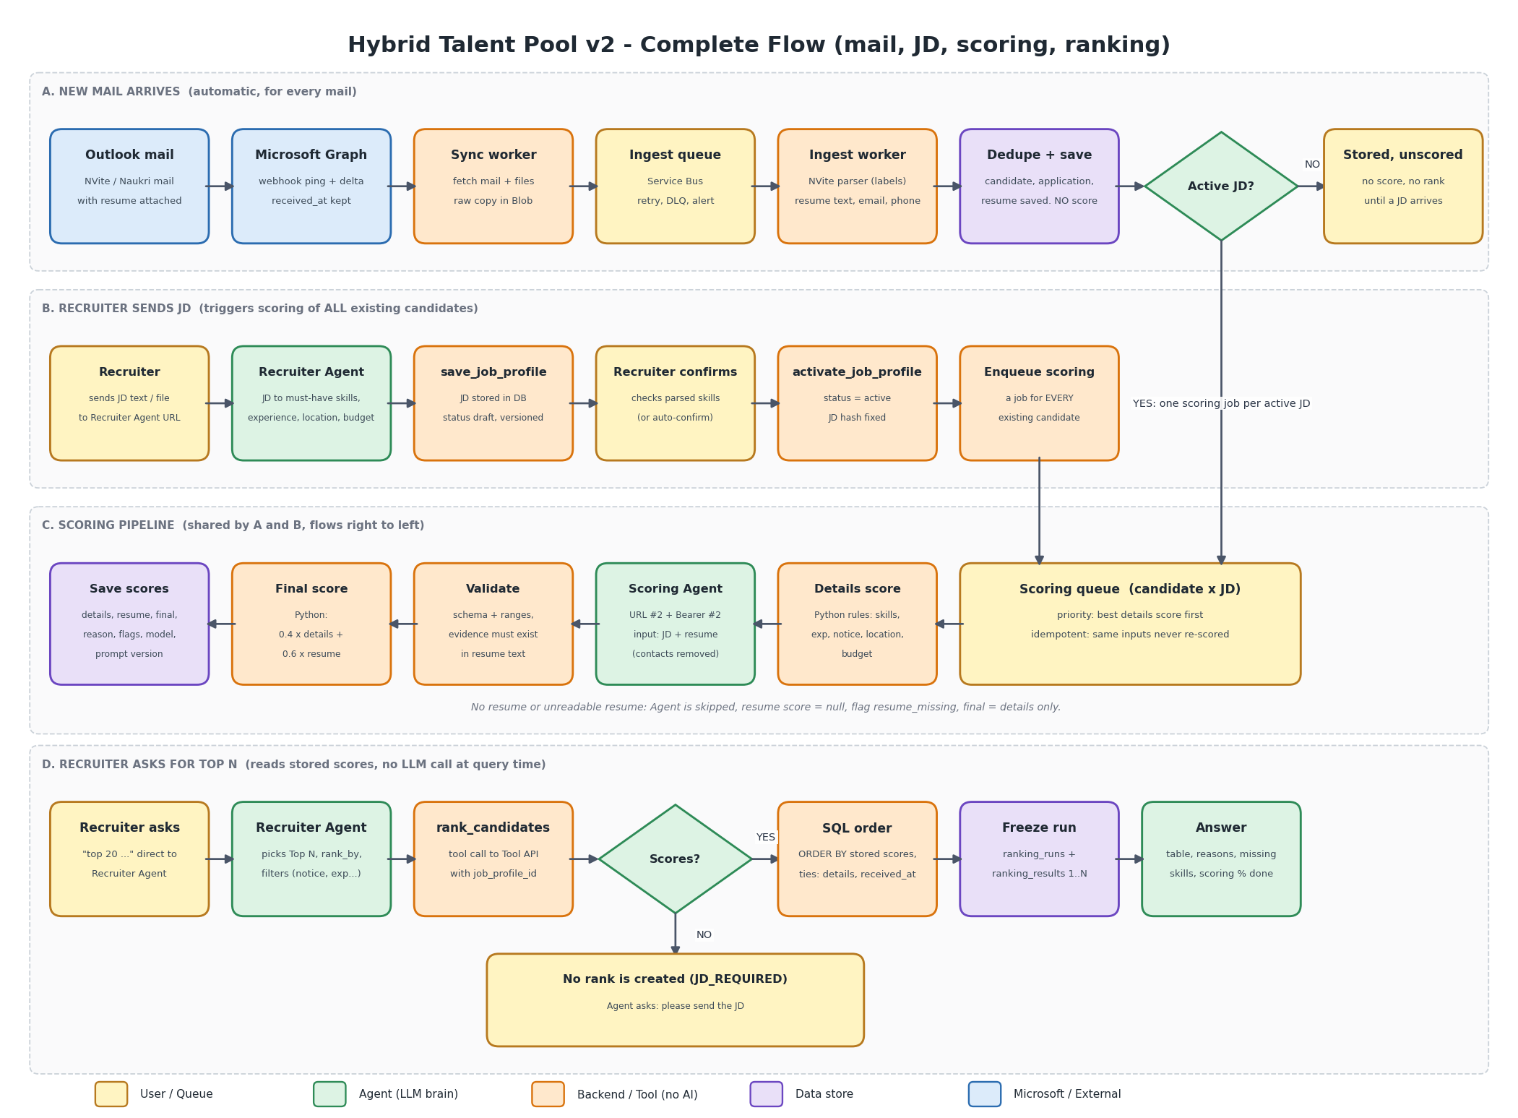

7.1 A. New mail arrives
- Graph pings the webhook; a periodic delta query is the safety net. The Sync Worker stores the raw mail and queues it.
- The Ingest Worker parses the NVite template, extracts resume text, email and phone, de-duplicates and saves candidate, application and resume with received_at.
- If an active JD exists, a scoring job is queued for every active JD. If not, processing stops here and the candidate stays unscored.

7.2 B. Recruiter sends a JD
- The Recruiter Agent turns the JD into structured requirements and calls save_job_profile. The JD is now in the database as a draft.
- The recruiter confirms the parsed must-have skills, experience, location and budget. This avoids scoring a thousand candidates against a mis-read JD. Auto-confirm can be switched on per tenant.
- activate_job_profile makes the JD active and queues a scoring job for every existing candidate.

7.3 C. Scoring pipeline
- Details score is calculated in Python and saved immediately, so partial results exist within seconds.
- Resume text has contacts and personal identifiers removed, then the Scoring Agent is called with the JD and resume.
- The Scoring Worker validates the JSON, checks the evidence against the resume text, calculates the final score and saves everything with model and prompt version.

7.4 D. Recruiter asks for Top N
- The Recruiter Agent picks Top N, rank_by and filters from the wording and calls rank_candidates.
- With no active JD or no scores, the tool answers JD_REQUIRED and the agent asks for the JD. No rank is created.
- Otherwise the backend orders by stored scores, freezes the run (rank 1 to N) and the agent answers with the table, reasons and scoring progress.

8. Lifecycle States

Candidate
State | Meaning
stored_unscored | In database, no active JD, so no score and no rank
partial | Details score exists, resume score pending
scored | Details and resume score exist (or resume missing and flagged)
review | Possible duplicate or unparsed mail needs the recruiter

Job profile (JD)
State | Meaning
draft | Stored from the Recruiter Agent, waiting for the recruiter to confirm the parsed requirements
active | Confirmed. Existing candidates are being scored and new mails are scored on arrival
archived | No new scoring. Old scores and ranking runs are kept
Changing a JD creates a new version with a new content hash. Scores of the old version are kept. The new version is scored from scratch.

9. Scoring Design

9.1 Details score (Python, 0 to 100)
Component | Rule | Default weight
Skills | Overlap of the candidate's skills (NVite key skills) with JD must-have (full) and nice-to-have (half) | 0.35
Experience | 100 inside the JD range, linear decay outside | 0.25
Notice period | Curve: 0 days 100, 15 days 90, 30 days 70, 60 days 40, 90 days or more 20 | 0.20
Location | Match 100, remote-ok 70, otherwise 0 | 0.10
Budget | Expected CTC within budget 100, up to 10 percent over 60, otherwise 20 | 0.10
Missing inputs are excluded and the remaining weights are renormalised. The breakdown is stored for explanation.

9.2 Resume score (Scoring Agent, 0 to 100)
The agent fills a fixed rubric. The backend adds up the sub-scores; the agent's own total, if any, is ignored.
Rubric part | Max | What is judged
Must-have coverage | 40 | Each must-have skill: met, partly, not met, with a short evidence snippet from the resume
Experience relevance | 25 | Years and type of work relevant to the JD responsibilities
Domain and project relevance | 20 | Industry, tools in real projects, migrations, scale
Seniority fit | 10 | Level and ownership compared with the JD
Education and certifications | 5 | Required or preferred qualifications

9.3 Final score (Python)
final = 0.4 x details + 0.6 x resume (weights in tenant configuration). If the resume is missing or unreadable, the Agent is skipped, resume score is null, final equals details score, and the flag resume_missing is shown.

9.4 Consistency target: about 90 percent the same
"90 percent same" is interpreted as: when the same JD and resume are scored repeatedly, at least 90 percent of repeated scores fall within 5 points of the reference score, and the Top 20 of two repeated runs share at least 18 candidates. This is a target to measure, not a measured result.
Mechanism | Effect
Cache by input hash | Same JD, resume, facts, model and prompt version always returns the stored score. Repeated queries cannot drift.
Structured JD stored once | JD parsing variance is removed from scoring. Every candidate is scored against the same confirmed requirements.
Anchored rubric with coarse steps | Sub-scores in fixed steps (for example multiples of 5) reduce jitter.
Totals computed by Python | The LLM does not do arithmetic.
Lowest-variance model settings, pinned model and prompt version | Temperature 0 where the model allows it. Settings differ by model, so this must be verified.
Evidence grounding | Every evidence snippet must exist in the resume text, otherwise it is discarded and the sub-score is reduced.
Optional repeat and median | For the top band only, run 3 times and take the median if measurement shows it is needed.
Nightly stability canary | A fixed set of resumes is re-scored and compared with their reference scores. Drift raises an alert.

9.5 Accuracy
Scoring accuracy is measured against recruiter-labelled resumes. Proposed starting targets, to be agreed after the first baseline run: rank correlation with human order of at least 0.7, and overlap of at least 7 of 10 between the model Top 10 and the human Top 10. These are proposals, not results.

10. Ranking Design
Recruiter says | rank_by | Behaviour
top 20 | final (default) | ORDER BY final_score DESC
top 20 based on resume | resume | ORDER BY resume_score DESC
top 20 by details | details | ORDER BY details_score DESC
top 20 by notice period and experience | custom sort | Filter to candidates with final score at least the tenant relevance floor (default 40, to be tuned), then ORDER BY notice asc, experience desc, final desc
top 10 who join in 15 days | final with filter | Filter notice_days_max at most 15, then ORDER BY final_score DESC
- Ties are broken by details score, then received_at (newest first), then candidate id, so the order is reproducible.
- If scoring is still running, the answer includes progress, for example 412 of 480 scored, and uses available final scores. Pending candidates are listed as a count.
- Without a JD the recruiter can still search, filter and sort a plain list (no score, no rank number). This is an assumption to confirm (section 16).

11. Duplicate Prevention
- Same mail twice: UNIQUE(tenant_id, message_id).
- Email or phone match from the resume: automatic merge.
- Name, company, experience and location: three or more signals agree, automatic merge.
- Weak match only: no merge. A possible_duplicate flag is created and the Recruiter Agent asks the recruiter to confirm.
NVite mails do not contain email or phone in the body. The identity key therefore comes from the resume. Do not scrape the View Contact Details link. After a merge, scores are re-evaluated; a changed resume or fact changes the input hash and queues re-scoring.

12. Data Architecture (overview)
Entity | Holds
mails | Graph message id, received_at, sender, subject, source, status, raw blob path
candidates | Person: name, contacts, experience, CTC, notice, location, skills
applications | Person x job x mail: job title, locations, Q and A, expected CTC, received_at
resumes | File, hash, extracted text, text quality
job_profiles | Raw JD, structured JD, content hash, version, status
scoring_jobs | Queue state per candidate x JD with input hash, attempts, errors
scores | Details, resume and final score, sub-scores, reason, flags, model, prompt version
ranking_runs, ranking_results | Frozen shortlist: rank 1 to N, who asked, filters used
duplicate_flags, sync_runs, audit_log | Review items, sync progress, every tool call

13. Non-Functional Requirements
All figures are design targets. None has been measured and each needs a load test.
Area | Target
Mail to stored candidate | Under 2 minutes after arrival (webhook path)
Details score for all candidates after JD activation | Seconds to a few minutes
Resume scoring of N candidates | Depends on Scoring Agent latency and concurrency. Illustration only: with 20 parallel calls at about 10 seconds each, 1000 candidates take about 8 to 9 minutes
Top N query | Under 3 seconds (SQL on stored scores)
Score stability | 90 percent within 5 points on repeat (section 9.4)
Tenant isolation | Zero cross-tenant reads, tested every build
Availability | Query path 99.5 percent. Ingestion and scoring survive outages through queues
LLM calls per JD = candidates with a readable resume x active JDs, minus cached scores. A per-tenant cap on active JDs (default 3) and a daily call budget limit cost.

14. Technology Choices
Concern | Choice | Reason
Backend | Python, FastAPI | OpenAPI schema is the tool contract for the Recruiter Agent
Database | PostgreSQL 16 with pg_trgm, citext | Relational plus fuzzy name matching. No vector store needed in v1
Queues | Azure Service Bus | Retry, dead-letter, scale on queue depth
Agents | Two HTTPS agent endpoints, URL and bearer token each | As requested. Hosting (own container or an agent platform) is open, see section 16
Tool protocol | Direct HTTP now, thin MCP adapter later | Simple, auditable, full control
Hosting | Azure Container Apps | Scale on queue depth
Secrets | Azure Key Vault, managed identity | No secrets in code or images

15. BRD Alignment and Corrections
BRD statement | Issue | Recommendation
Gmail in one use case, Outlook elsewhere | Inconsistent | Confirm Outlook and Microsoft Graph for v1
Business risk if incorrect: No | Bias and wrong rejection are real risks | Rate Medium. Human decision, reasons shown, blind scoring
Under 5 seconds per JD | Not realistic for scoring many resumes with an LLM | Ranking query under 3 seconds because scores are precomputed. Scoring is a background job with progress
No AI in the backend | Understanding resumes needs a model | Done only inside the two agents; the backend stays deterministic
Naukri job posting | Could imply scraping | Mail-only, no portal scraping

16. Risks, Assumptions and Open Questions
Item | Note
Assumption A-1 | Without a JD the recruiter may still list, filter and sort candidates (no score, no rank). If you want even sorting blocked, rank_candidates and search sort keys are disabled until a JD exists.
Assumption A-2 | "Each mail triggers scoring" means: scoring of that candidate against active JDs after ingestion, if a JD exists.
Assumption A-3 | Agents are HTTPS endpoints reachable by URL and bearer token. How the platform passes user identity to tool calls must be confirmed (Security section 4).
Question Q-1 | Which platform hosts the agents (own containers or a managed agent service)?
Question Q-2 | Is 90 percent the same defined as in section 9.4, or do you want exact score equality?
Risk | NVite HTML structure is unverified. Export 15 to 20 real mails and 5 resumes first.
Risk | Scoring cost grows with candidates x active JDs. Mitigation: cache, cap active JDs, budget.
Risk | LLM scores can vary and carry bias. Mitigation: rubric, evidence checks, blind scoring, human decision, measurement.
Risk | Personal data. DPDP Act, GDPR for EU data: retention, delete, audit, encryption.

