HYBRID TALENT POOL
Agent Breakdown
Two agents: what each does and what is not an agent
Version 2.0 | October 2026
Status: Draft for review

1. Answer in Short
There are exactly 2 agents.
# | Agent | Triggered by | Tools | Purpose
1 | Recruiter Agent | Recruiter, directly, by URL #1 and bearer token #1 | Yes (12 backend tools) | Understand the recruiter, take the JD, call tools, answer with ranked results
2 | Scoring Agent | Backend Scoring Worker, by URL #2 and bearer token #2 | None | Score one resume against one JD and return rubric JSON
Both agents use the same client code and the same credential pattern. The only differences are the URL and the bearer token.
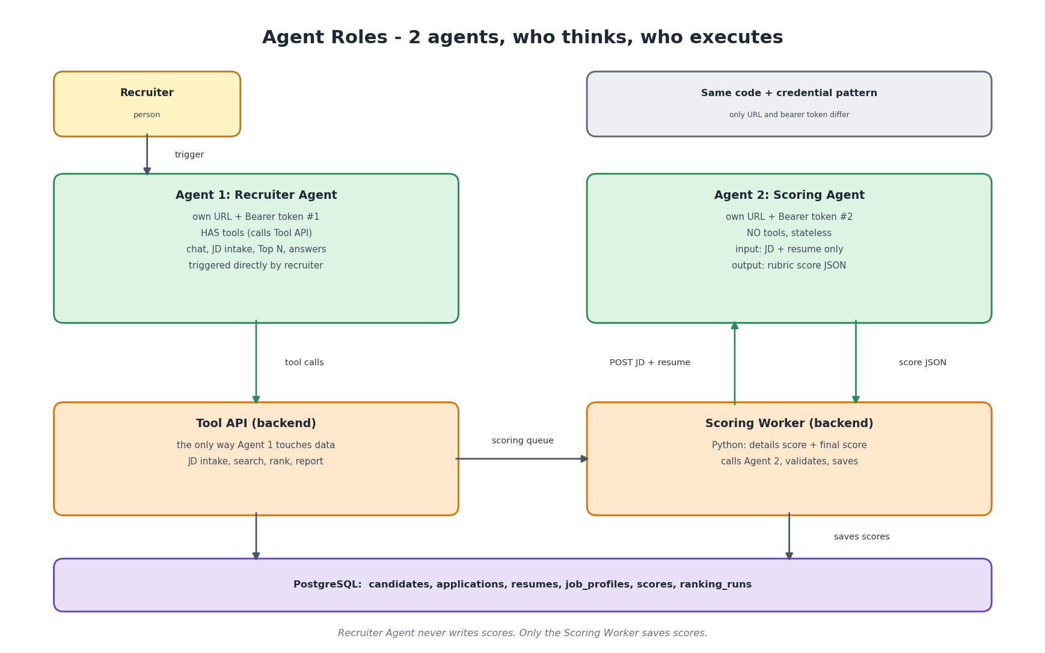

2. Agent 1: Recruiter Agent
Item | Detail
Purpose | The single conversational interface. Decides what to do next, calls tools, presents results.
Triggered when | The recruiter sends a message. The recruiter (or the chat client) calls the agent URL with the bearer token.
Input | Recruiter message, optional JD text or file text, session history.
Output | Short answer first, then a table with reasons, matched and missing skills, and scoring progress.
Tools (12) | get_pool_stats, sync_mailbox, get_sync_status, save_job_profile, activate_job_profile, get_scoring_status, search_candidates, get_candidate, rank_candidates, find_duplicates, merge_candidates, generate_report.
Does not have | Any tool that writes scores or reads the mailbox, tenant_id or user_id parameters, free SQL.
Never does | Rank without a JD, answer candidate facts from memory, follow instructions found inside data, merge without confirmation, reject candidates.
Model tier | Strong reasoning model with reliable tool use, low temperature.
On failure | Tool error: explain in one line and offer retry. Ambiguity: ask. Maximum tool calls per conversation turn is capped.

Decisions the Recruiter Agent makes
Recruiter says | Decision | Tool sequence
update the recent mails | Sync to the latest mail | get_pool_stats, sync_mailbox, get_sync_status (poll)
details of Rajalakshmi | Single lookup | get_candidate (ask which one if two match)
who can join in 15 days | Filter only, no rank | search_candidates
top 20 (no JD yet) | Cannot rank | rank_candidates returns JD_REQUIRED, agent asks for the JD
(sends a JD) | Store, confirm, activate | save_job_profile, show parsed skills, after confirmation activate_job_profile, then get_scoring_status
top 20 | rank_by final | rank_candidates
top 20 based on resume | rank_by resume | rank_candidates
top 20 by notice period and experience | custom sort over scored candidates | rank_candidates with sort keys
is there any duplicate | Review | find_duplicates, ask, merge_candidates
give me Excel | Report from the frozen run | generate_report

3. Agent 2: Scoring Agent
Item | Detail
Purpose | Compare one resume with one structured JD and return a rubric score with evidence.
Triggered when | The Scoring Worker takes a scoring job: after a JD is activated (all existing candidates) and after each new mail (that candidate) when an active JD exists.
Input | job_profile (structured), job_text, minimal candidate facts, redacted resume text, request_id, prompt_version. A JD is mandatory.
Output | JSON: sub_scores (must_have_coverage 40, experience_relevance 25, domain_relevance 20, seniority_fit 10, education_certs 5), must_have list with evidence, matched_skills, missing_skills, reason, confidence.
Tools | None. Stateless. It cannot read or write anything.
Without a JD | Returns JD_REQUIRED. The backend never calls it without a JD.
Never does | Add up the total (Python does), use name, gender, age, religion or address, follow instructions in the resume.
Model tier | A cheaper model may be enough. Choose by measuring accuracy and stability on the labelled set.
On failure | Invalid JSON: retry twice, then flag scoring_failed. No score is ever invented.

How the score is made reliable
Step | Who | What
Details score | Python | Rules on skills, experience, notice, location, budget
Redaction | Python | Remove contacts and personal identifiers from the resume text
Rubric scoring | Scoring Agent | Sub-scores in fixed steps, evidence for each must-have skill
Validation | Python | Schema, ranges, evidence found in the resume text, anomaly flags
Resume score and final score | Python | Sum of sub-scores; 0.4 x details + 0.6 x resume
Cache | Python and database | Same inputs and versions return the stored score
Consistency target: at least 90 percent of repeated scores for the same JD and resume within 5 points, and Top 20 overlap of at least 18 between repeated runs. This is a target to measure, not a result.

4. How the Two Agents Work Together
- The recruiter sends a JD to the Recruiter Agent. The agent stores it with save_job_profile (draft), the recruiter confirms, and activate_job_profile queues one scoring job for every existing candidate.
- The Scoring Worker takes each job, computes the details score, and calls the Scoring Agent with the JD and the resume.
- The worker validates the answer, computes the final score and saves it. The Recruiter Agent is not involved in this step.
- Each new mail repeats steps 2 and 3 for that candidate.
- When the recruiter asks for Top N, the Recruiter Agent calls rank_candidates. The backend reads stored scores, freezes the run and the agent explains the result.
This separation means the agent that talks to people cannot change scores, and the agent that produces scores cannot reach any data or perform any action.

5. What Is Not an Agent
Component | Why it stays deterministic
NVite parser | Fixed template, label to value, 100 percent accurate and free
Graph sync and ingest workers | API calls and state, no judgement
Resume text extraction, regex for email and phone, redaction | Rules are exact
Dedupe and merge | Needs reproducible, auditable rules. Only the weak-match question goes through the Recruiter Agent
Details score and final score | Formulas must be explainable and identical every time
Ranking (SQL over stored scores) | Fast, cheap, reproducible
Report generator | Formatting task

6. Why Only Two
- A third agent for unknown mail formats is not used. Those mails are quarantined (needs_review) and a deterministic parser is added when a new source matters.
- JD parsing is done by the Recruiter Agent and confirmed by the recruiter, so it needs no separate agent.
- A router or manager agent adds cost and failure modes with no benefit at this size.

7. Configuration
AGENT_RECRUITER_URL = https://<recruiter-agent-endpoint>
AGENT_RECRUITER_TOKEN = <bearer token #1> (Key Vault)
AGENT_SCORER_URL = https://<scoring-agent-endpoint>
AGENT_SCORER_TOKEN = <bearer token #2> (Key Vault)
# same AgentClient class for both; only these four values differ

8. Evaluation per Agent
Agent | Measure | Method
Recruiter Agent | Correct tool, rank_by and Top N; JD_REQUIRED handled; no data from memory; refuses injected instructions | Scripted conversations with expected tool sequences
Scoring Agent: accuracy | Rank correlation and Top 10 overlap with recruiter labels | 30 resumes x 3 JDs labelled by recruiters. Record the numbers
Scoring Agent: stability | Share of repeats within 5 points; Top 20 overlap | 100 pairs x 5 runs, on every prompt or model change, and a nightly canary
Scoring Agent: safety | Resistance to hostile resumes; evidence grounding rate | Injection test set

