TEMPLATE FOR RETROSPECTIVE TEAM H

PROCESS MEASURES

Macro statistics
- Number of stories committed(8) - Number of stories done(8)
- Total points committed(29) - Total points done(29)
- Nr of hours planned(48h35) - Nr of hours spent (42h05)

Detailed statistics
- Hours per task (average: 53min, standard deviation: 43min)

STORY ID | NUMBER OF TASK | POINTS | TOTAL HOURS ESTIMATED | TOTAL HOURS SPENT
14 | 7 | 3 | 7h30 | 6h40
15 | 6 | 5 | 8h | 4h35
16 | 6 | 2 | 5h | 5h
17 | 1 | 2 | 45min | 20min
18 | 7 | 2 | 6h | 4h30
19 | 5 | 2 | 5h30 | 3h25
20 | 7 | 5 | 7h30 | 11h35
21 | 8 | 8 | 8h20 | 6h

- Total task estimation error ratio: 1.15

QUALITY MEASURES
- Unit Testing:
  - Total hours estimated: 7h15
  - Total hours spent: 5h
- E2E testing:
  - Total hours estimated: 3h30
  - Total hours spent: 2h55
- Code review:
  - Total hours estimated: 10h30
- Total hours spent: 10h30

UNIT TESTING COVERAGE
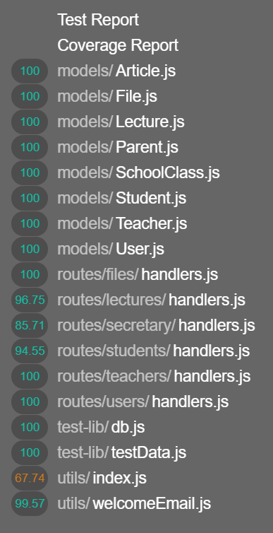

ASSESSMENT
- What caused your errors in estimation (if any)?
Time spent due to refactoring
Unexpected restyling
- What lessons did you learn (both positive and negative) in this sprint?
- Which improvement goals set in the previous retrospective were you able to achieve?
Docker issue has been fixed
Proper clarification of each story before implementing
- Which ones you were not able to achieve? Why?
- Propose 1 or 2 improvement goals for the next sprint and specify how to achieve them (technical tasks, team coordination, etc.)
- One thing you are proud of!!

