Exercise 2: Link State and Distance Vector Routing
Name: Pisit Tulachotikul Student ID: 6610408459 Date: 17/09/2569
Learning objectives: Apply Dijkstra and Bellman-Ford; construct forwarding tables; analyze convergence, failures, and count-to-infinity.
Network topology:
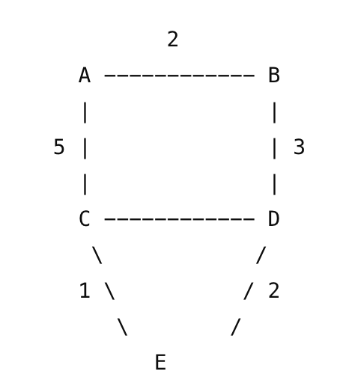

Part 1 — Link State Routing

Question 1 — Dijkstra's Algorithm
Starting at router A, execute Dijkstra's algorithm. Show every update and the node confirmed at each step.
Step | Confirmed Node | D(B), Prev. | D(C), Prev. | D(D), Prev. | D(E), Prev.
0 | A | 2,A | 5,A | Inf | Inf
1 | AB | - | 5,A | 5,B | Inf
2 | ABC | - | - | 5,B | 6,C
3 | ABCD | - | - | - | 6,C
4 | ABCDE | - | - | - | -

Question 2 — Shortest-Path Tree
Draw the shortest-path tree rooted at A, then list the shortest path and total cost.
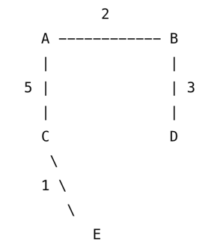
SPT sketch:
Destination | Shortest Path | Total Cost
B | AB | 2
C | AC | 5
D | ABD | 5
E | ACE | 6

Question 3 — Forwarding Table
Destination | Shortest Cost | Next Hop | Complete Path
B | 2 | B | AB
C | 5 | C | AC
D | 5 | B | ABD
E | 6 | C | ACE

Part 2 — Distance Vector Routing
Consider the same network. Initially, each router knows only the cost to its directly connected neighbors.

Question 4 — Bellman-Ford Update
Router A receives the following distance vectors from its neighbors:
From B:
A=2, B=0, C=4, D=3, E=5;
From C:
A=5, B=4, C=0, D=1, E=1.
Use the Bellman-Ford equation. Calculate router A's new distance to:
Show all calculations, including the neighbor through which the minimum-cost route is obtained.
Destination | Via B calculation | Via C calculation | Minimum Cost | Next Hop
B | 2 | 11 | 2 | B
C | 6 | 5 | 5 | C
D | 5 | 8 | 5 | B
E | 7 | 6 | 6 | C

Question 5 — Distance Vector Table
After receiving the distance vectors, construct router A's updated routing table.
Destination | Next Hop | Distance | Full Path
B | B | 2 | AB
C | C | 5 | AC
D | B | 5 | ABD
E | C | 6 | ACE

Part 3 — Routing Convergence

Question 6 — Link Failure
The C–D link fails. Explain separately what happens with Link State and Distance Vector routing.
Link State routing.
Your answer should describe:
- Which router(s) detect the failure.
- What information is flooded through the network.
- How routers update their link-state databases.
- How routers calculate new shortest paths.
Distance Vector routing.
Your answer should describe:
- How routers learn about the failure.
- How updated distance vectors propagate.
- Why routers may temporarily have incorrect routing information.
- How routing eventually converges.
Link State | Distance Vector
router C and D detect the broken link. | C and D detect no heartbeat signal. Other Router learns about it via distance vector updates
C and D create LSA to announce the link between them is disable. | C and D update their cost( setting D(des) = infinity) and inform this to their neighbors
Remove the broken link | A router may send old information to the node having a broken link, causing the loop.
Run Dijkstra's Algorithm without the disabled link to compute new path | The router recompute Bellman-Ford Algorithm by exchanging message between their neighbor until the distance vector table isn’t changed.

Part 4 — Count-to-Infinity
Consider
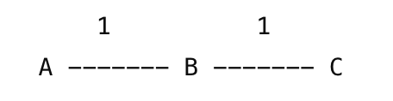
Initially A reaches C through B at cost 2. The B–C link fails, but B receives stale information from A saying C is reachable at cost 2.

Question 7
1. Why can this create a routing loop?
A tells B that C is reachable before receiving the notification that C is unreachable, misleading B that There is the other path to C via A; B updates its routing table and notify A. To go C from A, you must pass B, so A updates its table again, and notify to B.

2. Show how the estimated distance to C can increase over successive iterations.
Iter1
D_{B}(C) = min(1+D_{A}(C),inf ) = 3
Iter 2
D_{A}(C) = min(1+D_{B}(C),inf ) = 4
Iter 3
D_{B}(C) = min(1+D_{A}(C),inf ) = 5
Iter 4
D_{A}(C) = min(1+D_{B}(C),inf ) = 6
.
.
.
3. What is count-to-infinity?
A situation in Distance vector exchange routing table in loop, causing cost increases
4. Why does it occur in Distance Vector routing?
A router in Distance Vector communicate by sending only cost to destination without realizing that path rely on the disabled link
5. Name a mitigation approach.
Limit cost

Part 5 — Compare LS and DV

Question 8
Characteristic | Link State | Distance Vector
Basic algorithm | Dijkstra's algorithm | Bellman-Ford algorithm
Information maintained | Network topology | The distance cost from source to destination and the next hop
Information exchanged | Their neighbor and cost | Distance cost from them to destination
Algorithm
Topology knowledge | Global | Local
Routing updates | Event-triggered | Periodic and triggered
Convergence | Fast | slow
Routing loops | Rare | Yes
Count-to-infinity | No | Yes
Example protocol | OSPF, IS-IS | RIP, IGRP, BGP

Part 6 — Design Question

Question 9
You are designing a routing system for an enterprise with 500 routers requiring fast convergence, accurate topology knowledge, efficient routing, and hierarchical design. Choose LS or DV and justify your choice with at least three technical arguments. Your answer should discuss at least three advantages and/or disadvantages of your chosen approach.

LS algorithm has measurable complexity(n²); DV has varied time convergence, but count-to-infinity may occur. when one of the 500 routers is malfunction, the LS will be stable in convergence than DV, which suits fast convergence and efficient routing characteristic.LS algorithm maintains topology network that is crucial component for accurate topology knowledge. Therefore, The LS algorithm must be chosen over DV algorithm.
Disadvantages of LS approach:
Require hardware storage for network Topology
Wasting bandwidth
Complex

Challenge — Algorithmic Analysis

Question 10
For N routers and E links, compare LS and DV in information maintained, communication overhead, computation, convergence, and scalability. Explain why large-scale intra-domain routing generally favors Link State.

 | LS | DV
information maintained | network topology | Distance vector table
communication overhead | O(n^2) message | exchange between neighbors
computation | O(n^2) | varies
convergence | O(n^2 ) | convergence time varies
scalability | large | small

In physical world, a large-scale network faces the situation that a link between routers is broken. If they use DV approach, this failure may cause the count-to-infinity-loop. So, LS is preferred over DV for the large-scale intra-domain routing.

