# CHAPTER 5

# RESULTS

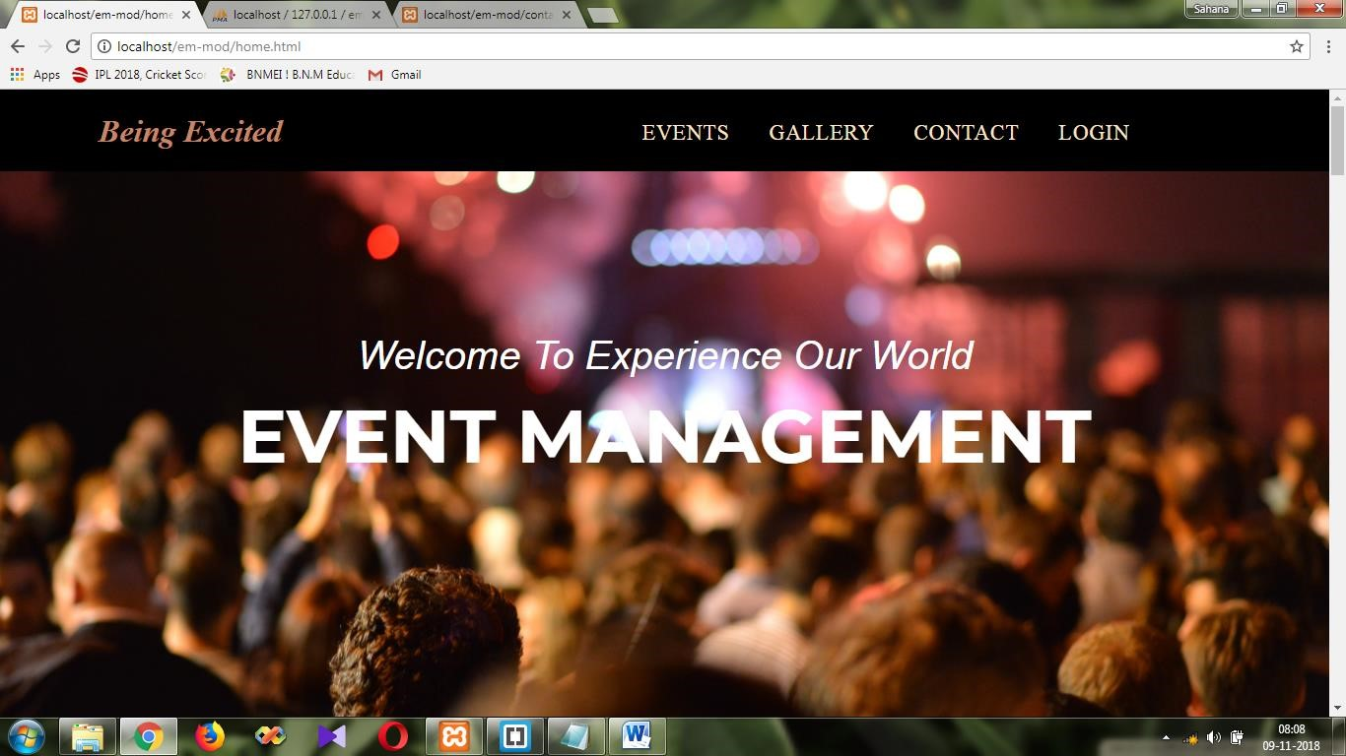

### FIGURE 5.1 HOME PAGE

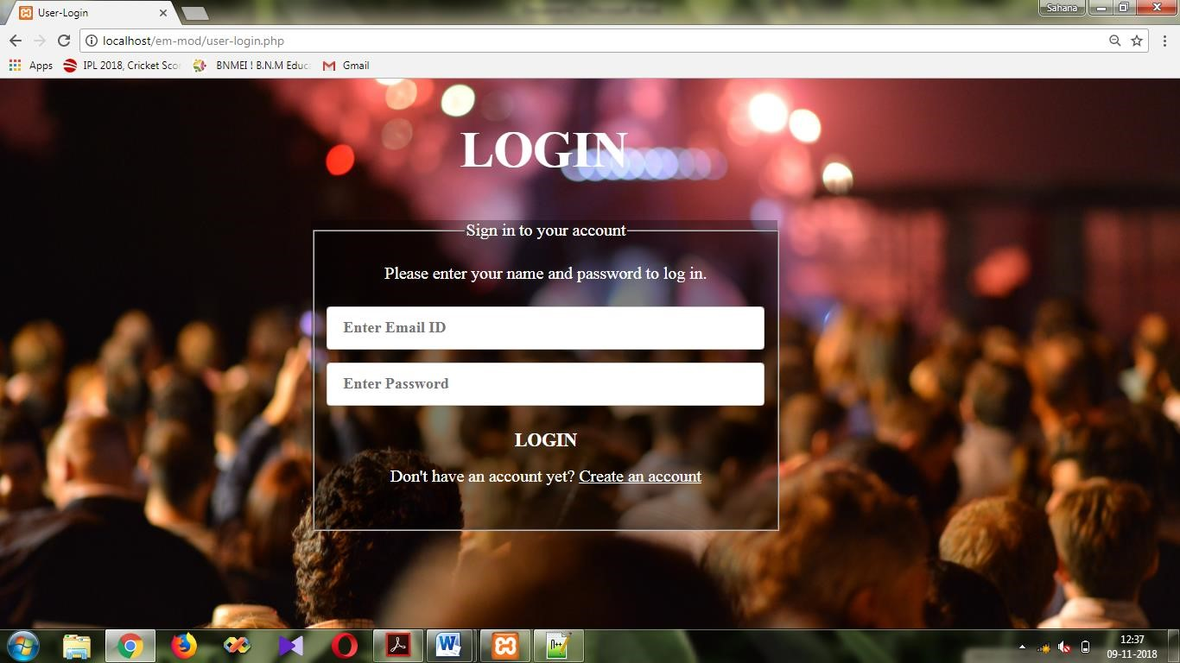

### FIGURE 5.2 LOGIN PAGE

**CHAPTER 6**

# CONCLUSION

The development of online event management system involved many phases. These problems, information needs and activities were documented and later used as the basis for system design. The design phase was concerned primarily with the specification of the system elements in manner that best met the needs. To implement this design, a computer program was then written in HTML, PHP and CSS. It is hoped that effective implementation of this software product would eliminate the many problems of the existing system.

“The Event Management” is designed and implemented using web Technology concepts which has become a widely accepted standard for developing web application and websites.

Usage of Web Technology concepts, functions and primitives are well understood and henceforth can be applied for real time applications by everyone.

This project is both informative and entertaining. This project provided an opportunity to learn the various concepts of the subject in detail and provided a platform to express creativity and imagination.

# CHAPTER 7

# FUTURE ENHANCEMENTS

This project/Website can have future enhancements that will make the website more popular and widely used.

This project can include enhancements such as enhance user interface by adding more user interactive features to personalize user experience. Event management can further be enhanced by adding many more events and services. Add different payment options and allow to save payment details for future use.