Bixi:
Logging:
The app did not encrypt the username and password in JSON.
PII: username, password
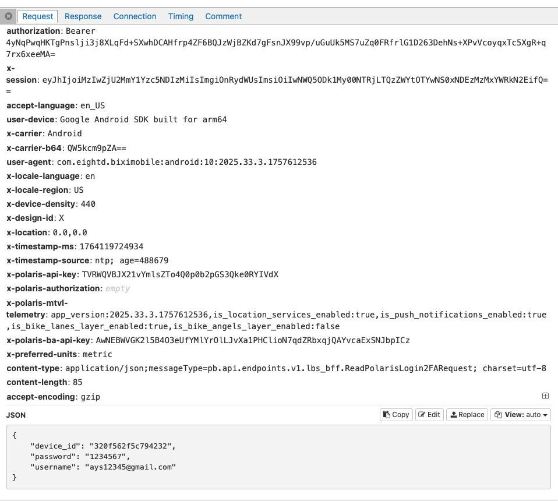
After the login request made, A separate request later was sent to Sentry. (3rd-party error and crash analytics service).
The app sends:exception logs, stack traces, view hierarchy,device model, OS version, timestamps, event IDs
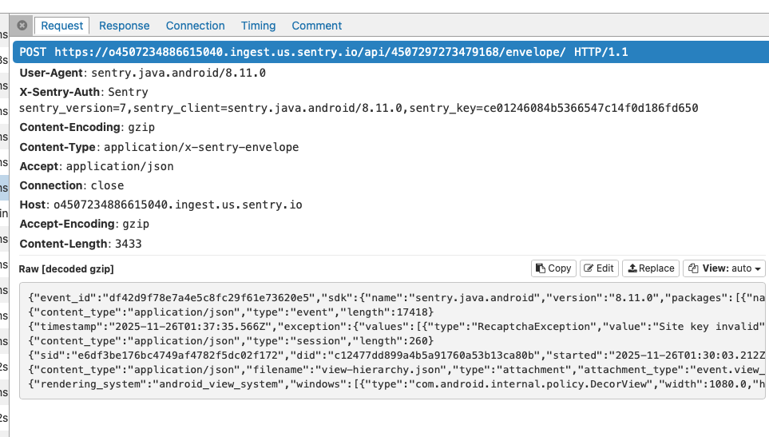

More third parties:
- Google Firebase(send App version & configuration version)
- Google Recaptcha (payload is Binary protobuf — encrypted)
- Mapbox (send App version, Location permission level (“always allowed”), Whether location is enabled, Device info)
- Sentry

Edit profile:
PII exposure in the response payload: email, names, phone, tax region, billing, subscriptions…
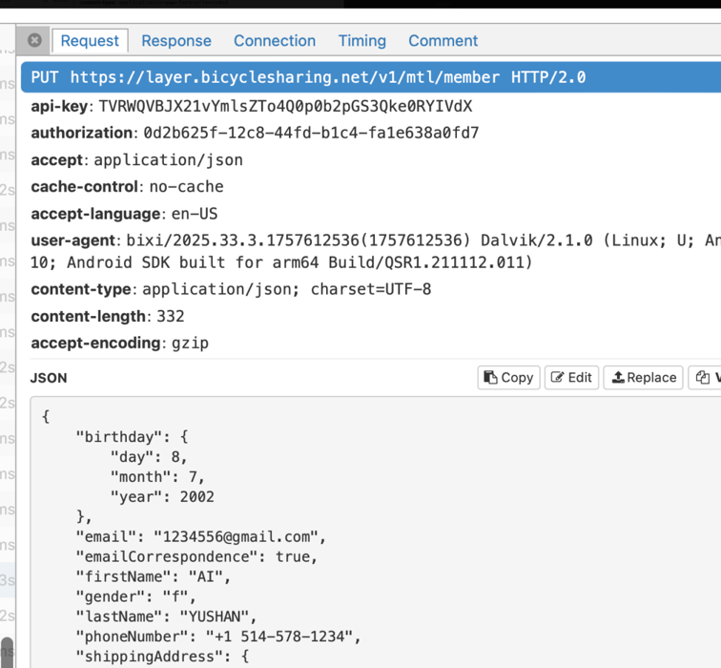

When opening ride history:
All the info in the response payload is not encrypted, include PII:
- number of previous rides
- Which stations I used
- Precise GPS coordinates of start and end
- Times, durations, distances, and costs
- Which specific bikes I rode

Communato:
Logging:
The app did not encrypt the username and password in JSON.
PII: username, password
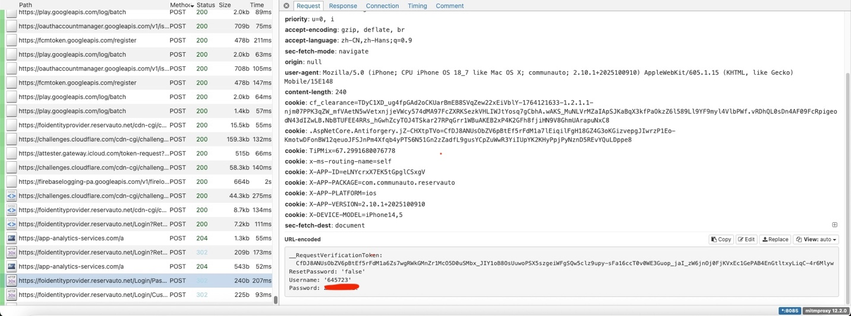

Apps/Domains Contacted:
- Google Analytics (sent device model, OS version, app version, session ID)
- Google Notifications(polling suggests background/ language sync)

When opening profile: the data is not encrypted in the response payload:
PII exposure: email, names, phone, home address, emergency contacts….

