Transit
https://api-s2.transitapp.com/vault/v2/blobs [Phone Number]
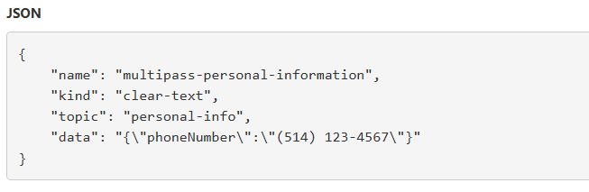
https://api-s2.transitapp.com/vault/v2/token/external [Phone Number, Device ID]
https://api-s2.transitapp.com/v3/proxies/spreedly/v1/payment_methods/01KA7HJ19W3CXE9PW89MRTZ39Q/retain.json [Full Name, Credit Card Last 4 Digits, Expiration Date, ZIP/Postal Code]
https://api-s2.transitapp.com/vault/v2/account [Email, First Name, Last Name, Password Hash Salt]
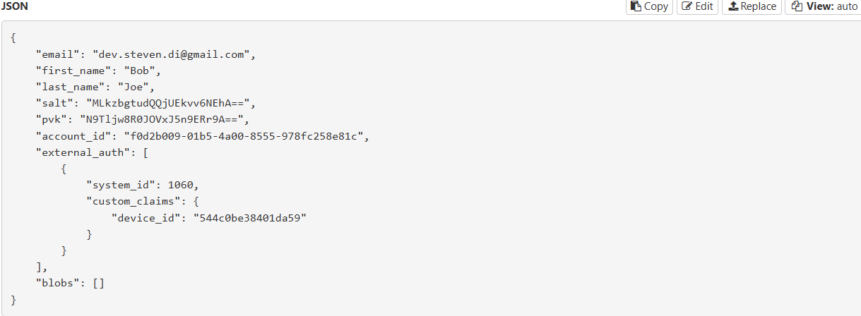
https://ebf4e0n9-android.mobile-messenger.intercom.com/messenger/mobile/users [Device Tokens, Transit Device ID, Push Token, City, Region, Country, Walk Speed, GO Minutes, Battery Level, Voice Shortcuts, Saved Locations, Subscription Status, Tracked Apps, Transit Account Properties, Country, Region, App Launches, Preferences] 3rd party
https://api2.amplitude.com/ [Device Tokens, Transit Device ID, Push Token, City, Region, Country, Walk Speed, GO Minutes, Battery Level, Voice Shortcuts, Saved Locations, Subscription Status, Tracked Apps, Transit Account Properties, Country, Region, App Launches, Preferences] 3rd party

Citymapper
https://us-sf-api.citymapper.com/2/journeytimes [Start and end locations coordinates]
https://global-api.citymapper.com/3/gotrips/starttrip [Journey end address, sequence of coordinates]
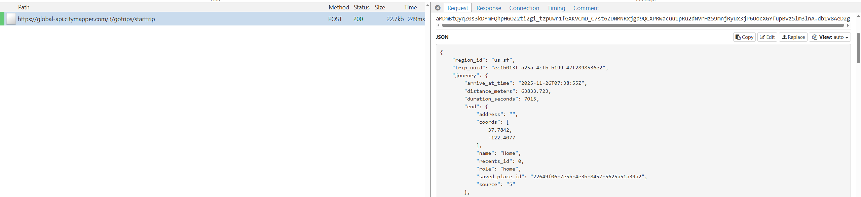
https://global-api.citymapper.com/1/gotrips/phasereport
[Exact GPS coordinates, Full street addresses, Coordinates for start/end locations]
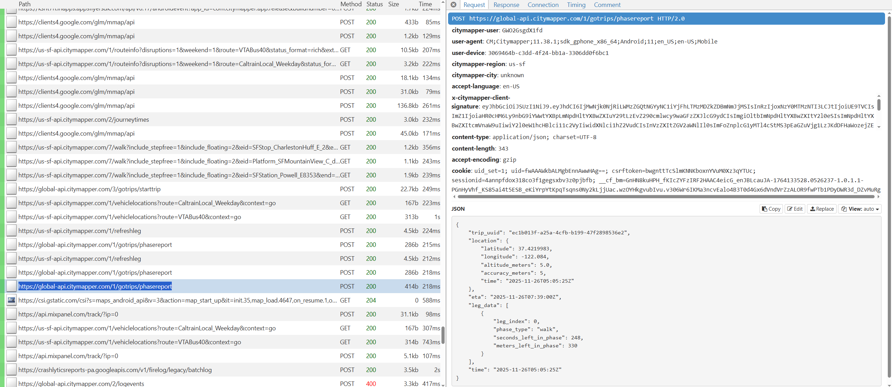

https://api.mixpanel.com/track/?ip=0 [No PII is shared, just tracks how users interact with the app.] (encoded)
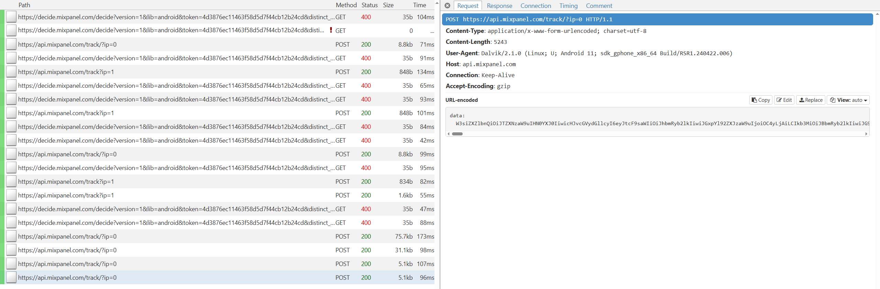
https://global-api.citymapper.com/2/identity/magiclink/create [Email]
https://global-api.citymapper.com/2/identity/contact_number/set_number [Phone Number]
Bird
https://api.bird.co/analytics/track
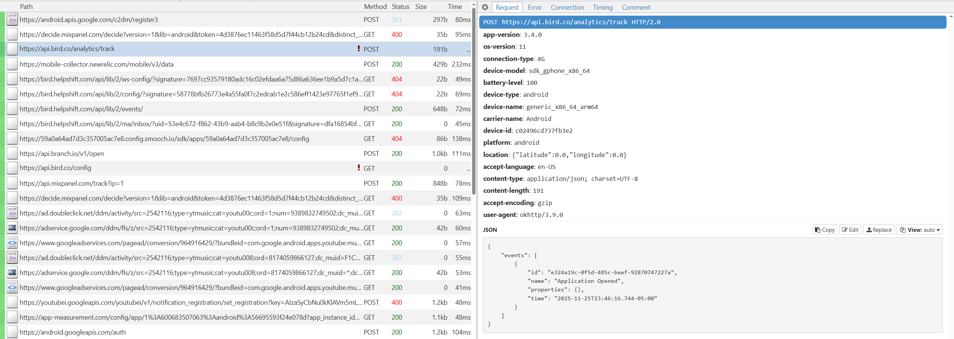
https://mobile-collector.newrelic.com/mobile/v3/data

https://api.mixpanel.com/track?ip=1 (encoded data)
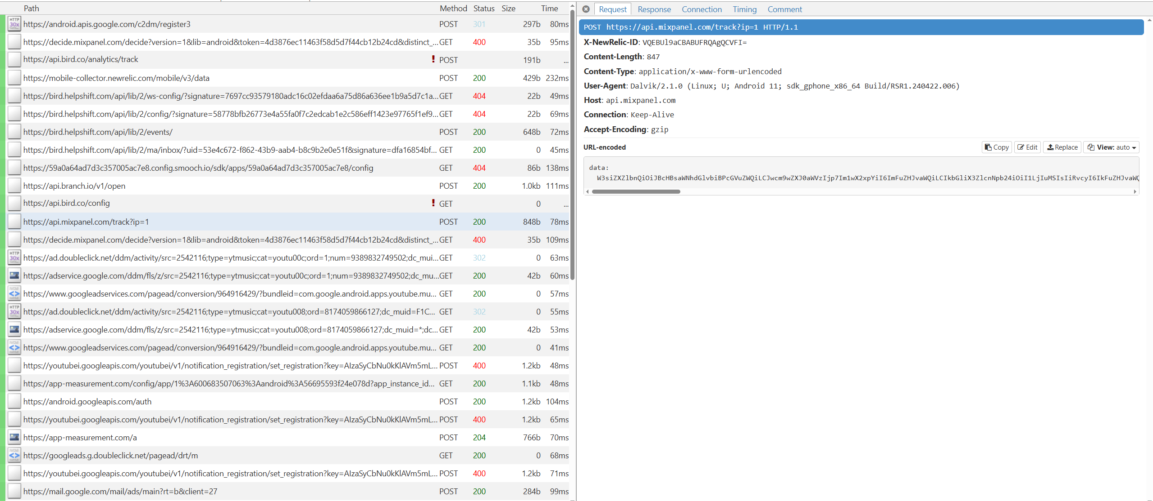
Can’t get past the login screen, Bird implements certificate pinning which is a security feature that makes the app only trust specific SSL certificates.

https://api.bird.co/user/login

