Uber:
Domain | Purpose
accounts.google.com | OAuth login, consent screen, token issuance
people-pa.googleapis.com | Retrieval of Google account profile data (email, name, gender, metadata)
lh3.googleusercontent.com | Profile image retrieval (multiple resolutions)
ssl.gstatic.com / www.gstatic.com | Google Identity UI scripts, JS modules, CSS
Google static JS modules (boq-identity) | Google login front-end logic and OAuth validation
Notes:
No third-party advertising or attribution SDKs appear in the login stage
No external analytics (AppsFlyer, TikTok, Meta, Amplitude, etc.)

2. Personal Data
2.1 PII returned via Google People API
Uber only receives:
OAuth access token
The subset of profile data permitted by Google’s consent screen

3. Encryption Evaluation

Transport encryption
good,All Google + Uber endpoints use HTTPS
Passwords
good, Never transmitted to Uber; handled by Google
Tokens
transmitted, Returned as encrypted JWT

4. Location Tracking and Mobility Data
No location data transmitted during login
Uber did not request GPS

5. Cross-Service Data-Sharing
No unexpected third-party flows

Lyft:

Domain | Purpose
api.lyft.com/v1/locations | Uploads high-frequency GPS data
api.lyft.com/v1/nearby-drivers-pickup-etas | Retrieves driver ETA based on user's live location
api.lyft.com/v1/core_trips/activetrips | Polls for ongoing trips
api.lyft.com/ping | Heartbeat / keep-alive
api.lyft.com/v1/realtime-rider-session | Syncs rider state
api.lyft.com/v1/eventingest/ingestbatch | Sends app analytics & event logs
app-analytics-services-att.com | Third-party analytics/telemetry endpoint

Presence of one third-party analytics domain, No external ad networks beyond the single analytics provider

2. Personal Data Exposure
exposes extremely detailed GPS + device metadata:
Example payload from /v1/locations:
lat: 45.4934130337
lng: -73.5824925158
gps_altitude_meters: 57.99
accuracy: 5.7m
precision: 1
location_id: UUID
source: polling_bg / polling_fg
measured_at_ms: 1764126875551

Lyft includes GPS in HTTP HEADERS, shouldnt.
3. Encryption Evaluation
PII in headers which is Critical privacy design flaw

4. Location Tracking & Mobility Data Behavior
/v1/locations sent every 200–500 ms
Each request contains multiple buffered GPS points
Both foreground and background signals included

Sensitive metadata included
Altitude
Precision values
Device timestamps
Unique location UUIDs
NTP timestamps

5. Cross-Service Data Sharing

Service | Data Shared
Lyft backend | All GPS, altitude, UUIDs, event logs
app-analytics-services-att.com | Behavioral analytics
Waze

Domain | Purpose
rt-xlb-am.waze.com/rtserver/distrib/command | Core navigation engine: location updates, road data, routing
rt-xlb-am.waze.com/rtserver/distrib/login | Device/session login
inbox-na.waze.com | Notifications/messages
cresg.waze.com/langs & tts | Language files and text-to-speech voices
tts-assets.voice.waze.com | Downloading turn-by-turn audio TTS MP3 files
ctilesgcs-am.waze.com/TileServer | Map tiles
firebaselogging-pa.googleapis.com | Analytics + crash logs
ads-resources.waze.com | Ad/partner resources (logos, icons)
sdk.waze.com/partner_logos | Third-party partner assets

No marketing trackers (Facebook/TikTok/AppsFlyer)

2. Personal Data Exposure

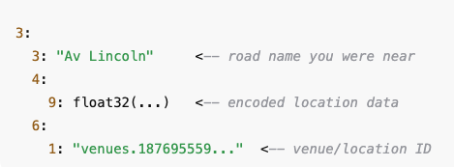
Waze transmits extremely detailed, structured protobuf messages that include:

Real-time GPS coordinates
Road segment IDs
Movement vectors
Search terms / partial address names
Map tile request patterns
User session cookie
Possibly device-level unique IDs

3. Encryption Evaluation

HTTPS transport has All endpoints encrypted
Protobuf payloads has Binary encoded

4. Location Tracking & Mobility Data Behavior

Waze semd data per second which each packet includes:
- User GPS
- Road segment intersection
- Current route state
- Map tile references
- Behavioral signals (speed, turn decisions)
5. Cross-Service Data Sharing
No major AdTech trackers (Meta/TikTok/AppsFlyer) appear in logs.

​​inDrive

Before Login
Domain | Purpose
skadsdkless.appsflyersdk.com | AppsFlyer attribution & ad analytics
inapps.appsflyersdk.com | Additional AppsFlyer telemetry
vector-prod-*.run.app | Google Cloud Functions for event collection
www.recaptcha.net | Google reCAPTCHA anti-abuse check
cas-cf.euce1.indriverapp.com/api/start | inDrive authentication bootstrap
cas-cf.euce1.indriverapp.com/api/authorization | SMS login flow
es-cf.euce1.indriverapp.com/track | Push notification tracking

After Login

Domain | Purpose
skadsdkless.appsflyersdk.com | Conversion tracking & session events
inapps.appsflyersdk.com | iOS event logging
vector-prod-*.run.app | Event collection & internal analytics
cas-cf.euce1.indriverapp.com/api/passkey/register/begin | Identity & passkey registration
es-cf.euce1.indriverapp.com/track | App push tracking

Third-party analytics remain involved
2. Personal Data Exposure

2.1 Before Login
When the user has not yet signed in, inDrive already sends identifying data, including:
"username": "15145XXXXX1" which is phone number ,it is transmitted in plaintext JSON, though encrypted via HTTPS.

3. Encryption Evaluation
All inDrive traffic uses HTTPS
AppsFlyer + CAPTCHA also encrypted
No plaintext credentials over HTTP
Phone number transmitted directly in JSON (though encrypted)
AppsFlyer includes device identifiers that can be used for fingerprinting

4. Location Tracking & Mobility Data Behavior
None

5.Third-Party Data Sharing
inDrive has the highest amount of third-party contact among all apps

Third-Party | Function | Data Sent
AppsFlyer | Attribution & advertising analytics | Device info, session counters, conversion values
Google reCAPTCHA | Fraud prevention | Device metadata, network signals
Google Cloud Run (vector-prod) | Telemetry | Behavioral analytics
Google Cloud Messaging (push tracking) | Push notifications | Push events & tracking IDs

Lime

Domain | Purpose
api.lime.com | Core Lime backend: scooters, user state, map data
tiles.lime.bike or map tiles CDN | Map rendering
api.segment.io | Segment analytics (key privacy risk)
config.segmentapis.com | Segment configuration fetch
mobile-collector.newrelic.com | NewRelic performance & crash telemetry
sentry.io | Error logging & crash reports
googleapis.com | Google services, FCM, Maps support
app-measurement.com | Google Firebase analytics
events.mapbox.com | Mapbox map telemetry

Lime contacts a large number of analytics vendors (Segment, NewRelic, Firebase, Mapbox, Sentry).
This begins before the user starts a ride.

2. Personal Data Exposure
Data Sent AFTER Login：

3. Encryption Evaluation
PII inside payload e.g.(GPS + device identifiers) is risky.
Third-party SDKs are High risk, Segment/Firebase share data broadly

4. Location Tracking Behavior
Continuous GPS sent every few seconds,Even when Not riding,No unlocking a scooter,Simply having the map open
GPS data includes:
lat, lng,accuracy,timestamp
5. Cross-Service Data Sharing

Lime uses at least 5 major analytics vendors:
Segment.io,NewRelic,Firebase / app-measurement.com,Sentry.io,Mapbox

Especially Segment, since it aggregates user data from multiple apps and sells analytics services which increases cross-app profiling.

Attachment

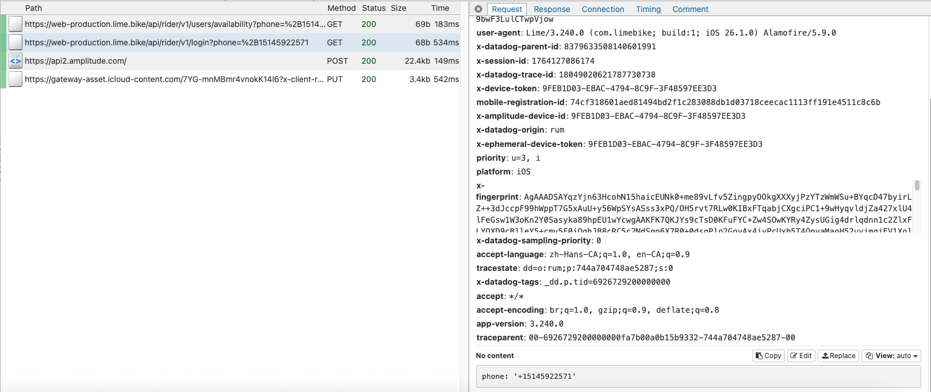
After logon , everything leaks
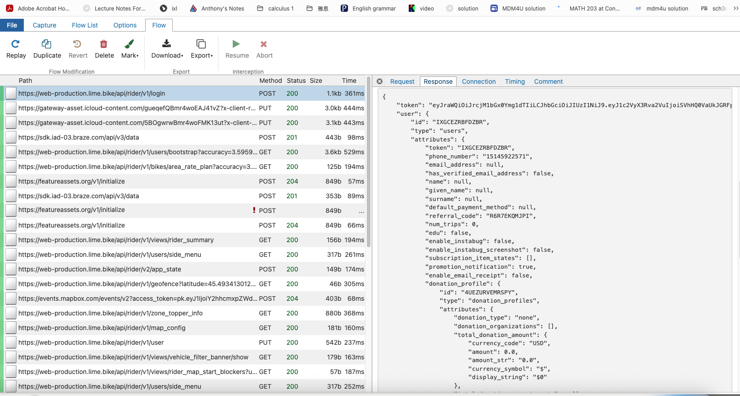
Obtain this after locate my self :