***CloudEQ***

***Git-Bash Calculator (Assignment)***

Here are the Code and Screenshots

LENOVO@LAPTOP-4OTBAR7F MINGW64 ~/Desktop/GitBash file

$ mkdir calculator

LENOVO@LAPTOP-4OTBAR7F MINGW64 ~/Desktop/GitBash file

$ ls

calculator/

LENOVO@LAPTOP-4OTBAR7F MINGW64 ~/Desktop/GitBash file

$ cd calculator

cal() {

echo "Enter the TWO numbers for the Operation:- "

read a

read b

echo "Provide your Choice of Operation from below the Options:- "

echo "1- Addition"

echo "2- Subtraction"

echo "3- Multiplication"

echo "4- Division"

echo "Choose one Option:- "

read opt

if [ $opt -eq 1 ]

then

echo " Answer:- " $[$a+$b]

echo " Answer:- " $[$a+$b] >> output

elif [ $opt -eq 2 ]

then

echo " Answer:- " $[$a-$b]

echo " Answer:- " $[$a-$b] >> output

elif [ $opt -eq 3 ]

then

echo " Answer:- " $[$a*$b]

echo " Answer:- " $[$a*$b] >> output

elif [ $opt -eq 4 ]

then

echo " Answer:- " $[$a/$b]

echo " Answer:- " $[$a/$b] >> output

else

echo "Invalid Choice"

echo "Invalid Choice" >> output

fi }

#type cal and run the Operation #

./calculator.sh

1-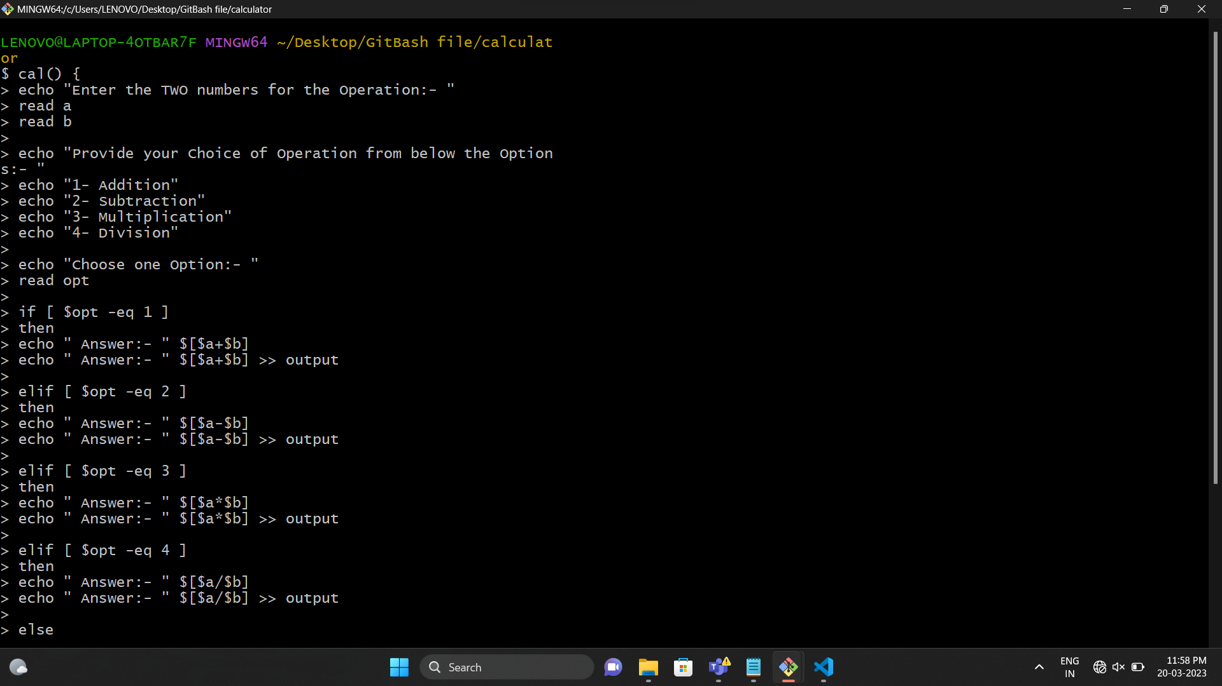2-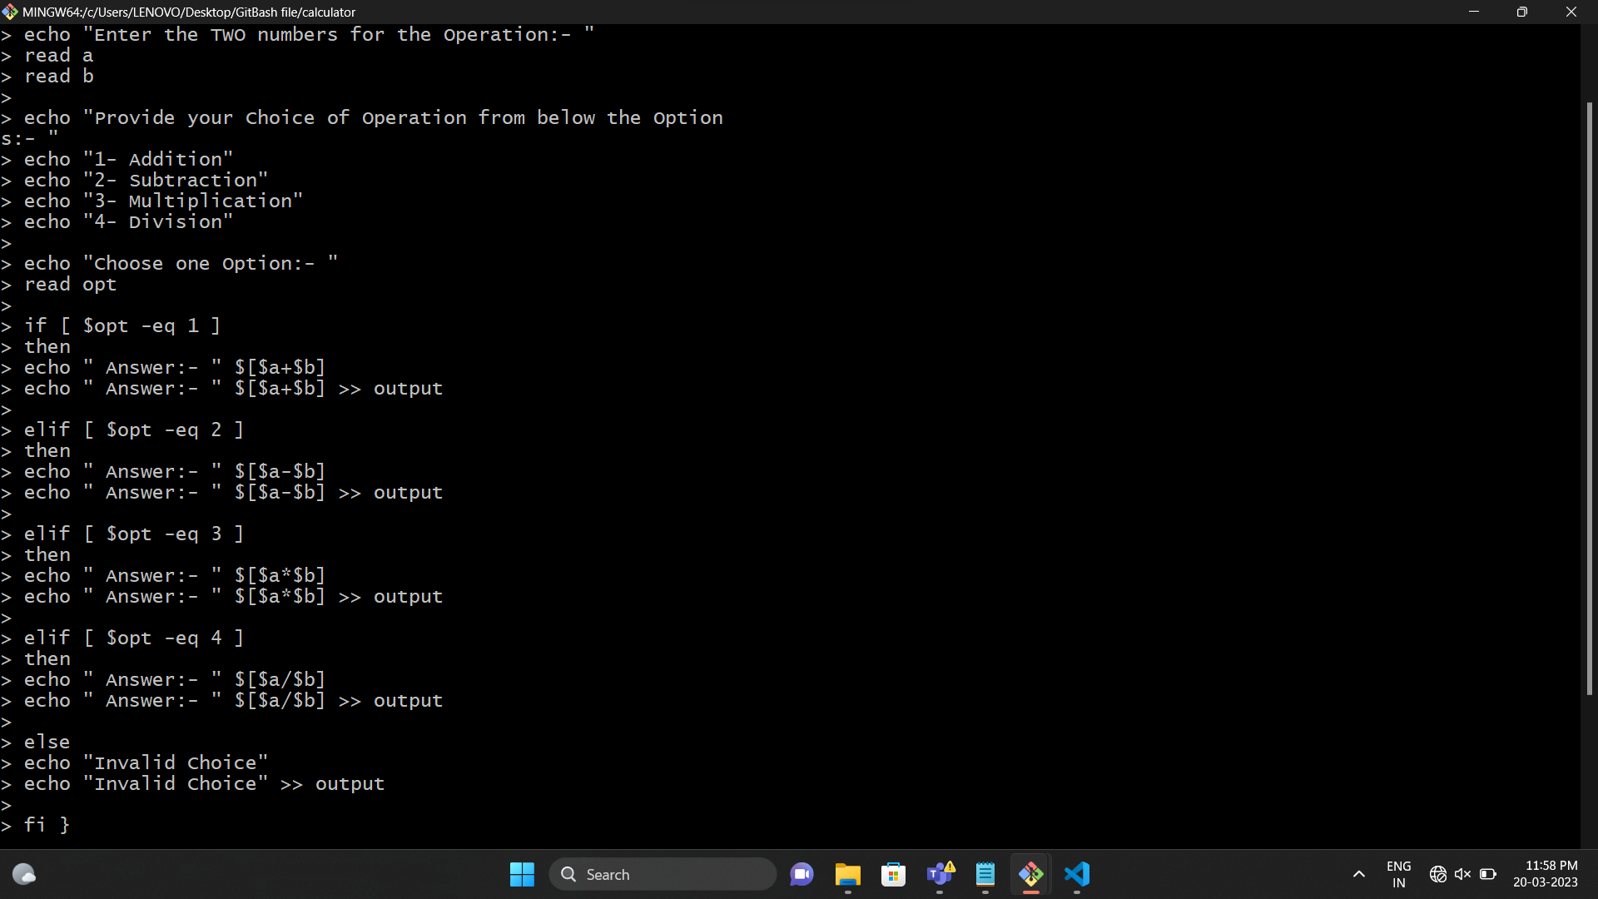

***Output***

LENOVO@LAPTOP-4OTBAR7F MINGW64 ~/Desktop/GitBash file

$ ls

calculator/

LENOVO@LAPTOP-4OTBAR7F MINGW64 ~/Desktop/GitBash file

$ cd calculator

LENOVO@LAPTOP-4OTBAR7F MINGW64 ~/Desktop/GitBash file/calculator

$ cal

Enter the TWO numbers for the Operation:-

10

10

Provide your Choice of Operation from below the Options:-

1- Addition

2- Subtraction

3- Multiplication

4- Division

Choose one Option:-

1

Answer:- 20

LENOVO@LAPTOP-4OTBAR7F MINGW64 ~/Desktop/GitBash file/calculator

$ cal

Enter the TWO numbers for the Operation:-

60

30

Provide your Choice of Operation from below the Options:-

1- Addition

2- Subtraction

3- Multiplication

4- Division

Choose one Option:-

2

Answer:- 30

LENOVO@LAPTOP-4OTBAR7F MINGW64 ~/Desktop/GitBash file/calculator

$ cal

Enter the TWO numbers for the Operation:-

7

5

Provide your Choice of Operation from below the Options:-

1- Addition

2- Subtraction

3- Multiplication

4- Division

Choose one Option:-

3

Answer:- 35

LENOVO@LAPTOP-4OTBAR7F MINGW64 ~/Desktop/GitBash file/calculator

$ cal

Enter the TWO numbers for the Operation:-

59

7

Provide your Choice of Operation from below the Options:-

1- Addition

2- Subtraction

3- Multiplication

4- Division

Choose one Option:-

4

Answer:- 8

LENOVO@LAPTOP-4OTBAR7F MINGW64 ~/Desktop/GitBash file/calculator

$ cal

Enter the TWO numbers for the Operation:-

7

59

Provide your Choice of Operation from below the Options:-

1- Addition

2- Subtraction

3- Multiplication

4- Division

Choose one Option:-

4

Answer:- 0

LENOVO@LAPTOP-4OTBAR7F MINGW64 ~/Desktop/GitBash file/calculator

$ cal

Enter the TWO numbers for the Operation:-

80

5

Provide your Choice of Operation from below the Options:-

1- Addition

2- Subtraction

3- Multiplication

4- Division

Choose one Option:-

4

Answer:- 16

LENOVO@LAPTOP-4OTBAR7F MINGW64 ~/Desktop/GitBash file/calculator

$ cal

Enter the TWO numbers for the Operation:-

90

3

Provide your Choice of Operation from below the Options:-

1- Addition

2- Subtraction

3- Multiplication

4- Division

Choose one Option:-

4

Answer:- 30

1-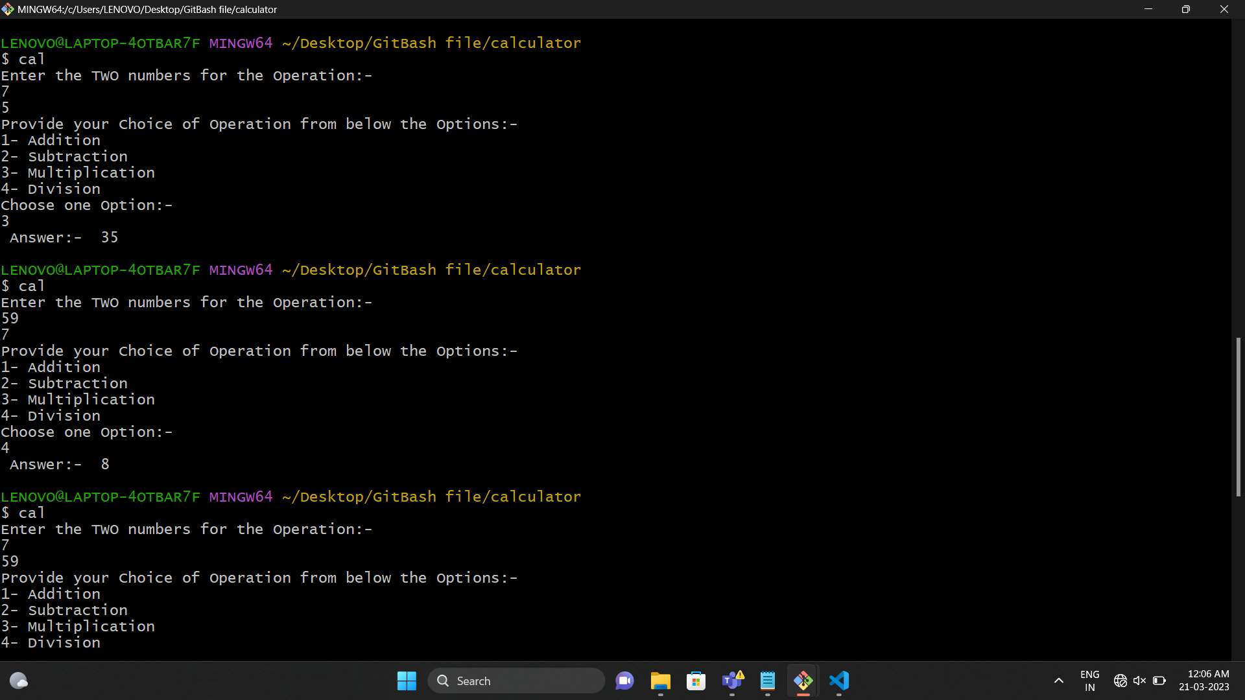

2-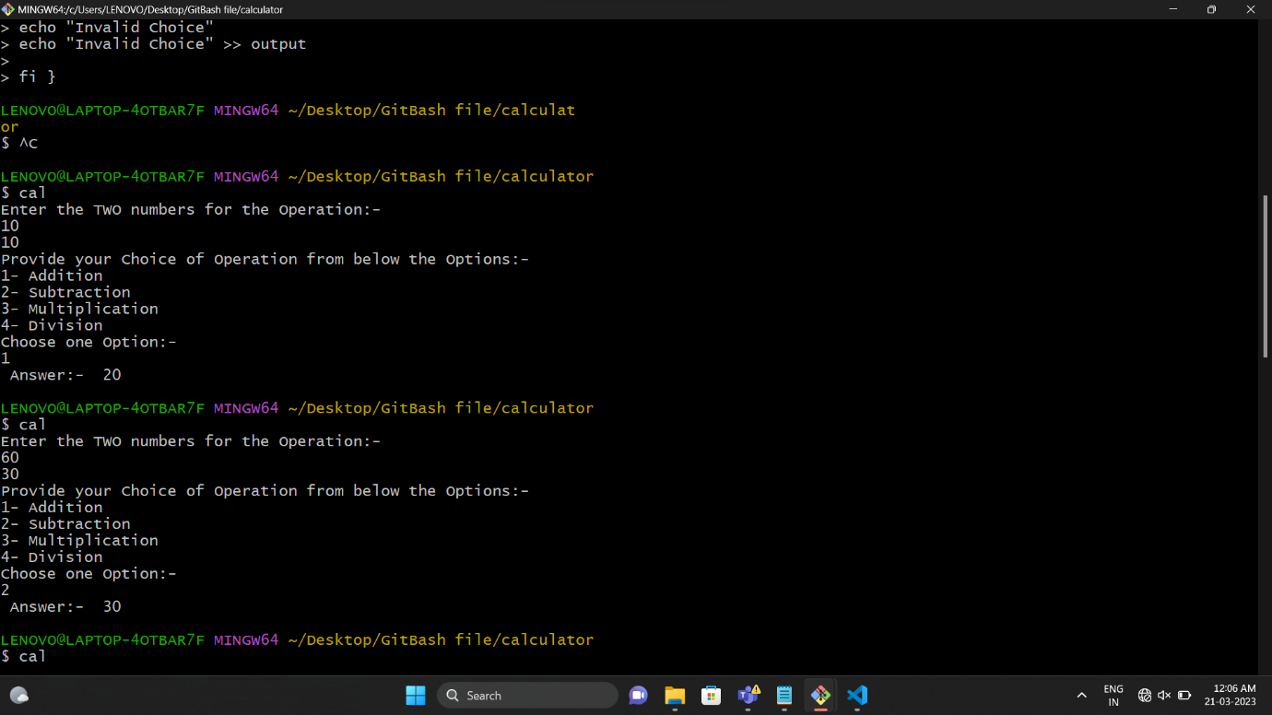3-