Laxmi Flowers Rentals
Rental catalog converted from the supplied PDF.

Catalog page 1
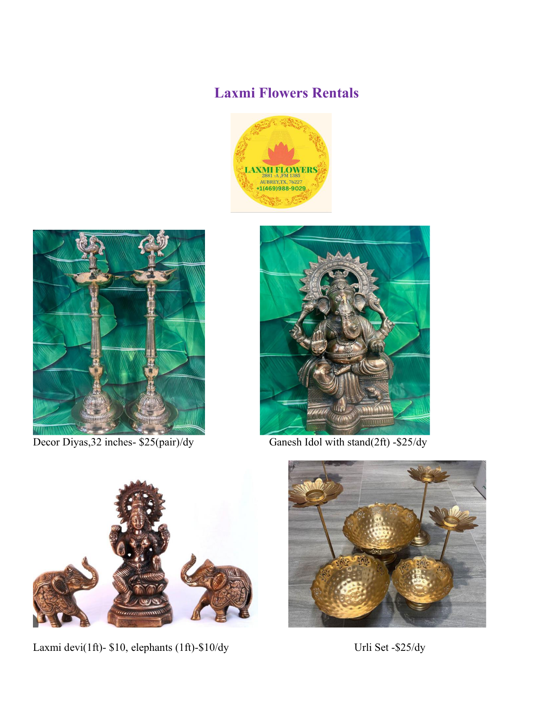

Catalog page 2
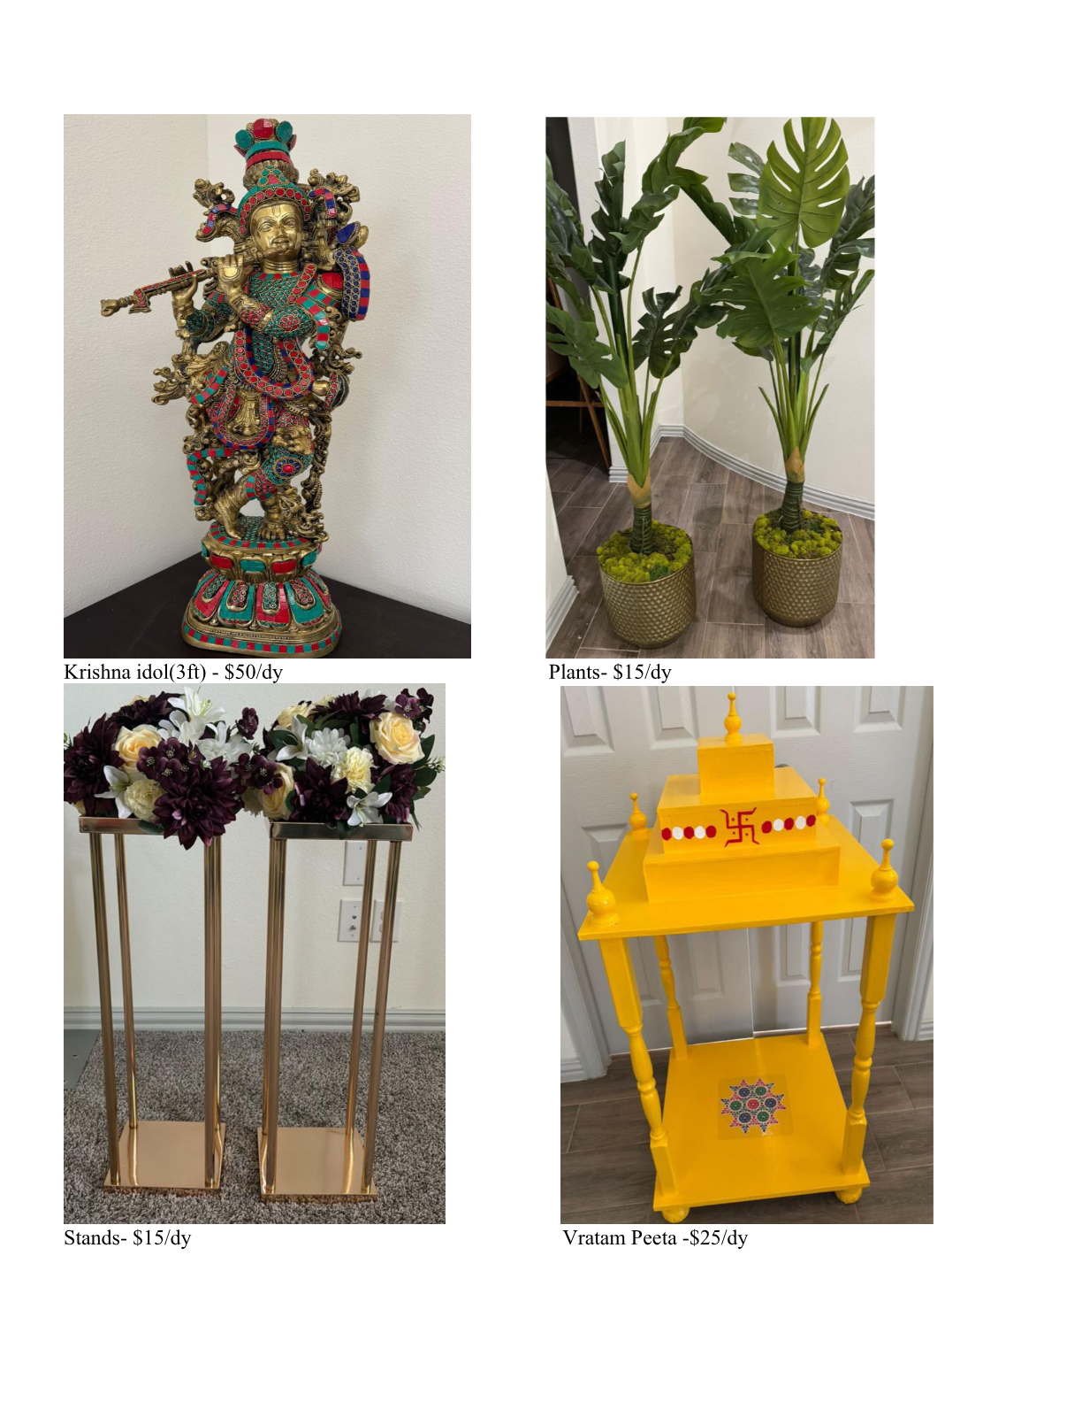

Catalog page 3
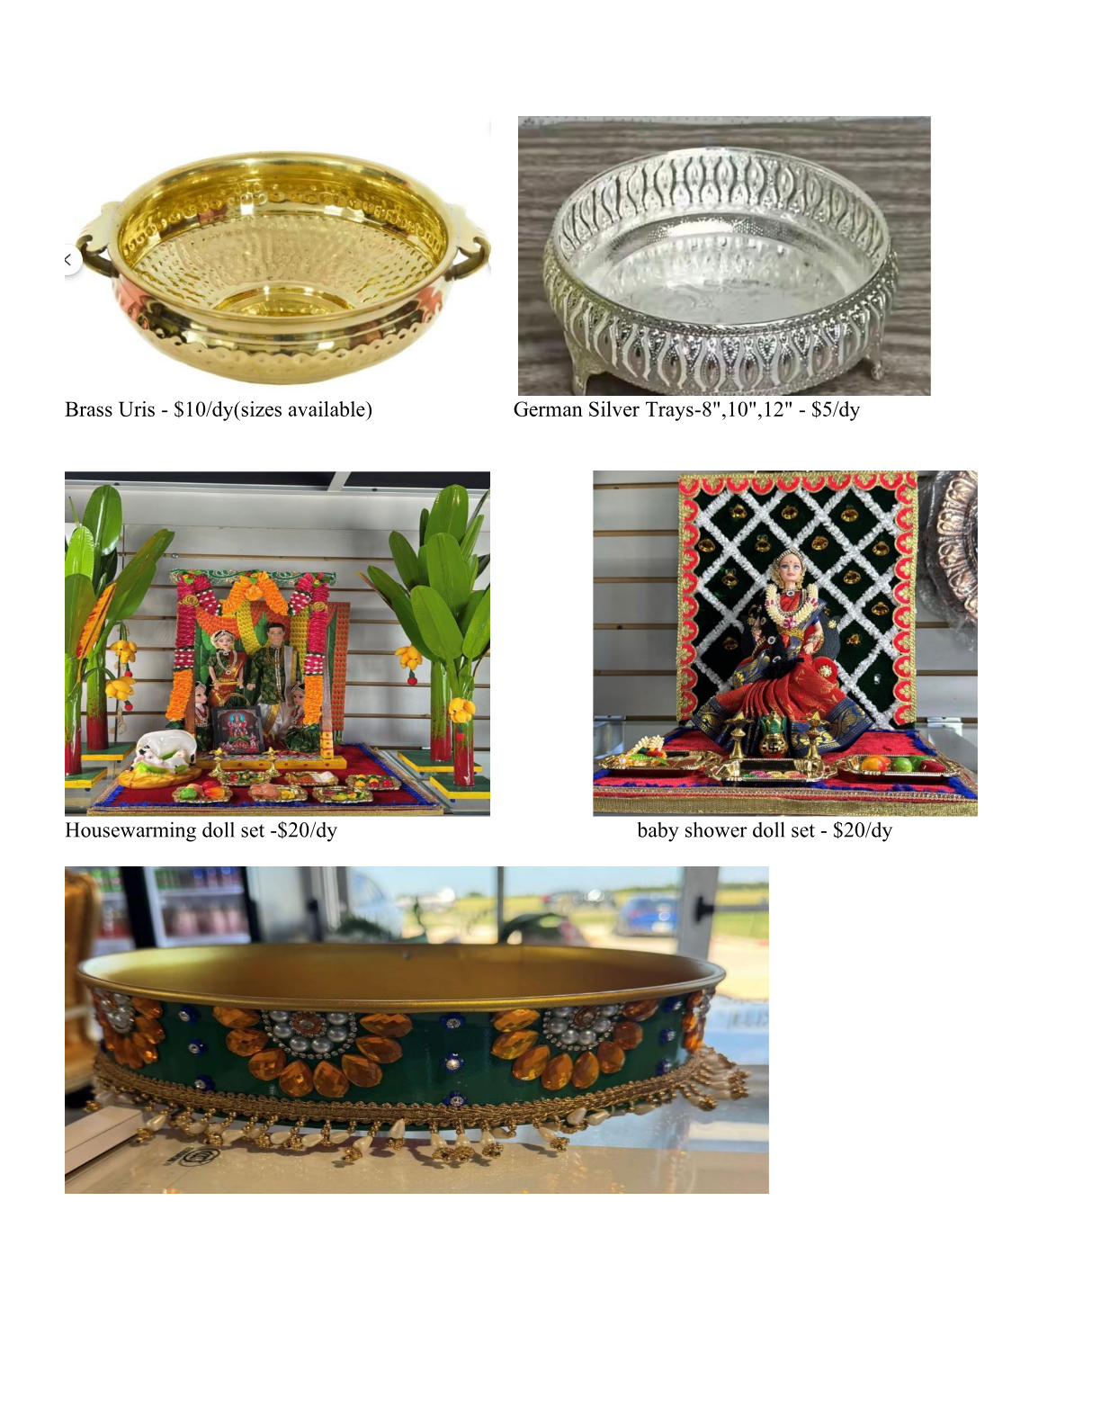

Catalog page 4
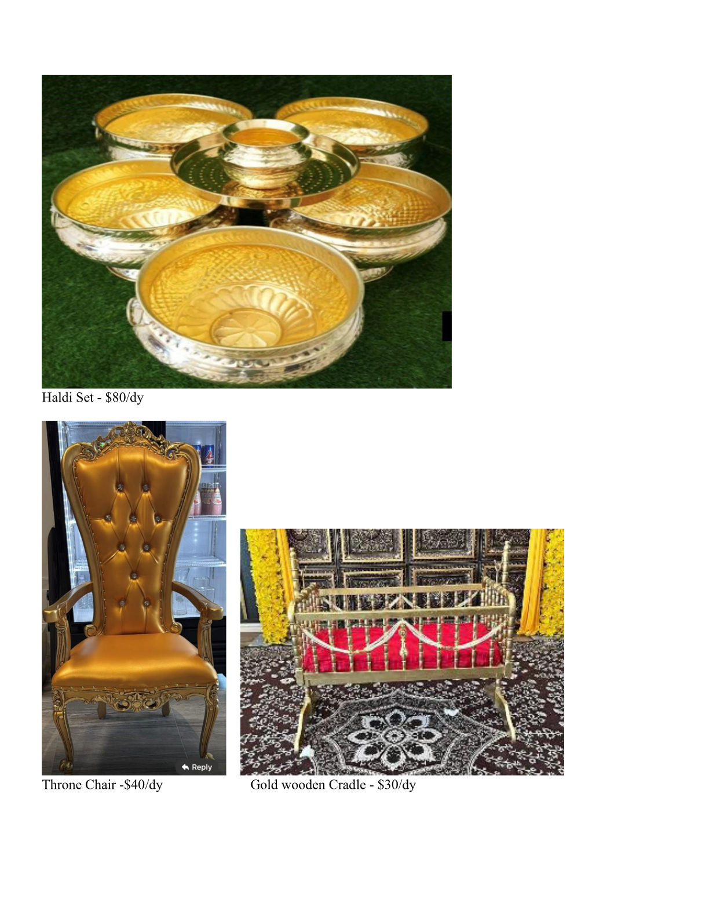

Catalog page 5
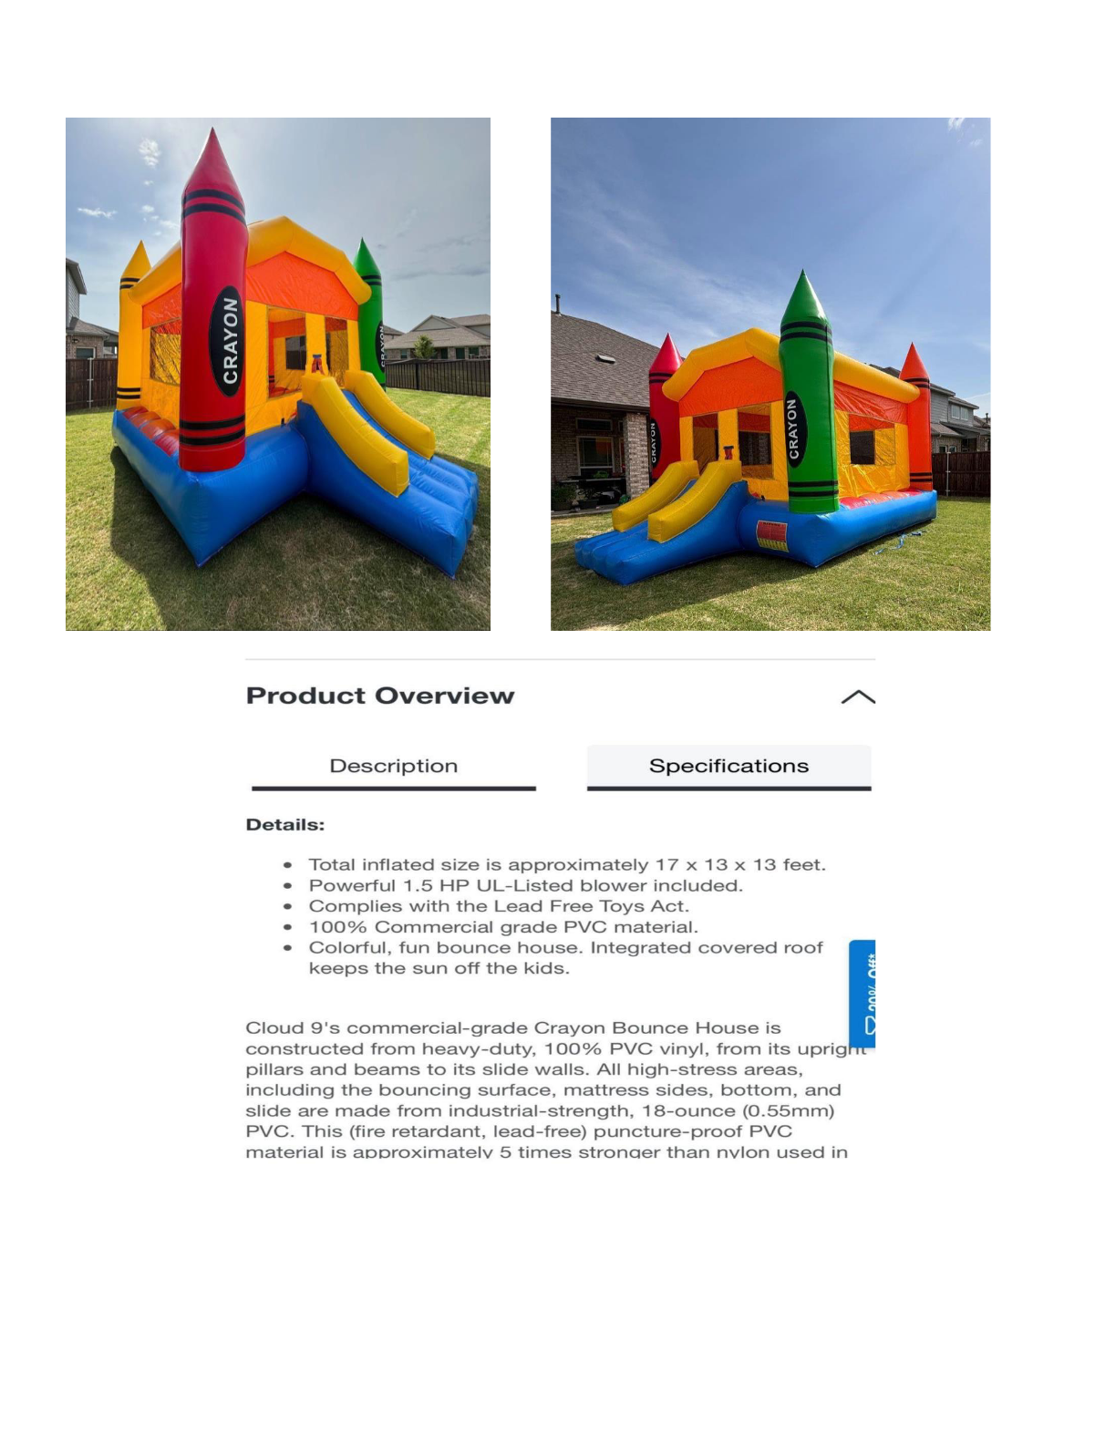

Catalog page 6


Catalog page 7
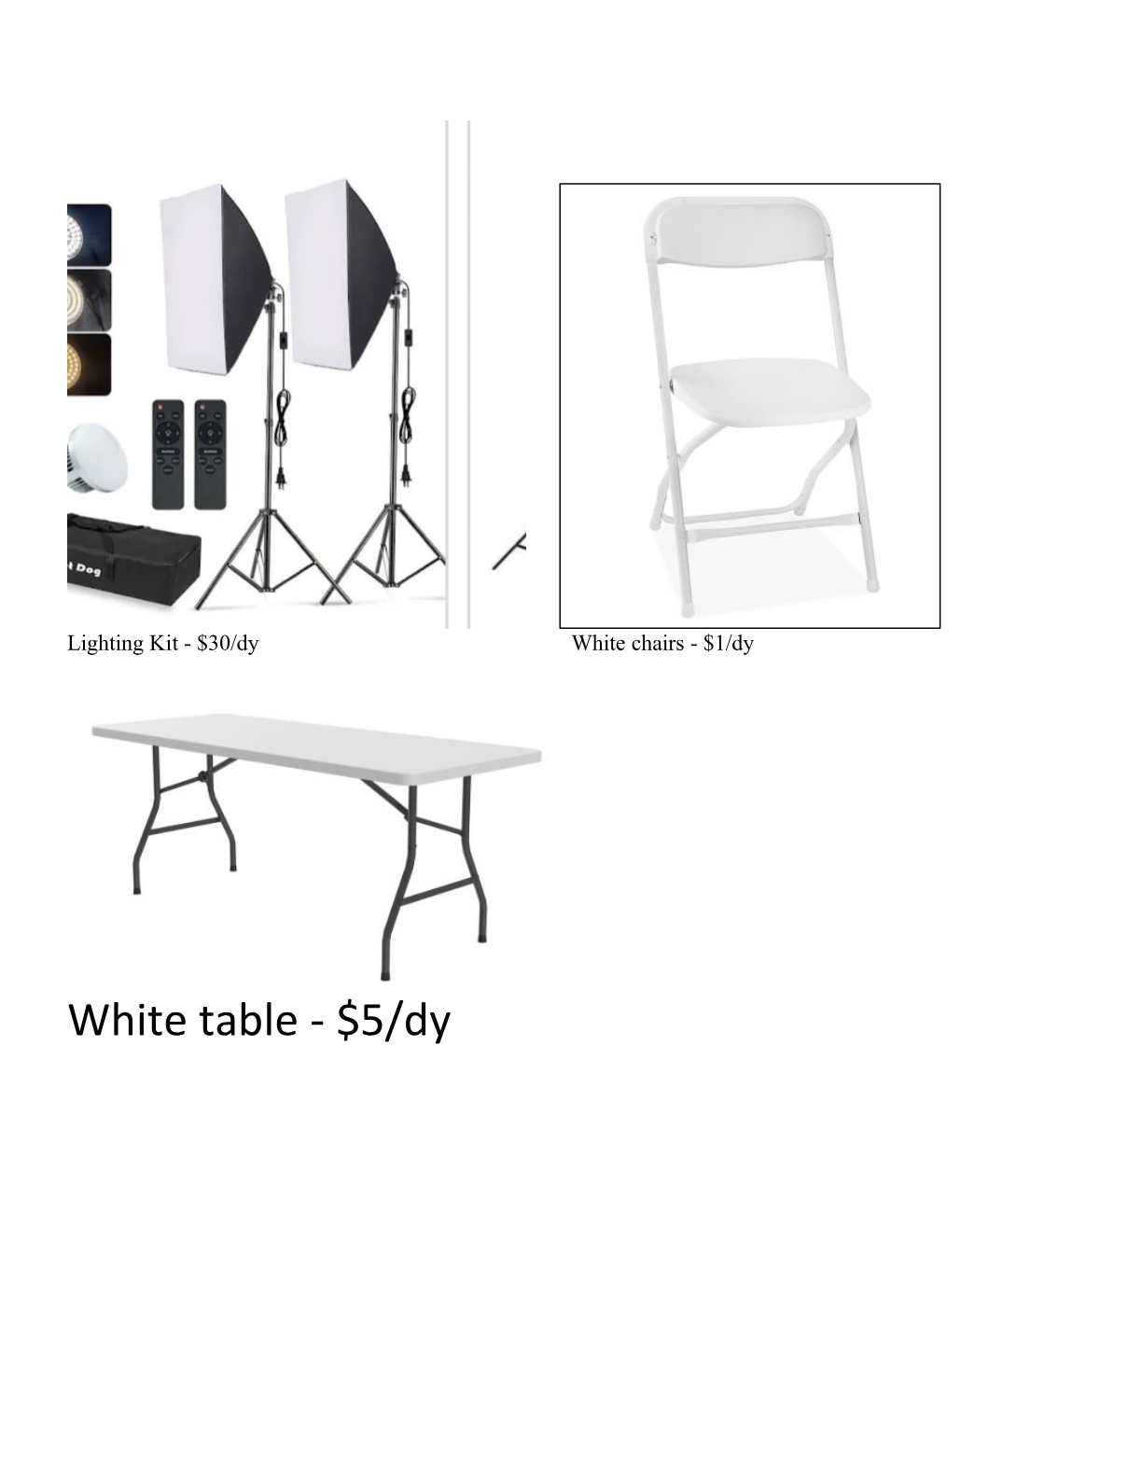

Catalog page 8
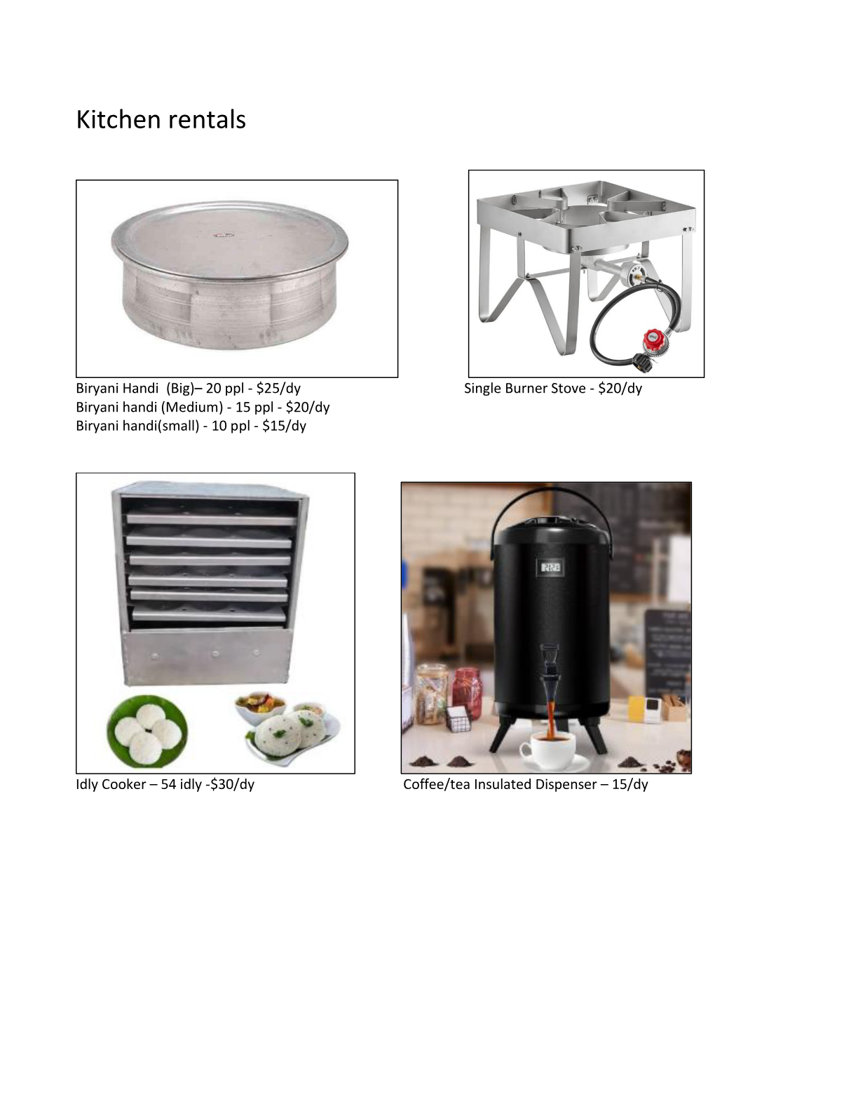

Catalog page 9


Catalog page 10

Catalog page 11

Catalog page 12

Catalog page 13

Catalog page 14

Catalog page 15

Catalog page 16

Catalog page 17

Catalog page 18

Catalog page 19

Catalog page 20

Catalog page 21

Catalog page 22

Catalog page 23

Catalog page 24

Catalog page 25

Catalog page 26

Catalog page 27

Catalog page 28

Catalog page 29

Catalog page 30

Rental items and prices
Decor Diyas: $25/pair/day
Ganesh Idol with stand (2 ft): $25/day
Laxmi Devi (1 ft): $10/day
Elephants (1 ft): $10/day
Urli Set: $25/day
Krishna Idol (3 ft): $50/day
Plants: $15/day
Stands: $15/day
Vratam Peeta: $25/day
Brass Uris: $10/day
German Silver Trays (8, 10, 12 in): $5/day
Housewarming Doll Set: $20/day
Baby Shower Doll Set: $20/day
Haldi Set: $80/day
Throne Chair: $40/day
Gold Wooden Cradle: $30/day
12 x 12 ft Heavy Duty Stand: $30/day
3 Metal Arch Stands (6, 6.5, 7 ft): $25/day
White Metal Square Stand: $25/day
Cake Cylinders (3): $15/day
Lighting Kit: $30/day
White Chairs: $1/day
White Table: $5/day
Biryani Handi (Big, 20 people): $25/day
Biryani Handi (Medium, 15 people): $20/day
Biryani Handi (Small, 10 people): $15/day
Single Burner Stove: $20/day
Idly Cooker (54 idly): $30/day
Coffee/Tea Insulated Dispenser: $15/day

