**RESUME**

NAME- PRIYAM DAVE

ADDRESS- D-113, AVANTIKA, SECTOR-1, ROHINI, DELHI-110085.

CONTACT- +91-8766382429

EMAIL- [dave.priyam4@gmail.com](mailto:dave.priyam4@gmail.com)

CAREER OBJECTIVE-

Aspire to be a successful media person with full dedication, hard work, management skills, communication skills and sincerity.

SUBJECT-

I will be glad to be a part of your team with full dedication, hard work, devotion, sincerity. I am fully liable to prove myself with full satisfaction, with a chance.

QUALIFICATION-

|  |  |  |  |
| --- | --- | --- | --- |
| **YEAR** | **STANDARD/COURSE and BOARD** | **SCHOOL/COLLEGE** | **RESULT** |
| 2010 | Xth CBSE | RMR PUBLIC SCHOOL | 61.66% |
| 2012 | XIIth CBSE | RMR PUBLIC SCHOOL | 72.75% |
| 2012-15 | B.A.(H) Mass Communication and Journalism | S.G.N.D. KHALSA COLLEGE, DU | 59.00% |
| 2015-16 | PGDMC T.V. PRODUCTION | IAAN School of Mass Communication | Qualified |

EXPERIENCE -

1. **Currently**, I am leading the Medicine/Pharmacy domain (articles & news) at Careers360. Here, I create content for news, articles, video scripts, blogs for the education industry. I am also a team member who provides relevant data in some in-house products like rank/college predictors. I also write content for these products.
2. At Careers360, we have also collaborated with NDTV and write for them as well.
3. I was designated as a **Senior Content Writer** in **Motachashma.com** from March 2018 to August 2018
4. I was working as a **Content Writer** at Entrance Corner, Pathfinder Publishing Pvt. Ltd. from October 2016 to March 2018.
5. I was the sub-editor for **Education Vijay.com (an educational news website)** and **Forth Pillar.com (a news website)** from January 2016 to August 2016.
6. I was a **Journalist (Reporter)** for newspaper **Salaam Delhi Newspaper** from September 2012 to January 2013.
7. During my work period at Salaam Delhi, I covered the **Nirbhaya Rape Case** and related movements.
8. I've worked and explored while being an intern/trainee/employee in some known production houses as **assistant production manager** and assistant director such as **Success Films Productions**, **Max Movies Productions** in the Production department as an assistant.
9. I have worked as an **Assistant Production Manager and Line Producer** in **Cine Martin Media,** a Line Production Company.

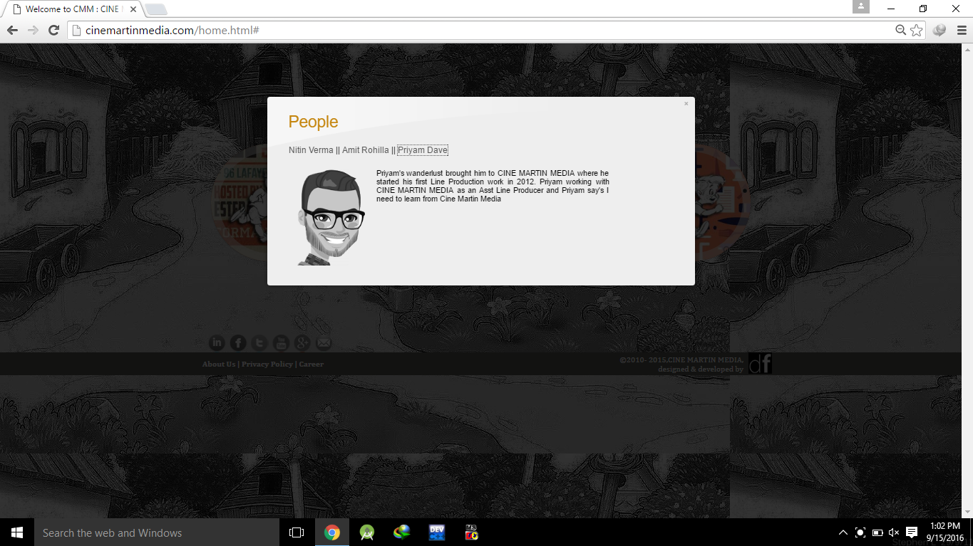

1. I worked as a **Production Assistant** in some projects of an Advertisement Agency namely, **Bijan Ads & Films.**
2. I was a part of **the Production Team** in **Bioscope Global Film Festival.**
3. I have played a key role in a **Documentary Film (Women Harassment)** prepared by the college students. Please find the link of the video here - <https://www.youtube.com/watch?v=q_bUKi0cJL8>
4. I have a few links to work as a team with Cameramen/Photographers, Editor/Graphics Designer, Actors/Supporting Actor and some companies to lease the shooting equipment.
5. I've been a part of the Dramatics team in National Bal Bhawan as a supporting actor or either managing the backstage.

Links Profile -

Please check the links for some of my works.

1. **Careers360 (news website) -** <https://news.careers360.com/author/7584752>
2. **Careers360 website -** <https://www.careers360.com/user/7584752>
3. <https://www.firstpost.com/author/priyam-dave>
4. **Entrance Corner** (medical domain) - <https://www.entrancecorner.com/medical/>
5. **Entrance Corner** (engineering domain) - <https://engg.entrancecorner.com/author/priyamdave04/>
6. **MotaChashma.com** (medical domain) - The links of my works are provided below:

* <https://www.motachashma.com/articles/neet-rank-letter.php>
* <https://www.motachashma.com/articles/neet-marks-vs-rank.php>
* <https://www.motachashma.com/articles/neet-marks-vs-rank.php>
* <https://www.motachashma.com/articles/neet-merit-list.php>
* <https://www.motachashma.com/articles/sainik-school-admission-age-limit.php>
* <https://www.motachashma.com/entranceexam/200358/icar-result->
* <https://www.motachashma.com/entranceexam/200835/neet-answer-key>
* <https://www.motachashma.com/entranceexam/200835/neet-answer-key>

1. **MotaChashma.com** (engineering domain) - Links of few works are mentioned below:

* <https://www.google.co.in/search?ei=0IV0W_b8NMTYvgSe5p_wAw&q=JEE+Main+paper+2+colleges&oq=JEE+Main+paper+2+colleges&gs_l=psy-ab.3..0l4j0i22i30k1l6.12406.13776.0.14490.8.6.0.2.2.0.204.570.0j2j1.3.0....0...1c.1.64.psy-ab..3.5.586....0.tdIfqcs9sSU>
* <https://www.motachashma.com/entranceexam/200486/jee-main-paper-2-result>
* <https://www.motachashma.com/entranceexam/200235/jee-main-result>
* <https://www.motachashma.com/entranceexam/200166/keam-result>
* <https://www.motachashma.com/articles/jee-advanced-analysis-by-resonance.php>
* <https://www.motachashma.com/articles/jee-advanced-answer-key-by-resonance.php>
* <https://www.motachashma.com/entranceexam/201105/jee-advanced-answer-key>
* <https://www.motachashma.com/entranceexam/200682/jee-main-answer-key>

1. **Education Vijay –** Please check the links of interviews below
2. <http://www.educationvijay.com/interviews.aspx>
3. <http://www.educationvijay.com/interview-byid.aspx?id=1014>
4. <http://www.educationvijay.com/interview-byid.aspx?id=1013>
5. <http://www.educationvijay.com/interview-byid.aspx?id=1009>
6. <http://www.educationvijay.com/interview-byid.aspx?id=1004>
7. <http://www.educationvijay.com/interview-byid.aspx?id=1008>

PERSONAL INFORMATION-

1. Date of Birth- October 4, 1994
2. Gender- Male
3. Hobbies- Playing Tabla, Singing, Dramatics.
4. Marital Status- Unmarried.
5. Language known- Gujarati, Hindi, English.
6. Nationality- Indian.
7. Strengths- Good Communication skills, Dedicated towards my work, hard worker, sincere.

DECLARATION-

I, hereby declare that above mentioned information is correct up to my knowledge and I bear the responsibility for the correctness of above mentioned particulars.

**DATE- PLACE-**

**Priyam Dave**

**8766382429**