**Name: Cristopher Ian Artacho  
  
Section: BSCS 3A  
  
Date for Activity: September 18, 2024**

**Guidelines:**  
Make an android app widget, just a simple widget apply what you learned from our previous discussion.

Application: A notes application that takes in user inputs for title and description. The application automatically takes note of the date the note was published and the character number dynamically responds to the user input in the content

Assets and Files: The images for the icons are stored in the assets/images in order to efficiency. The lib contains two files which are the “main.dart” which serves as the main screen or menu for the application and “input_seolection.dart” handles the adding notes and user inputs

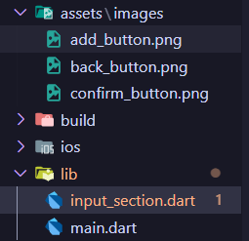

Code Explanation:

**main.dart**

1. **_addNote function:** The function serves to dynamically add information for a container whenever we add a note. These information consists of the title, content and the date we saved from the input_seolection.dart.

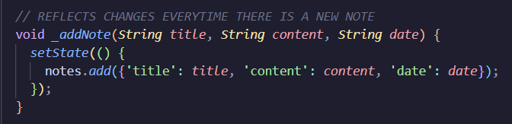

1. **Notes Container:** This part serves as the layout for displaying our notes.

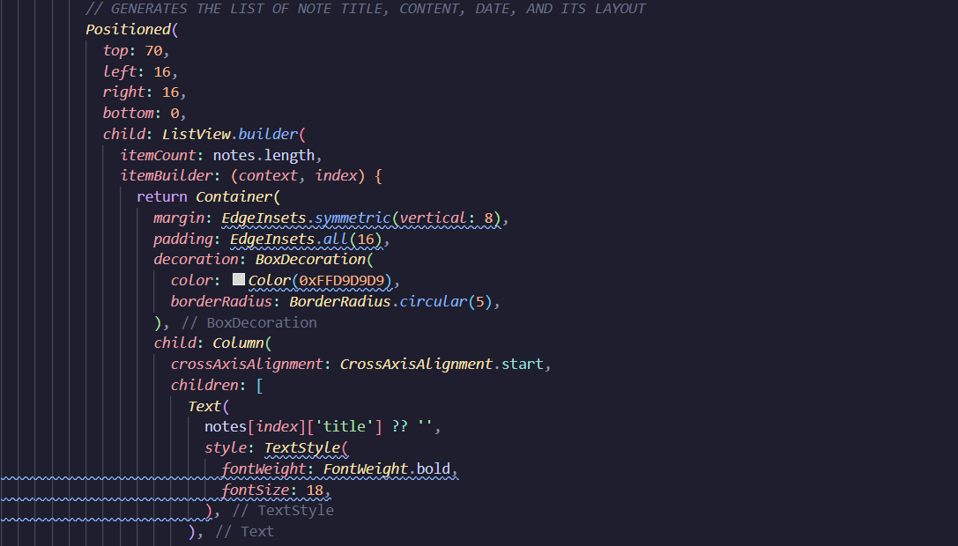

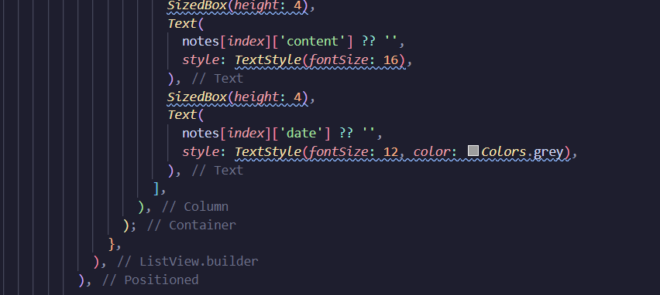

1. **Add button:** The add button is positioned in the bottom right of the screen and processes the information returned if they are valid to be saved in the screen to be displayed.

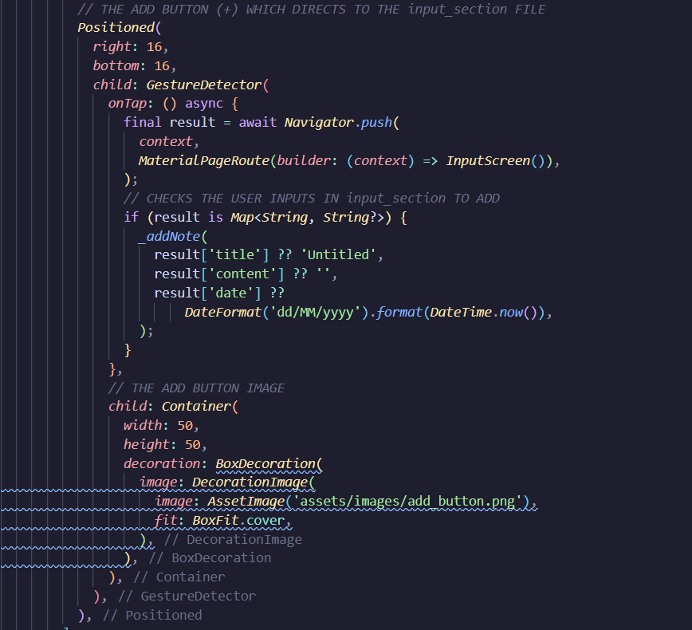

**input_section.dart**:

1. **_charCount:** This code snippet indicates the process of how the character count container dynamically changes for the character input in the content

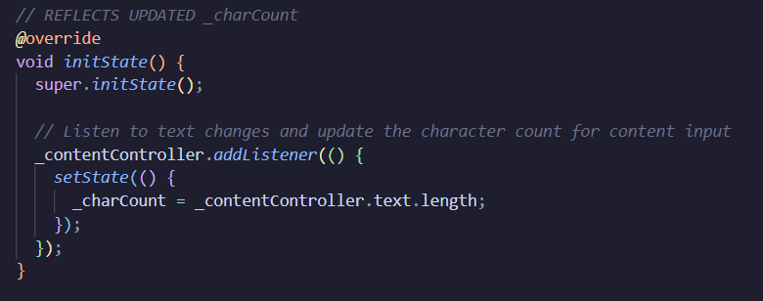

1. **Date feature:** This code line shows how the date is recorded automatically

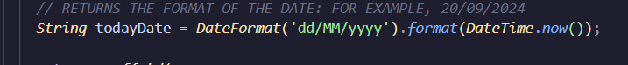

1. **Confirm Button:** The confirm button returns the title, content and date information once it is tapped

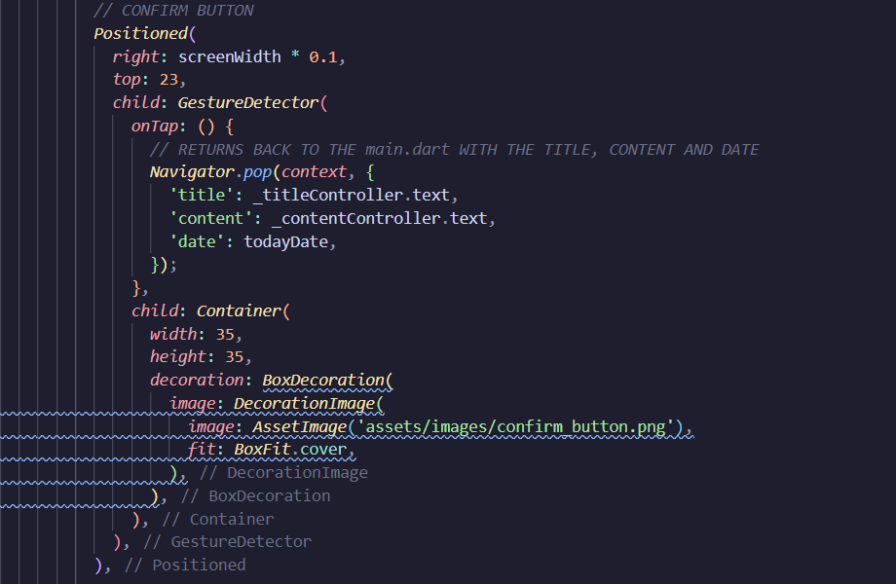

1. **Date:** This code snippet shows how the date is laid out and presented

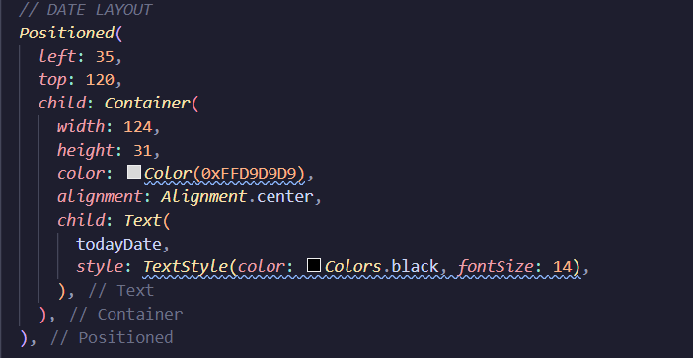

1. **Character Count:** This code snippet shows how the character count container is laid out along with the use of **_charCount**

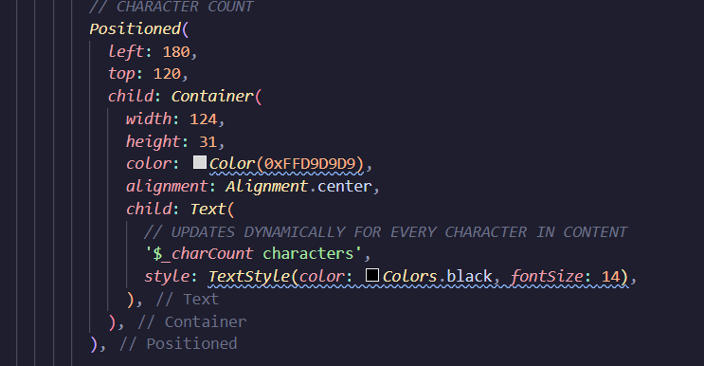

**Output:**

**Notes After Running Notes after Adding Content**

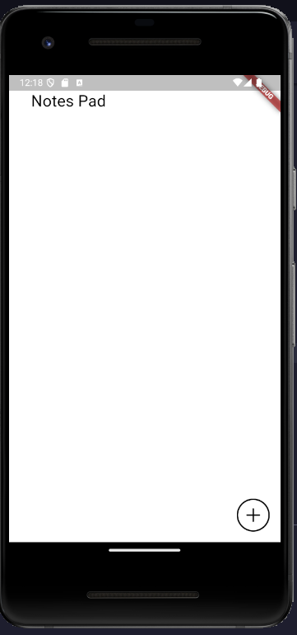

**Notes After Tapping Add**

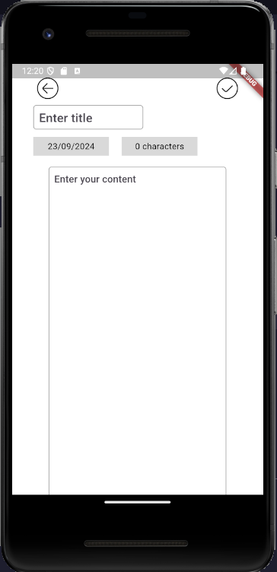

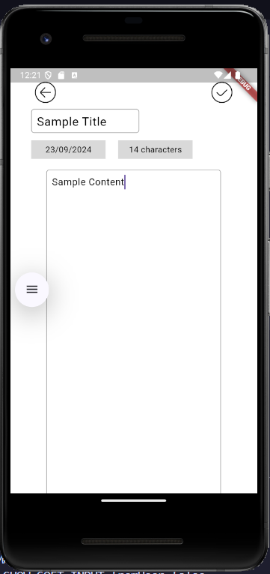

**Notes After Saving**

