**Name:** Dhominick John S. Billena  
  
**Section:** BSCS 3A  
  
**Date for Activity:** September 18, 2024

**Guidelines:**  
Make an android app widget, just a simple widget apply what you learned from our previous discussion.

**Application Purpose:**

To cycle an image by using an array function and the StatefulWidget as the counter function to show the assets that I made to the world for an app mascot named “Servi”.

**Loading Page for the Icon:**

I have utilized the AppBar widget and created a modified version that displays the icon and the AppName on the top utilizing the space using the MainAxisAlignment property discussed last meeting. There is also another neat feature that is baked into the AppBar by utilizing the fromseed.Color function that basically creates a Theme Pallate for the application that can be used to make the application compliant on other colors within the application based on the Material3 Standards. I am also planning on removing the debug icon on the top in the next screenshots by changing the debug properties of the AppBar widget.

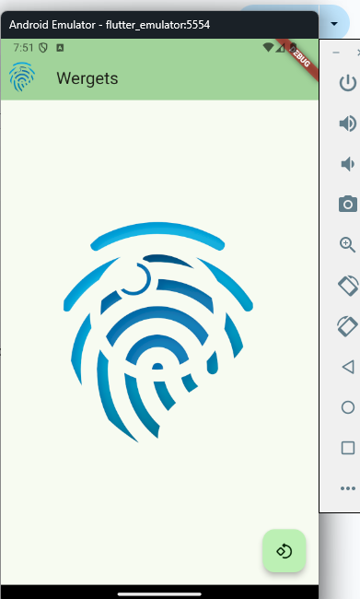

**Button Image Shifter Using Counters and Arrays on Different Classes to Display a Recurring Image (Stateful Widget)**

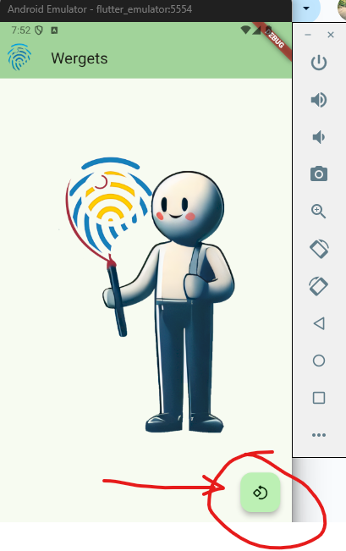

Using the FloatingActionButton widget to display a button to be able to cycle through the images, I have successfully been able to make the images rotate using the _counter method that and the rotation logic using modulo operator to ensure that it doesn’t go beyond what is the limit of the array. Further explanation of the logic is included on the comments of the source code.

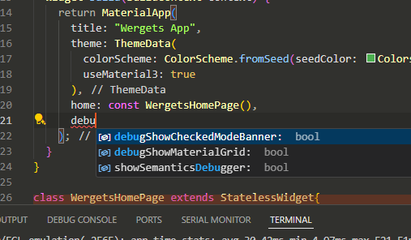**Removing the Debug Banner:**

Using this specific MaterialApp property, we can utilize the application to remove the debug banner / logo on the top of the application.

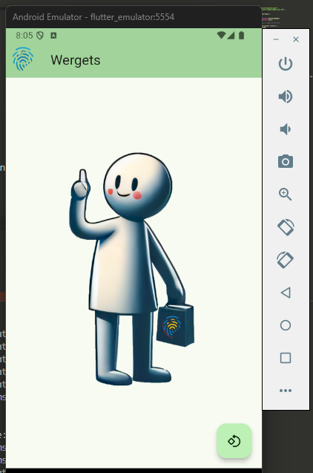

Thank you and have a nice day!