Name: Michael Rey Tuando  
  
Section: BSCS 3-A AI  
  
Date for Activity: September 19, 2024

Guidelines:  
Make an android app widget, just a simple widget apply what you learned from our previous discussion.

Put the screenshot of your widget code and output here, also upload the code to our repo.

Repo: <https://github.com/Pithovirus/Wergets.git>  
  
Attendance: <https://forms.gle/vx51RUTnv39WKuT59>

For this activity, I tried to create an app where when the user clicks the “Spin” button, a random number is generated. This is inspired by the classic ‘perya’ game we play called “roletas” when there is a town fiesta or anything that means FUN!

Here is a snippet of the app:

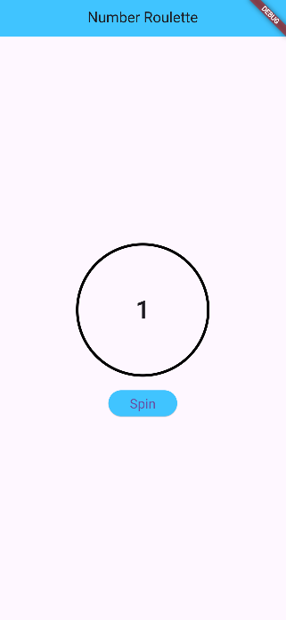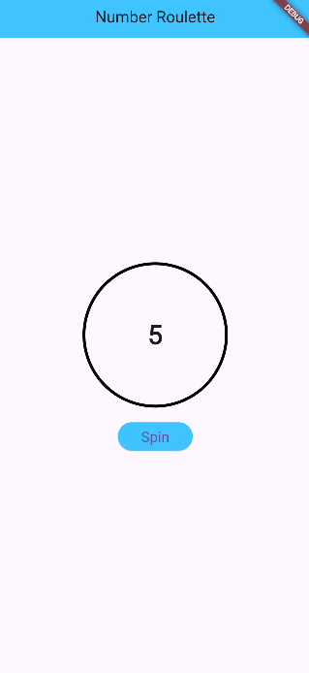

Here is the whole code for this application:

