Group assignment

Programme: | Bachelor of Engineering, Computer engineering
Subject: | ID101912 Object oriented programming
Assignment: | Assignment 5: Group project
Candidates: | Kristian Honningsvåg, Per Myren, Tor-Martin Holen
Date: | 24.04.2015

The assignment
The assignment is to create a music archive for a fictional radio station.
The solution is supposed to help with organizing the radio stations collection of audio medium. In order to do this, the solution must adhere to the given requirement specifications.

The finished product
See the project folder for the source code. Our solution has a graphical user interface, a command line interface (and a unfinished text based interface).The graphical user interface has a lot of functionality and feels very dynamic and responsive. You can search for something and you get the results as you type. We think that we learned a lot from this project, especially about developing applications and we got a good idea about how object oriented programming is in bigger projects.

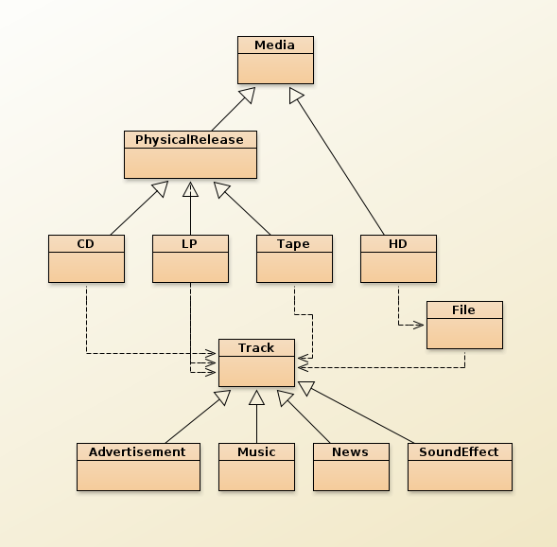
At the beginning of the project we created a class diagram to get a good idea of how the classes should work with each other, and this was great way to get a good idea to how the application should be made.

This class diagram is the one we created at the start of the project. If we had created another class diagram now at end of the project it would have contained a lot more classes than the what is reflected here. Classes for the different interfaces and other classes we found out that we needed.

