

What’s The Gist of the RC?
The Robotics Club is an organization that promotes experimentation with robotics and provides a forum for discussion and sharing of information and a community in which to participate and learn about the field of robotics.

Does the RC Fit My Schedule?
Meetings are conveniently held Wednesday evenings at 9:30 up in the UHC, 35th floor of the Cathedral of Learning.

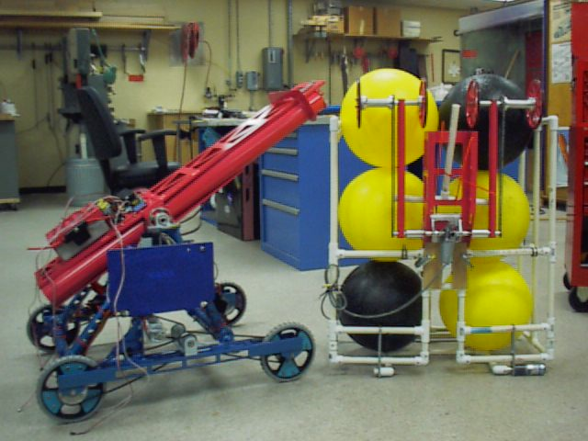
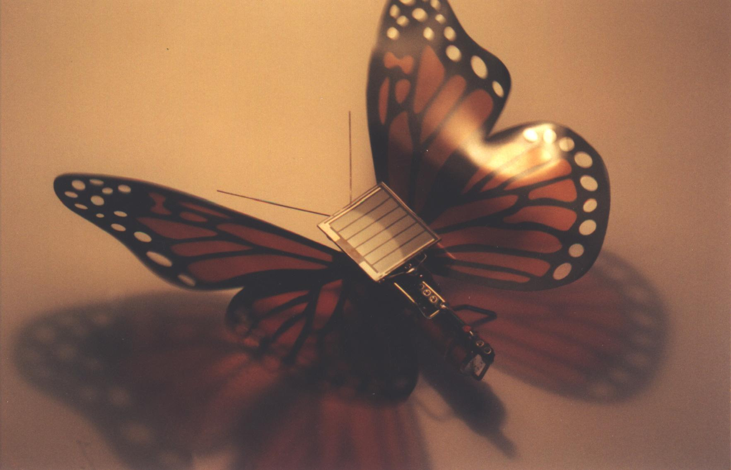

I like Its Goals and It Fits My Schedule, but Where Can I Get Some More Detailed Info?
Our excellent website is very helpful in getting you further acquainted with the RC. The address is www.pitt.edu/~robotics

I Like The Club, So How Do I Join?
You can become a member as easy as 1,10,11!
1. Open www.pitt.edu/~robotics on your favorite web browser
10. Click on the link to MEMBERSHIP
11. Fill out the short form, and you’re in!

Club Officers
President: Jeremy Romeiko jrr10@pitt.edu
Vice President: Derek Knight ddk2@pitt.edu
Treasurer: Mike Buric mpbst27@pitt.edu
Secretary: David Tyson datst38@pitt.edu







Robotics Club



