BEAM ROBOTICS:
BIOLOGY, ELECTRONICS, AESTHETICS, MECHANICS
FRESHMAN SUSTAINABILITY IN THE NEW MILLENNIUM CONFERENCE

Jeremy R. Romeiko

Abstract ⎯ Artificial Intelligence, as explored for the last thirty years, has been vastly limited by the practice of using finite manipulations of symbols to navigate the infinite facets of the a world. Through the use of analog systems capable of real-time interaction with, and perception of, an environment, rather than a digital interpretation, BEAM Robotics offers a solution to this age-old barrier. This new “Control Paradigm” allows for a highly complex robot behavior to be created from a very simple circuit, permits such a creature to be inexpensive, power efficient and easily mass-produced and even establishes a sort of self-sustainable survival ability and adaptability. The full range of applications will only take time to explore and evolve into such creatures with the level of refinement necessary for mass use in every-day life and in the exploration and scientific work thought today as merely fantastic.

Index Terms ⎯ BEAM, Biomorph, Nervous Network (Nv), Neural Network (Nu), Subsumption Architecture.

DREAMS IN DIGITAL
Many attempts at reaching a complient level of Artificial Intelligence, for the seemingly simple task of navigating the real-world, have failed misserably. The traditional method consists of a digitaly preset reconfiguration of sensor input symboligy. A virtual reconstruction of the robot’s environment within a Neural Network (Nu) which could be used for path mapping. Because of the limited symboligy of the neural path it is impossible for the network to constuct a complient path or even an accurate reconstruction of the emediate environment when conditions arrise which the system is not atuned to. Because of the impossibility of the world to be broken down into a finite symbology, these complications arrise quite often. Another major problem with Nu is the use of a singular processor for manipulation of all data which can be very slow, have high power consumption and can’t control all outputs independently with a real-time response.

One solution, as explored by Rodney Brooks, Director of the Massachusetts Institute of Technology (MIT) Artificial Intelligence Laboratory, is Subsumption Architecture. This is comprised of a “parallel and distributed computational formalism” which connects sensors to actuators via “layers of networks of augmented finite state machines.” To eliminate the dificulties of input symbolism and internal representations of the real-world It simply skips those traslatory steps and connects sensory perception directly to the subsystem action. The primary ideas behind this contriol architecture are as fallows.

- no traditional notion of planning
- no central representation of input
- parallel distributed computation
- multiple layerd, multiple behaviors, with simple conflict resolution
- direct implicit and explicit sensor input

It can now be seen how Subsumption Architecture may be utilised to defeat the delimas of, for example, a walking robot. Rather than representations of a world and a plan for future actions, a parallel and distributed system allows the inputs to be seperately and almost instantaniously percieved and acted appon among the indevidual legs, head and body (Fig.1). Each of these subsystems has it’s own behavior patters so that very little data need be comunicated among them for complient opperation. A leg will know when to step because of the orientation of the rest of the system though that system has little or no effect on the way in which it steps. Having multiple layers of behavior, walk, run, reverse, hide, attack, search,... gives a wide range of capability with minimal computational power and maximum efficiency. Conflicts among behaviors are settled among a prioratised schema; preventing damage to the robot holds precidence over a small gain towards mission completion. Sensor inputs are also, as mentiond before, not utilised in the traditional sense. Instead of any symbolic representation, an analog perception of the direct environment through implicit and explicit sensors, inputs and feedback from outputs, to directly alter the output of indevidual systems.
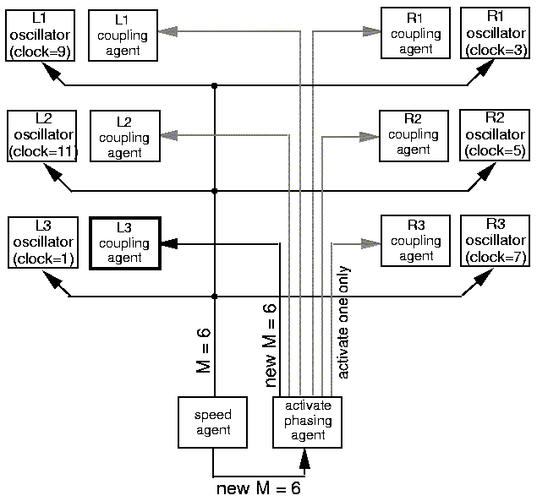

Figure. 1
Subsumption Architecture of a Six Legged, Eight Computer Walker.

Dr. Rodney Brooks proved the success of such systems through the creation of Attila, a six legged, eight computer walker with over sixty sensors. This six pound, 14 inch long robot is capable of persuing complex exploratory missions requiring it to climb meter high rocks and to walk speeds upwords of thirty feet per minute. It’s even capable of riting itself if tipped over and has a full 19 degrees of freedom (DOF). Attila’s abilities have amazed the most renound Nu faithful and have proven, overall, that “the world really is a rather good model for itself.”

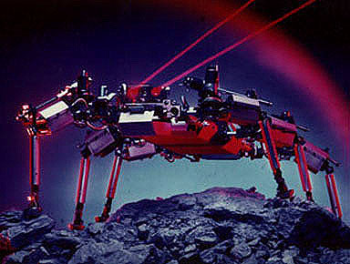

FIGURE. 2
Attila
BEAM ROBOTICS
Biological, Electronics, Aesthetics, Mechanical
There are a few inhearent flaws envolving the use of the subsumption architecture created for Attila. To begin with, sensitive components. Computers are sensitive to a multitude of conditions and stimulie including magnetic fields and electrostatic charges. They also require high amounts of energy, many components, ability limiting, digitaly based software and are very exspensive. The solution to this is a technology developed by Mark W. Tilden, a Robotics Physicist with the Biophysics Division of the Los Alamos National Laboratories , known as BEAM Robotics. BEAM is an acrenim for biology, electronics, aesthetics, mechanics signifieing a focus on the creation of systems which mimiche biology by mechanical ability, electronic structure, behavior and apearence. Mark W. Tilden’s primary ideals are:

- No programming.
- No computers.
- Simple, elegent ideas that biology uses and that, maybe, in engineering we can steel.

Conventional software-based control systems must fallow a singularly directional process of sensors to progam, program to mechanics. With which, as mentioned before, the filtering of the software, always to some degree, sevearly limits the acuracy and usefullness of sensory instruments. BEAM invokes a more rounded, analog system which allows not only sensor readings to directly alter outputs but also the environment to have a direct effect on the mechanics and other outputs. The two forms of control are illustrated in figure 3 below. This bidirectional approach gives the robot a sort of adaptability which for other systems has proved seemingly impossible. This creature-like ability is what has lead to this concept refered to as Biomorphic Design ( ).

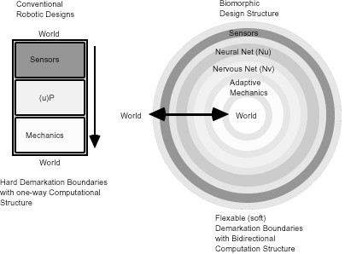

FIGURE. 3
Biomorphic Design Structure.

Among the world of robotics Research and Development (R&D) a shared belief is that sence evolution has been testing and refining the creations of biology for millions of years the life forms that allready exist among us serve as the best models for designing artificial creatures meant to live in this complex world. In facing this puzzeling challenge, just as with any other engineering issues, facets must be tackled one piece at a time. Therefore work has begun with lower level forms of life, such as insects.

In studying such forms of biology Mark W. Tilden realized that not only can the complexity of the creature be narrowed but the type of control system focussed on as well. In simpler insects he noticed that most actions are carried out not by a neural brain but by the nervous system. For example, if someone were to hold a match to your hand you would respond by pulling your hand away before you even knew what the problem was. Your response is a reflex triggered by the nervous structure of your spine. The heart of BEAM Robotics has come to be known as the Nervous Network (Nv).
In Mark W. Tilden’s words a Nv is “a real-time non-linear analog control system emulating a low level peripheral spinal system, based on the array of sequential RC (Resistor Capacitor)-time-based pulse delay circuits in closed loops. A Nv net is any circuit that can act as a media for sustaining independent control “processes.” The nerves can either be singular, leading into the primary circuit, or they can be assembled in loops of various fassions such as in figure 4 below. These singular nerves function as Pulse Delay Crcuits (PDC) which shape and delay a pulse traveling around a loop. If you were to, for instance, connect a motor across on of the nerves the motor would recieve power untill a charging cycle of its PDC was completed. The more power a motor draws during its opporation the slower a PDC will charge causing its cycle to legthen. Giving the creature this “selfsustainable” circuitry means that the more difficult a terain is to traverse the more power there will be going to a motor to traverse that terrain. This is precisely what gives BEAM Robots their adaptive abilities. Their walking gates are not fixed but are set to alter as needed for various types of environments

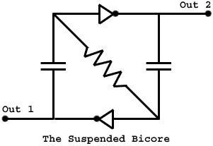

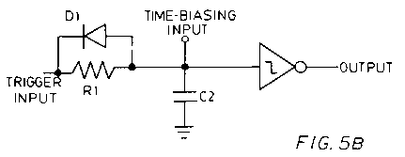

FIGURE. 4
Suspended Bicore and a Pulse Neutralizing Circuit

Most of Mark W. Tilden’s creations are modeled after specific creatures such as this BEAM version of an ant. Fire ants are said to have an equivalent of about 428 nerves throughout their entire anatomy. Again, with the intention of starting simple Mark W. Tilden has formed a Nv consisting of only 6 nerves. The circuit in Figure 5 is designed to use two apposing motors and two light sensors to search out a source of light. This creature can then be powered by a solar panel to give it full Phototropic abilities. This BEAMAnt searches for light and lives off of this light as it adapts to its environment, therefore it is a survival robot.

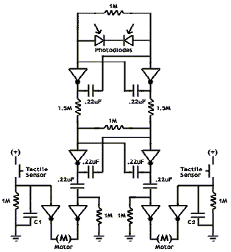
FIGURE. 5
BEAMANT Nervous Network

Hereare are a few of the charictoristics included in the BEAMAnt:

- Solar powered
- Single tank capacitor
- Unibody frame.
- 2 tactile, 2 visual sensors.
- Control Core
- Total: 8 transistors.
- Behavior:
- crawling convergence.
- powerful enviro. Adaptive abilities.
- strong, accurate phototaxis.
-gaits: stop, crawl
- backup/explore ability.

These feature allow the BEANAnt, pictured in figure 6 below, to crawl toward the light utilising the two motors in forward and reverse. When the creature approaches an obstical by using it’s light sensors it avoids the shadow of the object. It also can avoid absticals utilising the two touch sensors and traverse mildly rough terain using moroe feelback as mentioned earlier.
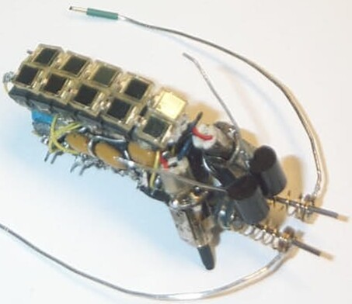

FIGURE. 6
JRR BEAMANT 1.2 (actual size)

There are many different ways to combine Nervous Network loops and many different types of loops. One way of combining these is much like what was done with Attila. Layers of behavior specific loops can be combined in a prioritised fassion. For walking robots walking and running gaits could be formed, when the terain will allow for the robot to run it will, but when them terain is rough the robot will walk cauciously forward. A very complex attempt at a walking creature is the Spyder. Spyder is a four legged, eight motored walking explorer. The spyder is capable of many walking gates and behaviors. Surprisingly, though, it has only a twenty four transistor circuit. Most robots of this exstensive form, such as attilla, have needed millions of transistor to run one or many computers. Spyder is build completely from off-the-shelf parts, and cost only $100.00 to build. Spyder is designed around a network that includes both Nv and an analog form of Nu. These layers are featured below.

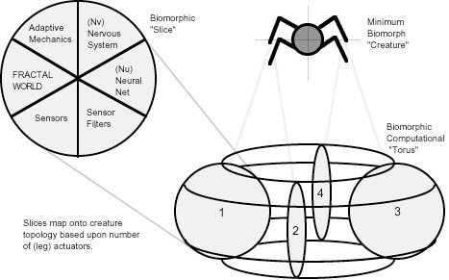

FIGURE. 7
Behavior Layer of a Four Legged Biomorphic Creature.

The spyder is also a very capable and survival able robot. Along with the phototropic features of the BEAMAnt it has an exstensive suspension system which allows it a very aracnid-like walking gait and aesthetic look as you can see in figure 8.

- Solar powered
- Single battery, 1.4Kg., Metal construction.
- Exoskeletal framework, 2.5 DOF per leg.
- Control Core (Experimental):
4 linked “microcore” Nv structure with
adaptive linkages, 4 trans Nu “head.”
- Total: 36 transistors.
- Emergent Behaviors:
-4 quasi-independent control structures
converge on a cooperative quadralaterally
symetric walking gait after only 10 steps.
- Leg independence allows for directed
action/responce despite distributed control.

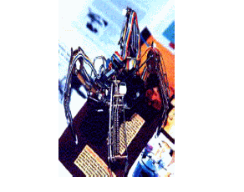

FIGURE. 8
VBUG 1.1 “SPYDER.”

SURVIVAL ROBOTICS

One of the most inspiring facts about BEAM Robotic is that so much has been accomplished in such little time. Over time Mark W. Tilden has been perfecting his design techniques and exploring the various facets of this technology to expand apon its possabilities. In this journey multitude of things have been learned and below a few of these are presented.

One of the most obvious questions you could ask is just big and complex and these systems be. These systems of loops have been combined in many ways. In the evolutionary scheme of things the BEAMAnt and Spyder are simple with somewhat limited abilities. In the figure below the process of evolution can be followed from the original form of spyder through to the final completed creature, Walkman.

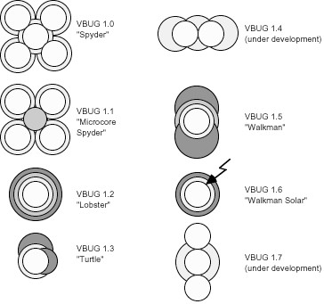
FIGURE. 9
The Evolution of BEAM Robotics

Walkman is by far the most succesfull of Mark W. Tilden’s creations. It’s even recognised as the most succesfull survival robot in the world. The amazing part is that it only cost $1.50 to construct. Walkman has the fallowing features:

- Solar powered.
- Single battery, 0.7Kg. metal/plastic
construction. Unibody frame.
- 5 tactile, 2 visual sensors.
- Control Core: 8 transistor Nv.
4 tran. Nu, 22 tran. motor.
- Total: 32 transistors.
- Behavior:
- High speed walking convergence.
- powerful enviro. Adaptive abilities.
- strong, accurate phototaxis.
- 3 gaits; stop, walk, dig.
- backup/explore ability.

Walkman is built from only twelve transistors. “Twelve transistors isn’t even enough to make a good radio let alone what you would think to make a resonable robot.”

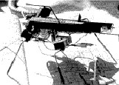

FIGURE. ??
VBUG 1.5 “Walkman ”

Over the next few years BEAM creatureswill continue to be explored. There is one slightly disapointing trate that has been descovered among this technology. The more complex a robot is, the less adaptable it becomes. This means that Mark W. Tilden must now find a way around this rule. He must find a break through in this evolution.

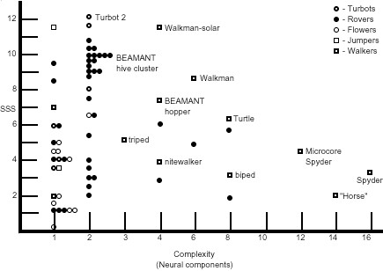

Figure. ??
Biomorphic Creature Complexity Vs. Complexity.

SUSTAINABILITY: FAST, CHEAP AND OUT OF CONTROL
-special
In just a few years systems and abilities have been developed in BEAM Robots which have not been succesfully reached with any digital computer system in the last thirty years. “Watching a million dollar autonomous robot bash itself to pieces against a desk adge is a frustrating experience for designers. No matter how much work went into the robot, it failed a basic preservation instinct obious to any layman.”[ ] The Nervous Network allows a “soft, complient and capable” creature architecture to be formed from the simplest and smallest amount of components, inturn, making them much cheaper to build and allowing a speedy production time. For single systems similar to that of SPYDER the cost has ranged anywhere from $100,000- $1,000,000. For this four legged, highly capable and adaptive robot with many walking gates and sensors the cost was only $100.00. This is closer to the price of a child’s Christmas present than a project requiring a research grant or corporate contract.

By beggining with “efficient lower bound architectures” such as insects Mark W. Tilden has begun from scratch, using every component to the highest of it’s ability, mirroring the progress of evolution working towards higher levels of intelegence and ability. Inded he has begun at the “premordial soup” of a fully complient and useful robot. With time these teshnologies have and will continue to develop into systems buisnesses, science, and the public demand of today.

Since the complex, digital systems build thus far not complient or adaptive in a creature sence and BEAM has not reached the level of control needed to carry out most complex missions, the best use of a BEAM Robot thus far is as a platform for more complex systems. By this it’s meant that alalog and digital systems should not be seen as two completely apposing styles of robotics but as two possible halfs of a fully controlable, complient and adaptive system capable of completing any mission under any condition.
Mark W. Tilden is presently looking into deploying a set of BEAM satalites which could “live” in the orbit of Earth with a small payload usefull for experimentation and astronomy. It’s been found that BEAM Nv architectures can suffer upto 80% total damage and still function in a usefull manor. This can be said of no other systems found today.

The Survival Features Mark W. Tilden has discovered in his work have lead to the creation of many systems usefull in todays technologically demanding world. BEAM Robotics will take Robotics from science fiction to historical fact.

- Hasslacher, Brosl, Tilden, Mark, W, “Living Machines”, 1994, Los Alamos National Laboratory.
- Tilden, Mark, W, “Mark Tildens Nervous Net Patent“, Patent, Ridout & Maybee.
- Tilden, Mark, W, “Biomorphic Robotics and Nervous Net Research: A New Machine Control Paradigm“, , EANN ’95 Conference Proceedings “Special Track on Robotics”. 1995. (http://people.ne.mediaone.net/bushbo/beam/Biomorphic.html)
- Brok, Wouter, “Suspended Bicore”
- http://www.space.com/missionlaunches/missions/moon_doggies_000918.html
- http://www.amsci.org/amsci/issuea/Sciobs98/sciobs98-03robots.html
- http:\\vsim.freeservers.com/amiller/layman.html
- http://people.ne.mediaone.net/bushbo/beam/advnnet.htmlBrooks,
- Brooks, Rodney,A, “Toward a Practice of Automation Systems: Proceedings of the First European Conference on Artificial Life,” Francisco J. Varela and Paul Bourgine, eds., MIT Press, Cambridge, MA, 1992, pp. 3-10. (Artificial Life and Real Robots)
- “Robotics and Automation Systems”, journal, Vol, No 6., pp. 3-15, 1990.
- “Journal of The Interplanetary Society”, Vol. No 42, PP 478-485, 1989.
- Ferrell, Cynthia, ”Global Behavior via Cooperative local Control”, MIT Artificial Intelligence Laboratory.
- Brooks, Rodney, A, “The Role of Learning in Autonomous Robots”, MIT Artificial Intelligence Laboratory.
- Brooks, Rodney, A,”A Robot that Walks; Emergent Behaviors from a Carefully Evolved Network”, IEEE Computer Society Press, Proceedings for the 1989 IEEE International Conference on Robotics and Automation, Vol. 2, 14-19 May 1989, P 692-694.

Jeremy R. Romeiko, University of Pittsburgh, Robotics Club, 466 Benedum Hall, Pittsburgh, PA 15261 robotics@pitt.edu

