Introduction
This year, the Robotics and Automation Society will be holding a competition that stresses the importance of autonomous programming. Practical robots must have the ability to make decisions and perform options without direct human intervention.
The purpose of the competition is to collect, autonomously, a series of objects scattered over a field. The objects will be empty toilet paper rolls stood on their ends. The robot will start in a box delimited by black tape and will be required to return each obstacle to the starting box. The field will not be walled in, but will be separated from the outside by black tape.
This document provides a specification of the robots, the game, and the rules of the game.
The competition will be held Tuesday, December 2, 2008 at 6:00 PM. The competition game field will be set up on the fourth floor of Benedum Hall. Work on the robots must end on November 31, 2008.
The Game Field
The game field will be 6 feet by 6 feet in size, and will be created directly on the tiled floor of Benedum Hall. The color of this floor is a mid-range cream color with a speckled design.
The game field will be delimited from the environment by black electrical tape. A single line of black electrical tape will form the four outside edges of the game board.
The starting box will be a 1 foot by 1 foot box, located at the bottom right-hand corner of the game field. Just as the edges of the game field are delimited, the starting box will be delimited by a single line of black electrical tape.
The starting box will double in function as the goal box.
A mock-up of the game field is shown on the next page:
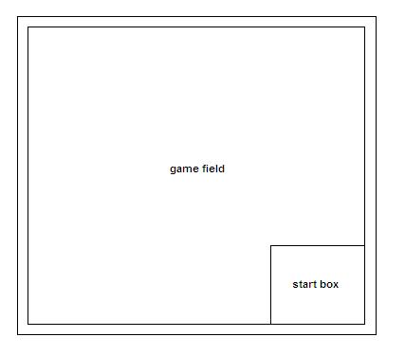
Figure 1: Competition Game Field
Game Goals
The goal of the game will be to autonomously traverse the game field, collect targets (the empty toilet paper rolls), and return them to the start / goal box. An auxiliary goal of the game will be to accomplish this task in the fastest time possible.
The players will be given an initial map of the locations of all but one target. The known targets will be known as “map targets.” One unknown target, the “mystery target,” will be placed in a random location on the game field at the beginning of each round of the competition. Please see section Game Point System for more information on the point value of targets.
Note: The detailed diagram displaying the locations of the “map” targets will be given 3 weeks before the competition date.
The winner of the competition will be the robot that gains the most number of points. If two robots receive the same point value, the robot that collected its points in the quickest amount of time will win.
This game will test the ability of robotics designers not only to design hardware that can efficiently and accurately manipulate objects and collect data about the environment, but also design software that will efficiently and quickly interpret measured environment data.

Basic Game Rules:
- There will be a total of ten targets on the game field. Nine of the targets will be considered “Map Targets,” in that their locations will be known to the competitors before competition time. The tenth target will be the “Mystery Target” whose location will be determined randomly at the beginning of each competition round. The “Mystery Target” will be given a heavily-inflated point value.
- The targets will be empty toilet paper rolls, stood on end.
- The robot must leave the start box, collect each target from the game field, and return it to the starting box.
- A target will be considered “collected” if more than 50% of it is deposited inside the start box.
- Once a target is considered “collected,” it will be removed from the game field, as to prevent it from causing problems in further robot function.
- The robot cannot be manipulating more than 2 targets at once. If the robot begins manipulating more than 2 targets, the game will pause and one of the targets in question will be returned to its original location.
- A robot can leave the game field twice without penalty. Leaving the game field is defined as having 50% or more of the robot across the outer edge of the boundary electrical tape. If the robot leaves the game field for a third time, its round will end and its score at the point of leaving the game field will be considered its final score.
- If the robot leaves the game field and remains “outside” of the game field (see description above) for more than 1 minute, the robot’s round will end. Its current score at the time of 1 minute elapsing will be counted as the robot’s final score.
- If a robot goes a period of five minutes without encountering a target, the robot will be considered “lost” and its round will end. Its score at the point five minutes has elapsed will be considered its final score.
Game Point System:
- Map Targets will be given 1 point each.
- The mystery target will be given 20 points.
- The case of two robots receiving the same point value, the fastest run time will win.

Robot Specifications
- The robot must have an easily-visible LED indicating when the robot is on and has power. The LED must be lit when either the microcontroller or the motors have active power.
- The robot must have a hard on/off switch capable of cutting power to both its microcontroller and its drive system. If the game must pause (when a robot manipulates more than 2 targets simultaneously), the on/off switch will be used to temporarily turn the competing robot off while one of the targets is returned to its original position.
- The robot must be able to fit into a cube of dimensions 1 foot by 1 foot by 1 foot.
- The robot will be permitted to expand out of the 1 foot by 1 foot by 1 foot cube during game play.
- The robot must travel outside of the starting box in order for any target captures to count.

