**Fall 2024 Robot Arms Progress Update:**

**Recruitment:**

(Going to leave out people’s names just in case that’s relevant, our main members all are in different years of study so that’s convenient to refer to them that way)

Excluding myself, we have one member (a second year) continuing with the project from the spring 2024 semester, the other 3-4 active members from that semester all decided they were too busy and wanted to spend their time on other things.

But we got 2 new active members this semester! A first year with solid prior experience and a fourth year with little prior experience but who is very eager to learn.

These 3 members (2 new 1 returning) have shown up consistently all semester and are making progress on assigned work as well as just generally building their skills so they can do more complex tasks in the future.

**Tasks/Projects:**

I assigned the task of removing and replacing the gripper mechanism of the linear-base robot arm to the first year. The old gripper didn’t function properly and relied on a poorly designed pulley that often got unwound or messed up for other reasons. We had an existing metal gripper assembly in our supplies, but it didn’t fit at all with our current arm setup and needed to be heavily adapted. The first year designed a way to adapt and mount this existing gripper assembly with the existing arm frame in a way that is much more solid and robust than the previous gripper! The member designed two parts in CAD and went through two-three iterations to get them working smoothly. One part was to mount the motor that would actuate the gripper and the other part was to attach the gripper to the arm itself.

Since the first year member finished this task he has been interested in developing a bio-mimetic hand, an idea that I proposed at one of our RAS GBM’s. I believe he is still in the ideating-early design phase of this project but I’m excited to see where it goes, and since it is a very hefty task/project it would also be a good place to assign any new members we acquire next semester or to have the current members work together more on, and not have this first year just do it himself.

Our returning member took on the difficult task of making a generalized inverse kinematics solver that could give us great control over all 3 of our current arms, and be easily applied to solve the IK for any future arms or just any arm like system in general. By around 2/3’s of the way through the semester the member says that he finished this software and started testing it on our Hebi arm, but ran into some bugs when trying to transition from simulation to physical robots. He then got pretty swamped with work for the rest of the semester and hasn’t finished fixing those bugs yet, but I’m sure he will do a great job with it next semester!

The new fourth year member had little experience coming in so spent a lot of time to start out with just messing around with Arduino and the little mini-arm we have to get acquainted with the technology. He then spent some time working on computer vision software in the lead up to the robotics discovery day, but I ended up picking up that work myself just to make sure it could be finished in time. At the last two meetings this semester the fourth year started working on a new task I proposed: developing a modular rotational end piece for the Hebi arm. The Hebi arm is great, but we’ve never put a gripper or other end effector on it, and it also only has four axes. A fifth rotational axis on the end would be very useful for many tasks like tightening screw drivers or opening door knobs. This members task is to design a fifth axis for the robot, that also comes with an easy way to attach any possible end effector to it. This way we could attach a gripper, a tool like a screwdriver or drillbit, or potentially even the bio-mimetic hand that is being developed! This member will likely need help on this task so I plan to either help him myself or assign the second year returning member to work on it with him, as he is a mechE and also mentioned being interested in doing some more hardware/mechanical work in addition to his current heavily math/software based task of IK solver.

As for me, I was very busy this semester and spent most of our in-meeting time teaching/helping the other members, so I didn’t get as much done as I would have liked in terms or technical progress on projects. But I got 3 members showing up consistently and being committed to the project which is a big win, I got all the parts in for the new arm we will build (I consider the new arm is that biggest capstone task of the robot arms team currently), and I also developed the CV Hand-Tracking demo on the linear-base arm which was a hit at the robotics discovery day. To elaborate on that last point, I developed a program that uses a webcam and allows you to control our linear-base robot arm with your hand, moving hand up-down and left-right respectively, and opening and closing your hand opens and closes the robot’s gripper. This software could also be extended to track the forearm as well to give more direct control of the gripper position and angle..

**Plans for next semester:**

I look forward to next semester being a semester of great progress for the robot arms project! Some big things to look out for for next semester include: biomimetic hand prototypes, a V1 of our new 6-axis arm design, and the Hebi arm finally being put to good use with a modular rotational fifth axis!

**Wrap-up:**

Although our progress this semester might not sound like much, it’s hard to get busy engineers to take time away from studying and friends and commit to a project and we did a great job of having that commitment. This semester we have also made this most progress we have any semester since I became the project lead so overall I take this semester as a big win for robot arms, and hope for next semester to be an even bigger win!

**Some media:**

Our members busy at work:

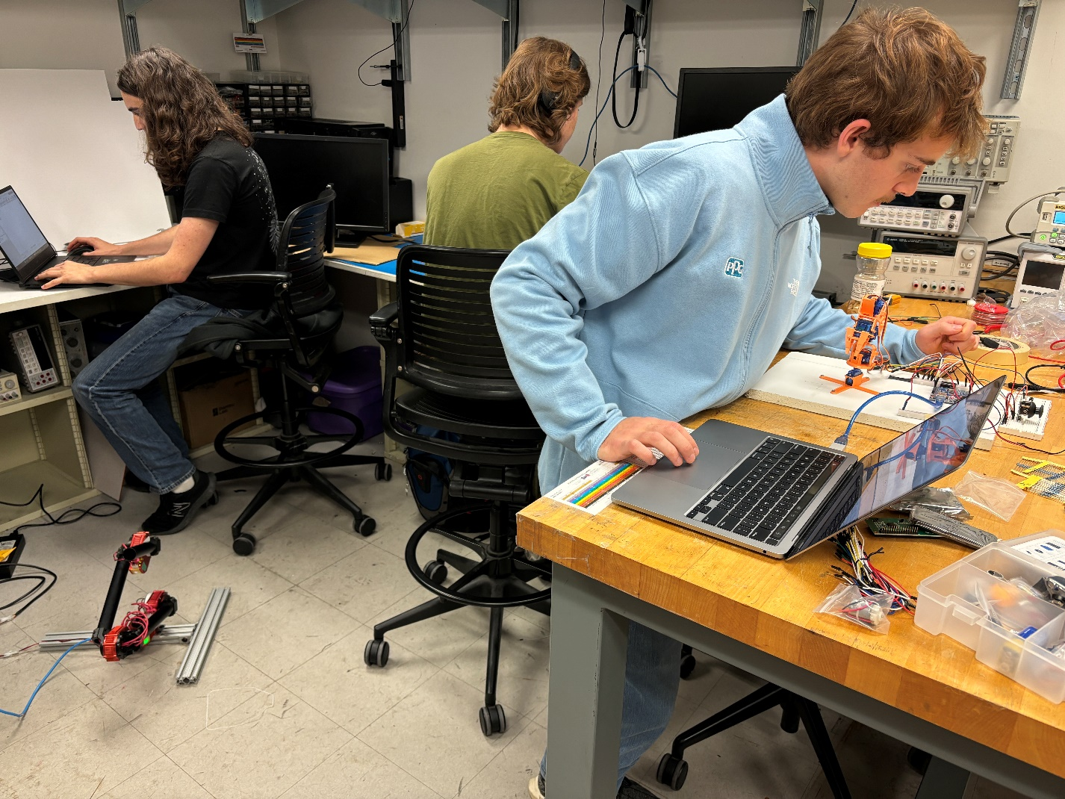

Hand tracking software closeup:

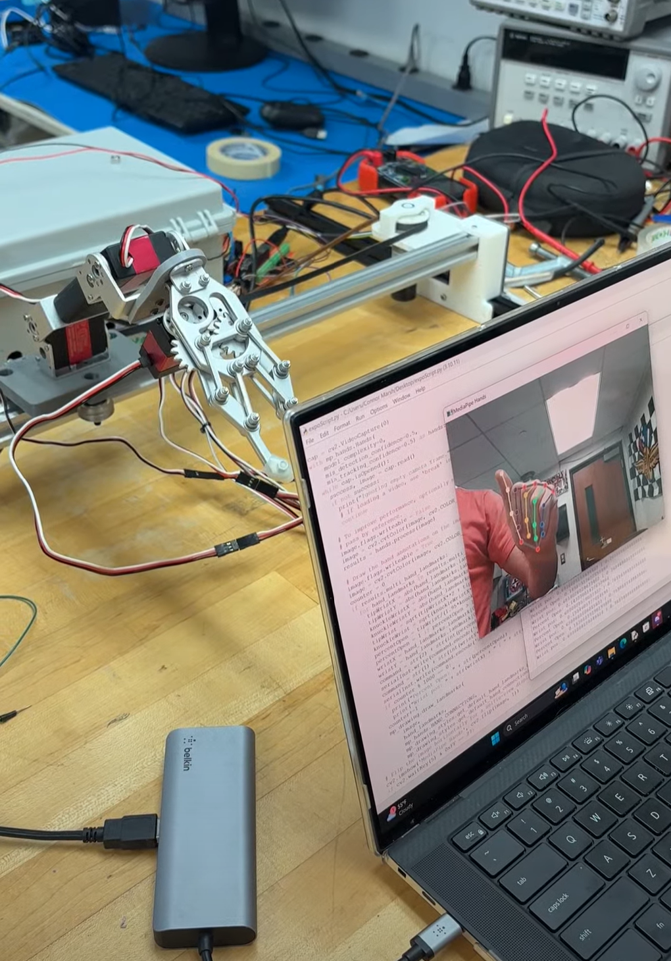

Kid enjoying our demo at the discovery day:

