LAIV-vs-TIV FRED simulations
Jay DePasse
12/18/2014

Read in data sets
job_key <- data.table(
read.csv("~/wrk/job_key.7.csv", stringsAsFactors=FALSE))
overall_clinical_attack_rate <- data.table(
read.csv("~/wrk/overall_clinical_attack_rate.7.csv", stringsAsFactors=FALSE))
vaccinf_day <- data.table(
read.csv("~/wrk/vaccinf_day.7.csv", stringsAsFactors=FALSE))
vaccinf_month <- data.table(
read.csv("~/wrk/vaccinf_month.7.csv", stringsAsFactors=FALSE))
AlleghenyCountyDemographics <- read.csv("~/wrk/AlleghenyCountyDemographics.csv",
stringsAsFactors=FALSE)
Set indexes for data.table, modify column names
setkey(job_key,job_id)
setkey(vaccinf_day,job_id)
setkey(vaccinf_month,job_id)
setkey(overall_clinical_attack_rate,job_id)
attack_rate = merge(job_key, overall_clinical_attack_rate)
setnames(attack_rate,'X0','ARs')

Overall Attack Rate Plots
Both of these plots show the effect of the R0 input parameter on the overall symptomatic attack rate for all ages

Symptomatic Attack Rate - Boxplot
ggplot(attack_rate, aes(R0,ARs)) +
geom_boxplot(aes(x=as.factor(R0), fill=vaccination)) +
facet_grid(primary_cases_timing ~ vaccination) +
theme_bw() + theme(legend.position='bottom') +
labs(list(title='Symptomatic Attack Rate as Function of Input R0 (All Age Groups)',
x='R0 (In Absence of Interventions)', y='Symptomatic Attack Rate'))
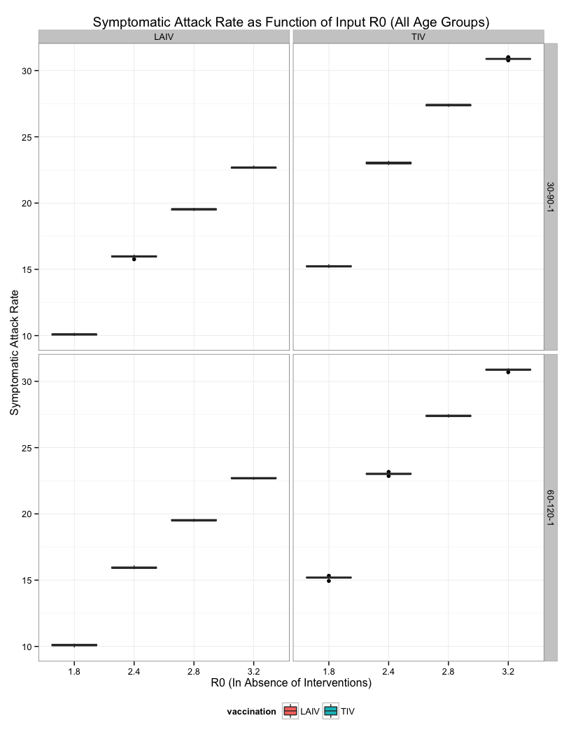

Symptomatic Attack Rate - Density/Contour Map
ggplot(attack_rate, aes(R0,ARs)) +
stat_density2d(geom="tile", aes(fill = ..density..), contour = FALSE) +
geom_density2d() +
facet_grid(primary_cases_timing ~ vaccination) +
theme_bw() + theme(legend.position='bottom') +
labs(list(title='Symptomatic Attack Rate as Function of Input R0 (All Age Groups)',
x='R0 (In Absence of Interventions)', y='Symptomatic Attack Rate'))
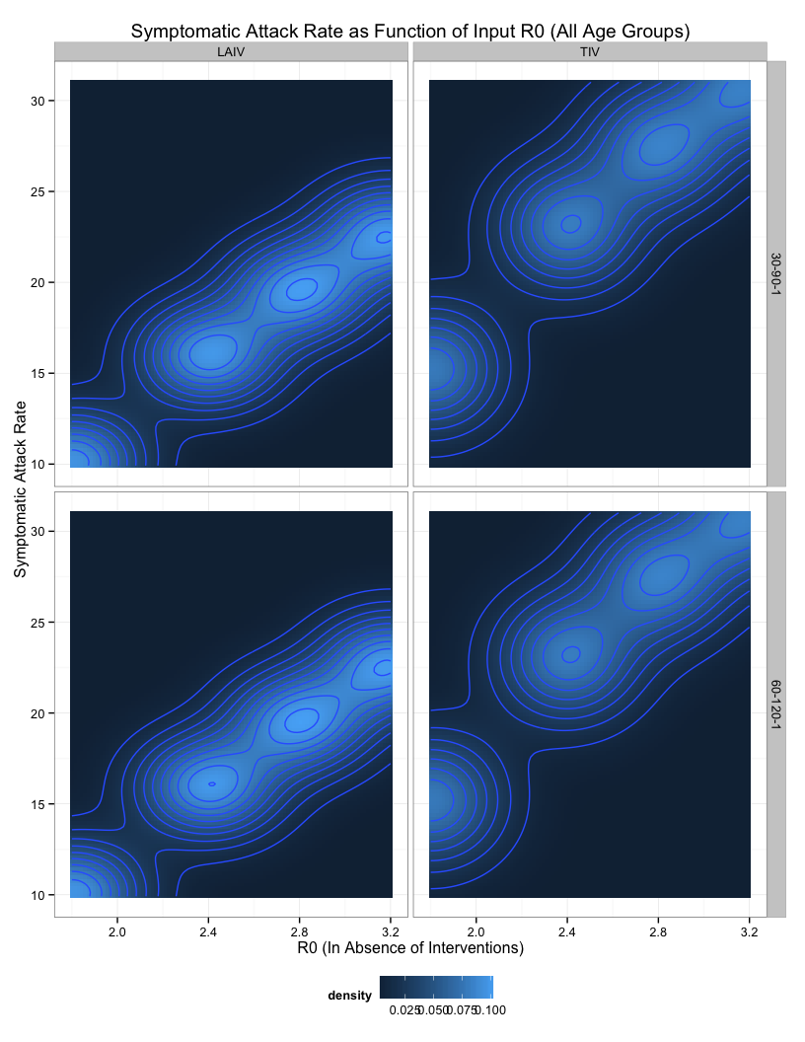

Results for 2-8 yrs. only

Melt the data tables into long format with the vaccinated/not_vaccinated condition as the measure variable.
df_month = melt(merge(job_key, vaccinf_month),
measure.vars=c('vaccinated','not_vaccinated'))
df_day = melt(merge(job_key, vaccinf_day),
measure.vars=c('vaccinated','not_vaccinated'))
target_pop_count = sum(
AlleghenyCountyDemographics[
AlleghenyCountyDemographics$age %in% 2:8, 'count'])

Output Data Tables for Overall and Monthly Case Reports
Two data tables showing the clinical case (symtomatic infections) counts and rates for 2-8 year olds. Both monthly and overall summaries are provided.
Values are aggregated over multiple stochastic simulations (three different initial values of the psuedo-random number generator), as well as over the day-of-week nuisance parameter.
These datatables are used to generate the plots in the next section as well.

Overall vaccinated and unvaccinated clinical attack rates and case counts for 2-8 year olds
overall_report = df_day[
,list(value=mean(value)), by=list(R0, vaccination, day, variable)][
,list(
clinical_attack_rate=100*sum(value)/target_pop_count,
clinical_cases=sum(value)),
by=list(R0,vaccination,variable)]
write.table(overall_report, file='fred.7.overall.report.csv',
row.names=F, sep=',')

Monthly vaccinated and unvaccinated clinical attack rate and case counts for 2-8 year olds
monthly_report = df_month[
,list(
monthly_clinical_attack_rate=100*mean(value)/target_pop_count,
monthly_clinical_cases=mean(value)),
by=list(R0, vaccination, month, primary_cases_timing, variable)]
write.table(monthly_report, file='fred.7.monthly.report.csv',
row.names=F, sep=',')

Plots for Overall and Monthly Case Reports
Vertical facets by vaccine type, horizontal by the R0 (1.8, 2.4, 2.8, 3.2) and the primary_cases_timing (30-90-1, 60-120-1)

Line Plots: Daily Symptomatic Attack Rate for ages 2-8
Line plots of individual epidemic trajectories, colored by the vaccinated/not_vaccinated measure variable.
Note that the distribution of epidemic peak day is bimodal, but individual epidemic curves are not 'camel-backed'.
ggplot(df_day, aes(day,value,target_pop_count=target_pop_count)) +
geom_line(aes(
y=100*value/target_pop_count, group=interaction(variable, job_id),
color=variable), alpha=0.5) +
facet_grid(R0 + primary_cases_timing ~ vaccination) +
theme_bw() + theme(legend.position="bottom") +
labs(list(title='Daily Symptomatic Attack Rate for Ages 2-8',
x='Day', y='Daily Symptomatic Attack Rate'))
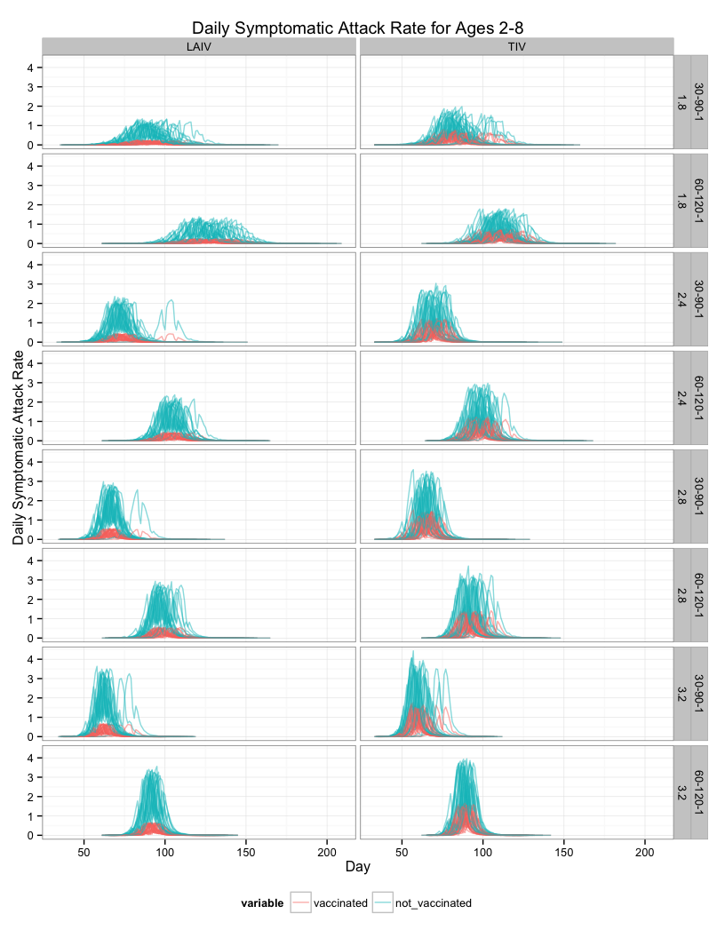

Summary Ribbon Plot: Average Daily Number of Symptomatic Cases for ages 2-8
The mean of the stochastic realizations and the weekday cycle is plotted, surrounded by an envelope +/- the standard error
Note that care must be taken to interpret the mean trajectory, as it is not the case that the typical epidemic curve will have two peaks.
ggplot(df_day, aes(day,value,target_pop_count=target_pop_count)) +
stat_summary(geom='ribbon', fun.data='mean_se', aes(
group=variable, color=variable, fill=variable), alpha=0.75) +
facet_grid(R0 + primary_cases_timing ~ vaccination) +
theme_bw() + theme(legend.position="bottom") +
labs(list(title='Daily Symptomatic Cases for Ages 2-8',
x='Day', y='Daily Symptomatic Cases (Mean +/- Standard Error)'))
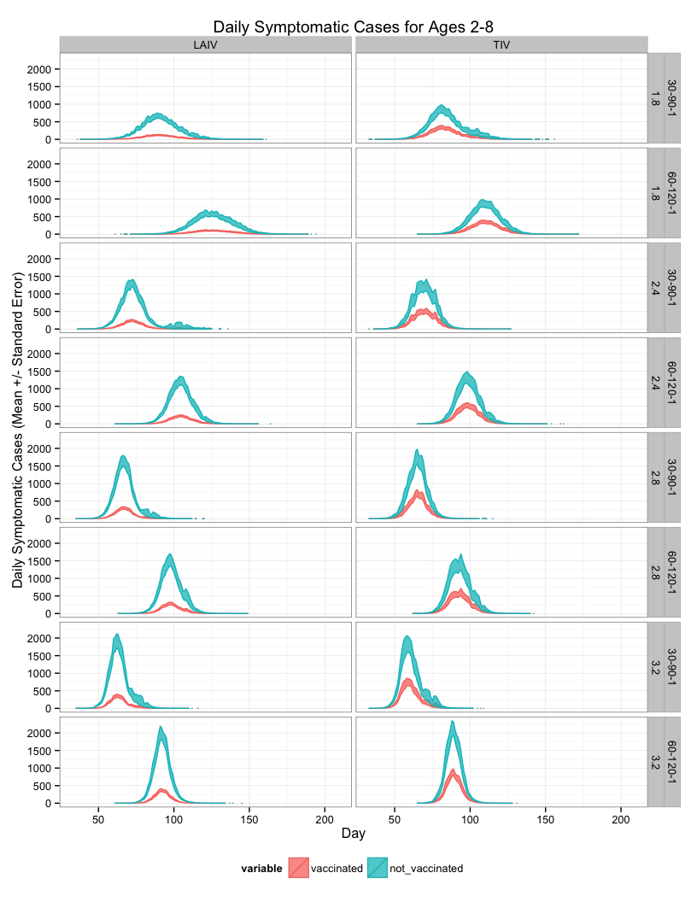
Slight variation on the above plot (facetting order is swapped)
ggplot(df_day, aes(day,value,target_pop_count=target_pop_count)) +
stat_summary(geom='ribbon', fun.data='mean_se', aes(
y=100*value/target_pop_count,
group=variable,
color=variable),
alpha=0.8) +
facet_grid(vaccination + primary_cases_timing ~ R0) +
theme(legend.position="bottom") +
labs(list(title='Daily Symptomatic Attack Rate for Ages 2-8',
x='Day', y='Daily Symptomatic Attack Rate'))
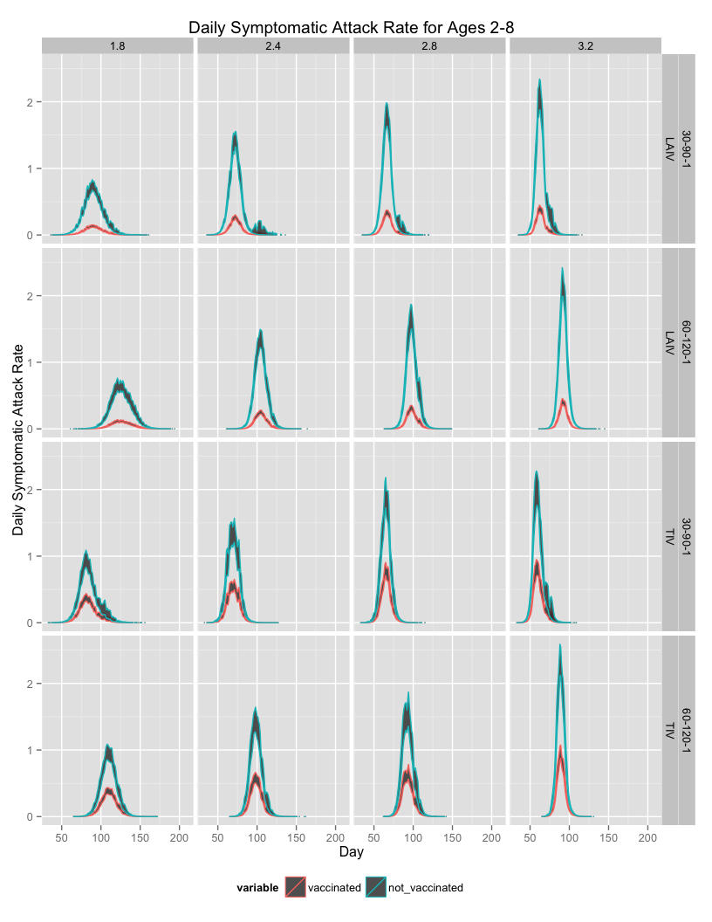
Another variantion where the curve shown is the mean.
ggplot(df_day, aes(day,value,target_pop_count=target_pop_count)) +
stat_summary(geom='line', fun.y='mean', aes(
y=100*value/target_pop_count,
group=interaction(primary_cases_timing,variable),
color=variable,
linetype=primary_cases_timing),
alpha=0.8, size=1.5) +
facet_grid(vaccination ~ R0) +
theme(legend.position="bottom") +
labs(list(title='Daily Symptomatic Attack Rate for Ages 2-8',
x='Day', y='Daily Symptomatic Attack Rate'))
