JENKINS

It is a continuous integration tool widely used by software project. Advantages of Jenkins :

* 1. **We can schedule the time for automation framework suite execution.**
  2. **Automatic kick off of automation suite execution as soon as the build gets deployed from DEV environment to QA environment.**

How to download jenkins URL :

<https://jenkins.io/download/> click on the link highlighted below.

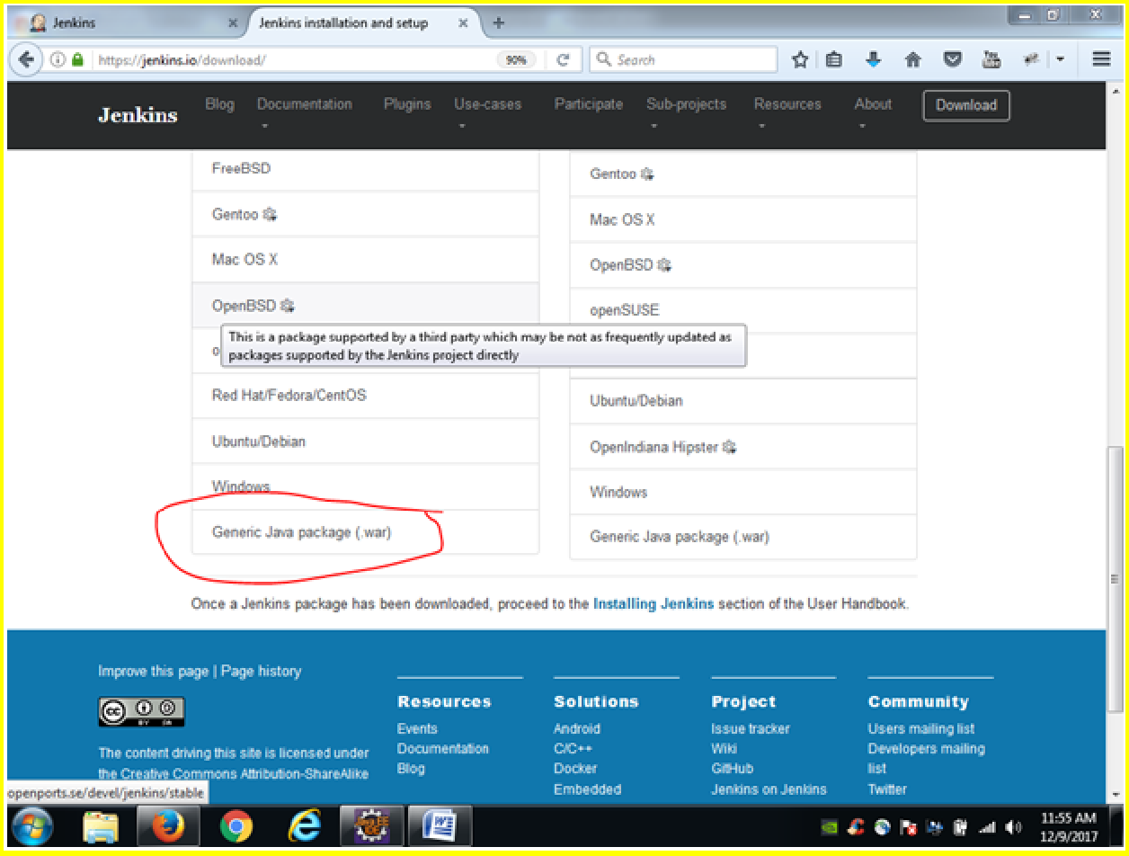

How to start the Jenkins server from Command promt ? Navigate to the below localton where ur jenkins.war is placed.

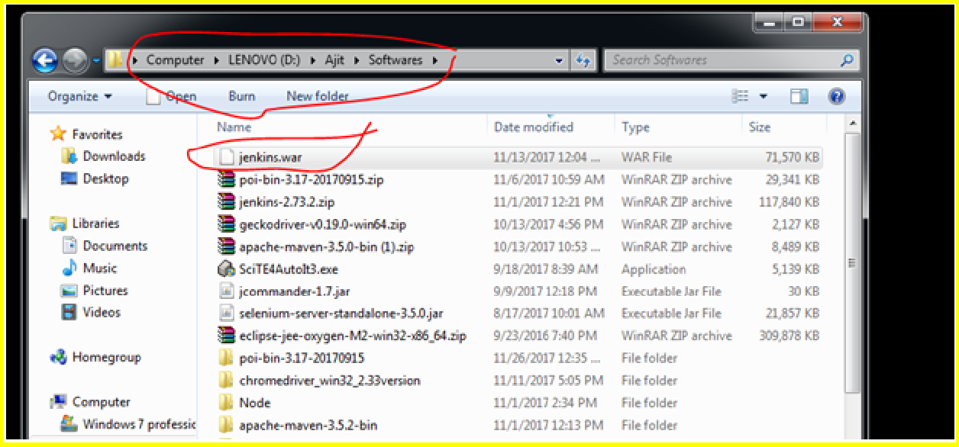

Open the command promt And type the below command

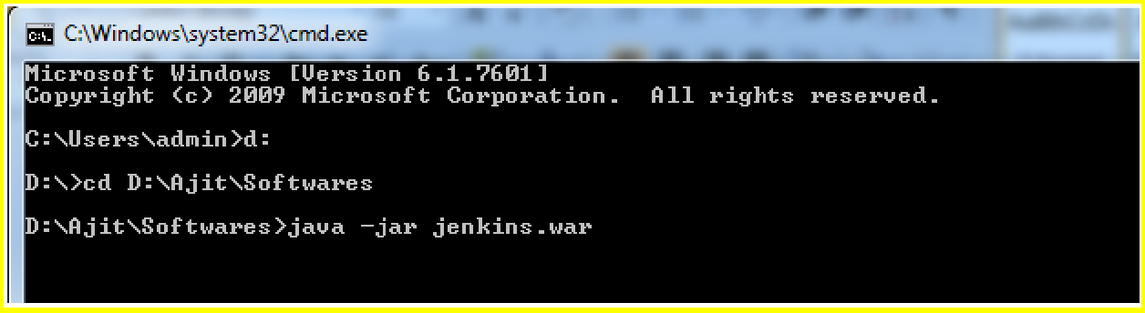

It will say – Jenkins Is up and running Now open the jenins dashboard.

Login to Jenkins using the below username and password Username : admin

Password is below;

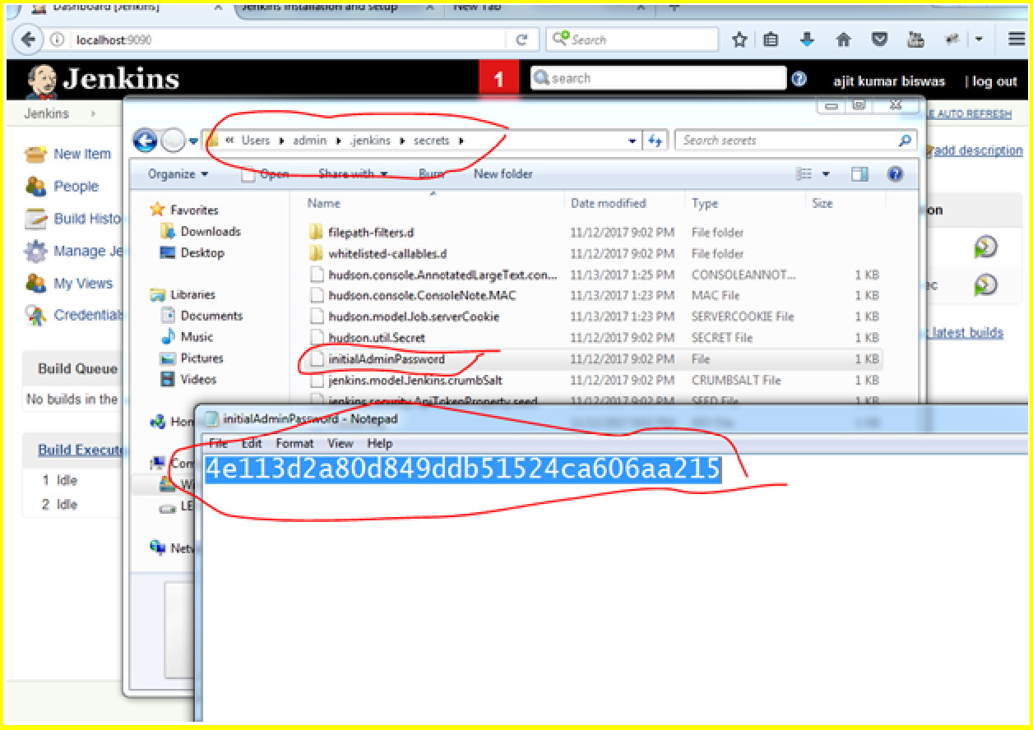

Jenkins dashboard page.

Click on Manage Jenkins and global tool configuration

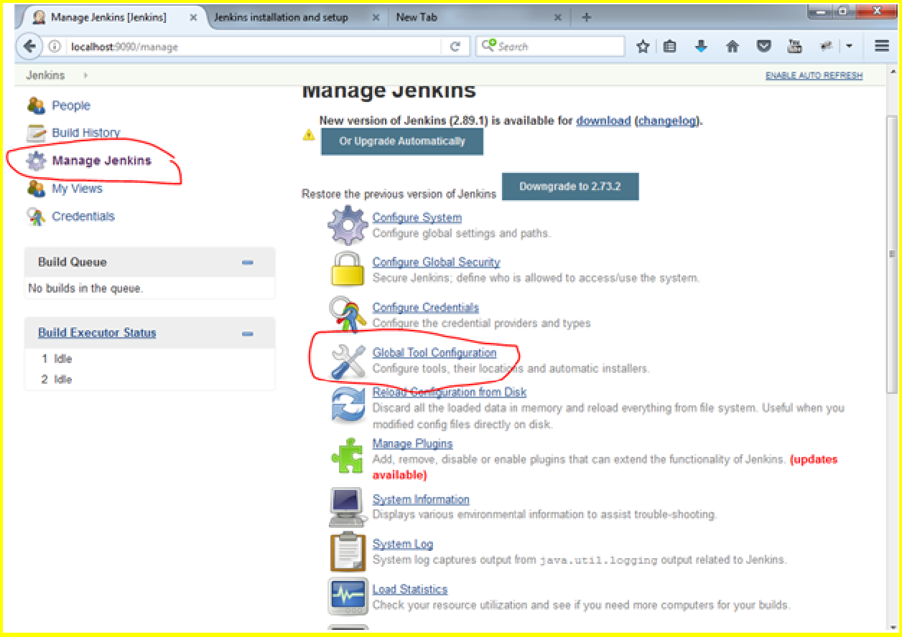

Add JDK to jenkins

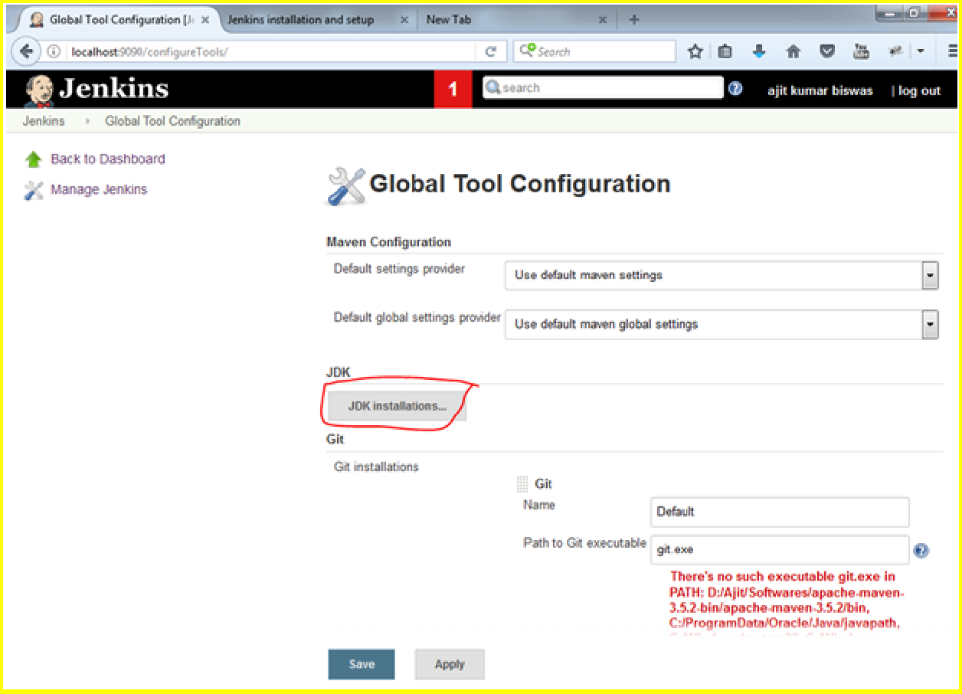

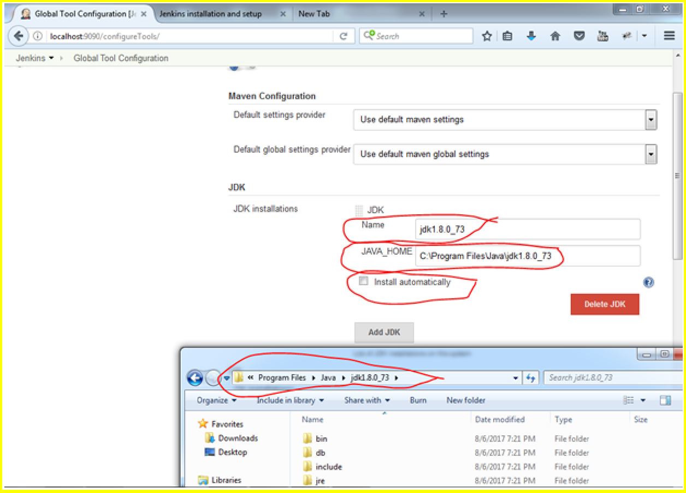

Add Maven Path as shown below.

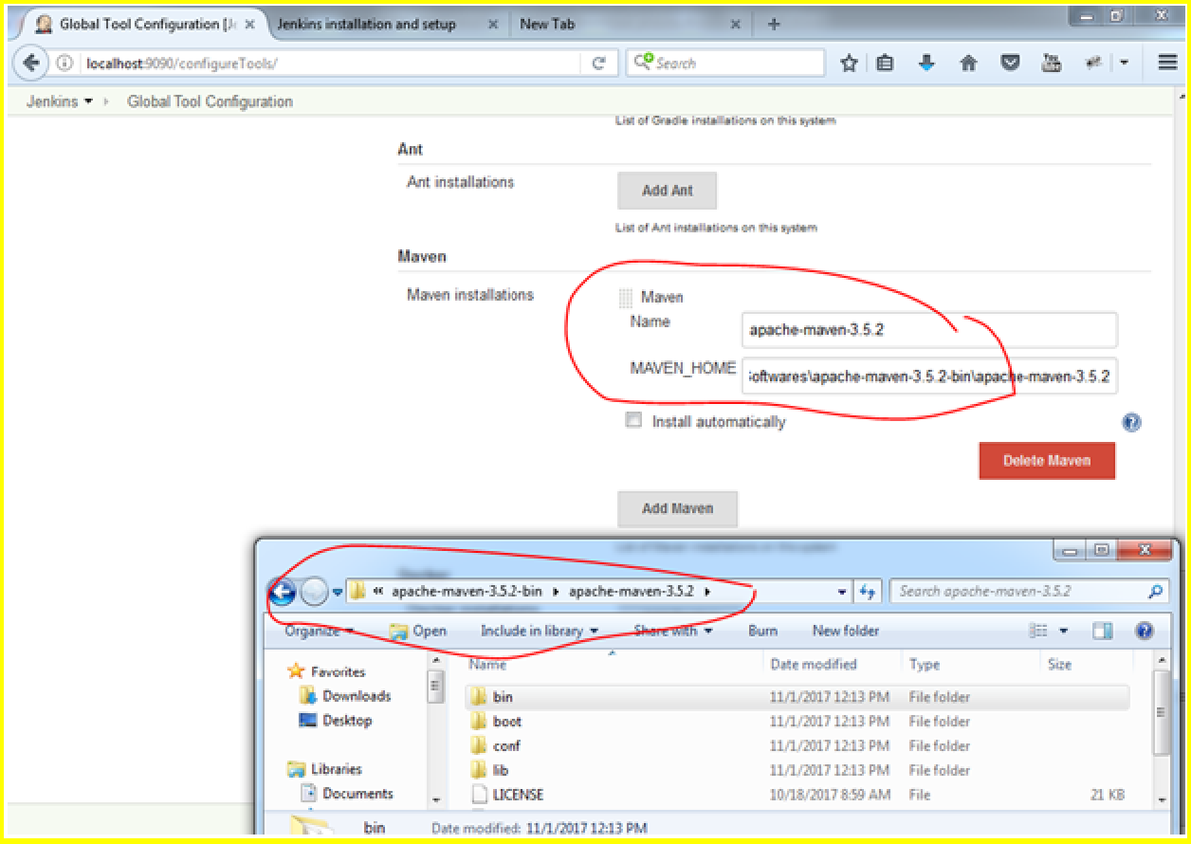

Once you save, u get this page.

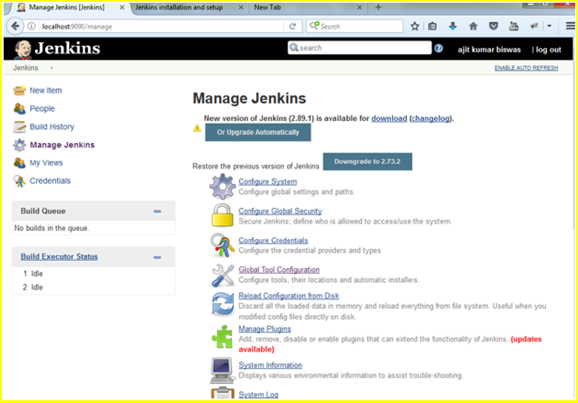

Copy the project that you want to execute from Jenkins as shown below

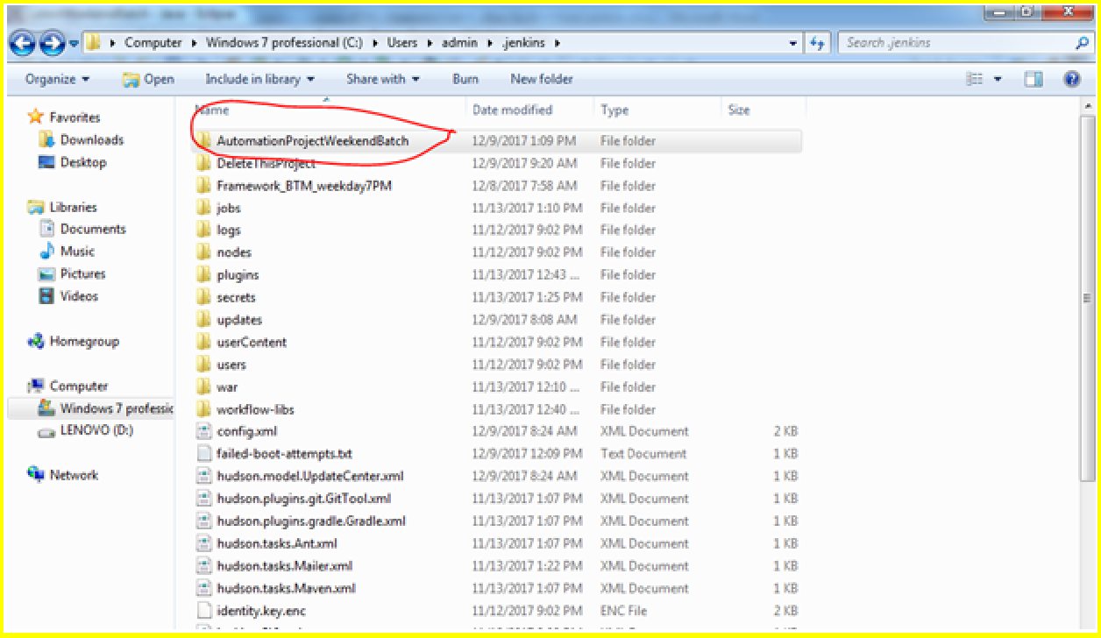

Copy the path till the project name

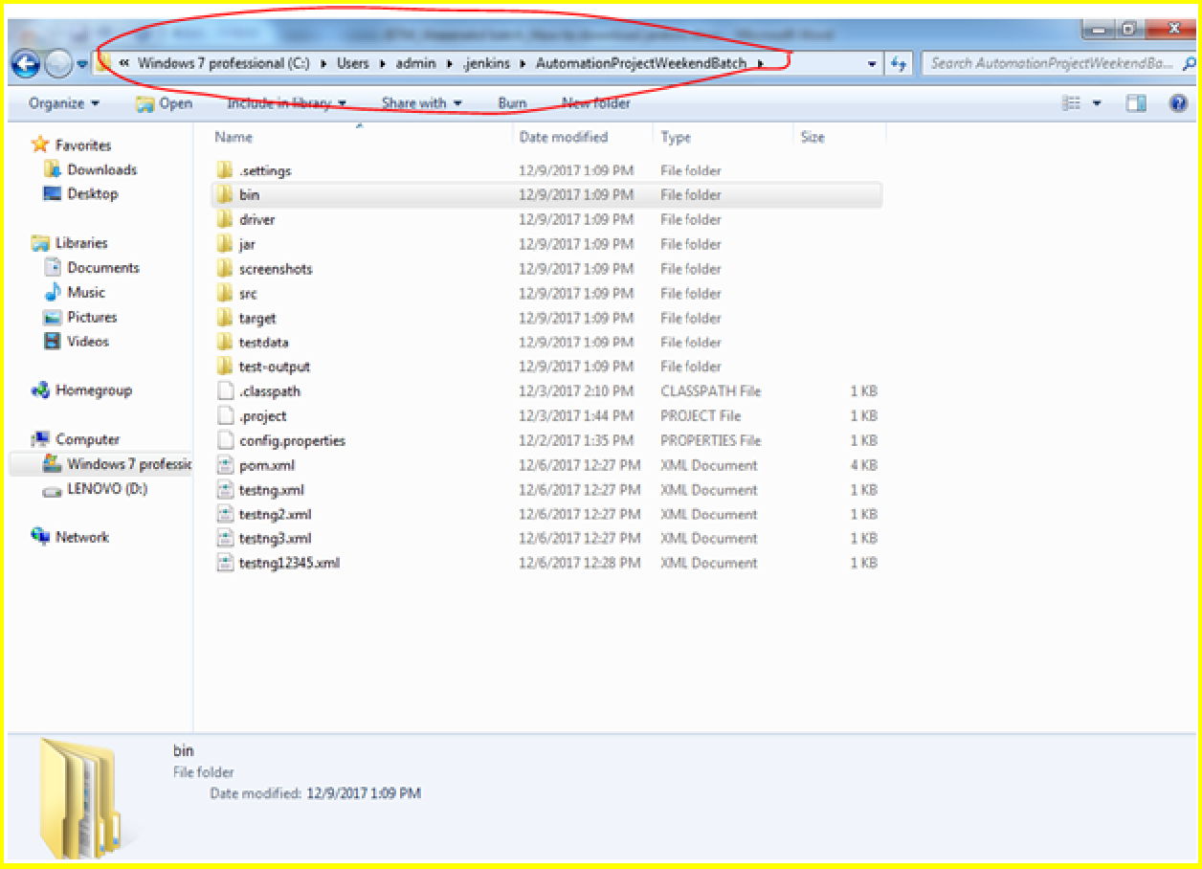

Create a new job by clicking on new ITEM

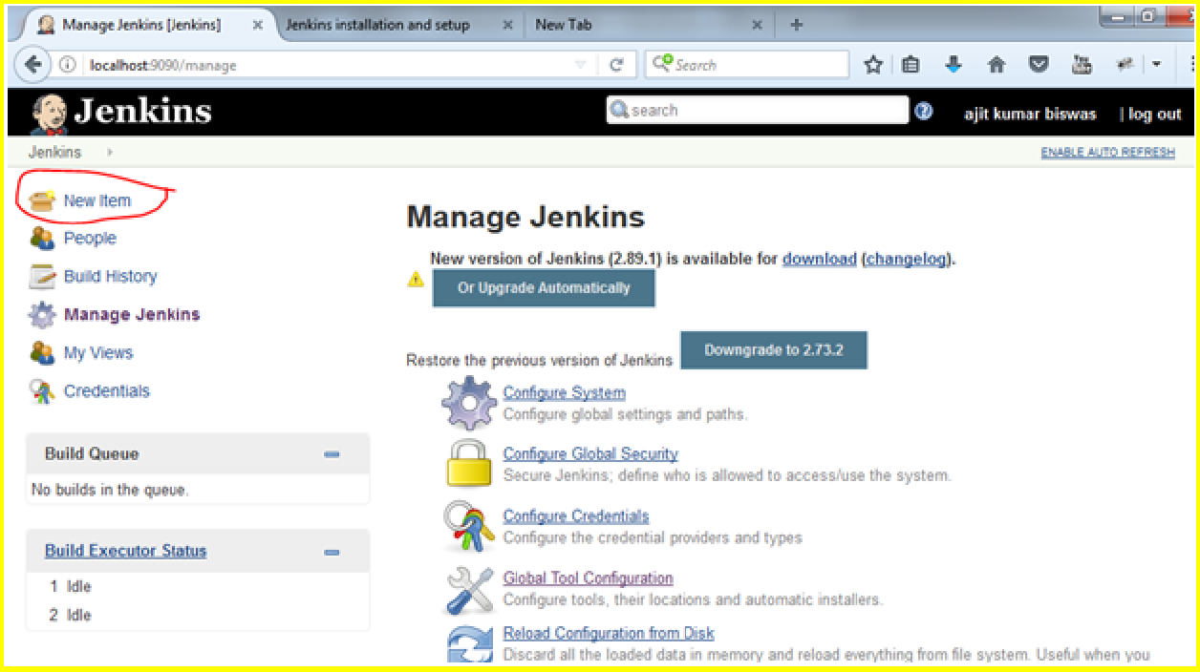

Enter name and click on free style project and click on OK button

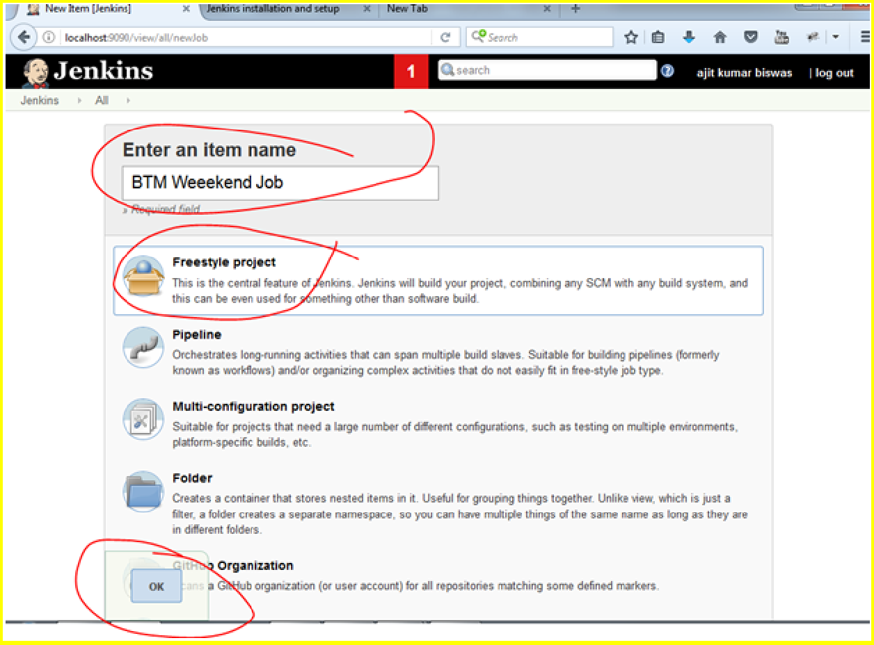

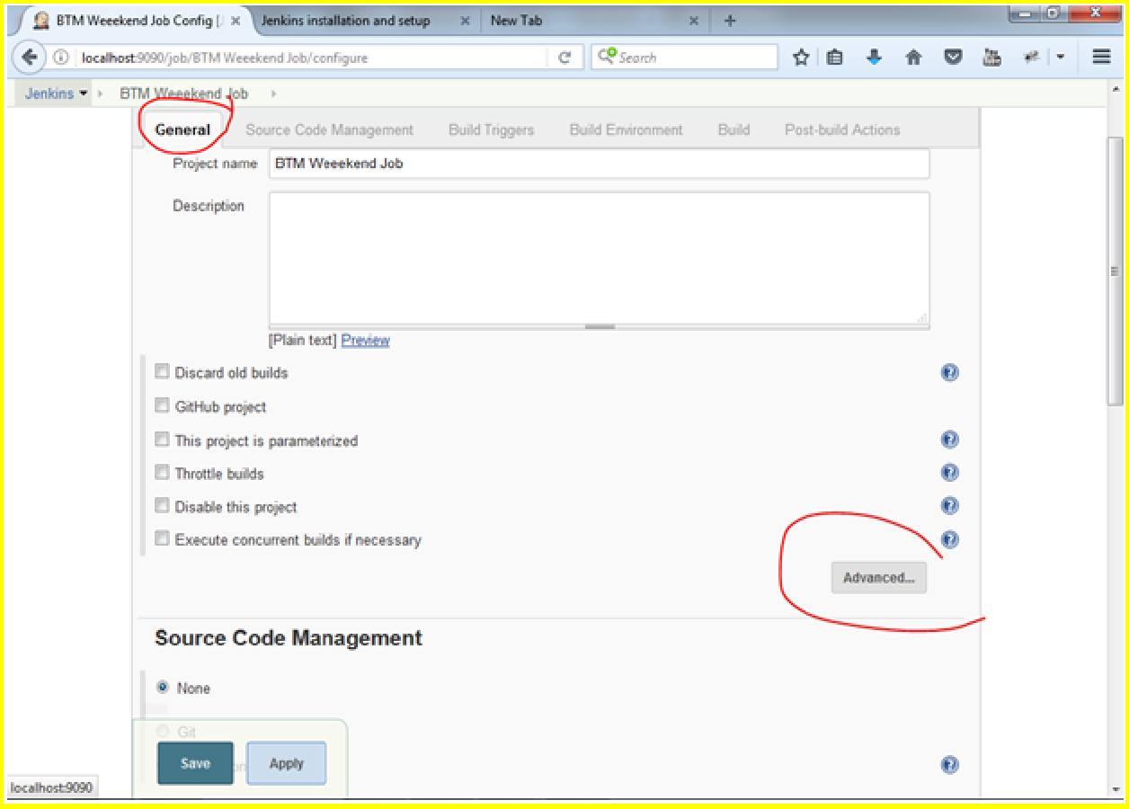

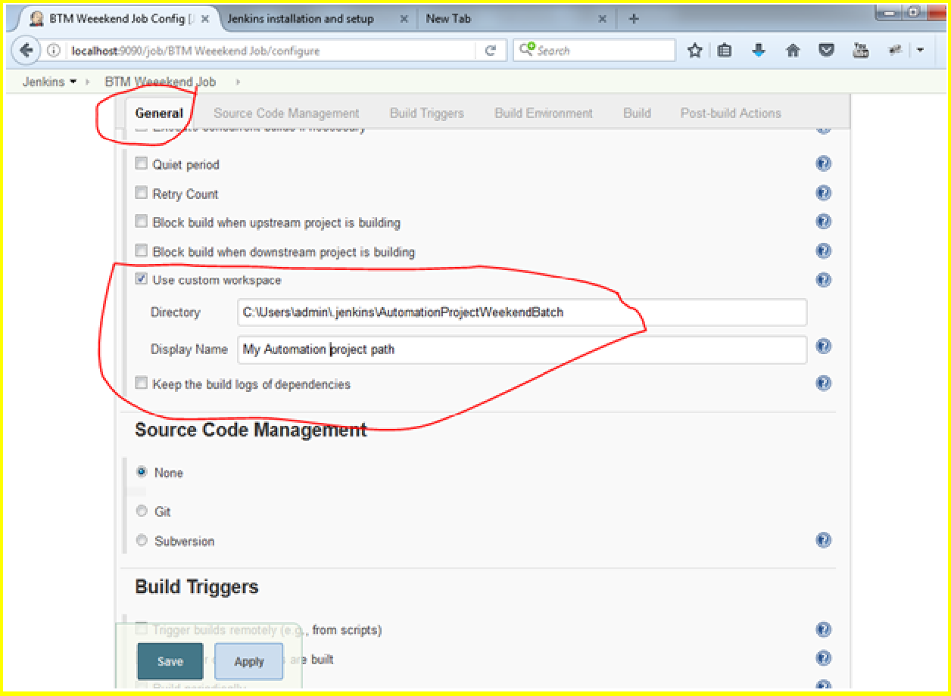

how to schedule suite execution time.

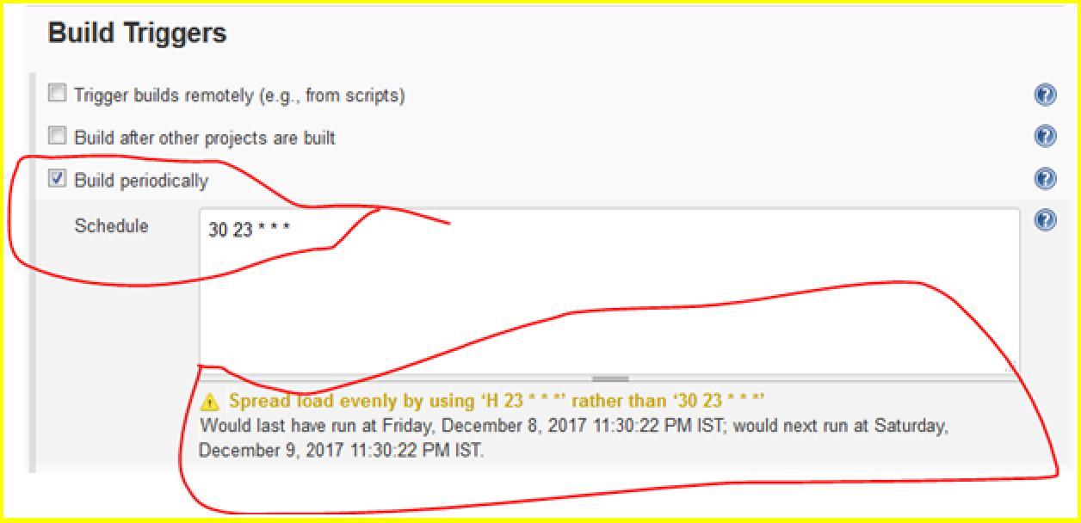

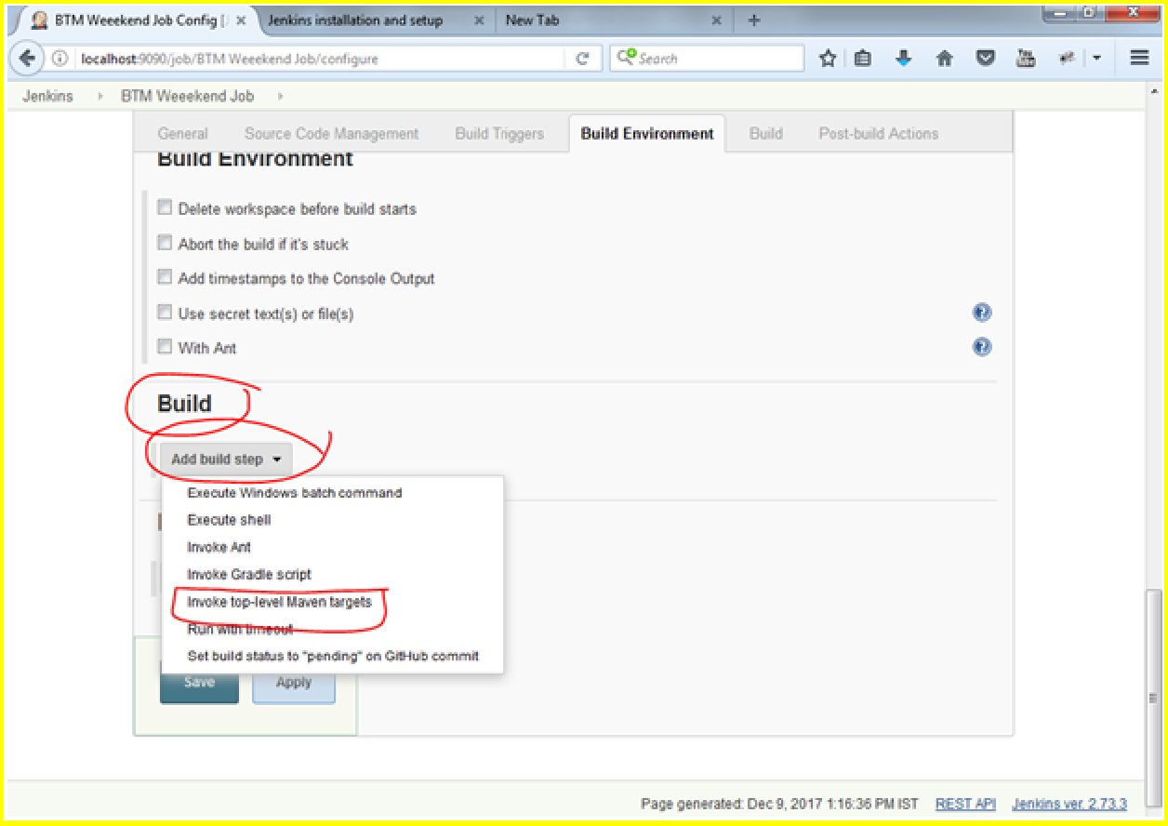

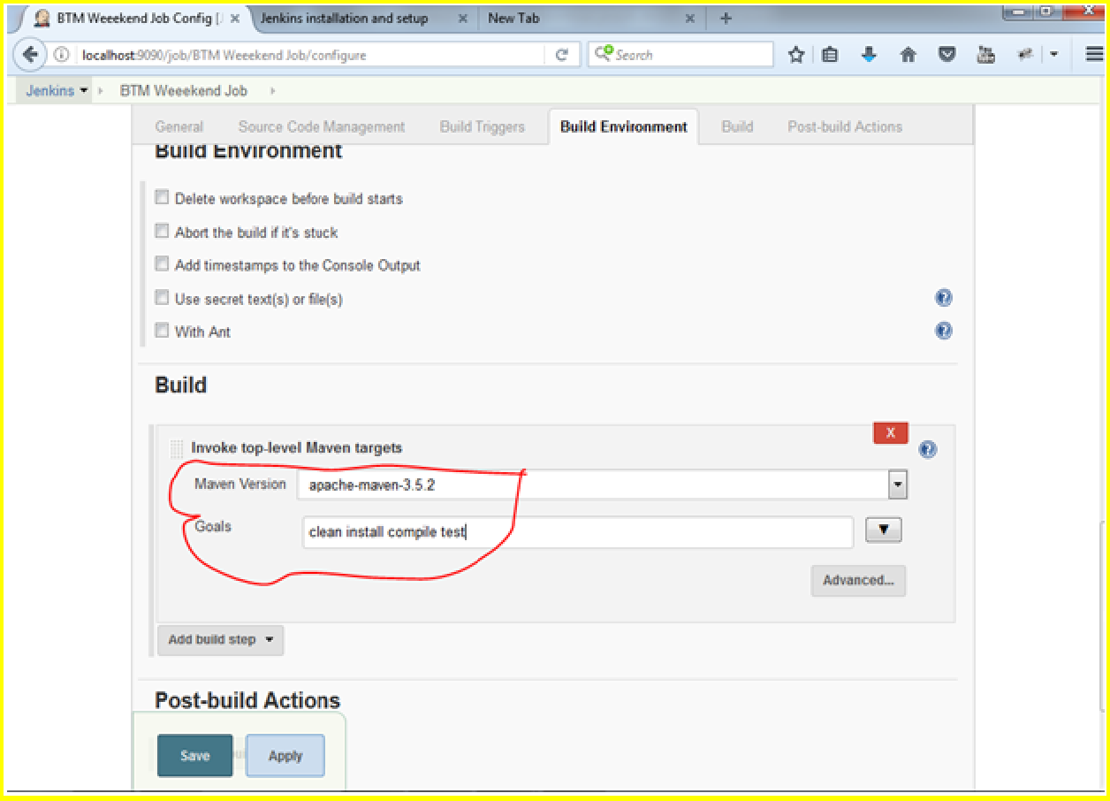

Save the above

Install testing results plugin

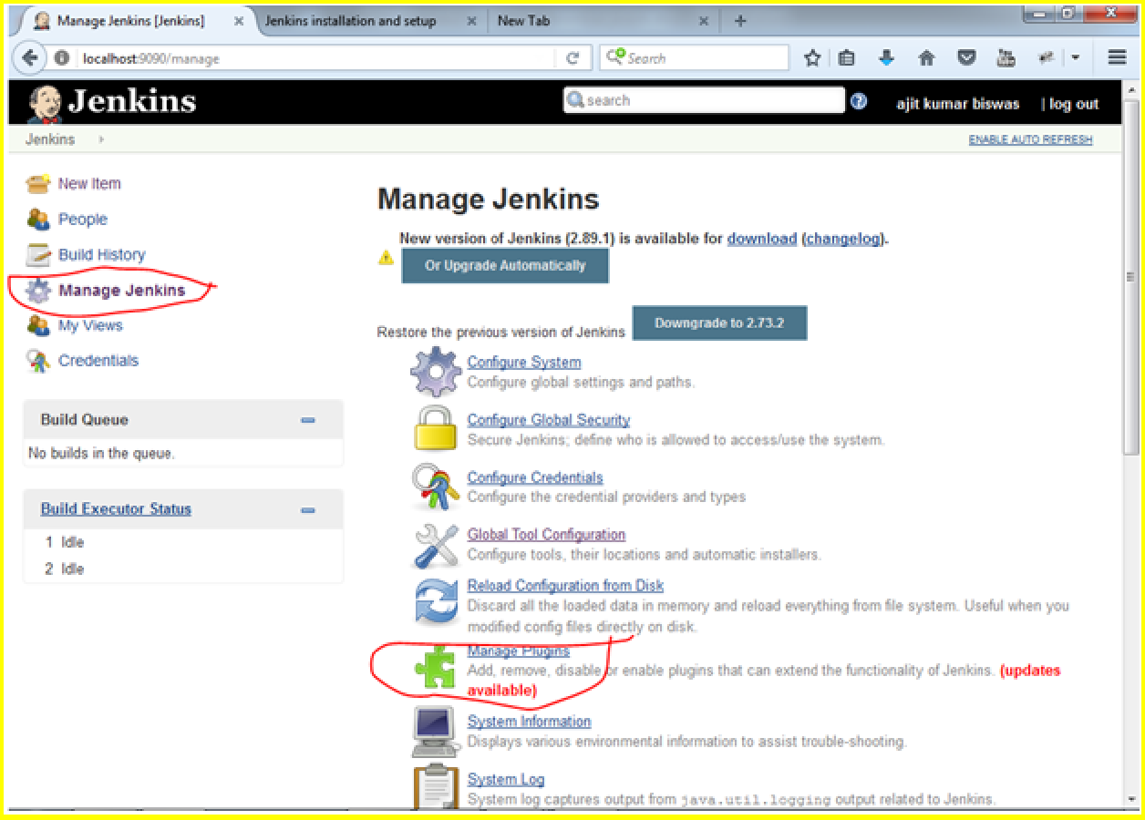

Navigate to available tab and search Testng Result plugin and install .. Select the job and click on configure..

Select below and save

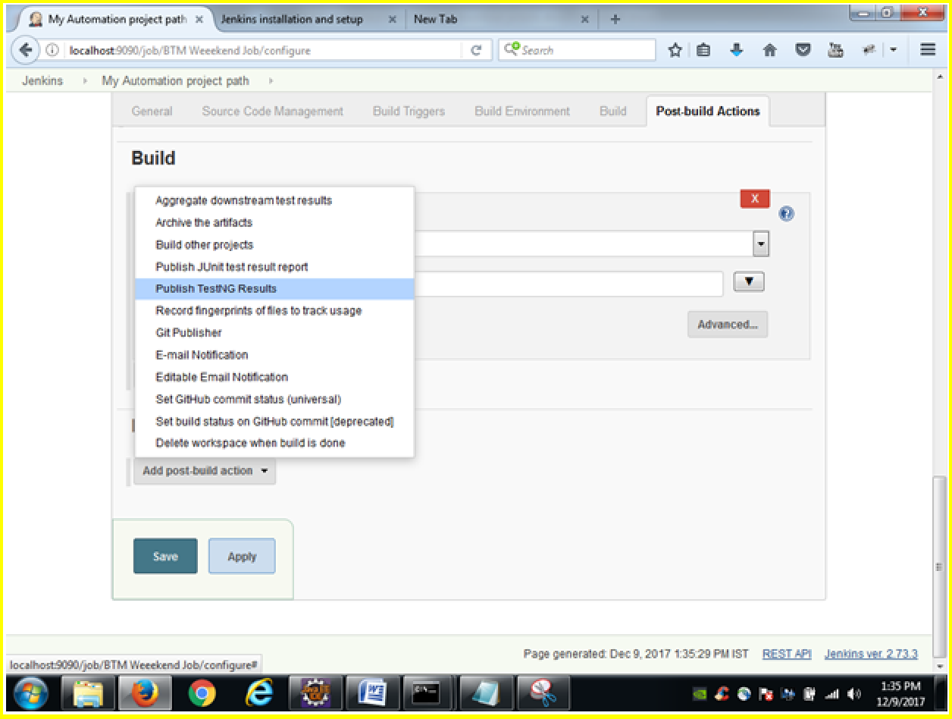



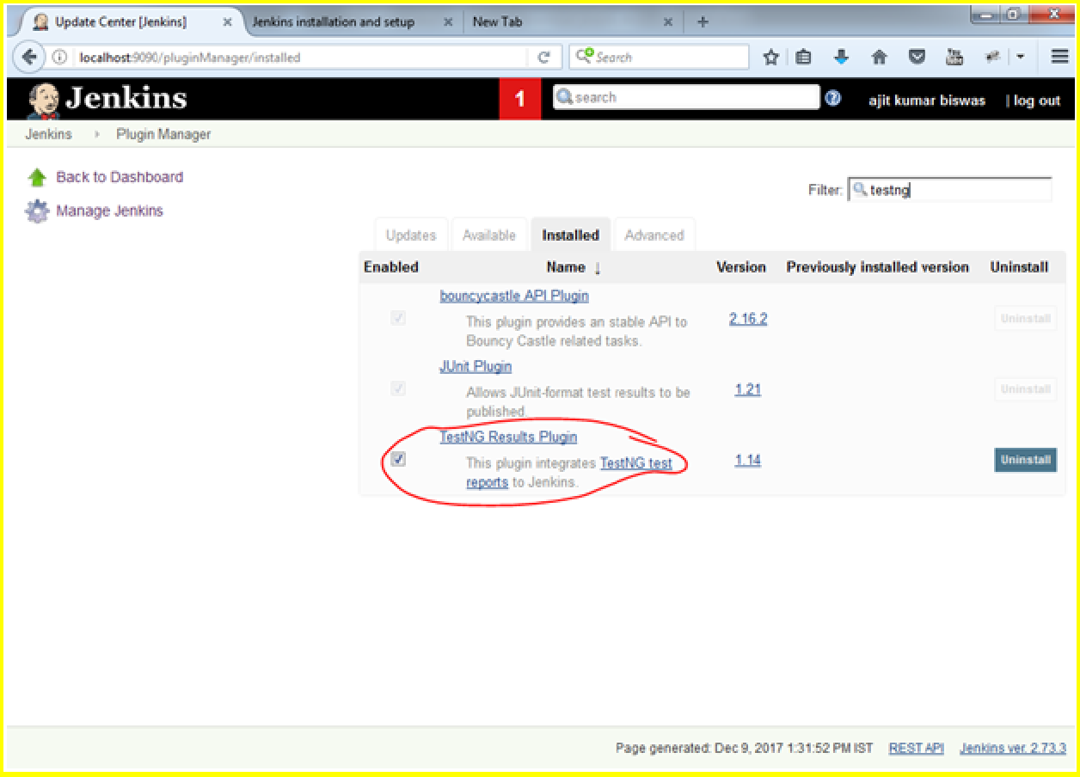

Click on Build now

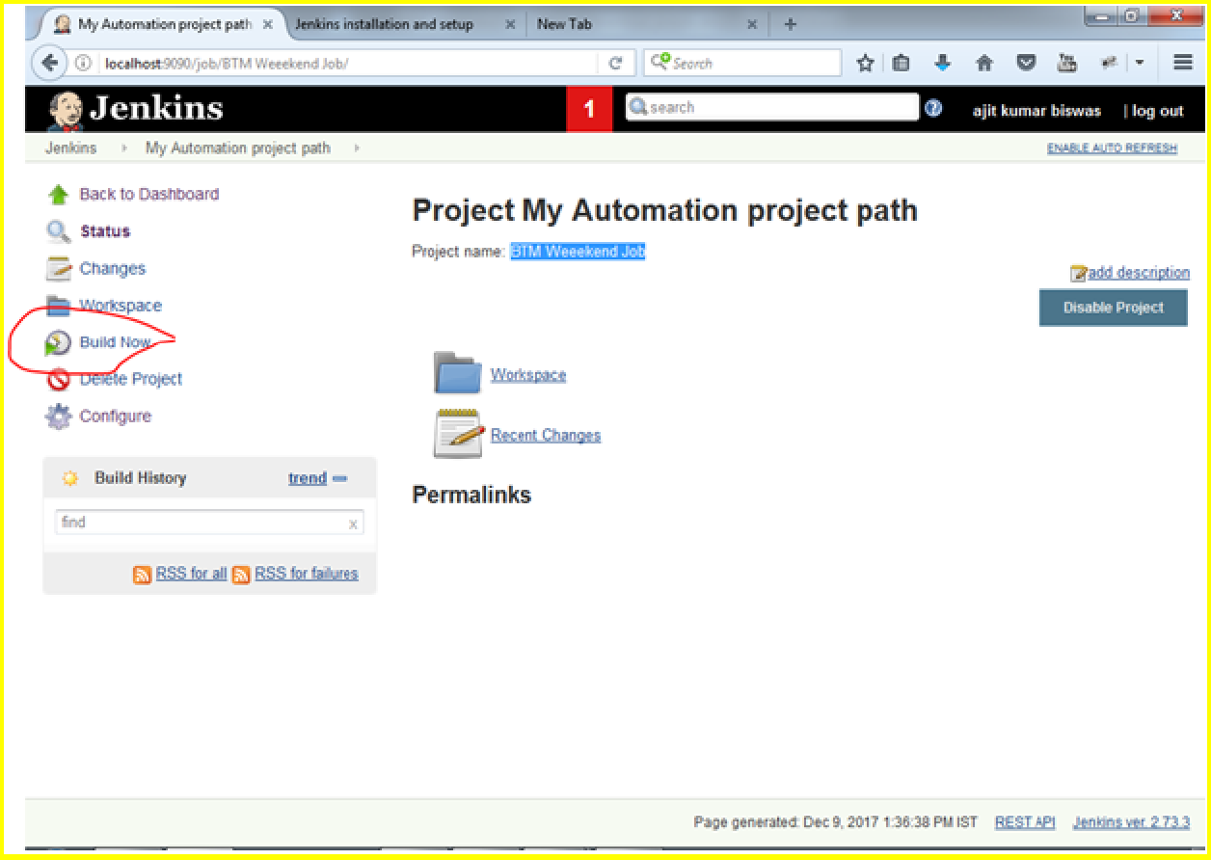

Job is running and in progress as shown below.

