**How to Download and Install MS SQL Server**

**SQL Server Login Database**

SQL Server login database is a simple credential which is used to access SQL Server.

There are four types of logins provided by SQL Server:

1. A login based on Windows credentials.
2. A login specific to SQL Server.
3. A login mapped to a certificate.
4. A login mapped to asymmetric key.

Logins based on Windows credentials facilitates you to log in to SQL Server using a Windows username and password. If you want to create your own credentials (username and password,) you can create a login specific to SQL Server.

To create, alter, or remove a SQL Server login, you can take one of two approaches:

1. Using SQL Server Management Studio.
2. Using T-SQL statements.

Using SQL Server Management Studio

Open SQL Server management studio

Go to Security:

It will open a new page:

Here you can set a login name and password.

**SQL Server CREATE DATABASE:**

A database is an organized collection of data that is structured into tables, rows, columns, and indexes. It helps the user to find the relevant information frequently. It enables the user to access and manage the records through the database very easily. Usually, each database in SQL Server stores all files in the form of tables.

**Why we need a database?**

Most companies and organizations need a database because it maintains all of its relevant information, such as employee records, transactional records, salary information, etc. **The following are the popular reasons for the need for the database:**

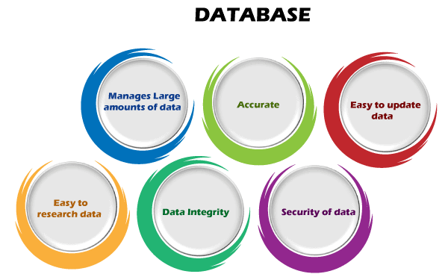

**Manages large amounts of data:** Each database can store and manage a large volume of data at a single place on a daily basis. There are no other tools available, including a spreadsheet, to do the same.

**Accurate:** Each database can store the data accurately because it provides built-in constraints, checks, and other features. Therefore, database information is almost always guaranteed to be correct.

**Easy to update:** A user can easily update the database using various Data Manipulation languages (DML) commands such as SQL, SQL Server, etc.

**Security:** Each database enables users to ensure the security of data using various methods. For example, a login is required to access the database or give the rights to access only specific parts of the database, not all.

**Data integrity:** Each database ensures that the stored data is accurate and consistent. A user can do this by using various constraints for data or conform to ACID property rules.

**Easy to research data:** A database enables users to search and find the relevant information quickly using the Data Query Languages (DQL).

SQL Server provides two types of databases:

1. System databases
2. User Databases

**System Databases:** The system databases are created automatically while installing the MS SQL Server on our system. It plays an essential role in the server such database run perfectly. The following are the **list of system databases** in SQL Server:

* Master
* Model
* MSDB
* Tempdb

**User Databases:** The user databases are created by database users like **DBAs** and **testers** who can access a database also.

We can create a database in SQL Server mainly in two ways:

1. SQL Command
2. SQL Server Management Studio
3. **Create Database using SQL Command:**

**syntax**:

**create** **database** database_name

In the above syntax, the **database_name** indicates the name of a new database.

**Rules to create a new database**

We must follow the following rules for creating a new database:

* The name of a new database should be **unique** within a particular server instance.
* Each database should have a maximum of 128 characters.

We can also list all databases stored in the database engine by using the following command:

**select** **name** **from** master.sys.databases **order** **by** **name**;

We can also use **stored procedure statement** to list all databases stored in the database engine as below:

**select** **name** **from** master.sys.databases **order** **by** **name**;

Executing the stored procedure will display the list of all databases, including its size and remarks if any. Otherwise, this field is shown **NULL**.

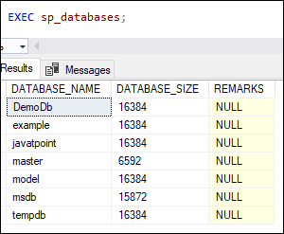

1. Select Database

**syntax:**

**use** database_name;

1. DROP database using SQL Command:

**syntax:**

**drop** **database** [if exist] database_name;

If we want to delete more than one database within a single command, we can use the comma-separated list of database names as below:

**drop** **database**  [ if exists ] database_name , database_name2, ...;

In this syntax, the **database_name** indicates the name of a database we want to remove from the server instance. The IF EXIST is an optional clause indicating the database will be deleted if it already exists in the server.

**We must remember the following points before deleting a database:**

The DROP DATABASE command will delete the database as well as the database's physical disc files. As a result, we are required to keep a database backup if we need to recover it in the future.

We are unable to delete the currently active database. If we will do this, SQL Server issues the following error:

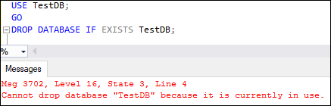

1. CREATE TABLE using SQL command

Syntax:

CREATE TABLE [database_name.][schema_name.]table_name (

column_definition1,

column_definition2,

........,

table_constraints);