

HEFTY CREATIVE TECHNOLOGIES PRIVATE LIMITED

# Pay slip for the month of **MARCH**-2022

|  |  |  |  |
| --- | --- | --- | --- |
| **Employee Name** | : Bandari Srikanth | **Date of Joining** | : 02/05/2019 |
| **Employee Code** | : 190503 | **Pan Number** | : DLSPB6893L |
| **Month** | : MAR-2022 | **Department** | : IT |
| **Location** | : Hyderabad | **NWD** | : 31 |
| **Designation** | : QA Automation Engineer | **LOP** | : 0 |
| **Bank Name** | : HDFC | **Account Number** | : 50100367251928 |

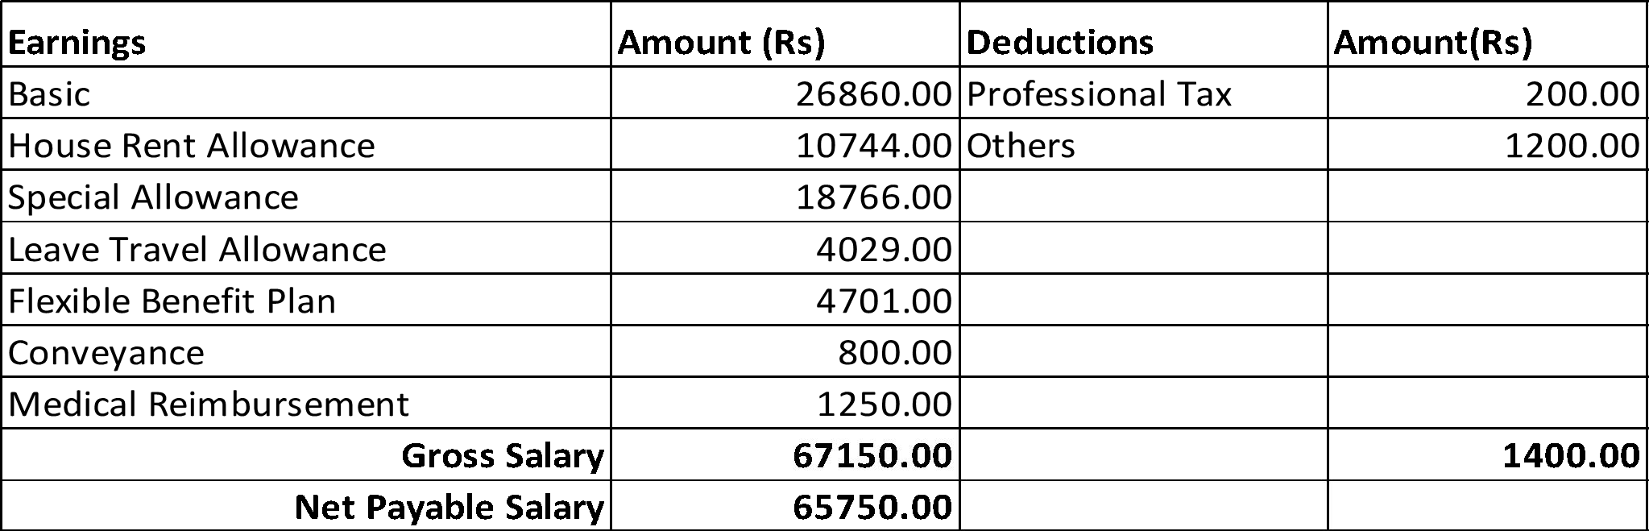

Note: This is a computer generated Payslip and does not require signature or any company seal.

# HEFTY CREATIVE TECHNOLOGIES PRIVATE LIMITED

Vasista Bhavan, 4th Floor, opp. lane to DLF Cyber City, APHB Colony, Indira Nagar, Gachibowli, Hyderabad, Telangana 500032. [hr@htsolutionsco.com](mailto:hr@htsolutionsco.com), +91 7670810097