Use Case Diagram
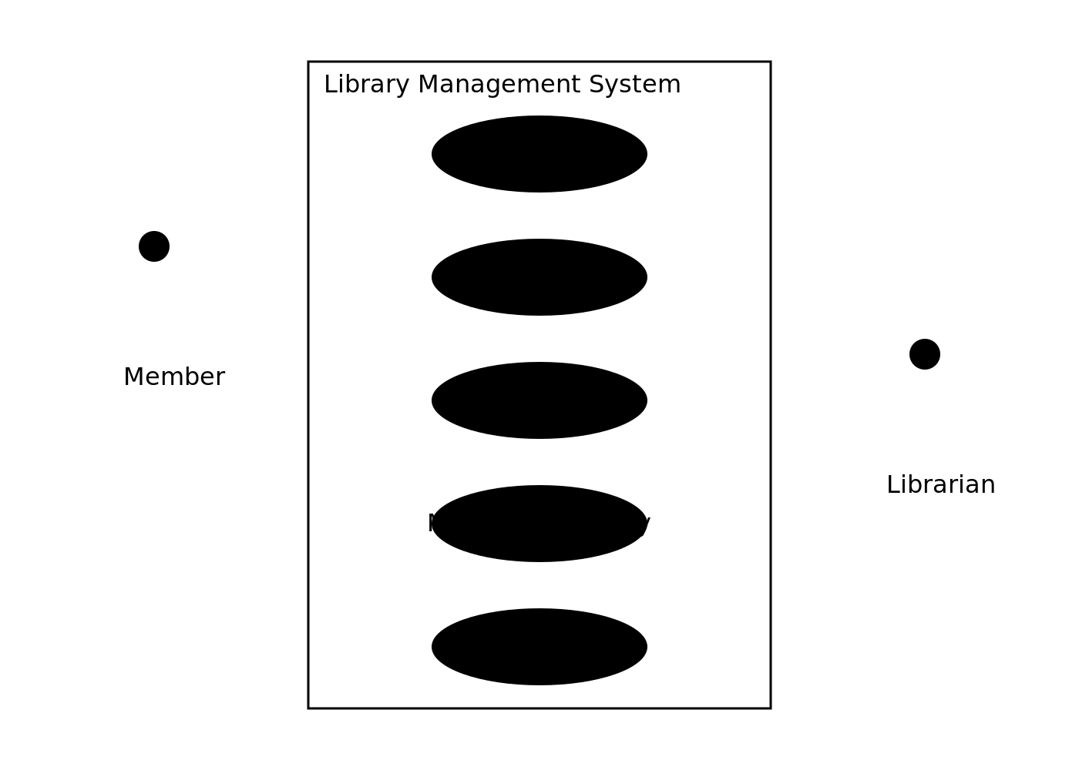

Activity Diagram

Class Diagram
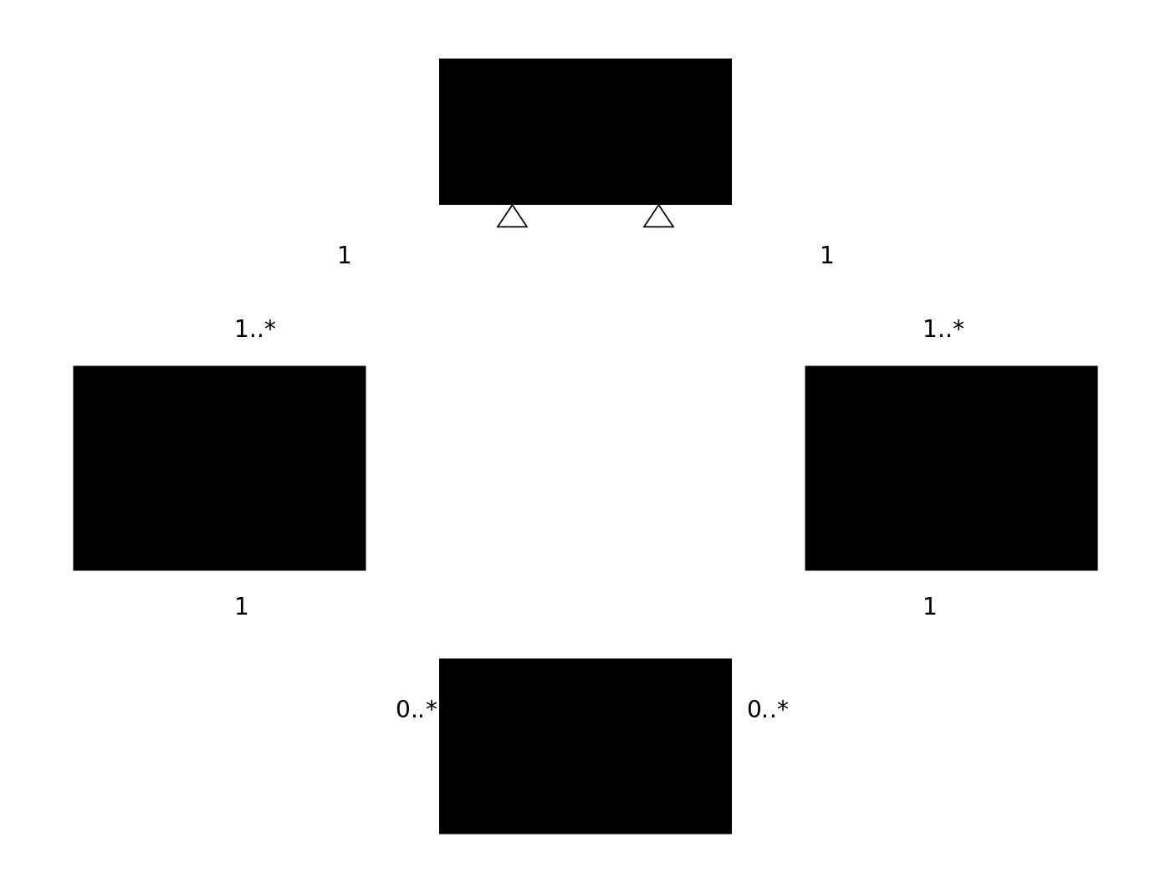

Sequence Diagram

Data Flow Diagram (Level 0 / Context)

Work Breakdown Structure (WBS)
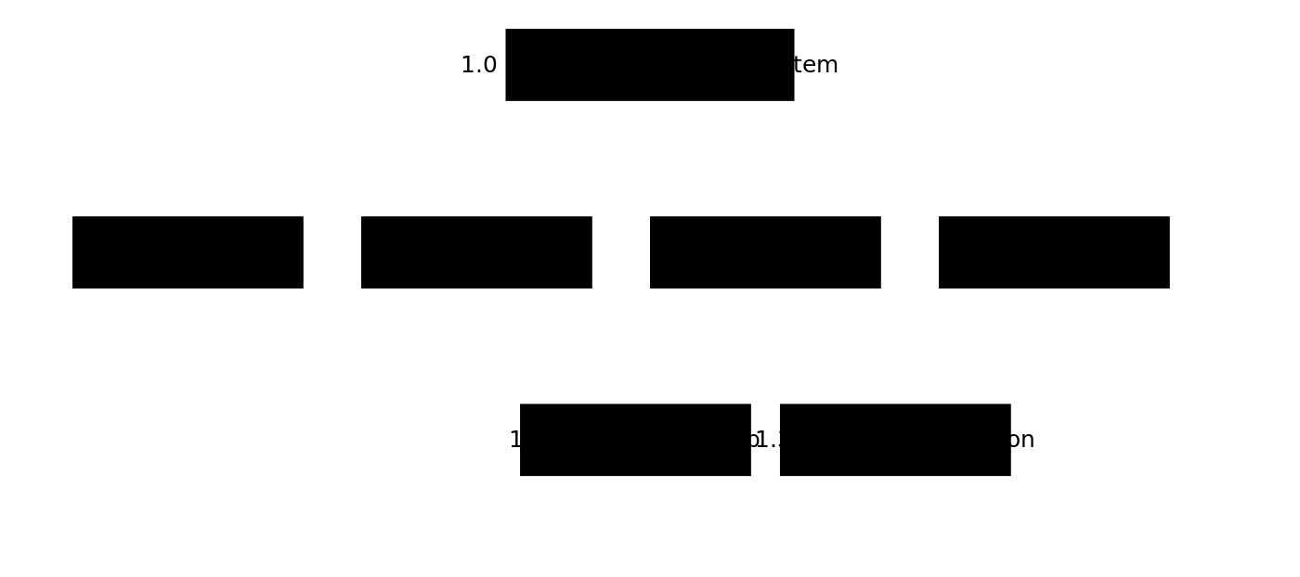

Critical Path Method (CPM)

Gantt Chart
