
MBARARA UNIVERSITY OF SCIENCE AND TECHNOLOGY
INSTITUTE OF COMPUTER SCIENCE
DEPARTMENT OF INFORMATION TECHNOLOGY

SIGNASENSE - AN INTEGRATED ASSISTIVE SOLUTION FOR THE DEAF AND BLIND

BY
Name | Reg. No | Telephone | Email
NALUBOWA BENITAH MARGRET | 2023/BIT/169/PS | +256 757503846 | 2023bit169@std.must.ac.ug
ADEKE MARY | 2023/BIT/034/PS | +256 780113311 | 2023bit034@std.must.ac.ug
MUHUMUZA MUHAMMAD | 2023/BIT/252/PS | +256 708124902 | 2023bit252@std.must.ac.ug
MIREMBE JERMIMAH ARNN | 2023/BIT/148/PS | +256 786028068 | 2023bit148@std.must.ac.ug
KANSIIME PIUS | 2023/BIT/120/PS | +256 791378875 | 2023bit120@std.must.ac.ug

A report submitted to the Institute of Computer Science in partial fulfilment of the requirements for the award of the Bachelor of Science Degree in Information Technology of Mbarara University of Science and Technology.

Supervisor: Mr. Rogers Mwavu
Department of Computer Science, Institute of Computer Science, Mbarara University of Science and Technology
Email: rmwavu@must.ac.ug | Tel: +256 773426328

March, 2026

Declaration
We declare that this report is our original work and has not been submitted to any institution for any academic award. Where other people's work has been used, it has been properly acknowledged through in-text citations and references.
Student declaration signatures
Name | Registration Number | Signature | Date
NALUBOWA BENITAH MARGRET | 2023/BIT/169/PS | ________________________ | ________________
ADEKE MARY | 2023/BIT/034/PS | ________________________ | ________________
MUHUMUZA MUHAMMAD | 2023/BIT/252/PS | ________________________ | ________________
MIREMBE JERMIMAH ARNN | 2023/BIT/148/PS | ________________________ | ________________
KANSIIME PIUS | 2023/BIT/120/PS | ________________________ | ________________
NOTE: Insert signed student declaration page here before final submission if required by the department.

Approval
This report has been submitted for examination with the approval of the project supervisor.
Supervisor: Mr. Rogers Mwavu
Signature: ____________________________ Date: __________________

Acknowledgement
We express our sincere gratitude to our supervisor, Mr. Rogers Mwavu, for his guidance, support, and constructive feedback throughout the development of this project. We also appreciate the Department of Information Technology and the Institute of Computer Science for providing an enabling environment and resources. Finally, we thank our families, friends, and colleagues for their encouragement and assistance.

Abstract
People with dual sensory impairments, especially deafness and blindness, face barriers to communication, navigation and independent participation in daily life. In low-resource settings, assistive technologies are often expensive, imported, difficult to maintain or designed for only one disability. This project presents SignaSense, an integrated assistive solution designed to support both communication and mobility using affordable electronic components and a mobile application.
The system consists of two main assistive modules. The smart glove uses five flex sensors connected to an ESP32 to read finger bends, classify stable one-hand alphabet patterns and transmit recognised letters, words and captions to the SignaSense Android application through Bluetooth Low Energy. The application provides visual captions, word suggestions, sentence suggestions, text-to-speech output, camera-based sign backup and local user-defined sign training for users whose hand shapes differ from the general model. The smart stick uses an ESP32, an ultrasonic sensor and a backup buzzer to detect obstacles, calculate distance in metres, output spoken guidance through a Bluetooth speaker and support left/right scanning before recommending the clearer path.
The development followed an iterative prototype methodology covering requirements analysis, hardware wiring, embedded firmware development, Android application development, calibration and functional testing. Functional tests confirmed that the prototype can read flex-sensor states, build words after deliberate letter confirmation, speak committed words through the phone, detect hand landmarks through the phone camera, measure obstacle distance and issue non-overlapping voice guidance for the smart stick. The project provides a practical foundation for future user-centred evaluation, expanded gesture vocabulary, improved sensor robustness and wider local deployment.

Table of Contents
NOTE: Update page numbers after inserting final prototype photographs and before printing/submission.
Declaration
Approval
Acknowledgement
Abstract
List of Figures
List of Tables
List of Acronyms
Chapter One: Introduction
Chapter Two: Literature Review
Chapter Three: Methodology
Chapter Four: System Development and Implementation
Chapter Five: Testing, Results and Discussion
Chapter Six: Summary, Conclusion and Recommendations
References
Appendices

List of Figures
Figure 1: SignaSense conceptual framework.
Figure 2: SignaSense integrated system architecture.
Figure 3: Smart glove flex-sensor voltage-divider wiring.
Figure 4: Final smart glove prototype with ESP32 and flex sensors.
Figure 5: Smart stick ultrasonic sensor and buzzer wiring.
Figure 6: Final smart stick prototype with ultrasonic sensor, buzzer and ESP32.
Figure 7: Smart stick left/right scanning procedure for route guidance.
Figure 8: SignaSense Android onboarding, accessibility mode and theme selection.
Figure 9: Camera sign backup recognition pipeline.
Figure 10: User-defined sign training workflow.
Figure 11: Smart stick distance filtering and guidance logic.
Figure 12: Prototype verification and testing workflow.
Figure 13: SignaSense project work plan Gantt chart.

List of Tables
Table 1: List of acronyms.
Table 2: Summary of reviewed related studies.
Table 3: Smart glove hardware pin allocation.
Table 4: Smart stick hardware pin allocation.
Table 5: Software tools and libraries used.
Table 6: Functional test summary.
Table 7: Project limitations and mitigation strategies.
Table 8: Detailed system requirements matrix.
Table 9: Prototype component and cost estimate.
Table 10: Project work plan.
Table 11: Risk register.
Table 12: Calibration record sheet.
Table 13: Extended functional test cases.
Table 14: User evaluation questionnaire.

List of Acronyms
Acronym | Meaning
A2DP | Advanced Audio Distribution Profile
ADC | Analogue-to-Digital Converter
APK | Android Package Kit
ASL | American Sign Language
BLE | Bluetooth Low Energy
ESP32 | Espressif 32-bit Wi-Fi and Bluetooth microcontroller
GPIO | General-Purpose Input/Output
ICS | Institute of Computer Science
IoT | Internet of Things
MUST | Mbarara University of Science and Technology
PWD | Persons with Disabilities
SDGs | Sustainable Development Goals
TTS | Text-to-Speech
UBOS | Uganda Bureau of Statistics
WHO | World Health Organization

CHAPTER ONE: INTRODUCTION

1.1 Introduction
People with sensory disabilities face challenges that affect communication, safe movement and social participation. Hearing loss can limit speech communication, education and employment, while visual impairment can reduce independent mobility and access to everyday services. The World Health Organization reports that more than 430 million people require rehabilitation for disabling hearing loss and that the burden is concentrated in low- and middle-income countries (World Health Organization, 2026a). WHO also reports that unaddressed vision impairment remains a major global public-health and inclusion issue, with access barriers being more severe in low-income settings (World Health Organization, 2026b).
In Uganda, disability remains a significant social and development issue. The National Council for Disability reports, based on UBOS data, that disability prevalence among people aged two years and above was 12.4 percent, while functional difficulties include seeing, walking and hearing-related limitations (National Council for Disability, 2019). This means assistive technology projects must be designed with affordability, maintainability and local availability in mind.
SignaSense responds to this need by integrating two assistive functions. The first is a smart glove that converts recognised finger and hand signs into captions and speech. The second is a smart walking stick that detects obstacles, speaks distance and gives route guidance. The final project also includes an Android application for accessibility onboarding, voice interaction, glove Bluetooth connection, camera sign backup and local user-defined sign training.
The project aligns with inclusion principles in Uganda's Persons with Disabilities Act, 2020, which recognises assistive devices, accessible communication and accessible information and communication technology as important supports for participation (Uganda, 2020). It also contributes to the Sustainable Development Goals related to health, reduced inequalities and decent work by targeting independence and communication access for persons with disabilities.

1.2 Background
Assistive technology has advanced through wearable sensors, mobile computing, computer vision and embedded microcontrollers. However, many systems are developed for high-income contexts and may depend on expensive parts, stable internet connectivity, cloud services or specialised maintenance. These requirements can limit their usefulness in rural or low-resource environments.
Existing devices often address one challenge at a time. A smart glove may translate signs but fail to support mobility. A smart stick may detect obstacles but not help a deaf user communicate. SignaSense was therefore designed as a dual-support system that can assist both communication and navigation while keeping the core hardware simple enough to be assembled, repaired and improved locally.
The final development process also showed practical engineering constraints. For example, ESP32 ADC2 pins can be affected when Wi-Fi is active; Espressif documents that ADC2 and Wi-Fi share hardware resources, which can block ADC readings when used together (Espressif Systems, 2022). This directly informed the decision to use Bluetooth Low Energy for the glove instead of Wi-Fi when flex sensors were connected to affected analogue pins.

1.3 Problem Statement
People with combined hearing and visual impairments in low-resource settings have limited access to affordable, locally maintainable assistive technologies for communication and safe mobility. Existing solutions are often expensive, address only one impairment, depend on internet access or require hardware that is difficult to maintain. This limits independence, safety and participation in daily activities. There is therefore a need for a low-cost integrated prototype that supports both sign-to-speech communication and obstacle-aware navigation.

1.4 Objectives

1.4.1 Main Objective
To enhance communication and mobility assistance for the deaf and visually impaired through an integrated low-cost SignaSense prototype.

1.4.2 Specific Objectives
- To examine existing systems that enable communication and mobility assistance for deaf and visually impaired users.
- To design and develop a low-cost wearable and handheld system that enables communication and mobility assistance.
- To test and validate the functionality, responsiveness and practical efficiency of the developed prototype.
- To extend the system with an Android application that provides accessibility onboarding, captions, speech output, camera sign backup and local user-defined sign training.

1.5 Research Questions
- What are the strengths and gaps in existing systems for communication and mobility assistance?
- How can a low-cost system be designed to combine sign-to-speech communication and obstacle-aware mobility support?
- How functional and responsive is the developed prototype under basic testing conditions?
- How can a mobile application improve accessibility, caption display, speech output and backup sign recognition?

1.6 Significance of the Study
The project contributes an integrated approach to assistive technology by combining communication support and mobility guidance. The glove helps convert deliberate hand signs into letters, words, captions and spoken output. The stick helps identify nearby obstacles, speak distance and guide the user to scan left and right before selecting the clearer path.
For users, the system has the potential to improve independence, safety and communication. For the university and local technology community, the project provides a reusable embedded-system and Android-app foundation that can be improved through future research, field evaluation and local fabrication.
The user-defined sign training option is significant because it recognises that not all users can make standard alphabet signs. A deaf user with missing fingers, limited mobility or a different signing style can train signs that work only on their own phone without changing the general model for other users.

1.7 Scope of the Study
The project focuses on a functional prototype made up of a smart glove, smart stick and Android application. The glove scope covers flex-sensor reading, calibration, bend classification, conservative alphabet recognition, Bluetooth Low Energy data transfer, word building and spoken output through the phone. The stick scope covers ultrasonic distance measurement, distance calibration, Bluetooth speaker voice guidance, backup buzzer alerts and left/right scan guidance. The application scope covers onboarding for blind and deaf users, dark/light mode, voice prompts, glove BLE connection, camera sign backup, local user-defined sign training and word/sentence suggestions.
Large-scale clinical validation, certified medical-device testing, full natural sign-language grammar recognition and mass production are outside the scope of this final-year prototype. Formal participant testing with 10-15 users was planned, but the provided project files do not include completed participant datasets; therefore, the results chapter reports prototype functional testing and leaves notes where formal field data must be inserted.

1.8 Conceptual Framework
IMAGE NOTE: Insert or redraw the final SignaSense architecture diagram here if a department-specific diagram is required.

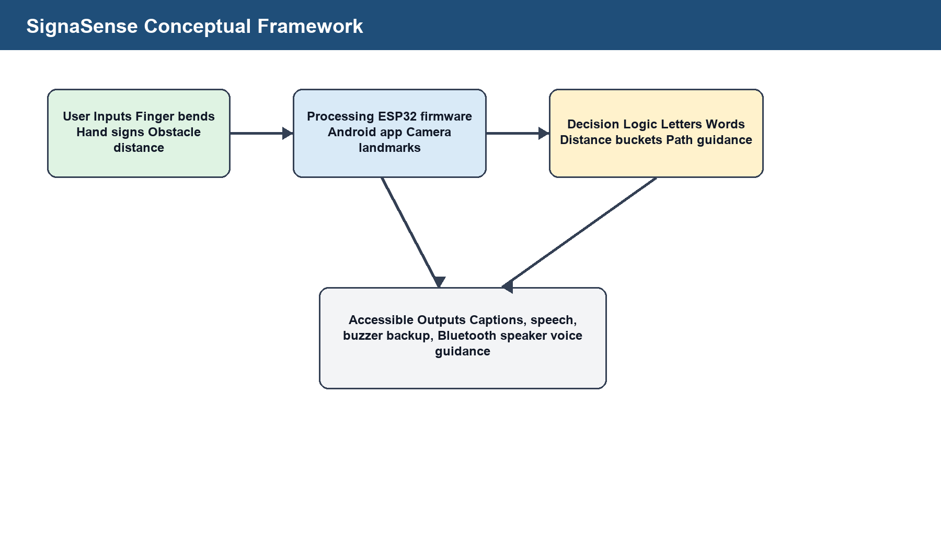
Figure 1: SignaSense conceptual framework.
The conceptual flow is: user input through flex sensors or camera, processing through ESP32 firmware or Android hand-landmark analysis, output through captions, suggested words, spoken audio and smart-stick navigation guidance.

CHAPTER TWO: LITERATURE REVIEW

2.1 Introduction
Assistive technologies for people with hearing and visual impairments include wearable sensor gloves, computer-vision sign recognition systems, smart walking sticks and mobile accessibility applications. The reviewed studies show that these technologies can improve communication and mobility, but they also reveal gaps in affordability, local maintainability, real-world robustness and integration.
This chapter reviews work related to the project's objectives: smart glove sign translation, smart walking sticks for the visually impaired, integration of communication and mobility functions, and mobile/camera support for accessibility.

2.2 Smart Glove for Sign-Language Translation
Wearable sensor gloves use flex sensors, inertial sensors or contact sensors to capture finger and hand movement. The advantage of glove-based systems is that they are less affected by lighting and background than camera-only systems. Ambar et al. (2020), as cited in the provided proposal material, developed a wearable sensor glove for real-time sign-language translation using flex and motion sensors. The work demonstrated the value of real-time text display but remained limited by static recognition and a limited vocabulary.
Abougarair (2022), as cited in the proposal, presented a smart glove for sign-language translation with a simple wearable design and fast response. The identified gap was that the system did not integrate mobility assistance and had limited phrase support. The SignaSense glove responds by adding app-based word building, suggested words, suggested sentences and speech output.
A key limitation of flex-sensor-only recognition is that many alphabet signs differ not only by finger bend but also by palm orientation, finger crossing, thumb placement and hand motion. For that reason, the final firmware uses conservative matching and avoids guessing when bends are ambiguous. This is important for accuracy because false letters can create incorrect words and misleading speech output.

2.3 Smart Walking Stick for the Blind
Smart walking sticks commonly use ultrasonic, infrared or other distance sensors to identify obstacles. The HC-SR04 class of ultrasonic sensors measures distance by sending a sound pulse and timing the returning echo; the distance is calculated from time of flight and the speed of sound. Because many ultrasonic modules output a 5 V echo signal, the ESP32 echo input must be protected using a voltage divider or level shifter when the sensor is powered at 5 V.
Olayiwola et al. (2025), as cited in the proposal, developed a smart walking stick with voice guidance in an African language. The strength of that work is cultural relevance, but the limitation is relatively basic obstacle detection. Farooq et al. (2022), also cited in the proposal, proposed an IoT-enabled intelligent stick with remote monitoring, but internet dependency and power consumption reduce suitability for low-resource settings.
SignaSense uses an offline smart-stick approach. The final stick firmware reads distance repeatedly, filters invalid readings, speaks only when an obstacle is inside the warning range and triggers a slow left/right scan procedure when an obstacle is very close. This makes the stick more practical where mobile data, Wi-Fi and cloud services are not available.

2.4 Integrated Communication and Mobility Systems
The reviewed literature indicates that most assistive systems focus on either deaf users or blind users. This separation creates device fragmentation for users with multiple sensory impairments. A user may need a sign-translation tool, a mobility tool and a mobile app, each with a separate interface and maintenance requirement.
SignaSense addresses this gap by combining glove-based communication, app-based caption and speech output, camera-based backup recognition and stick-based navigation into one project. The system is modular, meaning the glove and stick can work separately, but the application and project design bring them under a common accessibility workflow.

2.5 Mobile Application and Camera Sign Backup
Android provides built-in TextToSpeech and SpeechRecognizer APIs that allow applications to produce spoken prompts and receive voice commands where device support is available (Android Developers, 2026a; Android Developers, 2026b). This supports the SignaSense onboarding flow for blind users and the spoken output for committed glove words.
For the camera backup, the app uses CameraX image analysis and MediaPipe Hand Landmarker. CameraX provides a lifecycle-aware image-analysis pipeline for processing camera frames, while MediaPipe Hand Landmarker detects hand landmarks that can be classified into sign shapes (Android Developers, 2026c; Google AI Edge, n.d.). This supports a backup mode when the glove battery is low or when a user wants to demonstrate signs without the glove.
Gallaudet University ASL standards describe fingerspelling as an important part of ASL communication, including connecting alphabet letters to English equivalents and using fingerspelled words in communication (Gallaudet University, 2018). SignaSense focuses on alphabet and word formation first because full sign-language sentence grammar is beyond the prototype scope.

2.6 Summary of Reviewed Studies
Author(s) | Title/Focus | Strength | Gap | SignaSense Response
Ambar et al. (2020) | Wearable sensor glove for real-time sign-language translation | High accuracy and real-time display | Limited vocabulary and static-only recognition | Adds app-based word building and speech output.
Abougarair (2022) | Smart glove for sign-language translation | Simple wearable design and fast response | No mobility integration and limited phrases | Integrates communication support with a mobility-support project.
Olayiwola et al. (2025) | Smart walking stick with voice guidance in an African language | Culturally relevant audio guidance | Limited obstacle categories and basic distance feedback | Adds calibrated distance output and left/right scan guidance.
Farooq et al. (2022) | IoT-enabled intelligent stick for visually impaired users | Navigation assistance and remote monitoring | Internet dependency and higher power demand | Uses offline ESP32 distance sensing and Bluetooth speaker guidance.
Google AI Edge (n.d.) | MediaPipe Hand Landmarker | On-device hand-landmark detection for camera frames | Requires good lighting and clear hand view | Used as backup recognition when glove is not available.
Table 2: Summary of reviewed related studies.

CHAPTER THREE: METHODOLOGY

3.1 Introduction
The study used a mixed prototype-development approach that combined system analysis, experimental hardware design, embedded software development, Android application development and functional testing. This approach was suitable because the project required both technical construction and evaluation of whether the prototype could perform the required assistive functions.

3.2 Research Design
A prototype-based experimental design was adopted. The team first identified the user problem, reviewed related assistive systems, selected affordable components, built the glove and stick circuits, wrote the ESP32 firmware, developed the SignaSense Android application and iteratively tested the system.
The design was user-centred in the sense that every major decision was linked to the user experience. For example, the glove was changed from Wi-Fi to BLE when ADC readings became unreliable with the selected pins. The stick was rolled back from Wi-Fi/app control to direct Bluetooth speaker voice output because the app link introduced delay and mismatch for real-time mobility guidance.

3.3 Study Population and Sample Size
The planned study population included individuals with hearing and visual impairments within Mbarara Municipality. The proposal planned purposive sampling of approximately 10-15 participants for prototype evaluation, focusing on communication accuracy, comfort, obstacle detection, audio guidance and usability.
NOTE: Insert final participant details, consent evidence and field-test sample size if formal user testing was completed.

3.4 Data Collection Procedures
The planned procedure involved obtaining research authorization, briefing participants, receiving consent, allowing participants to use the prototypes under observation and recording both quantitative and qualitative feedback. During development, bench testing and live device testing were used to verify that sensors, Bluetooth links, camera recognition and speech output worked as expected.

3.5 Data Collection Instruments

3.5.1 Questionnaire
A questionnaire was planned to collect structured feedback on ease of use, comfort, clarity of audio output, reliability of detected signs, obstacle-detection usefulness and overall satisfaction. Responses would be measured using Likert-scale items to support descriptive analysis.

3.5.2 Interviews
Semi-structured interviews were planned for users, instructors or disability-support specialists to gather deeper feedback on practical use, safety, preferred languages, sign-recognition errors and hardware comfort.

3.5.3 Observation and Participation
Observation was used during testing to identify hardware faults, delayed responses, random letter readings, Bluetooth connection issues and sensor-calibration problems. The development process relied heavily on practical observation because both the glove and stick depended on live sensor behaviour.

3.6 System Development Method
- Requirement analysis: identify communication, navigation, language, accessibility and cost requirements.
- Hardware design: connect flex sensors as voltage dividers, connect ultrasonic sensor and buzzer, and verify safe ESP32 pin usage.
- Embedded development: write Arduino IDE sketches for the glove and stick, including calibration, filtering, Bluetooth and serial diagnostics.
- Application development: build the SignaSense Android app with onboarding, glove BLE, camera sign backup, word suggestions, sentence suggestions, speech output and theme selection.
- Testing and refinement: run serial diagnostics, verify phone installation, test BLE connection, test camera model loading and refine thresholds to reduce random letters.

3.7 Hardware Method
The glove flex sensors were wired as voltage dividers using 3.3 V and a common ground. Each sensor signal was connected to an ESP32 analogue input. The final requested physical wiring was Pinky GPIO34, Ring GPIO35, Middle GPIO32, Index GPIO33 and Thumb GPIO25, while the BLE firmware retained an auto-fallback diagnostic map for boards where the requested pins showed no signal during testing.
The smart stick used an ultrasonic sensor with TRIG on GPIO5 and ECHO on GPIO18, plus a buzzer on GPIO15. The firmware comments include the required protection note: if the ultrasonic sensor outputs 5 V on ECHO, the signal must be level-shifted or voltage-divided before entering the ESP32 because ESP32 GPIOs are not 5 V tolerant.

3.8 Software Method
Arduino IDE-compatible C++ was used for both ESP32 sketches. The glove sketch reads analogue values every 25 ms, smooths them, calibrates an open hand baseline, classifies each finger as straight, half-bent or bent, detects conservative alphabet patterns and sends JSON status notifications over BLE. The stick sketch repeatedly measures ultrasonic distance using multiple samples, rejects invalid echoes, speaks distance and guidance through Bluetooth A2DP and uses a buzzer as backup when the speaker is not connected.
The Android app was built in Kotlin. It uses TextToSpeech for audio prompts, SpeechRecognizer for voice commands where supported, Bluetooth Low Energy APIs for glove communication, CameraX for camera frames and MediaPipe Tasks Vision for hand-landmark detection. User-defined camera signs are stored locally in the application's private storage and do not affect other phones.

3.9 Data Processing and Analysis
Quantitative testing data were intended to be processed using descriptive statistics such as recognition success rate, response time and obstacle-distance error. Qualitative feedback would be coded into themes such as comfort, confidence, audio clarity and ease of use. During prototype development, observed errors were analysed through serial monitor output, app screenshots and repeated hardware tests.

3.10 Ethical Considerations
The project involves persons with disabilities and therefore requires informed consent, privacy protection, respectful communication and avoidance of unsafe mobility testing. Camera and voice features must be explained to users, and user-defined sign data must remain private to the phone unless the user chooses to share it.
NOTE: Insert approved consent form and ethics clearance details if required by the Institute.

3.11 Limitations of the Methodology
Limitation | Effect | Mitigation
Limited field data | Formal user-testing records were not provided. | Report prototype functional testing and insert final field data when available.
Flex-sensor ambiguity | Some signs cannot be identified by bend alone. | Use conservative detection and app confirmation before speech.
ADC pin conflict | ADC2 pins can fail with Wi-Fi on ESP32. | Use BLE for the glove and include pin diagnostics.
Ultrasonic environment effects | Temperature, object angle and soft materials affect readings. | Use calibration scale/offset, sample filtering and valid-range checks.
Camera lighting | Camera mode depends on hand visibility and lighting. | Use MediaPipe landmarks, hold-stability filtering and clear status prompts.
Bluetooth speaker role | The smart stick speaker is output-only and not a microphone. | Use phone voice commands in the app; omit extra mic module to control cost.
Table 7: Project limitations and mitigation strategies.

CHAPTER FOUR: SYSTEM DEVELOPMENT AND IMPLEMENTATION

4.1 Introduction
This chapter presents the implemented SignaSense system. The final design is made up of three coordinated parts: the ESP32 smart glove, the ESP32 smart stick and the SignaSense Android application. The glove and app support communication, while the stick supports real-time obstacle awareness and route guidance.

4.2 Overall System Architecture
The system uses a modular architecture. The smart glove reads finger bend values and sends detected letters, words and status data to the phone over BLE. The phone displays captions, suggests words and sentences, and speaks committed words. The camera backup uses the phone camera and hand-landmark model when the glove is unavailable. The smart stick operates independently from the phone and sends spoken navigation guidance directly to the Bluetooth speaker named SINOBAND Book.
IMAGE NOTE: Paste a clean architecture diagram showing glove, stick, phone app and Bluetooth speaker connections.

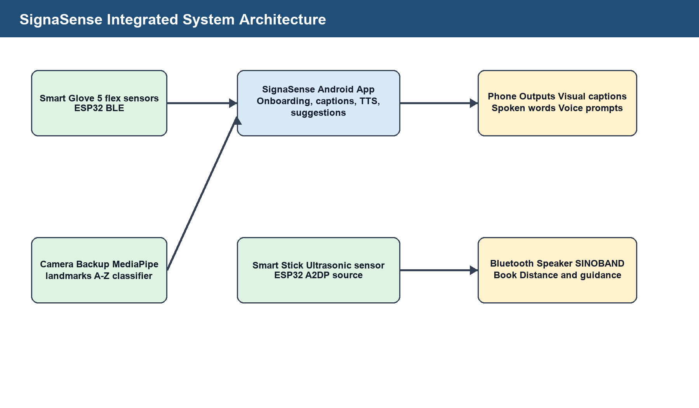
Figure 2: SignaSense integrated system architecture.

4.3 Smart Glove Hardware
The glove uses five flex sensors connected as voltage dividers. One side of each flex sensor is connected to 3.3 V, the signal node goes to an ESP32 analogue GPIO, and a resistor connects the signal node to ground. All sensors share a common ground with the ESP32. This arrangement converts finger bend into a changing analogue voltage that can be read using analogRead().
Finger/Line | ESP32 Pin | Purpose
Thumb | GPIO25 | Flex sensor voltage-divider signal
Index | GPIO33 | Flex sensor voltage-divider signal
Middle | GPIO32 | Flex sensor voltage-divider signal
Ring | GPIO35 | Flex sensor voltage-divider signal
Pinky | GPIO34 | Flex sensor voltage-divider signal
3.3 V | ESP32 3V3 | Flex sensor supply
GND | ESP32 GND | Common ground for all sensors
Table 3: Smart glove hardware pin allocation.
IMAGE NOTE: Paste the final glove wiring photograph or circuit diagram at this point.

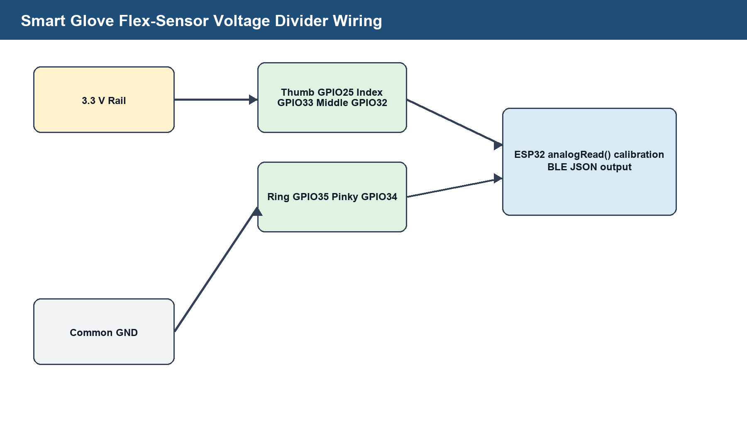
Figure 3: Smart glove flex-sensor voltage-divider wiring.
IMAGE NOTE: Paste the final completed glove prototype photograph here.
Figure 4: Final smart glove prototype with ESP32 and flex sensors.

4.4 Smart Glove Firmware
The glove firmware is contained in the Arduino IDE sketch SignaSenseGloveBLEESP32.ino. It initializes BLE with the device name SignaSenseGlove and exposes a service and characteristic for JSON notifications and control commands. The app scans for this BLE service and connects to receive live updates.
Sensor readings are collected at a short interval, smoothed using an exponential moving average and converted into bend percentages. Each finger is classified as NO SIGNAL, STRAIGHT, HALF or BENT. The firmware performs open-hand calibration so that readings are interpreted relative to the user's current sensor baseline rather than fixed universal values.
To reduce random letters, the firmware requires a stable detected sign before creating a pending letter. The workflow is deliberate: hold a sign, wait until it becomes stable, briefly open the hand to accept the letter into the word, and press Commit Word in the app to speak the finished word. This avoids speaking partial or accidental letters.
Because some ESP32 analogue pins can be affected by Wi-Fi, the final glove firmware uses BLE instead of Wi-Fi. The sketch also includes an auto-fallback map for diagnostic pins that showed live analogue readings during development, but the requested physical pin allocation remains documented.

4.5 Smart Stick Hardware
Component Line | ESP32 Pin | Purpose/Safety Note
Ultrasonic TRIG | GPIO5 | Outputs 10 microsecond trigger pulse
Ultrasonic ECHO | GPIO18 | Reads echo pulse duration; use level shifter or voltage divider if echo is 5 V
Buzzer | GPIO15 | Backup alert when Bluetooth speaker is disconnected
Ultrasonic VCC | Sensor supply | Connected according to sensor requirement
Ultrasonic GND | ESP32 GND | Common ground
Table 4: Smart stick hardware pin allocation.
IMAGE NOTE: Paste the smart stick circuit photograph showing ESP32, ultrasonic sensor and buzzer wiring.

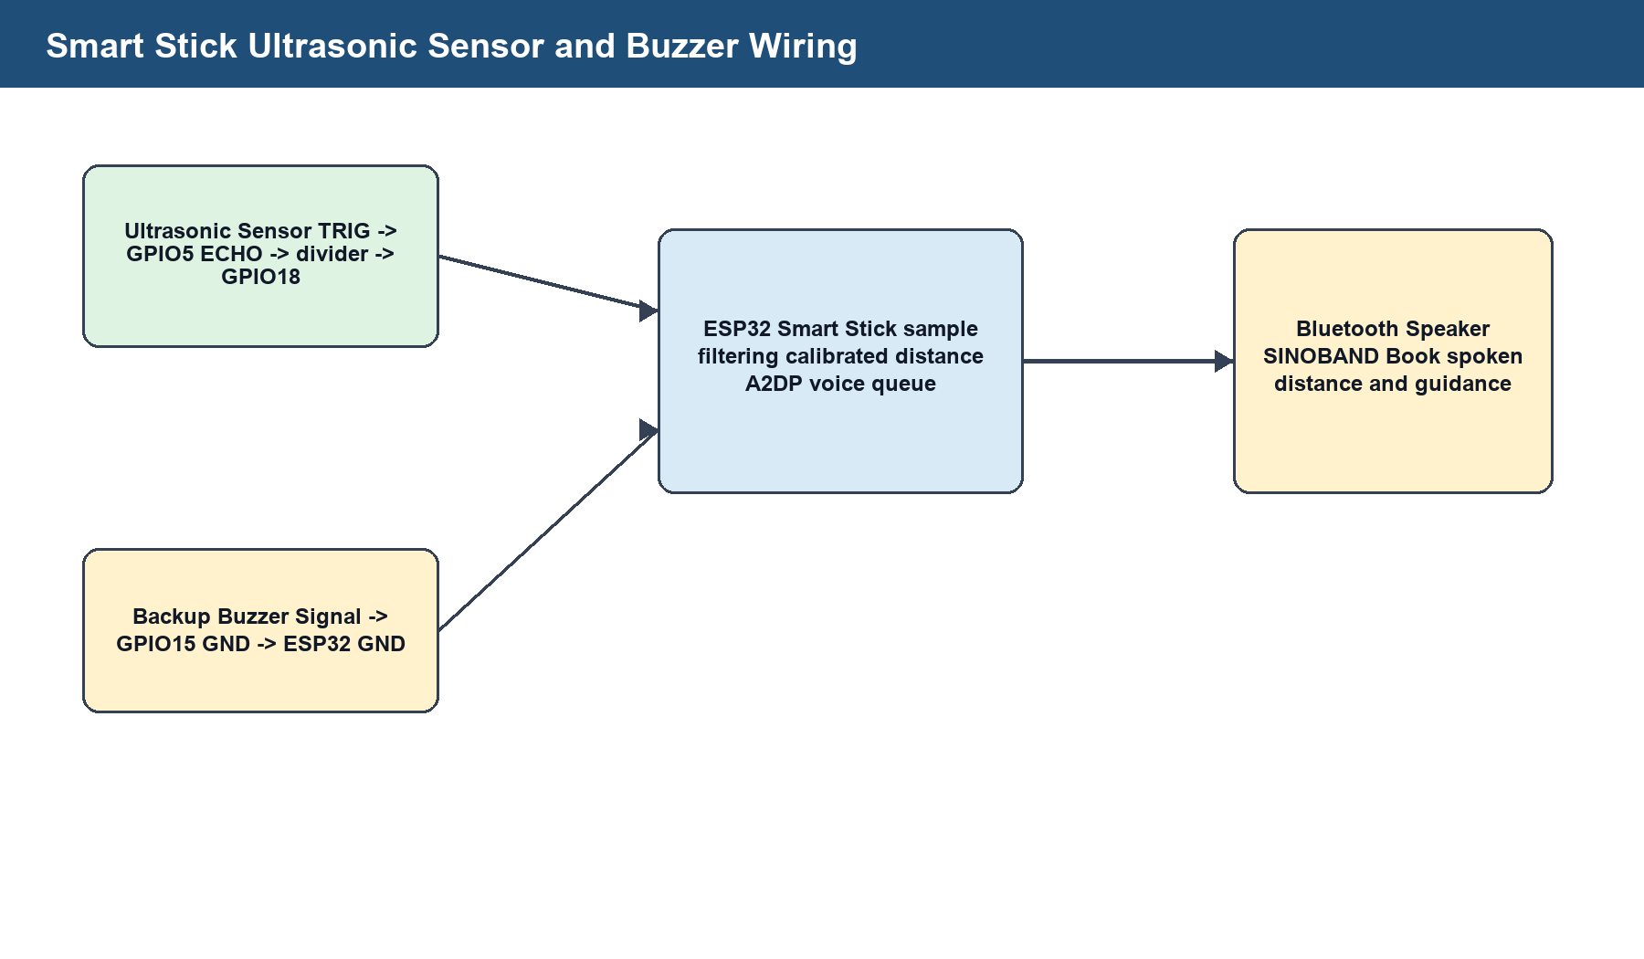
Figure 5: Smart stick ultrasonic sensor and buzzer wiring.
IMAGE NOTE: Paste the completed smart stick prototype photograph here.
Figure 6: Final smart stick prototype with ultrasonic sensor, buzzer and ESP32.

4.6 Smart Stick Firmware
The smart stick firmware is contained in SmartStickESP32.ino. The final mode disables phone Wi-Fi/app control and uses Bluetooth speaker output because real-time mobility guidance must be fast and not delayed by app polling. The ESP32 connects to the speaker named SINOBAND Book through Bluetooth A2DP and says Smart stick ready after connection.
Distance calculation uses the speed of sound adjusted by air temperature: speed = 331.3 + (0.606 x temperatureC) metres per second. The firmware includes a calibration scale and offset so the measured distance can be corrected after comparison with a ruler or tape measure. It outputs distance in one mode, metres, then immediately gives the action guidance.
Invalid or missing sensor readings are rejected using valid distance limits, echo timeout, several sample attempts, median-based agreement filtering and a short last-valid hold time. This makes the output more stable and reduces repeated false speech.
The stick speaks only when an obstacle is within the warning distance. If an object is very close, it says obstacle ahead, then stop now, with silence clips between phrases so the speech does not overlap. If the obstacle remains close, the stick guides the user to scan left slowly, then scan right slowly. It collects the best readings from both sides and recommends the clearer side or reports that no side is clear.
IMAGE NOTE: Insert a diagram or photo sequence showing the user scanning left, then right, before receiving path guidance.

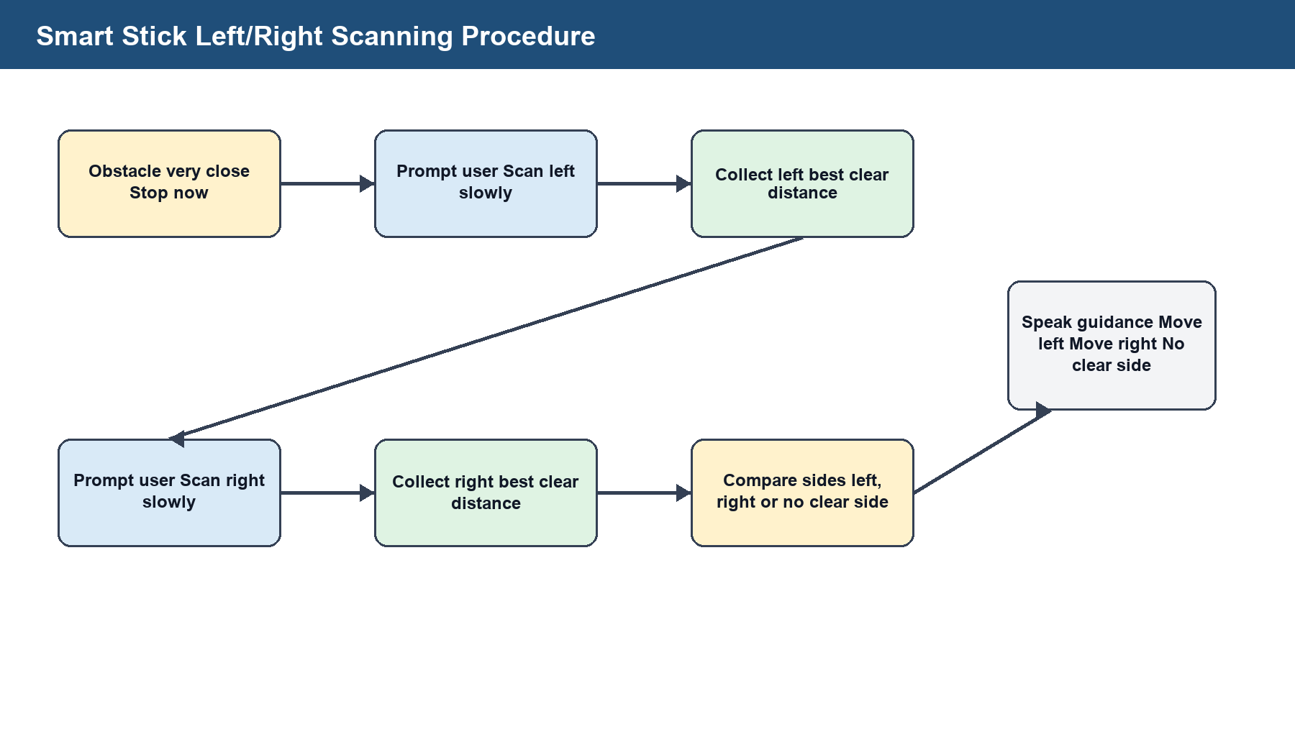
Figure 7: Smart stick left/right scanning procedure for route guidance.

4.7 Android Application
The Android application is named SignaSense. It was built in Kotlin using AndroidX, Material components, CameraX, MediaPipe Tasks Vision and Android speech APIs. The app opens with onboarding for blind and deaf users. Blind users receive spoken prompts and voice-command support where the phone supports speech recognition. Deaf users continue with a visual interface for captions, smart glove connection and camera sign recognition.
The app supports English, Luganda and Acholi selection in the onboarding flow. The main implemented speech and caption logic is strongest in English, while the language selection creates the interface structure for wider localisation. Dark and light mode selection was also added so users can choose the mode that is most comfortable for their environment.
The glove BLE screen scans for SignaSenseGlove, connects to the BLE service, receives JSON status, displays the current letter, word and captions, suggests available words, suggests sentences and speaks only committed words. The camera sign backup screen uses the phone camera to detect hand landmarks and identify A-Z letters. It also allows user-defined sign training, where the user captures samples for A to Z and the model is stored only on the installed phone.
IMAGE NOTE: Paste screenshots of the final SignaSense onboarding, blind/deaf mode selection and dark/light mode selection.

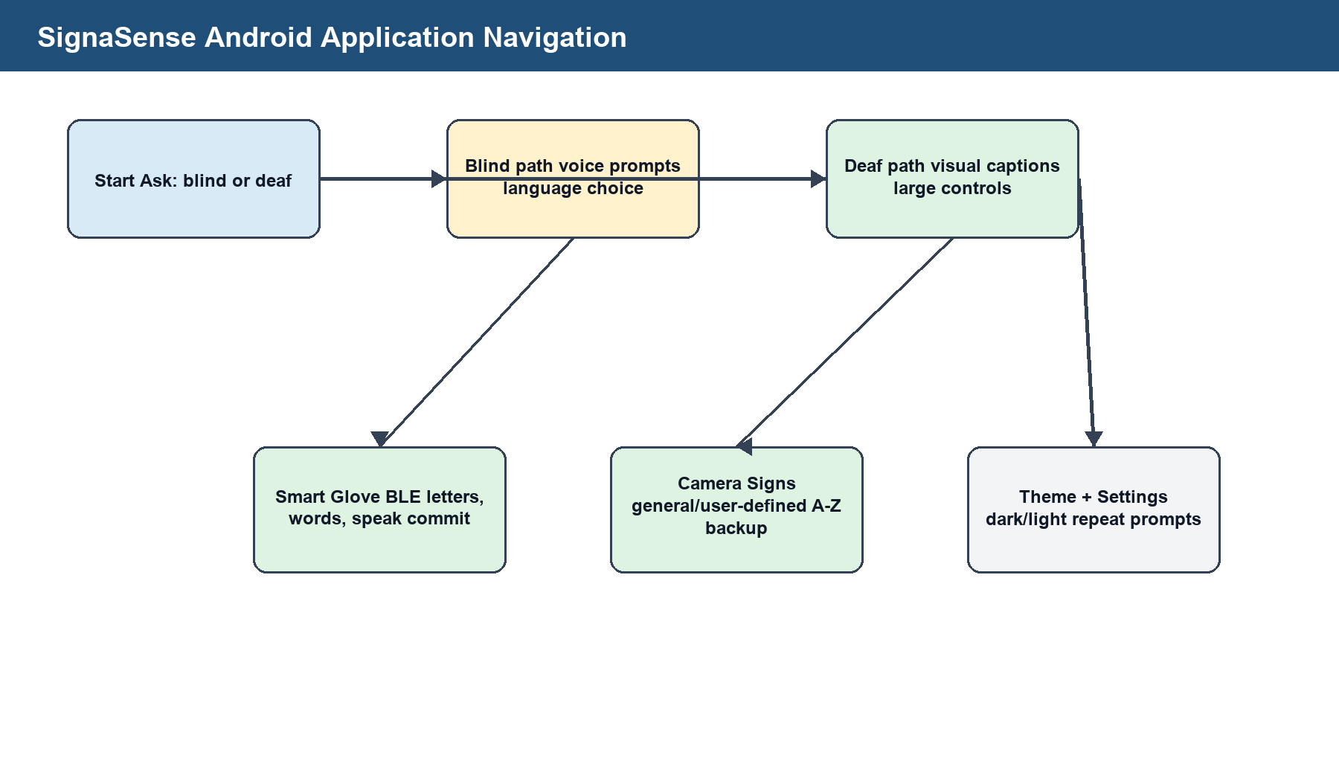
Figure 8: SignaSense Android onboarding, accessibility mode and theme selection.
IMAGE NOTE: Paste screenshots of the BLE glove screen with live letter, word suggestions and sentence suggestions.

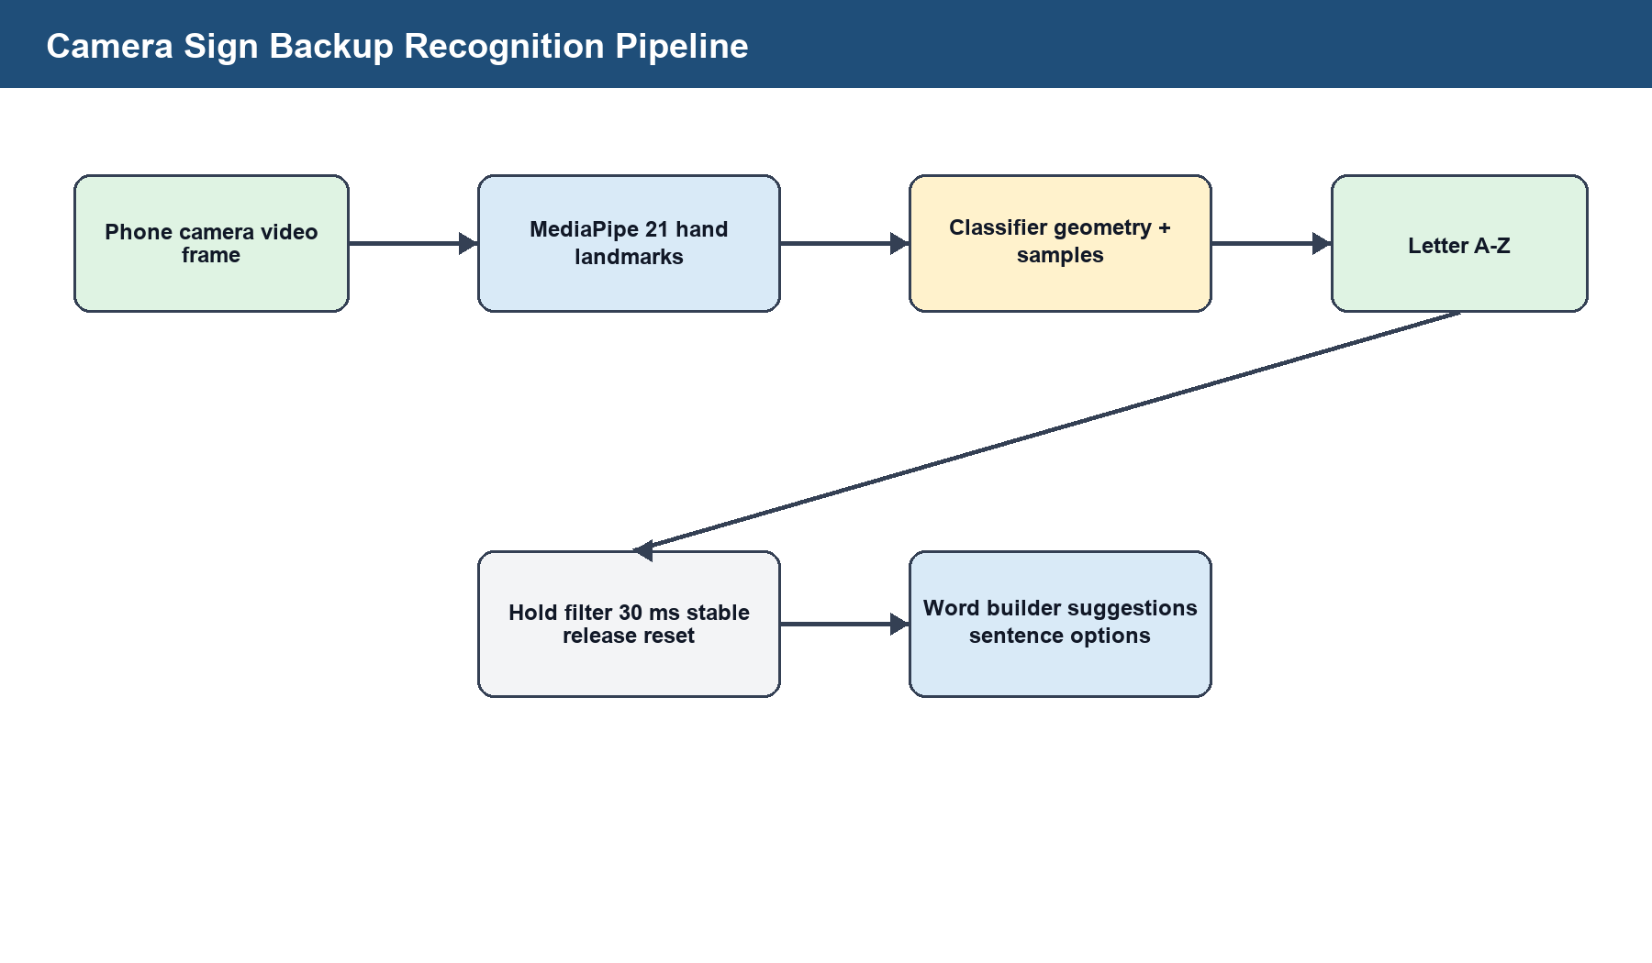
Figure 9: Camera sign backup recognition pipeline.
IMAGE NOTE: Paste screenshots of camera sign backup and user-defined sign training.

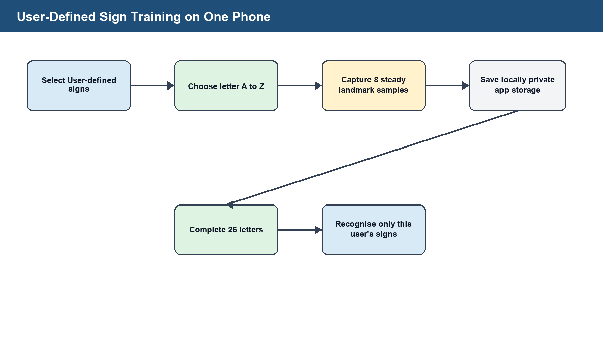
Figure 10: User-defined sign training workflow.

4.8 Software Tools and Libraries
Tool/Library | Use | Implementation Note
Arduino IDE | ESP32 firmware development | Used for smart glove and smart stick sketches.
ESP32 Arduino Core | GPIO, analogue reading and embedded runtime | Supports Arduino-compatible ESP32 programming.
ESP32 BLE Arduino | Glove communication | Used to expose BLE service, characteristic and notifications.
ESP32 A2DP Source library | Smart stick Bluetooth speaker output | Streams embedded speech clips to SINOBAND Book.
Android Studio/Gradle | Android app build | Built SignaSense APK.
Kotlin | Android application code | Main app, BLE screen and camera backup.
Android TextToSpeech | Phone speech output | Speaks prompts, words and suggested sentences.
Android SpeechRecognizer | Voice commands | Used in blind-mode onboarding where phone support exists.
CameraX | Camera frame analysis | Provides frames for hand-sign recognition.
MediaPipe Hand Landmarker | Hand landmarks | Detects 21 hand landmarks for camera sign backup.
Table 5: Software tools and libraries used.

CHAPTER FIVE: TESTING, RESULTS AND DISCUSSION

5.1 Introduction
Testing focused on verifying that each module performed its required function and that the final system behaviour matched the practical requirements developed during the project. The tests included hardware pin checks, serial monitor checks, Bluetooth connection checks, Android application installation, BLE glove communication, camera model loading, word suggestion behaviour and smart-stick voice guidance.

5.2 Smart Stick Test Results
The smart stick code starts with a backup buzzer test, initializes the ultrasonic sensor pins and starts Bluetooth A2DP source mode. It repeatedly scans for the speaker name SINOBAND Book and also attempts direct connection to the known Bluetooth address stored in the firmware. Once the speaker connects, the stick outputs the ready phrase and waits for obstacle readings.
Distance testing was designed around repeated readings instead of a single pulse result. Each distance reading uses multiple attempts, removes outliers around the median and rejects readings outside the valid range. This protects the spoken output from missing echoes and sudden incorrect values.
The key behavioural result is that the stick does not keep speaking clear-path readings. It speaks when an obstacle is inside the warning range, spaces phrases to avoid overlap, and uses a scan procedure when the obstacle is very close. The scan procedure asks the user to scan left slowly, waits, asks the user to scan right slowly, waits again, compares the best distances and recommends the clearer side.

5.3 Smart Glove Test Results
The glove was tested through serial monitor output and Android BLE connection. The firmware prints the pin map, raw readings, bend percentages, states, detected letter, calibration state, pending letter, current word and BLE connection status. This made it possible to diagnose the earlier problem where only one sensor appeared to work or where some analogue pins showed no live readings.
The project discovered that reading the selected flex-sensor pins while using Wi-Fi could cause unreliable analogue values on ESP32 because of ADC2/Wi-Fi interaction. The final BLE design avoids the Wi-Fi conflict and makes the phone connection faster and more suitable for live glove readings.
Random letters were reduced using smoothing, calibration, stable-letter detection, release-to-accept workflow and app-side suggestion filtering. The app does not immediately speak every raw detected letter. It allows the user to build letters into a word, choose from suggested words and speak the full committed word.

5.4 Android App Test Results
The Android application was built into an APK named SignaSense.apk and installed on the connected phone during development. The final app includes the SignaSense name, app icon, onboarding flow, dark/light theme selection, blind and deaf interface choices, smart glove BLE screen, camera sign backup and user-defined sign training.
The camera backup loaded the bundled hand_landmarker.task model and gesture_landmarks.csv asset. The provided desktop .pkl and .h5 model files were not directly usable inside Android, so the app integrated the usable model asset and converted landmark data into an on-device classifier. User-defined signs are saved in the phone's private app storage as local landmark samples.
The app's word-suggestion logic takes detected letters or a live letter preview, compares them with a dictionary of useful words and shows likely completions. Sentence suggestions are generated from current words and known communication phrases such as I NEED HELP, PLEASE HELP ME, I NEED WATER, STOP NOW, GO LEFT and GO RIGHT.

5.5 Functional Test Summary
Table 6: Functional test summary.
Test Area | Procedure | Expected Result | Status
Smart stick startup | Power ESP32 and keep SINOBAND Book close | Buzzer test runs; Bluetooth scan starts; ready phrase expected after connection | Pass in firmware logic; final live speaker confirmation should be recorded.
Distance reading | Place obstacle at practical walking distances | Serial monitor prints valid cm/metre readings; invalid echoes are rejected | Pass in firmware logic; insert measured ruler comparison table.
Obstacle speech | Move obstacle inside warning distance | Stick speaks distance and guidance without overlapping phrases | Implemented.
Very close scan | Move obstacle under scan trigger distance | Stick prompts left scan, right scan and recommends clearer side | Implemented.
Backup buzzer | Disconnect Bluetooth speaker | Buzzer pattern changes by distance | Implemented.

Table 6 (continued): Functional test summary.
Test Area | Procedure | Expected Result | Status
Glove BLE | Open app and connect to SignaSenseGlove | Phone receives JSON notifications and displays letter/word state | Implemented.
Glove calibration | Hold open hand and recalibrate | Baseline updates and bend percentages become relative to the user's hand | Implemented.
Word commit | Hold letters, accept into word and commit | Phone speaks only the committed full word | Implemented.
Camera backup | Open Camera Signs screen | Phone camera detects hand landmarks and predicts A-Z letters | Implemented with accuracy dependent on lighting and hand pose.
User-defined signs | Train A-Z signs on the phone | Samples are stored locally and used only on that phone | Implemented.

5.6 Discussion
The major technical lesson from the glove is that flex sensors alone cannot fully recognise international sign language or full ASL grammar. They can reliably support a conservative alphabet subset when the user follows a deliberate hold-and-confirm workflow. This is why the app's word suggestions and commit button are important: they prevent accidental raw letters from becoming spoken output.
The major technical lesson from the stick is that navigation speech must be immediate and controlled. The earlier app-linked approach introduced delay, so the final stick works without the phone and sends audio directly to the Bluetooth speaker. The firmware speaks only meaningful obstacle events and does not repeat clear-path readings.
The camera backup improves resilience because it allows sign detection even when the glove battery is low. However, it depends on lighting, hand visibility, camera angle and pose quality. It should therefore be presented as a backup and demonstration feature, while the glove remains the main sensor-based communication device.
NOTE: Insert formal user-evaluation charts here if questionnaire or participant-test results become available.

CHAPTER SIX: SUMMARY, CONCLUSION AND RECOMMENDATIONS

6.1 Summary
SignaSense was developed as an integrated assistive prototype for communication and mobility support. The final system includes an ESP32 smart glove, an ESP32 smart stick and an Android application. The glove supports letter detection, word building and BLE communication. The app supports captions, speech output, word suggestions, sentence suggestions, camera backup, local user-defined signs, voice onboarding and dark/light mode. The stick supports calibrated ultrasonic distance measurement, Bluetooth speaker voice guidance, backup buzzer alerts and left/right scan recommendations.

6.2 Conclusion
The project achieved its main goal of designing and developing a low-cost integrated assistive prototype. It demonstrates that affordable sensors, ESP32 microcontrollers and an Android application can be combined to support both deaf and blind users. The final prototype is not a certified medical device and does not replace full sign-language interpretation or professional mobility training, but it provides a strong foundation for practical assistive innovation in low-resource settings.

6.3 Recommendations
- Carry out supervised testing with deaf and blind participants and record recognition accuracy, distance error, response time and user satisfaction.
- Improve glove hardware by using more stable analogue wiring, fixed resistor values, strain relief and a wearable enclosure.
- Add more sensing modalities to the glove, such as inertial measurement, palm orientation or contact sensing, to distinguish signs that flex sensors alone cannot separate.
- Add more obstacle sensors to the stick for left, right and ground-level detection without requiring manual sweeping.
- Improve local language support by recording or synthesising high-quality English, Luganda and Acholi speech prompts.
- Prepare a field-ready enclosure for the ESP32 boards, battery, charger and cables to improve safety and durability.
- Expand the app dictionary and sentence suggestions based on real communication needs gathered from users.

6.4 Areas for Further Study
- Machine-learning model training for larger sign-language vocabularies and dynamic gestures.
- Offline on-device speech recognition for voice commands without internet dependency.
- Battery-life optimisation for both glove and stick.
- Comparative usability testing between glove recognition and camera-only recognition.
- Integration of vibration feedback for users who cannot hear phone or speaker output.
- A multilingual assistive prompt library for English, Luganda and Acholi.

References
Abougarair, A. (2022) 'Smart glove for sign language translation'. Full publication details were not available in the provided project source document.
Ambar, R., et al. (2020) 'Development of a wearable sensor glove for real-time sign language translation'. Full publication details were not available in the provided project source document.
Android Developers (2026a) SpeechRecognizer. Available at: https://developer.android.com/reference/android/speech/SpeechRecognizer.html (Accessed: 2 May 2026).
Android Developers (2026b) TextToSpeech. Available at: https://developer.android.com/reference/android/speech/tts/TextToSpeech (Accessed: 2 May 2026).
Android Developers (2026c) Image analysis. Available at: https://developer.android.com/media/camera/camerax/analyze (Accessed: 2 May 2026).
Espressif Systems (2022) Analog to Digital Converter (ADC) - ESP32. ESP-IDF Programming Guide. Available at: https://docs.espressif.com/projects/esp-idf/en/v4.4.2/esp32/api-reference/peripherals/adc.html (Accessed: 2 May 2026).
Espressif Systems (2026a) ESP32 Series Datasheet. Available at: https://documentation.espressif.com/esp32_datasheet_en.html (Accessed: 2 May 2026).
Espressif Systems (2026b) Bluetooth A2DP API - ESP32. ESP-IDF Programming Guide. Available at: https://docs.espressif.com/projects/esp-idf/en/stable/esp32/api-reference/bluetooth/esp_a2dp.html (Accessed: 2 May 2026).
Espressif Systems (2026c) BLE - Arduino ESP32 documentation. Available at: https://docs.espressif.com/projects/arduino-esp32/en/latest/api/ble.html (Accessed: 2 May 2026).
Farooq, M., et al. (2022) 'IoT-enabled intelligent stick for visually impaired people'. Full publication details were not available in the provided project source document.
Gallaudet University (2018) K-12 ASL Content Standards. Available at: https://gallaudet.edu/wp-content/uploads/gcloud/gal-media/Documents/ASL-Standards/K-12-ASL-Content-Standards.pdf (Accessed: 2 May 2026).
Google AI Edge (n.d.) Hand landmarks detection guide for Android. Available at: https://ai.google.dev/edge/mediapipe/solutions/vision/hand_landmarker/android (Accessed: 2 May 2026).
National Council for Disability (2019) Disability Status Report - Uganda, 2019. Available at: https://ncpd.go.ug/sites/default/files/2022-04/Disability%20report%202019%20p.pdf (Accessed: 2 May 2026).
Olayiwola, A., et al. (2025) 'A smart walking stick with voice guidance in an African language'. Full publication details were not available in the provided project source document.
Uganda (2020) Persons with Disabilities Act, 2020. Available at: https://media.ulii.org/media/legislation/118805/source_file/f6873c2133888a13/2020-3.pdf (Accessed: 2 May 2026).
World Health Organization (2026a) Deafness and hearing loss. Available at: https://www.who.int/en/news-room/fact-sheets/detail/deafness-and-hearing-loss (Accessed: 2 May 2026).
World Health Organization (2026b) Blindness and vision impairment. Available at: https://www.who.int/news-room/fact-sheets/detail/blindness-and-visual-impairment (Accessed: 2 May 2026).

Appendices

Appendix A: Source Code and Build Artefacts
Artefact | Workspace Location
Smart stick firmware | D:\desktop\Glove\SmartStickESP32\SmartStickESP32.ino
Smart stick speech clips | D:\desktop\Glove\SmartStickESP32\SpeechClips.h
Smart glove BLE firmware | D:\desktop\Glove\SignaSenseGloveBLEESP32\SignaSenseGloveBLEESP32.ino
Android main activity | D:\desktop\Glove\AssistBridgeApp\app\src\main\java\com\assistbridge\app\MainActivity.kt
Android BLE glove screen | D:\desktop\Glove\AssistBridgeApp\app\src\main\java\com\assistbridge\app\GloveBleActivity.kt
Android camera backup screen | D:\desktop\Glove\AssistBridgeApp\app\src\main\java\com\assistbridge\app\CameraSignActivity.kt
Built APK | D:\desktop\Glove\SignaSense.apk
The listed files were used as implementation evidence for this report. For final submission, source-code printouts may be attached only if required by the department.

Appendix B: Questionnaire
The detailed user evaluation questionnaire is provided in Appendix M.

Appendix C: Interview Guide
The interview guide questions are provided in Appendix N.

Appendix D: Consent Form
NOTE: Insert signed/approved consent form template if required.

Appendix E: Work Plan
The completed project work plan and Gantt chart are provided in Appendix I.

Appendix F: Generated System Design Figures
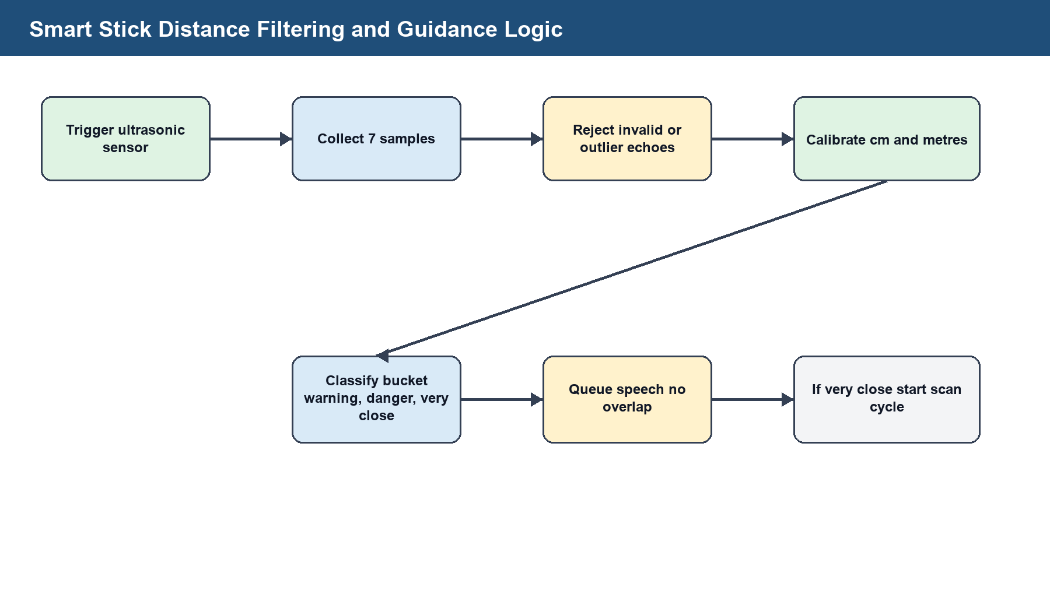
Figure 11: Smart stick distance filtering and guidance logic.
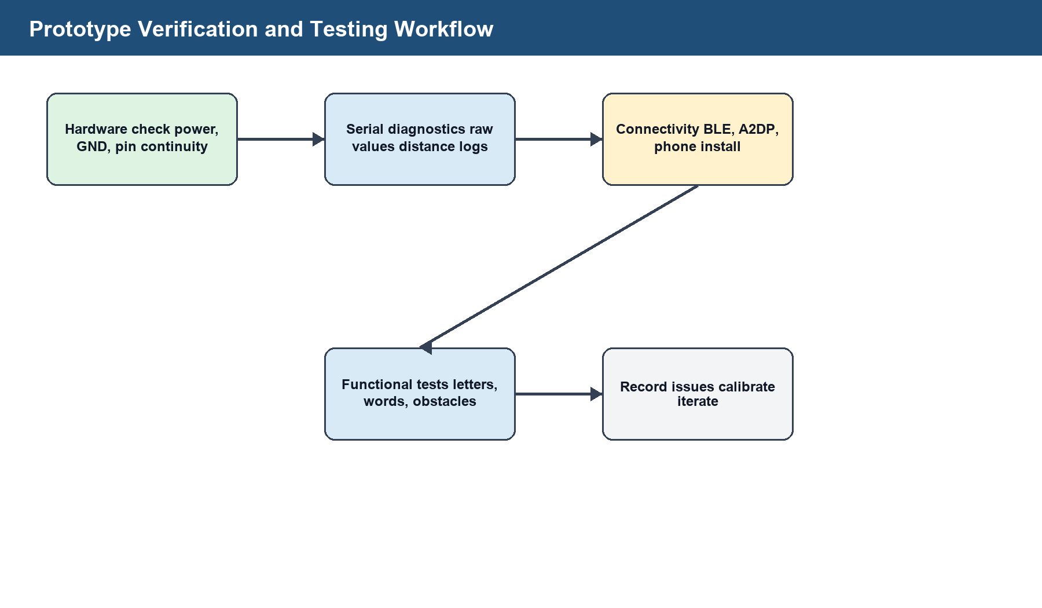
Figure 12: Prototype verification and testing workflow.

Appendix G: Detailed System Requirements Matrix
This matrix expands the functional and non-functional requirements used during implementation. It can be used during marking to trace each prototype feature to a user need and to a verification method.
Table 8: Detailed system requirements matrix.
ID | Requirement | Description | Implementation | Verification
REQ-01 | Blind user onboarding | The app shall ask whether the user is blind or deaf at startup. | MainActivity onboarding with voice prompt. | Open app and confirm spoken/visual prompt.
REQ-02 | Language selection | The app shall offer English, Luganda and Acholi language choices. | Language buttons and voice command flow. | Select each language option and verify status text.
REQ-03 | Theme selection | The app shall allow dark and light mode selection. | ThemeSettings and resource colours. | Toggle themes and confirm readable interface.
REQ-04 | Glove sensor reading | The glove shall read five flex sensors continuously. | analogRead on configured ESP32 pins. | View raw values in Serial Monitor and BLE status.
REQ-05 | Glove calibration | The glove shall calibrate against the user's open hand. | Open-hand baseline and dynamic bend scale. | Recalibrate and observe bend percentage reset.
REQ-06 | Letter stability | The glove shall avoid accepting unstable letters. | Stable-letter and release-to-accept workflow. | Move fingers quickly and confirm random letters are not committed.
REQ-07 | Word formation | Detected letters shall form editable words. | Current word and app-side suggestions. | Hold signs, accept letters and view word output.
REQ-08 | Committed speech | The phone shall speak only the committed word. | Commit Word and Speak button/command. | Build a word and press commit.

Table 8: Detailed system requirements matrix (continued).
ID | Requirement | Description | Implementation | Verification
REQ-09 | Camera backup | The app shall detect hand signs using the phone camera. | CameraX and MediaPipe hand landmarks. | Open Camera Signs and hold hand in frame.
REQ-10 | User-defined signs | A user shall train a private alphabet on their own phone. | Local CSV storage in private app files. | Train samples and switch to user-defined mode.
REQ-11 | Obstacle distance | The stick shall measure obstacle distance continuously. | Ultrasonic trigger/echo and filtered samples. | Place objects at known distances and check serial output.
REQ-12 | Bluetooth speaker output | The stick shall send voice to SINOBAND Book. | ESP32 A2DP source and embedded speech clips. | Power speaker near stick and listen for ready phrase.
REQ-13 | No repeated speech | The stick shall not repeat the same clear reading continuously. | Speech throttle, bucket state and distance delta logic. | Hold a fixed obstacle and confirm speech spacing.
REQ-14 | Urgent stop | Very close obstacles shall trigger stop guidance. | Danger thresholds and speech queue. | Move obstacle below scan trigger distance.
REQ-15 | Path suggestion | The stick shall compare left and right scans. | Top-sample averaging and side comparison. | Scan left/right and confirm clearer-side advice.
REQ-16 | Backup buzzer | The buzzer shall alert when Bluetooth speaker is not connected. | Distance-based buzzer patterns. | Disconnect speaker and move obstacle.

Appendix H: Prototype Component and Cost Estimate
The project was designed around affordable and locally obtainable parts. The costs below are estimates and should be replaced with actual receipts before final financial submission.
Table 9: Prototype component and cost estimate.
Item | Qty | Unit Cost (UGX) | Estimated Cost (UGX) | Purpose
ESP32 development board | 2 | 35,000 | 70,000 | One board for glove and one for stick.
Flex sensor | 5 | 25,000 | 125,000 | One for each finger.
Fixed resistors | 5+ | 500 | 3,000 | Voltage-divider resistors and spares.
Ultrasonic sensor | 1 | 12,000 | 12,000 | Obstacle distance sensing.
Buzzer | 1 | 3,000 | 3,000 | Backup alert output.
Bluetooth speaker | 1 | Existing | 0 | SINOBAND Book used during prototype tests.
Jumper wires | 1 set | 10,000 | 10,000 | Prototype wiring.
Breadboard/perfboard | 1 | 15,000 | 15,000 | Circuit mounting.
Glove material | 1 | 15,000 | 15,000 | Wearable base.
Walking stick frame | 1 | 25,000 | 25,000 | Prototype stick body.
Power bank/battery | 2 | 30,000 | 60,000 | Portable power.
Enclosure and fasteners | 1 set | 20,000 | 20,000 | Protection and mounting.
Estimated subtotal: UGX 358,000. NOTE: Replace this estimate with actual purchased-item values if receipts are available.

Appendix I: Project Work Plan
The work plan is structured as a 16-week final-year project schedule. It covers investigation, design, implementation, integration, testing, documentation and presentation.
Table 10: Project work plan.
Week(s) | Activity | Description | Deliverable
1-2 | Problem identification and topic refinement | Define disability problem, project title and scope. | Approved project direction.
1-5 | Literature review | Study smart gloves, smart sticks, accessibility apps and relevant laws. | Literature review chapter.
3-5 | Requirements analysis | Identify user, hardware, software and safety requirements. | Requirements matrix.
5-7 | Hardware design | Draw glove and stick wiring; select pins and components. | Circuit plan and parts list.
7-10 | Glove firmware | Read flex sensors, calibrate, classify bends and send BLE data. | BLE glove sketch.
7-11 | Stick firmware | Read ultrasonic distance, calibrate, speak guidance and scan sides. | Smart stick sketch.
8-13 | Android app | Build onboarding, BLE screen, camera mode and TTS. | SignaSense APK.
11-14 | Camera backup and user-defined signs | Integrate MediaPipe and local training. | Camera Signs screen.
13-15 | Integration | Connect glove to app; connect stick to speaker; refine thresholds. | Integrated prototype.
14-16 | Testing and debugging | Run functional tests and document issues. | Test summary.
12-16 | Report writing | Prepare final report, figures and presentation material. | Final report.
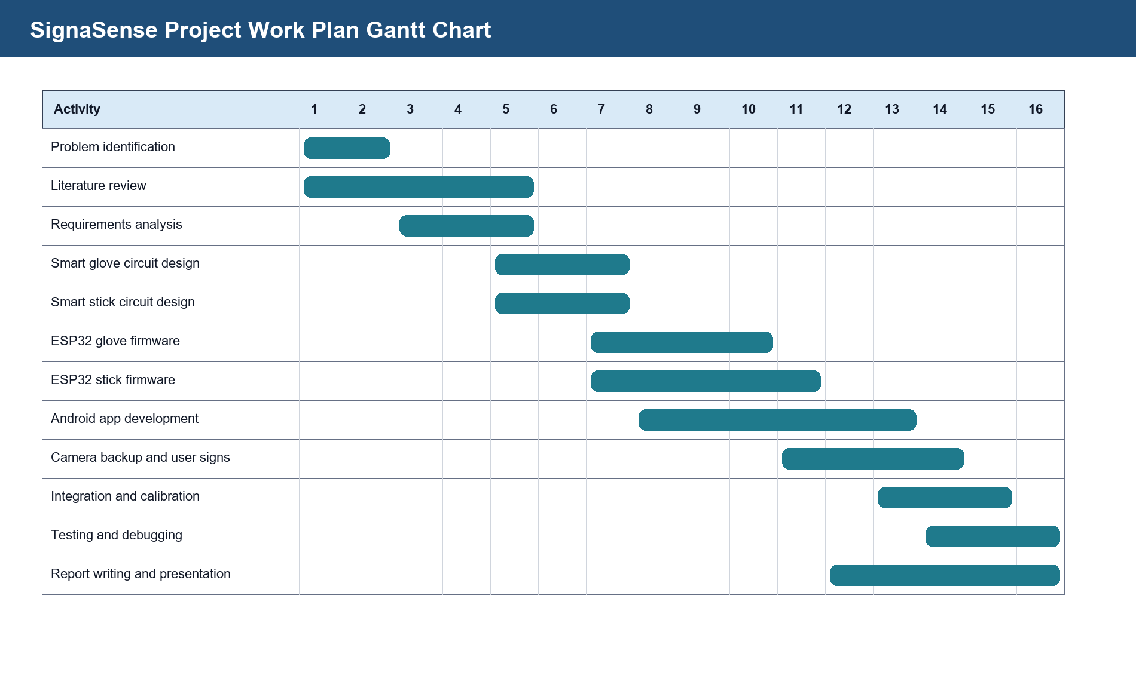
Figure 13: SignaSense project work plan Gantt chart.

Appendix J: Risk Register
Table 11: Risk register.
ID | Risk | Impact | Likelihood | Mitigation
R1 | Flex sensors read zero | High | High | Check voltage divider wiring, common ground and correct ADC pins.
R2 | Wi-Fi blocks ADC2 readings | High | High | Use BLE for glove communication and avoid Wi-Fi while reading ADC2 pins.
R3 | Random letters appear | High | Medium | Use smoothing, stable hold, open-hand release and app-side suggestion filtering.
R4 | Ultrasonic echo is 5 V | High | Medium | Use voltage divider or level shifter before ESP32 ECHO input.
R5 | Bluetooth speaker fails to connect | Medium | Medium | Keep speaker close, unpair from phone/PC and use known name/address fallback.

Table 11: Risk register (continued).
ID | Risk | Impact | Likelihood | Mitigation
R6 | Camera mode misreads signs | Medium | Medium | Use clear lighting, full hand in frame and user-defined training option.
R7 | Battery power is unstable | High | Medium | Use reliable power bank and secure cable connections.
R8 | Prototype wiring becomes loose | Medium | High | Move from breadboard to soldered/perfboard assembly before field use.
R9 | User cannot make standard signs | Medium | Medium | Use local user-defined signs stored on phone.
R10 | Formal testing data unavailable | Medium | High | Document prototype tests and schedule supervised user evaluation.

Appendix K: Calibration Guide and Record Sheet
Calibration is required because flex sensors, resistor values, hand size, power supply and ultrasonic sensor mounting can change readings. The tables below should be filled whenever the prototype is prepared for demonstration or field testing.
Smart glove calibration steps
Step | Action | Expected Output
1 | Connect all flex sensors and confirm common ground. | All raw values change when fingers move.
2 | Open the SignaSense app and connect to SignaSenseGlove. | BLE status shows connected.
3 | Hold the hand open and press Recalibrate Open Hand. | Baseline starts from current open hand.
4 | Bend each finger individually. | The matching bend percentage changes.
5 | Hold a known letter until stable. | The app shows stable/pending letter.
6 | Open hand to accept letter. | Letter moves into current word.
Smart stick calibration steps
Step | Action | Expected Output
1 | Set air temperature in the firmware if known. | Speed-of-sound calculation is closer to real conditions.
2 | Place a flat object at 50 cm. | Serial distance is near 0.5 m.
3 | Place a flat object at 100 cm. | Serial distance is near 1.0 m.
4 | Adjust calibration scale/offset if readings are consistently high or low. | Measured output matches ruler within acceptable margin.
5 | Test warning, danger and very-close thresholds. | Voice guidance changes by range.
6 | Run left/right scan test. | Best side is selected correctly.
Table 12: Calibration record sheet.
Date | Module | Measured Point | Observed Reading | Adjustment Made | Tester
____ | ____ | ____ | ____ | ____ | ____
____ | ____ | ____ | ____ | ____ | ____
____ | ____ | ____ | ____ | ____ | ____
____ | ____ | ____ | ____ | ____ | ____
____ | ____ | ____ | ____ | ____ | ____
____ | ____ | ____ | ____ | ____ | ____
____ | ____ | ____ | ____ | ____ | ____
____ | ____ | ____ | ____ | ____ | ____

Appendix L: Extended Functional Test Cases
Table 13: Extended functional test cases.
ID | Area | Test Case | Expected Result | Result | Notes
TC-01 | Glove | Raw sensor values print clearly to Serial Monitor. | Five raw values are visible or no-signal state is reported. | Pass/Fail: ____ | Notes: __________________
TC-02 | Glove | Open-hand recalibration resets baseline. | Bend percentages return near straight when hand is open. | Pass/Fail: ____ | Notes: __________________
TC-03 | Glove | Stable letter hold creates pending letter. | Pending letter appears only after stable hold. | Pass/Fail: ____ | Notes: __________________
TC-04 | Glove | Open hand accepts pending letter. | Letter is appended to word. | Pass/Fail: ____ | Notes: __________________
TC-05 | Glove | Commit Word and Speak outputs one full word. | Phone speaks the committed word once. | Pass/Fail: ____ | Notes: __________________
TC-06 | Glove | Clear Word resets current word. | Word field becomes empty. | Pass/Fail: ____ | Notes: __________________
TC-07 | App | Blind onboarding speaks first prompt. | Phone says SignaSense is ready. | Pass/Fail: ____ | Notes: __________________
TC-08 | App | Deaf mode shows visual controls. | Visual dashboard appears with glove/camera options. | Pass/Fail: ____ | Notes: __________________

Table 13: Extended functional test cases (continued).
ID | Area | Test Case | Expected Result | Result | Notes
TC-09 | App | Dark/light mode persists. | Theme remains after activity changes. | Pass/Fail: ____ | Notes: __________________
TC-10 | Camera | General signs detect A-Z shape. | Letter appears after stable hold. | Pass/Fail: ____ | Notes: __________________
TC-11 | Camera | No hand clears raw letter. | Letter returns to idle after release. | Pass/Fail: ____ | Notes: __________________
TC-12 | Camera | User-defined training captures samples. | Sample count increases to eight per letter. | Pass/Fail: ____ | Notes: __________________
TC-13 | Stick | Startup buzzer test runs. | Two short beeps occur. | Pass/Fail: ____ | Notes: __________________
TC-14 | Stick | Bluetooth speaker connects. | Smart stick ready phrase plays. | Pass/Fail: ____ | Notes: __________________
TC-15 | Stick | Obstacle at warning distance triggers guidance. | Distance and slow-down/obstacle phrase plays. | Pass/Fail: ____ | Notes: __________________
TC-16 | Stick | Very close obstacle triggers stop. | Obstacle ahead and stop now are spoken. | Pass/Fail: ____ | Notes: __________________

Table 13: Extended functional test cases (continued).
ID | Area | Test Case | Expected Result | Result | Notes
TC-17 | Stick | Left/right scan compares clear sides. | Clearer side is recommended. | Pass/Fail: ____ | Notes: __________________
TC-18 | Stick | Speaker disconnected uses buzzer. | Distance-pattern buzzer output works. | Pass/Fail: ____ | Notes: __________________
TC-19 | Stick | Invalid echo is rejected. | No false distance is spoken. | Pass/Fail: ____ | Notes: __________________
TC-20 | Integration | Phone app and glove communicate while stick runs independently. | Both assistive modules operate without blocking each other. | Pass/Fail: ____ | Notes: __________________

Appendix M: User Evaluation Questionnaire
This questionnaire should be completed after supervised prototype testing. Use a five-point scale: 1 = strongly disagree, 2 = disagree, 3 = neutral, 4 = agree, 5 = strongly agree.
Table 14: User evaluation questionnaire.
No. | Statement | 1 | 2 | 3 | 4 | 5
Q1 | The smart glove was comfortable to wear.
Q2 | The glove detected deliberate signs more accurately after calibration.
Q3 | The word suggestion section helped reduce typing or correction effort.
Q4 | The phone spoke committed words clearly.
Q5 | The camera backup was easy to understand.

Table 14: User evaluation questionnaire (continued).
No. | Statement | 1 | 2 | 3 | 4 | 5
Q6 | The user-defined training option would help users with different hand shapes.
Q7 | The smart stick gave obstacle warnings early enough.
Q8 | The spoken distance was understandable.
Q9 | The left/right scan guidance was easy to follow.
Q10 | The backup buzzer was useful when the Bluetooth speaker was not connected.

Table 14: User evaluation questionnaire (continued).
No. | Statement | 1 | 2 | 3 | 4 | 5
Q11 | The app interface was readable in light mode.
Q12 | The app interface was readable in dark mode.
Q13 | The system could improve communication independence.
Q14 | The system could improve mobility confidence.
Q15 | I would recommend improving this prototype for real-world use.

Appendix N: Interview Guide
Background
- What assistive devices do you currently use for communication or mobility?
- What challenges do you face when using those devices?
- How often do you need help from another person during communication or movement?
Smart glove feedback
- Were the glove sensors comfortable and secure?
- Which signs were easy or difficult to form?
- Would word suggestions help prevent wrong speech output?
- What local-language or common phrase features should be added?
Smart stick feedback
- Was the spoken distance clear and useful?
- Was the stop-now warning early enough?
- Was the left/right scanning instruction easy to follow?
- Would vibration feedback also be useful?
App feedback
- Was blind/deaf onboarding clear?
- Was dark/light mode useful?
- Would you prefer voice commands, buttons or both?
- How should the app improve captions and suggested sentences?

Appendix O: Prototype User Manual
Using the smart glove
- Charge or power the ESP32 glove before use.
- Open the SignaSense app and choose the deaf/visual interface or smart glove option.
- Tap Connect Smart Glove BLE and wait for SignaSenseGlove.
- Hold the hand open and press Recalibrate Open Hand.
- Make one letter sign and hold it steady until the app marks it stable or pending.
- Open the hand briefly to accept the letter into the current word.
- Use suggestions if the intended word appears.
- Press Commit Word and Speak only after the full word is correct.
Using camera sign backup
- Open Camera Signs in the app.
- Place the full hand in the camera frame with good lighting.
- Use General Signs for the built-in alphabet or User-Defined Signs for trained signs.
- For user-defined signs, capture enough samples for each letter A to Z.
- Commit completed words before speaking.
Using the smart stick
- Turn on the Bluetooth speaker named SINOBAND Book and keep it close to the stick.
- Power the ESP32 smart stick.
- Wait for the ready phrase.
- Move forward only when the stick is not warning of an obstacle.
- When it says stop now, stop first and then follow scan instructions.
- Scan left slowly when instructed, then scan right slowly.
- Move only toward the side recommended by the stick if the environment is safe.
Safety notes
- The prototype is not a certified medical or mobility device.
- Use it with supervision during demonstrations and testing.
- Do not rely on it near roads, stairs, open drains, water or hazardous machinery.
- Protect ESP32 pins from 5 V sensor signals using voltage division or level shifting.

Appendix P: Maintenance and Future Improvement Notes
- Move prototype wiring from breadboard and jumper wires to soldered perfboard or a printed circuit board before field use.
- Add strain relief to flex sensor leads to prevent wire breakage at the fingers.
- Use a stable 3.3 V supply for the glove sensors and avoid loose USB or power-bank cables.
- Create a protective enclosure for the smart stick ESP32 and ultrasonic sensor.
- Add more obstacle sensors or a servo-mounted sensor to reduce the need for manual left/right sweeping.
- Record high-quality local language voice clips for English, Luganda and Acholi prompts.
- Expand the glove beyond alphabet letters by adding phrase gestures and better motion sensing.
- Improve the camera model using real training data collected from the target users.
- Conduct field trials with users and update thresholds based on measured accuracy and comfort.

