# Performance Comparisons

## PRE GemFire 9.0.1 Testing Hash and Set testing

The following are the JUNIT test performance when ran against GemFire version 9.0.1 prior to introducing these changes.

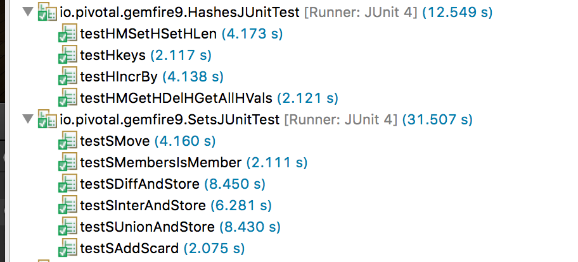

## AFTER Hash and Set Pull Request Changes

The following are the JUNIT test performance when ran against the GEODE-2469 changes.

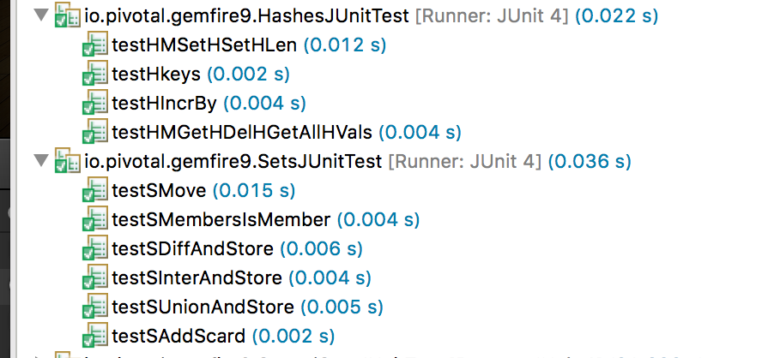

# Spring Data Redis Fix

The initial Spring Data Redis test running against GemFire 9.0.1 Spring Data Redis Tests all failed.

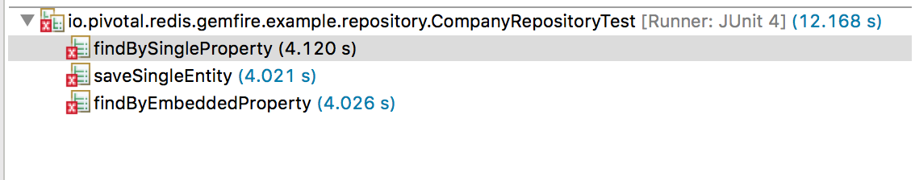

See <https://github.com/Pivotal-Data-Engineering/gemfire9_examples/tree/person_example_sdg_Tracker139498217/redis/spring-data-redis-example/src/test/java/io/pivotal/redis/gemfire/example/repository>

Exceptions related the keys having separated characters based on object:key format

See HASH section of the <https://redis.io/topics/data-types-intro> for more information on objects.

[Server error]

[fine 2017/02/10 16:04:33.289 EST server1 <Function Execution Processor2> tid=0x6a] Region names may only be alphanumeric and may contain hyphens or underscores: companies: 1000

java.lang.IllegalArgumentException: Region names may only be alphanumeric and may contain hyphens or underscores: companies: 1000

at org.apache.geode.internal.cache.LocalRegion.validateRegionName(LocalRegion.java:7618)

at org.apache.geode.internal.cache.GemFireCacheImpl.createVMRegion(GemFireCacheImpl.java:3201)

at ….

While hashes are handy to represent objects, actually the number of fields you can put inside a hash has no practical limits (other than available memory), so you can use hashes in many different ways inside your application.

The command [HMSET](https://redis.io/commands/hmset) sets multiple fields of the hash, while [HGET](https://redis.io/commands/hget) retrieves a single field. [HMGET](https://redis.io/commands/hmget) is similar to [HGET](https://redis.io/commands/hget) but returns an array of values:

> hmget user:1000 username birthyear no-such-field 1) "antirez" 2) "1977" 3) (nil)

There are commands that are able to perform operations on individual fields as well, like [HINCRBY](https://redis.io/commands/hincrby):

> hincrby user:1000 birthyear 10 (integer) 1987 > hincrby user:1000 birthyear 10 (integer) 1997

You can find the [full list of hash commands in the documentation](http://redis.io/commands#hash).

It is worth noting that small hashes (i.e., a few elements with small values) are encoded in special way in memory that make them very memory efficient.

## Spring Data Redis Geode Fix Performance

The following is the performance from GEODE-2469

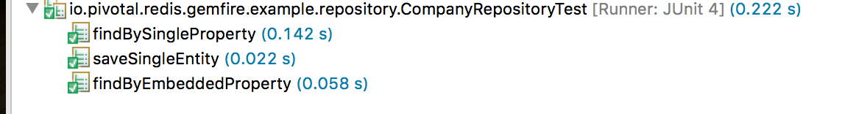

The following is how this is compared when point the Spring Data Redis code to a Redis version 3.2.7

