# OUTPUTS

PROGRAM 1  


PROGRAM 2  


PROGRAM 3  


PROGRAM 4  


PROGRAM 5  


PROGRAM 6  


PROGRAM 7  


PROGRAM 9  


PROGRAM 10  
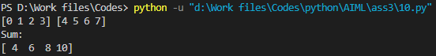

PROGRAM 11  


PROGRAM 12  


# OUTPUTS

PROGRAM OUTPUT  
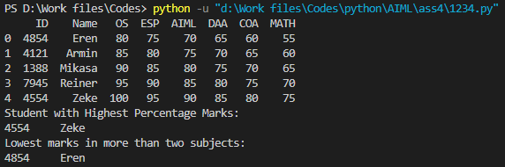

CSV FILE LOCATION  
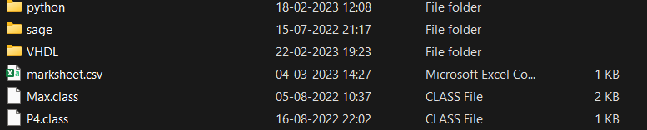

CSV FILE