# ADDER & SUBTRACTOR

## Half Adder

## Half Subtractor

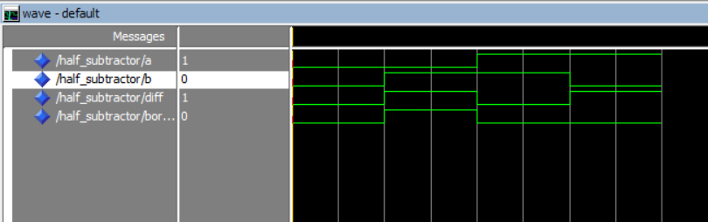

## Full Adder

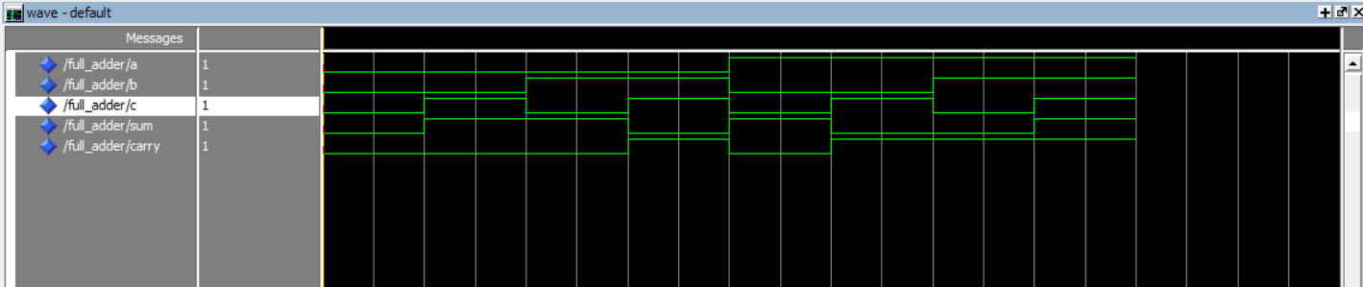

## Full Subtractor

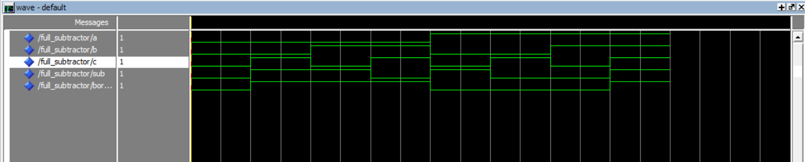

# MUX & DEMUX

## 2:1 MUX

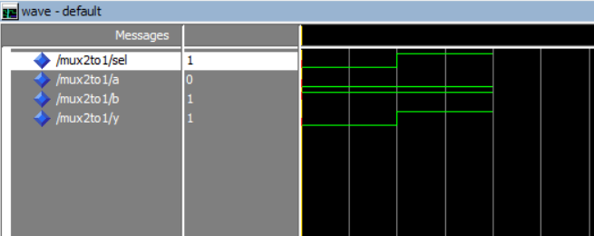

## 1:4 DEMUX

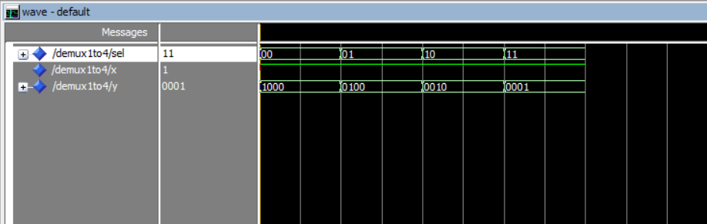

# CODERS

## DECODER

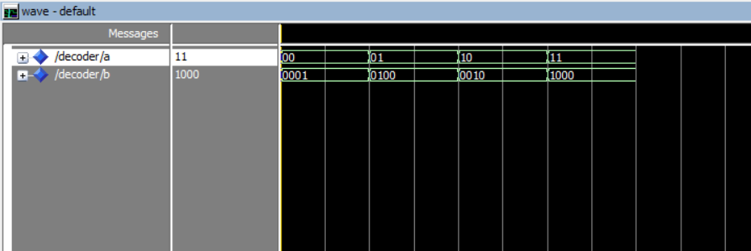

## ENCODER

## COMPARATOR

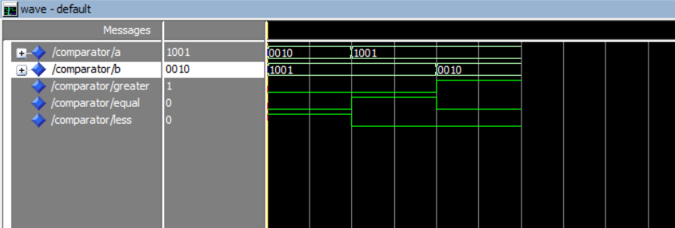

# PARITY

## PARITY ENCODER

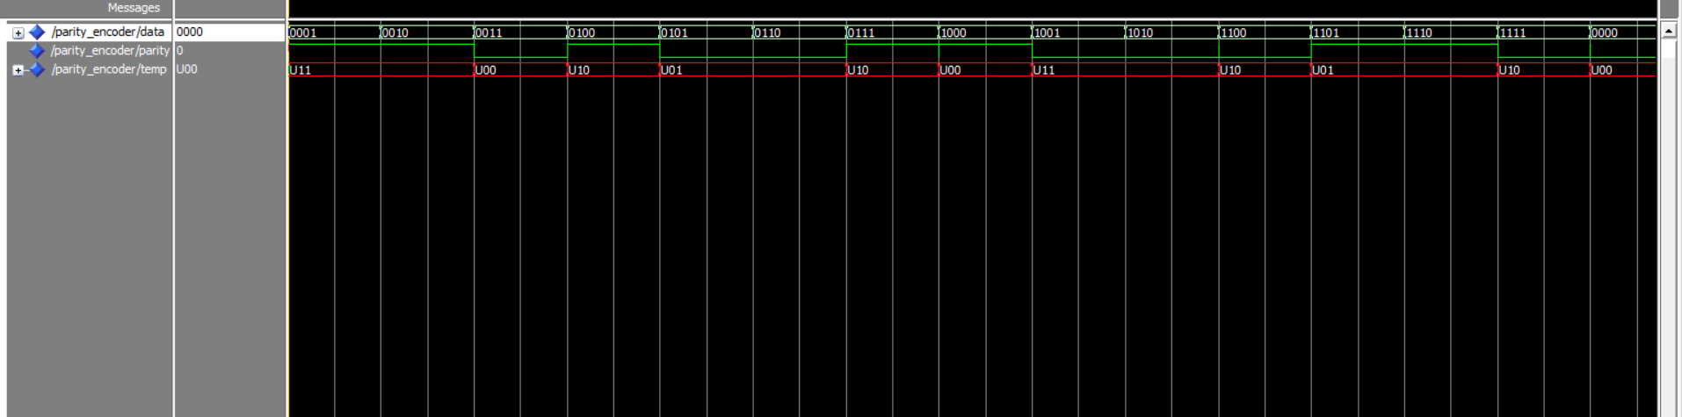

EVEN PARITY GENERATOR  
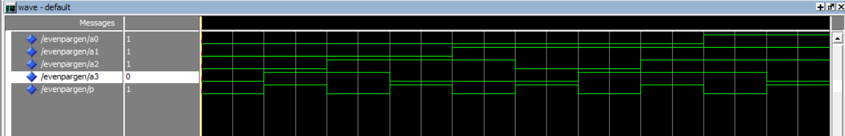

## ODD PARITY GENERATOR

## EVEN PARITY CHECKER



## ODD PARITY CHECKER

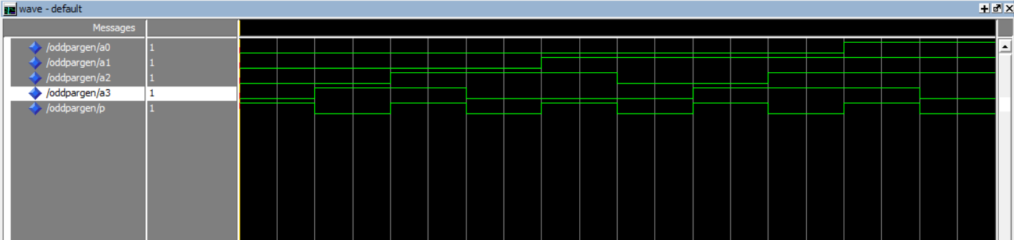

# CPU

## ALU

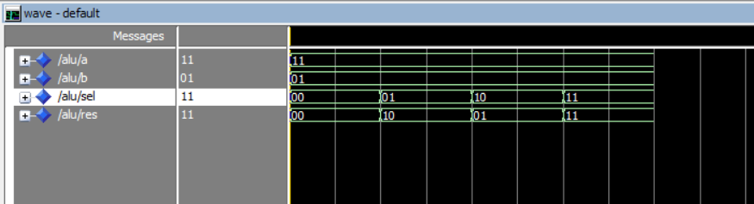

## ARITHMETIC UNIT

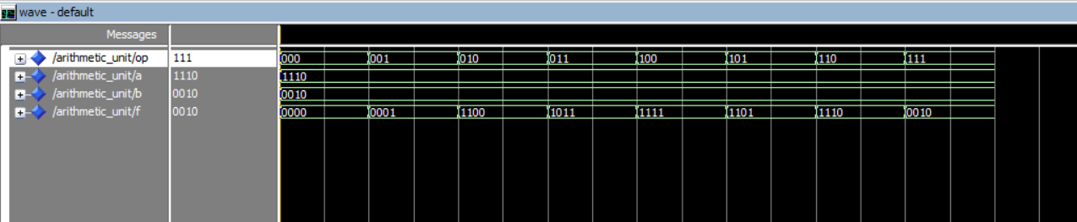

## LOGICAL UNIT

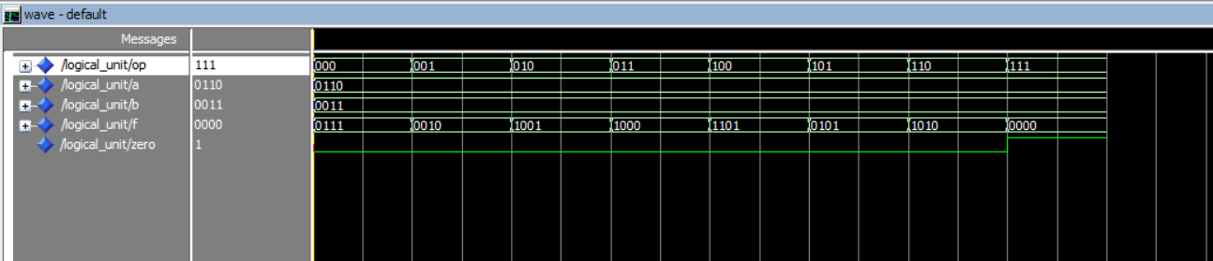

# RAM

