# OUTPUTS

## IMPLEMENTATION IN PYTHON:

PROGRAM 1  
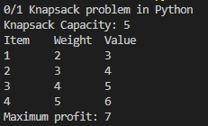

PROGRAM 2  


## IMPLEMENTATION IN C:

PROGRAM 1  
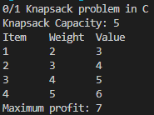

PROGRAM 2  
