# OUTPUTS

## Implementation in C:

PROGRAM 1  


PROGRAM 2  
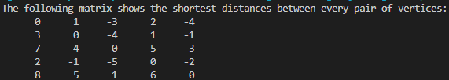

## Implementation in Python:

PROGRAM 1  


PROGRAM 2  
