# OUTPUTS X

## Implementation in Python:

PROGRAM 1:  
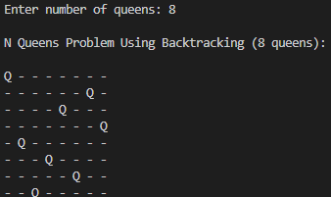

PROGRAM 2:  


## Implementation in C:

PROGRAM 1  
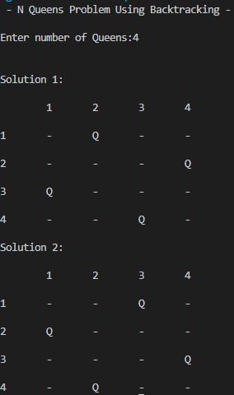

PROGRAM 2  
