# OUTPUTS

PROGRAM 1  
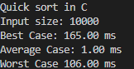  
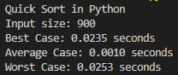

PROGRAM 2  
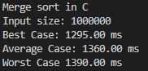  
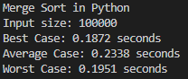

PROGRAM 3  
