# OUTPUTS

## LAB:

PROGRAM 1  
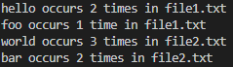

PROGRAM 2  
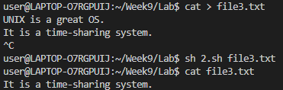

PROGRAM 3  
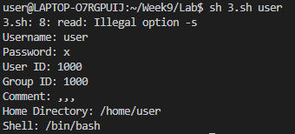

PROGRAM 4  
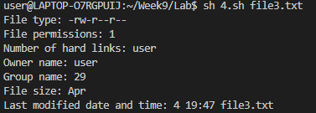

## HOME:

PROGRAM 1  
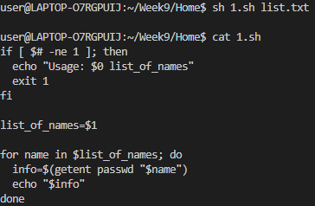

PROGRAM 2  


PROGRAM 3  
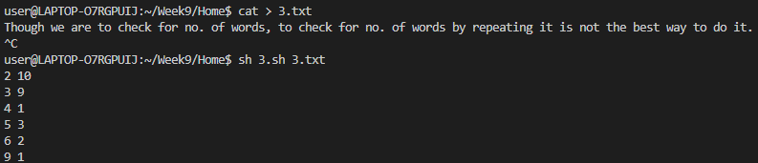

PROGRAM 4  
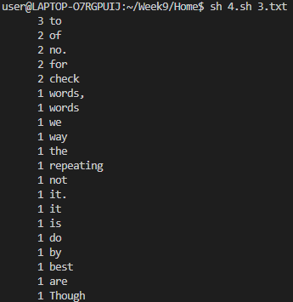

# OUTPUTS

## LAB:

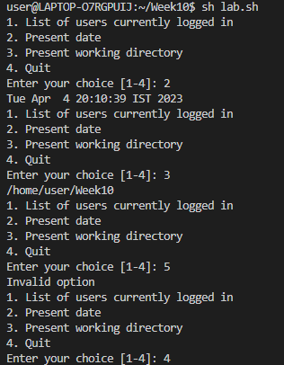

## HOME:

## 