# OUTPUTS

## LAB:

PROGRAM 1  
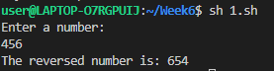

PROGRAM 2  
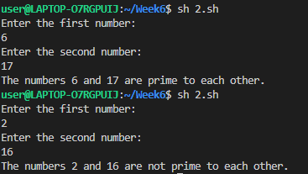

PROGRAM 3  
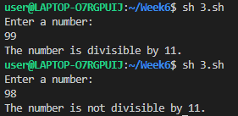

PROGRAM 4  
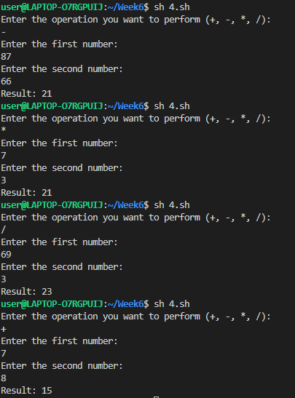

## HOME:

PROGRAMS 1, 2, 3 and 4 labelled as .sh files respectively  
