# OUTPUTS 7

## LAB:

PROGRAM 1  
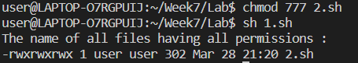

PROGRAM 2  
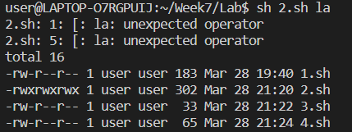

PROGRAM 3  
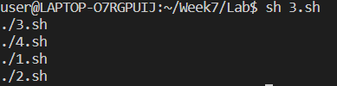

## HOME:

PROGRAM 1  
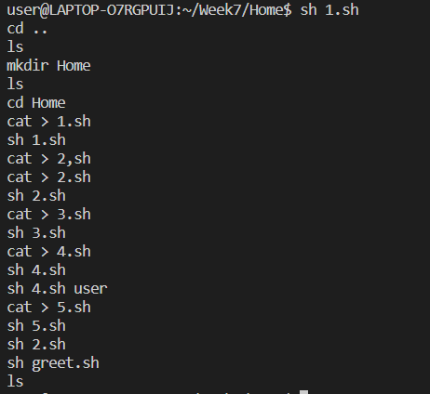

PROGRAM 2  


PROGRAM 3  
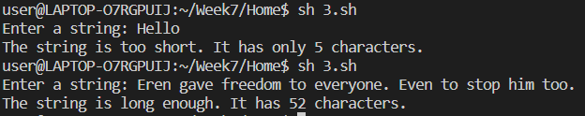

PROGRAM 4  


PROGRAM 5  
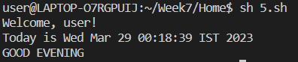

# OUTPUTS 8

## LAB:

PROGRAM 1  
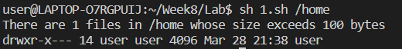

PROGRAM 2  
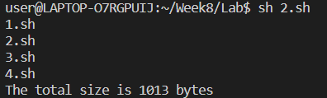

PROGRAM 3  


PROGRAM 4  


## HOME:

PROGRAM 1  
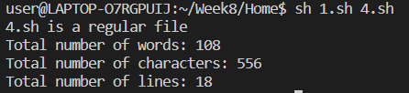

PROGRAM 2  
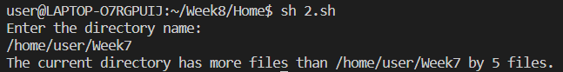

PROGRAM 4  
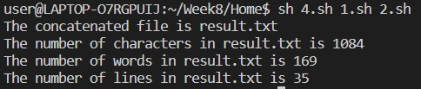

PROGRAM 5  


PROGRAM 3  
