CERTIFICATE OF COMPLETION
This is to certify that
Mr. Tayyab – Miss. Aliza & Miss. Muznah has participated in the e-project at the end of their semester, and the project that is being submitted is not being submitted by anyone else.

CONTENTS
INTRODUCTION 3
PROBLEM 4
SRS REQUIREMENTS 5
PROJECT PLAN 6
ER DIAGRAM 7
FLOW CHART 8
INTERFACE 9
UNIT TESTING CHECK LIST /FINAL CHECKING LIST 14

INTRODUCTION
In the wake of the unprecedented global challenges brought forth by the Coronavirus pandemic, societies have had to rapidly adapt and innovate to protect public health. One critical aspect of this response has been the development of digital tools to facilitate efficient healthcare services and mitigate the spread of the virus. This thesis embarks on a journey to address these pressing needs by proposing the design and development of a web application that serves as an online test and vaccination booking system for patients during the ongoing Covid-19 crisis.
The Covid-19 pandemic has reshaped the way healthcare services are delivered and accessed. It has highlighted the necessity of robust digital infrastructure to ensure seamless communication between healthcare institutions, administrative bodies, and individuals seeking healthcare services. The proposed web application serves as a powerful bridge connecting patients, hospitals, and healthcare administrators, fostering a united front against the pandemic.
This thesis explores the multifaceted capabilities and functionalities of the Covid-19 web application. The primary objectives of this web application include tracking vaccination appointments, maintaining comprehensive vaccination histories, and disseminating crucial Covid-19 solution guidelines for managing symptoms. By accomplishing these objectives, the application aims to streamline the healthcare process, enhance patient engagement, and provide valuable insights to healthcare providers and policymakers.
The Covid-19 web application emerges as a crucial solution in our collective fight against the pandemic. It leverages the power of digital technology to facilitate efficient healthcare management and coordination, thereby reducing the burden on healthcare systems and helping individuals make informed decisions about their health.
In the following chapters, this thesis will delve into the technical details, design principles, and implementation strategies of the Covid-19 web application. It will also highlight the significance of such digital solutions in a post-pandemic world, emphasizing the potential for continued innovation and adaptation in healthcare technology. Together, we will explore how this web application contributes to the global effort to combat Covid-19 and lays the foundation for a more resilient and interconnected healthcare ecosystem.

PROBLEM
Proposed Solution: Bridging the Healthcare Gap
The global response to the Coronavirus pandemic has unveiled the critical need for a unified healthcare infrastructure that not only connects various healthcare providers but also empowers individuals to take charge of their health. In this context, the proposed web application, designed and developed as part of this thesis, offers a comprehensive solution to an ever-evolving problem in the healthcare sector.
Online Registration System (ORS) is at the heart of our proposed solution, acting as a transformative framework that connects hospitals nationwide through a mobile number-based online registration and appointment system. This framework facilitates a seamless online appointment system for both Covid-19 testing and vaccination.
One of the core features of this portal is its ability to generate detailed reports, offering insights into the information of patients who have scheduled appointments through the system. This feature not only assists healthcare providers but also empowers administrative bodies with valuable data to make informed decisions regarding resource allocation and public health initiatives.
Moreover, this platform welcomes hospitals to join its network, allowing them to provide appointment slots for online booking by patients. This collaborative approach not only enhances the accessibility of healthcare services but also eases the burden on individual hospitals by distributing patient flow across the network.
Additionally, the system streamlines the registration and appointment process for hospitals, simplifying the management of appointments and the monitoring of patient flow. It ensures that healthcare providers can focus more on delivering high-quality care and less on administrative tasks, ultimately improving the overall patient experience.
The proposed web application is not just a technological innovation; it's a solution to a pressing problem that the pandemic has brought to the forefront. It exemplifies the power of digital technology in connecting healthcare institutions, optimizing patient care, and contributing to the global effort to combat Covid-19.
In the subsequent sections of this thesis, we will delve into the technical architecture, design principles, and implementation details that bring this innovative solution to life. We will also explore the potential for scalability and adaptation beyond the pandemic, envisioning a healthcare ecosystem that is not only interconnected but also resilient in the face of unforeseen challenges.

SRS REQUIREMENTS
ADMIN
- All Patient details | ✓
- Report of Covid test/vaccination | ✓
- Test report, Vaccination (Date/week/monthly report) | ✓
- List of vaccine | ✓
- available or unavailable | ✓
- Approval Hospital Login | ✓
- List of hospitals | ✓
ADMIN
- Register | ✓
- Login | ✓
- List of patient details | ✓
- Request from patient (Covid test/Vaccination) | ✓
- Approve or Reject | ✓
- Update Covid test result | ✓
- Update Vaccination status | ✓
PATIENT
- Register | ✓
- Login | ✓
- Search Covid Test/Vaccination hospital | ✓
- Request for Covid Test/Vaccination for hospital | ✓
- Report of covid test/Vaccination taken | ✓
- Book Hospital appointment | ✓
- My Appointment | ✓
- View Results | ✓
- My profile | ✓

PROJECT PLAN
Across the World People Are Facing Unforeseen Challenges
Due to Coronavirus Pandemic. Design and Develop A Web Application for Online Test and Vaccination Booking System for Patient. The Coved Web App Connects The People With The Hospital And The Administration To Come Together And Fight The Pandemic With The Web App, One Can Track The Vaccination Appointment, History And Coved Solution Guidelines For Symptoms’ Will Provide Online Registration System(OR’s)Is A Framework To Link Various Hospitals Across The Country For Mobile Number Based Online Registration And Appointments System. Portal Facilitates Online Appointments For Vaccination. Detail Reports Showing Information About Test And Vaccination Patients Taking Appointments Through The Portal Can Be Seen. Hospitals Can Come On Abroad This Platform And Provide Their Appointment Slots For Online Booking By Patients. The System Facilitates Hospitals To Easily Manage Their Registration And Appointment Process And Monitor The Flow Of Patients.

ER DIAGRAM

User
User_Id (primary key)
First Name
Last Name
Email
Contact
Password
Address
City
State
Postal
Country
Verified
Role
Reports
Report_Id (primary key)
User_Id (Foreign Key)
Hospital_id (Foreign Key)
Report Timing
Type
Test Type
Test Result
Vaccine Type
Vaccine Result
Available_Vaccine
Id (primary key)
Hospital_id (Foreign Key)
Vaccine Type
Vaccine Quantiy
Vaccine Color

Available Test
Id (primary key)
Hospital_id (Foreign Key)
Test Type

Hospitals
Hospital_id (Primary Key)
Hospital Name
Timing
Area
City

Hospital Users
User_Id (primary key)
Hospital_id (Foreign Key)
Name
Email
Password
Approved

Appointments
Appointment_Id (primary key)
User_Id (Foreign Key)
Hospital_id (Foreign Key)
Type
Status
Booking Time
Appointment Time
Codes
Id (primary key)
Mail
Type
Code

FLOW CHART

SITE FLOW CHART

START FLOW CHART
S
Normal Login & Register

Verify
Hospital Login & Register

Master
Approved
Admin
User

1. Doctors can update their hospital Vaccinations
2. Doctors can Add or Remove Vaccination and Tests from their hospital
3. Doctors can Reject or Approve Patient Appointments that are booked on their hospital
4. Doctors can see all approved patient details
5. Doctors can update user Covid Test and Vaccination Results
1. User Can Book Appointment in any hospital
2. User can see their appointments
3. User can see their covid-19 results
4. User can see their Vaccination suggestions and reports
5.User can customize their profile
1. Admin can export covid test and vaccine results
2. Admin can Add New Hospitals
3. Admin Can See list of all hospital and approve new doctors in each hospital
4. Admin Can See Vaccine Availability in Each Hospital
5. Admin Can See All Patient Details
6.Admin Can See All Booking and can see connected patient details
Master Can Add New Admins

INTERFACE

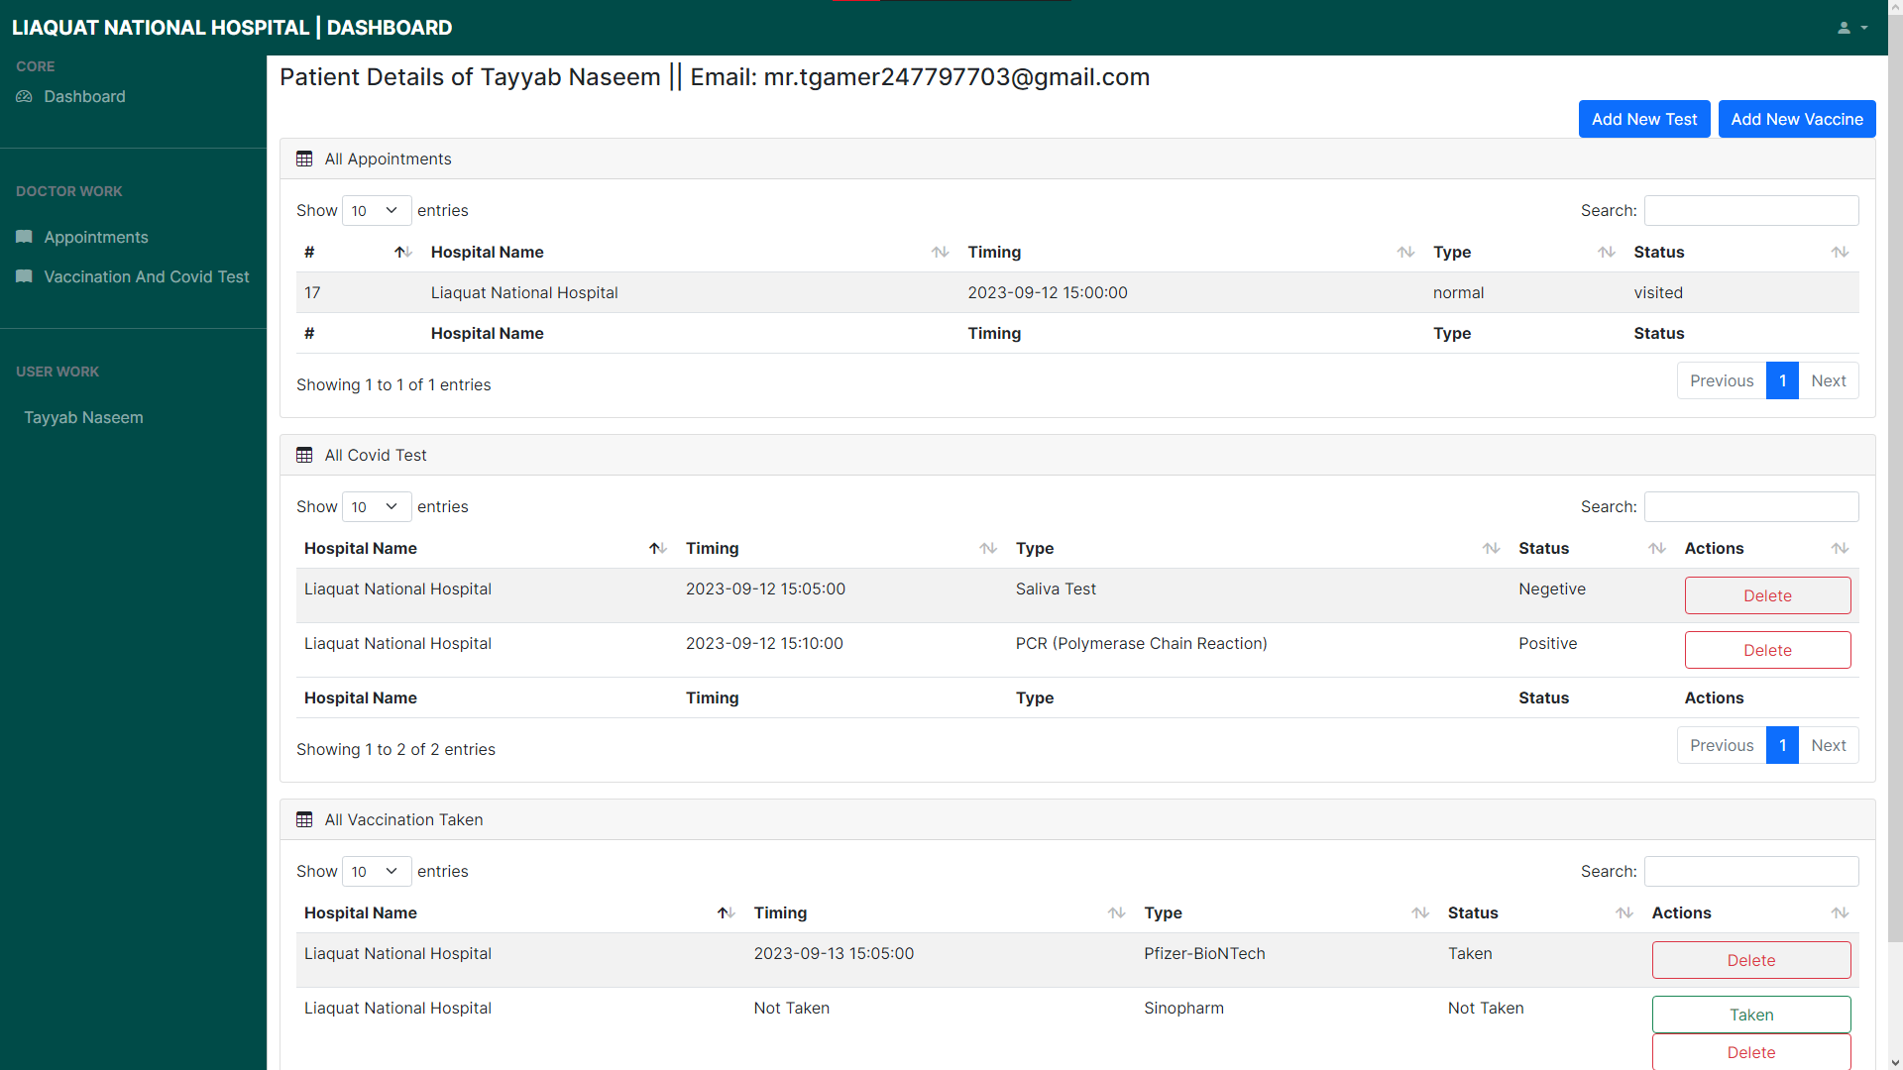
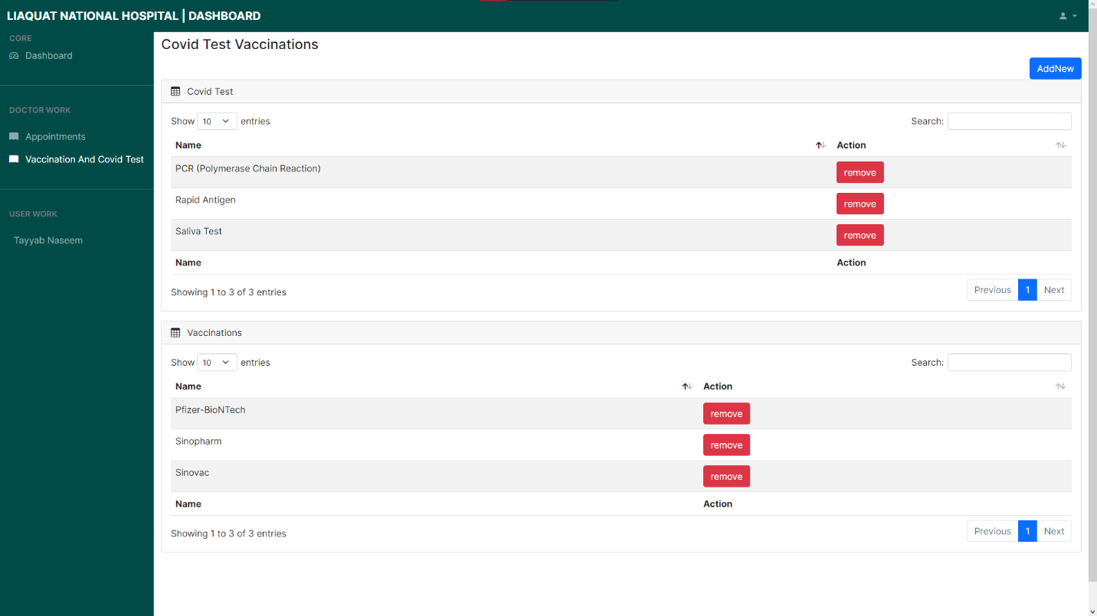

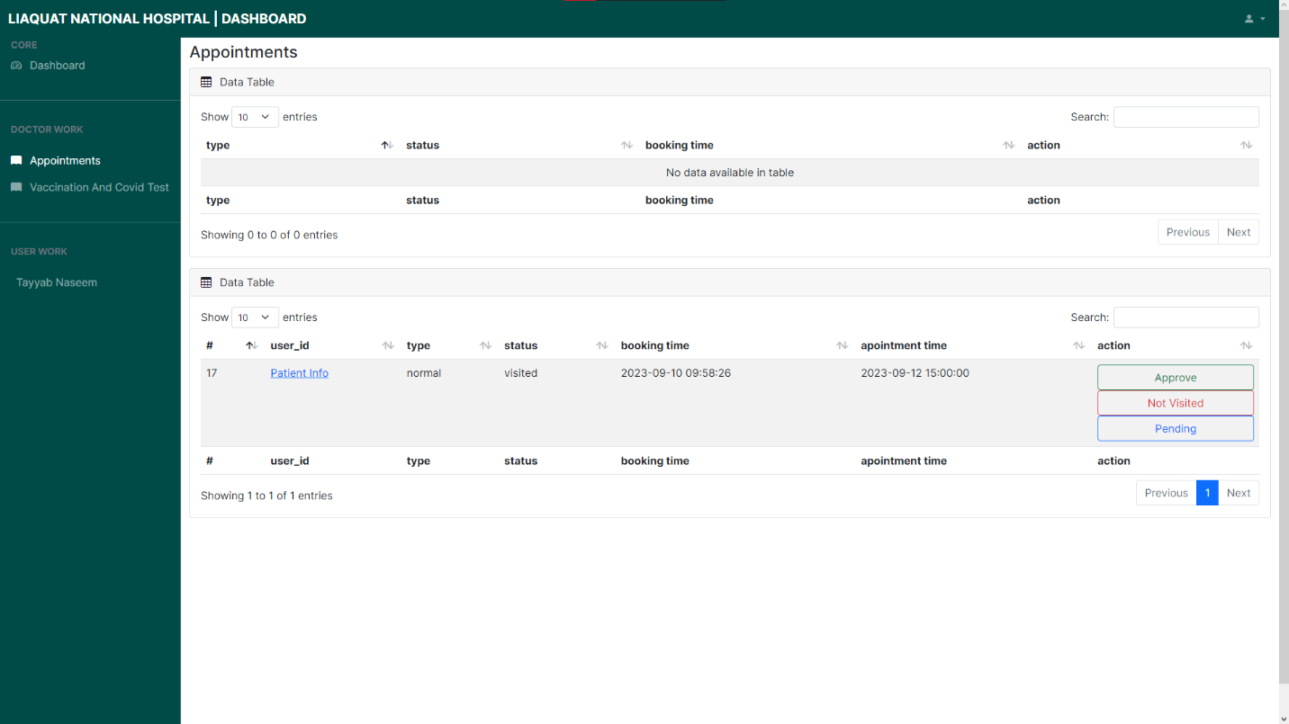
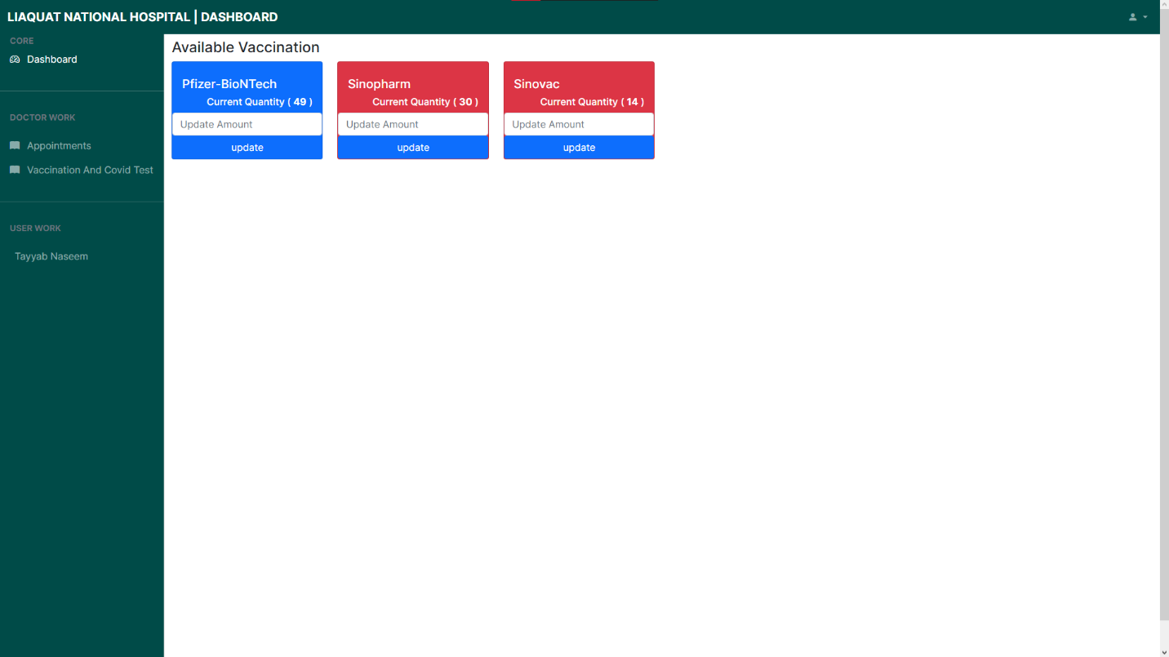
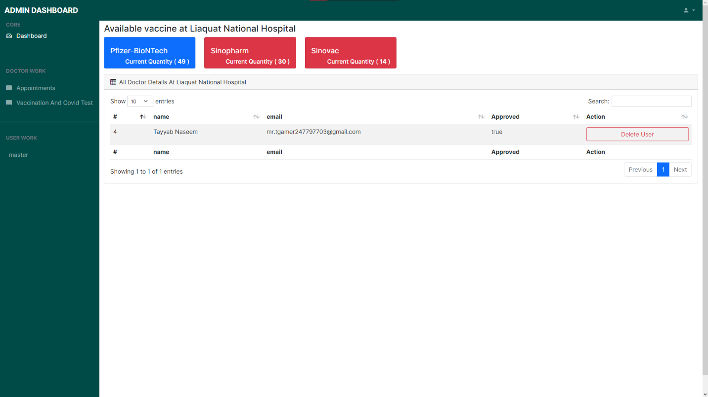
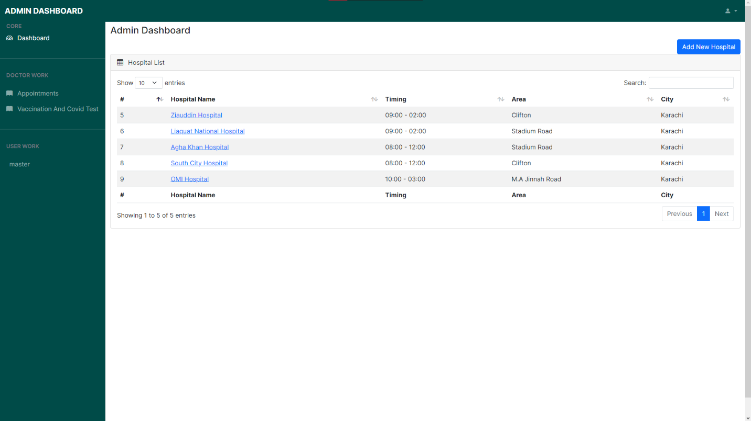
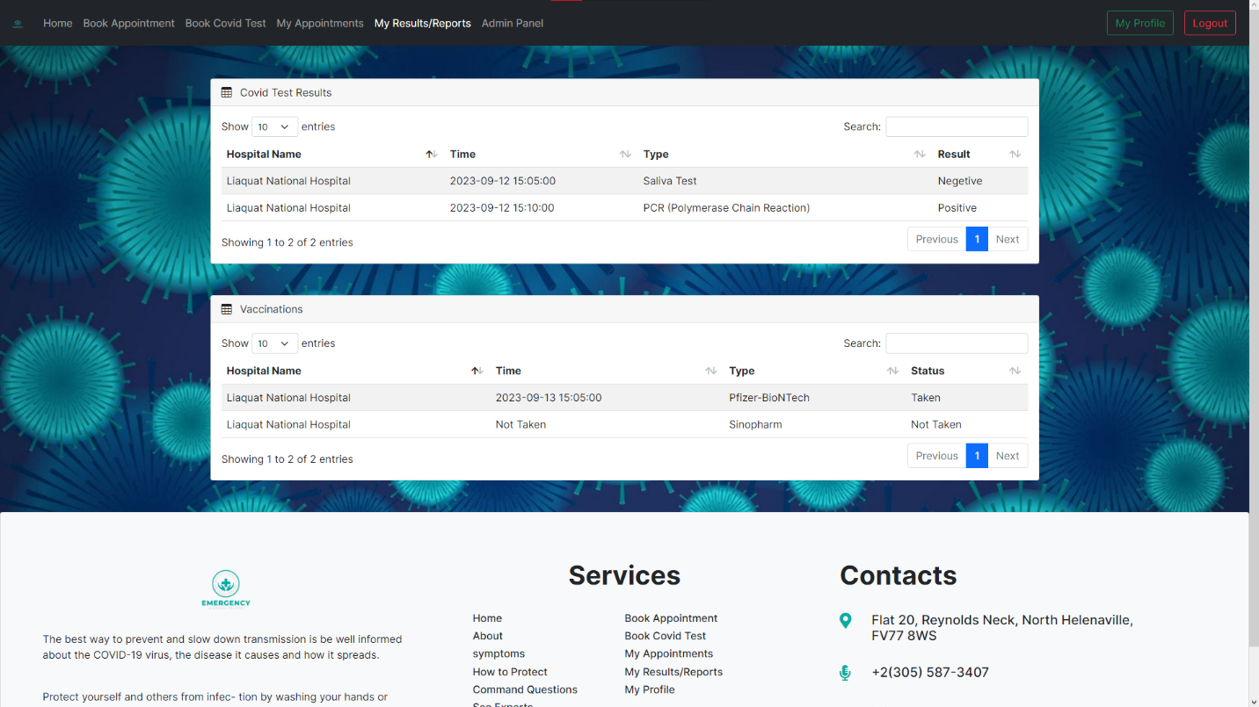
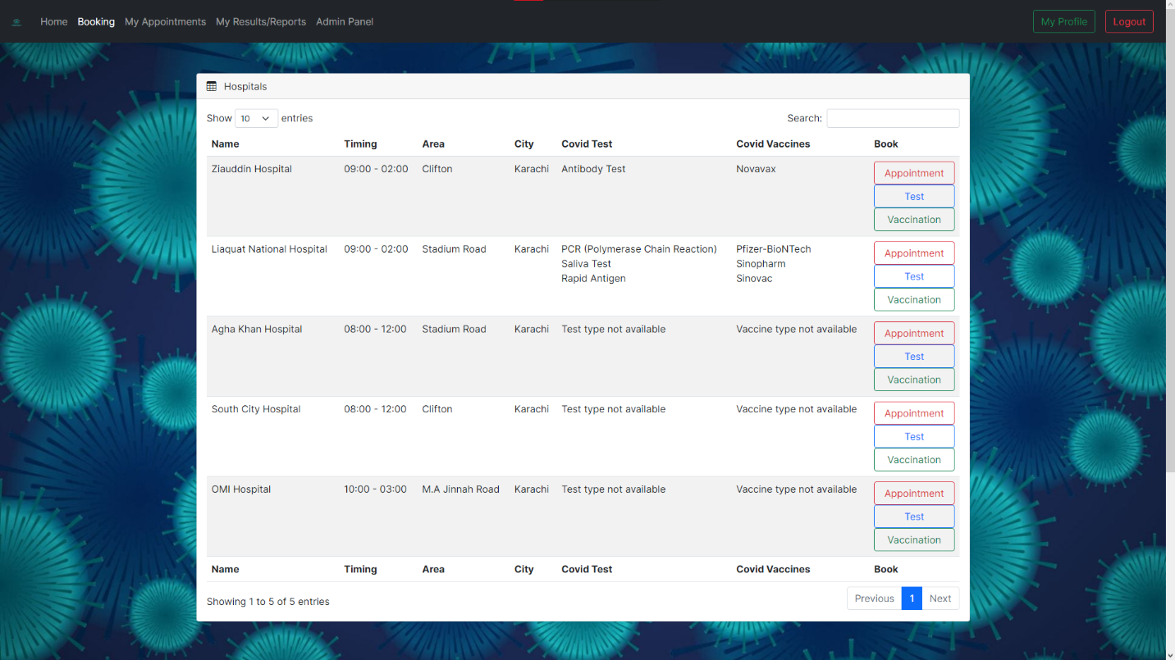
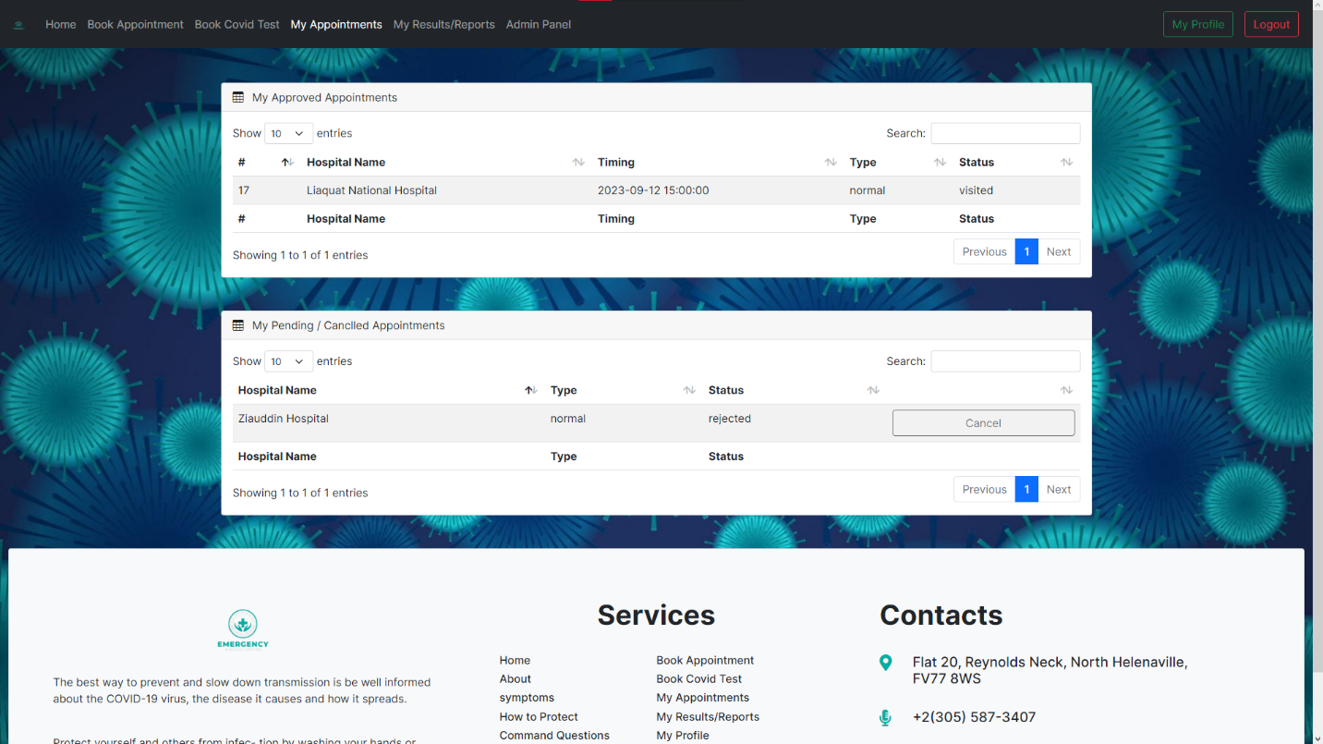

UNIT TESTING CHECK LIST /FINAL CHECKING LIST
- Certificate of completion
- Table of contents
- Problem of definition
- Customer requirement specification
- Project plan
- E.R diagram
- Algorithms
- GUI standard documents
- Interface design document
- Task sheet

