# MESD Documentation LMS-64-View-grades-for-assignments-quizzes-monthly-and-termly-marks

As a student in Moodle, viewing grades for assignments and quizzes involves accessing the gradebook and reviewing your individual grades. Here are the general steps you can follow:

**Viewing Grades for Assignments and Quizzes:**

1. **Log in to Moodle:**
   * Log in to your Moodle account using your credentials.
2. **Access the Course:**
   * Navigate to the course for which you want to view grades.
3. **Navigate to the Gradebook:**
   * Look for a link or tab named "Grades" in the course navigation menu. Click on it to access the gradebook.

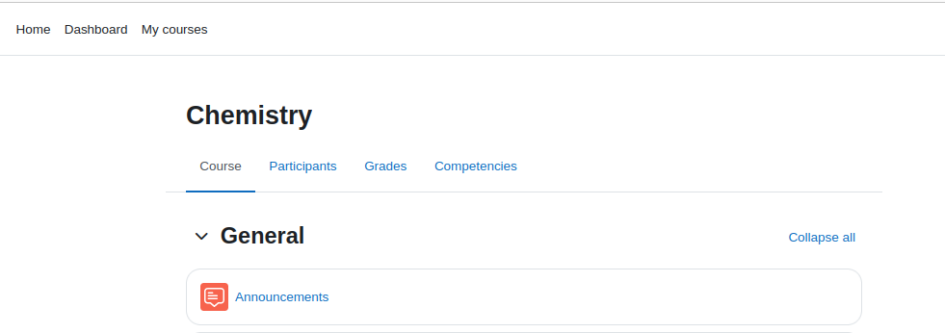

1. **Locate Your Grades:**
   * In the gradebook, you should see a list of assignments, quizzes, and other graded activities and to be able to view your individual grades.

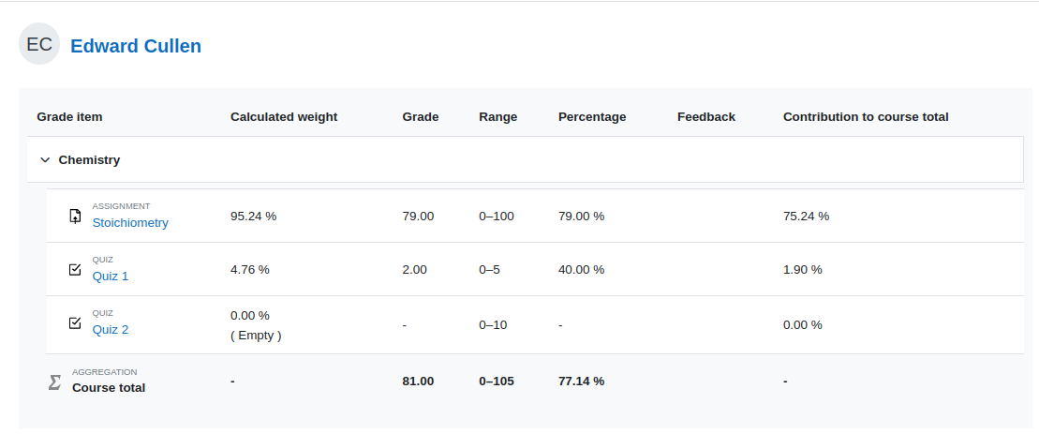

1. **Review Individual Grades:**
   * Find the assignments and quizzes you want to check. Click on the assignment or quiz to check feedback and any comments left by the grader

Example for the assignment;

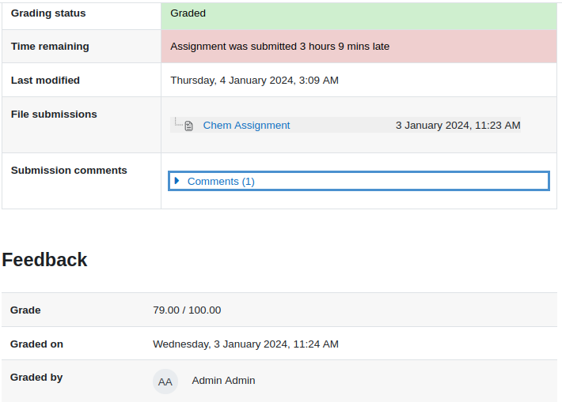

Example for the Quiz;

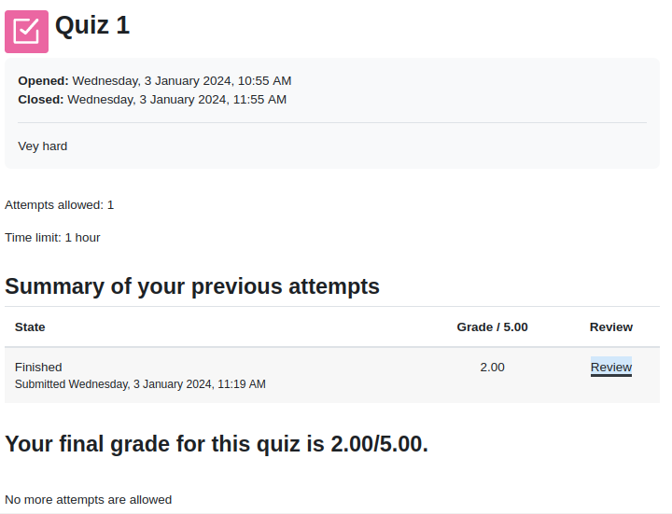

Click the review to analyse the answers and questions