V
CSE
AMB1301 - Data Visualization and Analytics
(Regulation 2023)
Time: Three Hours | Maximum Marks: 100 Marks
 | PART- A | (10 x 2 = 20 Marks)
Q.No. | Answer ALL Questions | CO | BTL | Marks
1 | Which of the following statement is incorrect? Explain your answer with justification a) Stress is directly proportional to strain within elastic limit b)Thes stress is force per unit area c)Hook's law hold good upto the breaking point d)The ratio of linear stress to linear strain is called young's modulus. | CO1 | 2 | 2
2 | Demonstrate the details of tensile strain, compressive strain. | CO1 | 2 | 2
3 | False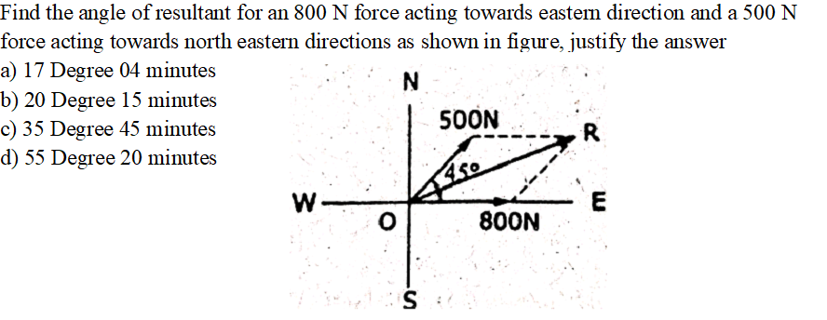 | CO2 | 4 | 2
4 | Clarify Lami’s theorem | CO2 | 2 | 2
5 | Justify, in projectile motion, the nature of horizontal velocity component will be  a) Uniform b) Increasing c) Decreasing d) Zero | CO3 | 3 | 2
6 | Resolve the term kinematics and kinetics | CO3 | 3 | 2
7 | What is the term for the geometric center of a plane area, where the entire area can be considered to be concentrated? Justify your answer. a) Neutral Axis b) Centre of gravity c) Centroid d) Centre of mass | CO4 | 3 | 2
8 | Apply the methods to analyse the truss to determine the member property. | CO4 | 3 | 2
9 | The shear force at supports of a simply supported beam with central point load is. Justify your answer.  a) Zero  b) Equal and opposite  c) Maximum bending moment  d) Parabolic | CO5 | 3 | 2
10 | Draw shear force and bending moment diagram of a a simply supported beam carries an uniformly distributed load throughout the span. | CO5 | 3 | 2
 | PART- B | (5 x 16 = 80 Marks)
Q.No. | Answer All Questions | CO | BTL | Marks
11 a | A rectangular block 260 mm x 110 mm x 70 mm is subjected to axial loads as follows:  450 KN (tensile) in the direction of its length.  970 kN (tensile) on the 260 mm x 70 mm faces.  1100 kN (compressive) on the 260 mm x 110 mm faces.  Taking E = 200 GN/m² and Poisson's ratio as 0.25.  Find the following:  i. Change in volume of the block.  ii. Values of the modulus of rigidity and bulk modulus for material of the block. | CO1 | 2 | 16
(OR)
11 b | The following data release to a bar subjected to a tensile test. Diamter of the bar=30mm Tensile load=54kN Gauge length=300mm Extension of the bar=0.112mm Change in diamter=0.00366mm Calculate i) Poisson's ratio, ii)The values of three modulii | CO1 | 2 | 16
12 a | Real time application problems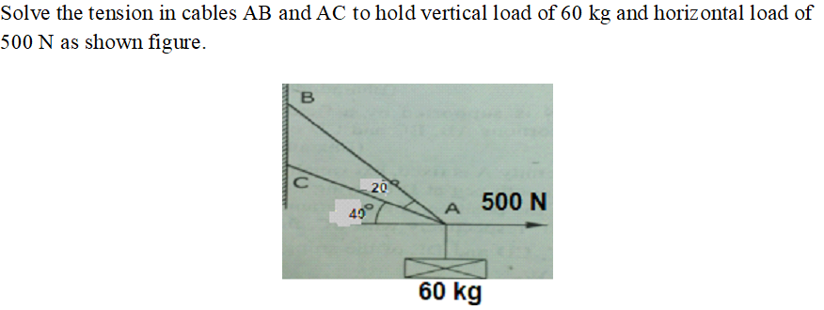 | CO2 | 3 | 16
(OR)
12 b | Real time application problems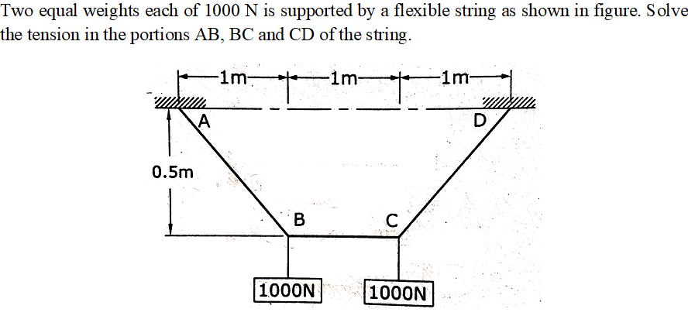 | CO2 | 3 | 16
13 a | A car 'A' starts from rest with uniform acceleration of 0.7 m/s². A second car ‘B’ starts from the same point after 15 seconds. The car ‘B’ follows the same route with an acceleration of 1.4 m/s². Determine the time necessary to overcome the car A, and the distance covered when B passes A. | CO3 | 4 | 16
(OR)
13 b | A particle is projected with an initial velocity of 50 m/s at an angle of 65° with the horizontal. Analyze the following  i) Maximum height attained by the particle  ii) Horizontal range of the particle  iii) Time taken by the particle to reach highest point  iv) Time of flight | CO3 | 4 | 16
14 a | Analysis of a given problem with solution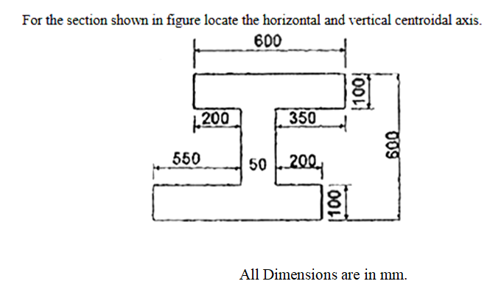 | CO4 | 4 | 16
(OR)
14 b | Deconstruct an application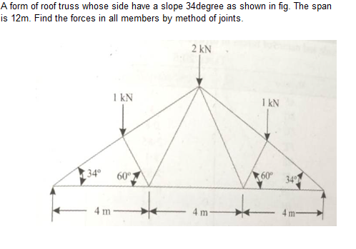 | CO4 | 4 | 16
15 a | Draw the shear force diagram and bending moment diagram for a simply supported beam of length 9m and carrying a uniformly distributed load of 10kN/m for a distance of 6m from the left end. Also calculate the maximum bending moment on the section. | CO5 | 3 | 16
(OR)
15 b | Determine the diameter of a solid shaft which will transmit 90 kW at 160 r. p. m. Also determine the length of the shaft if the twist must not exceed 1º over the entire length of the shaft. The maximum shear stress is limited to 60 N/mm². Take the vales of modulus of rigidity 8x10⁴ N/mm². | CO5 | 3 | 16

******************
QP123

