EXP 1:

Query 1: Write a SQL statement to create a simple table country including columns country_id,country_name and region_id.

Query 2: Display the structure of country table

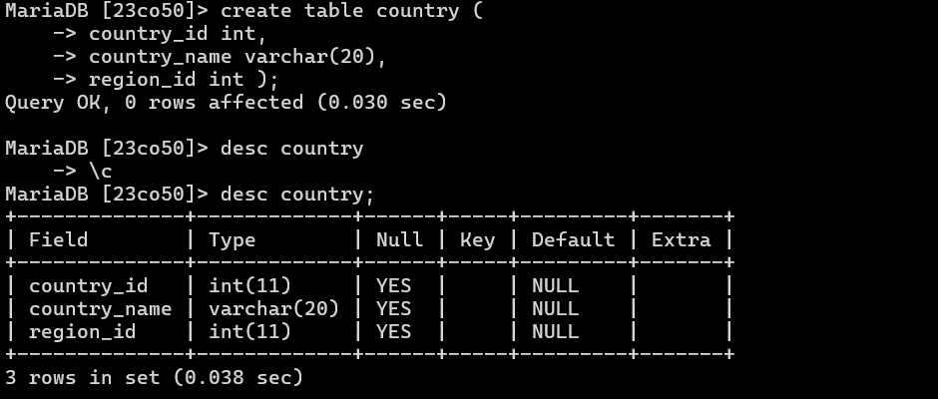

Query 3: Write a SQL statement to create a duplicate copy of countries table including structure and data by name dup_country.

Query 4: Display the structure of dup_country table

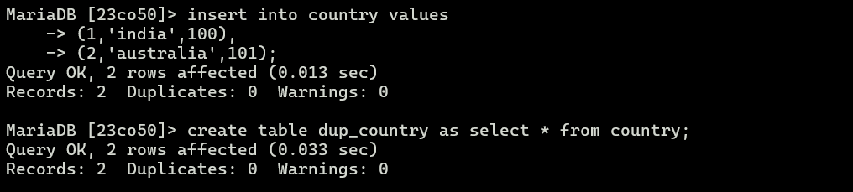

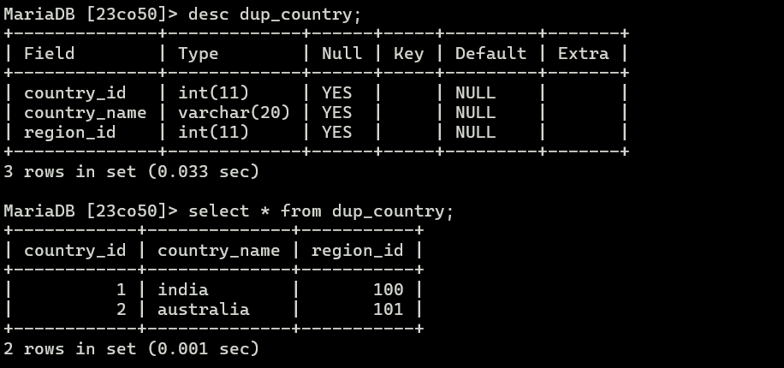

Query 5 : Write a SQL statement to create a table named jobs including columns job_id( primary key), job_title (Not Null and unique), min_salary, max_salary and check whether the max_salary amount exceeding the upper limit 25000.

Query 6: Display the structure of jobs table

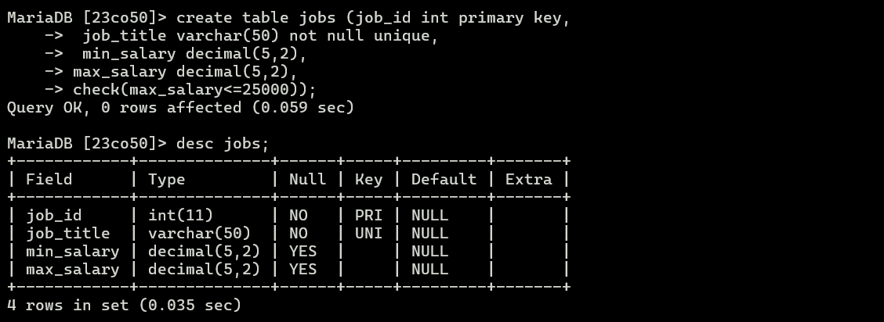

Query 7: Write a SQL statement to rename the table country to country_new.

Query 8 : Display the structure of country_new table

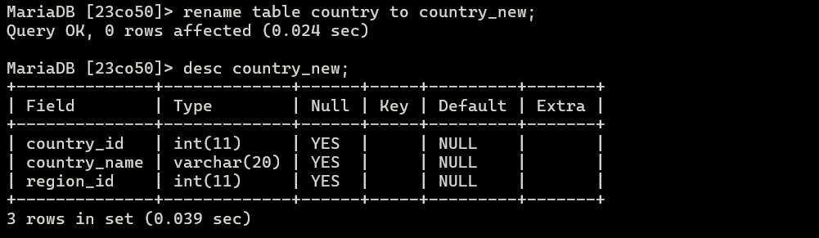

Query 9 : Write a SQL statement to add a column area to the table country_new.

Query 10 : Display the structure of country_new table

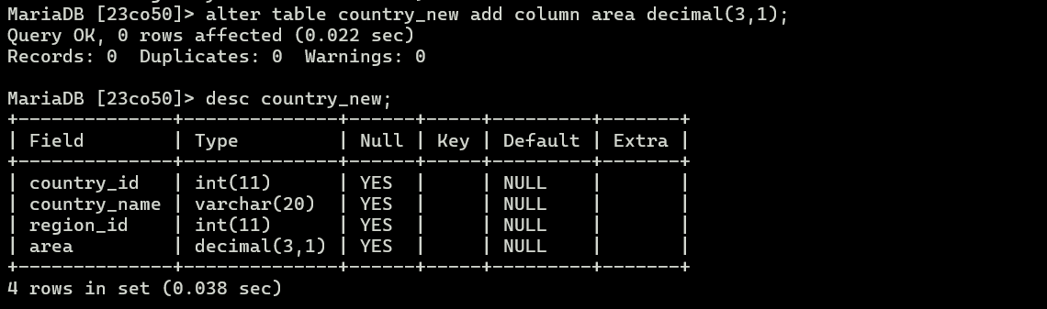

Query 11 : Perform the following on country_new table

1. Add primary key constraint to country_id field.
2. Display the structure of country_new table

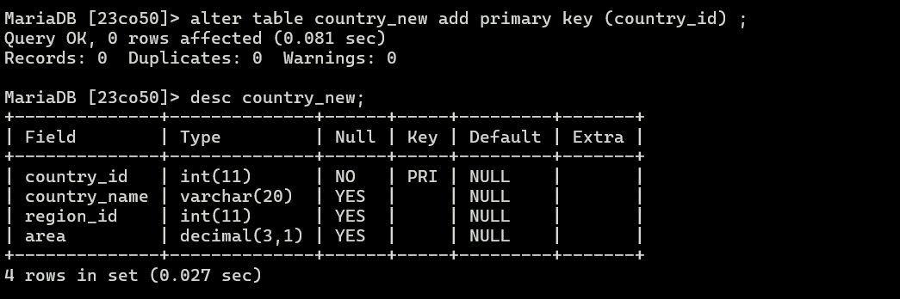

c. Modify the length of country_id field to adding more 5 digits

d. Display the structure of country_new table

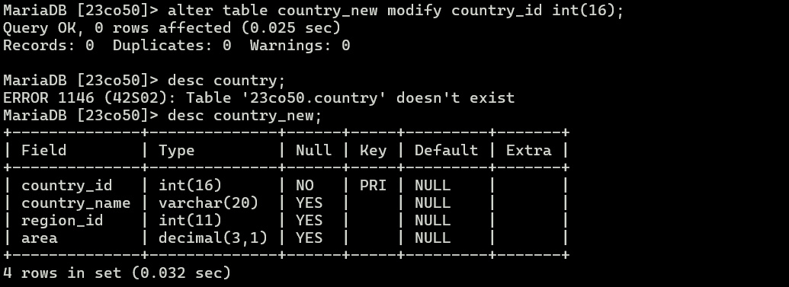

e. Rename the column name region_id to regionid

f. Display the structure of country_new table

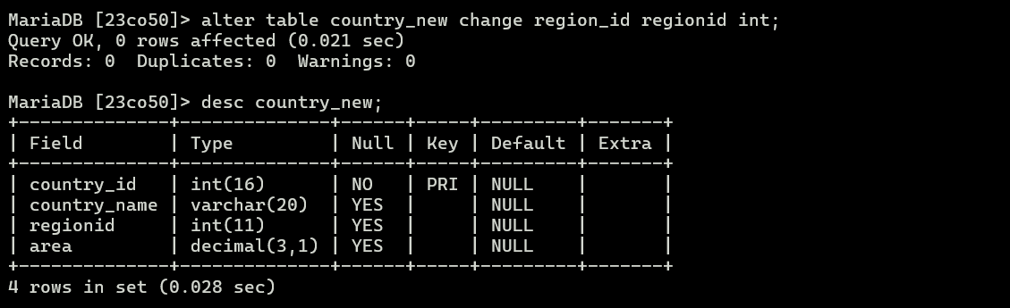

g. Drop column area

h. Display the structure of country_new table

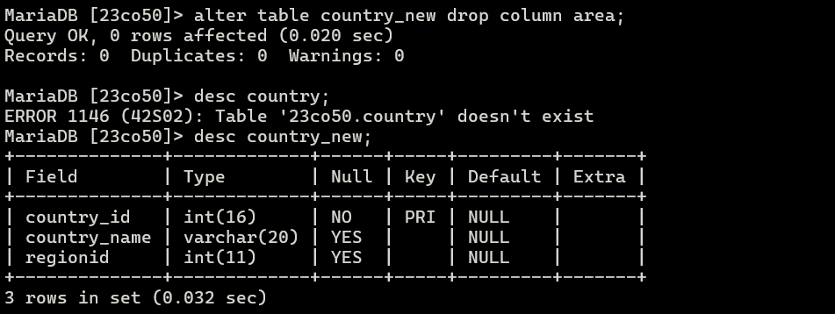

Query 12 : Insert 5 records in country_new table

Query 13: Display the details of country_new table

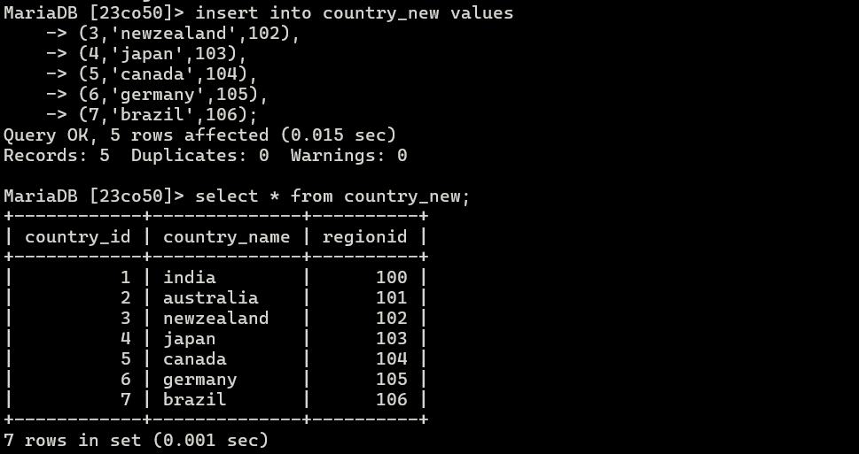

Query 14 : Truncate country_new

Query 15 : Display the details of country_new table

Query 16 : Display the structure of country_new table

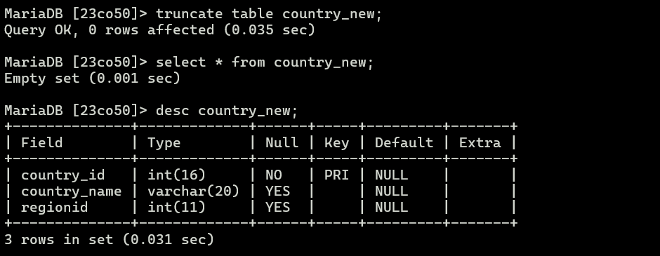

Query 17 : Drop table country_new

Query 18 : Display the structure of country_new table

